Reaching Wind Resource Limits? An examination of energy resource quality trends in wind turbine projects
Dénes Csala
Sgouris Sgouridis
Jacinto Estima
Sgouris Sgouridis
This paper analyzes country-level wind resource utilization trends. We find that leading countries with significant wind generation capacity deployed, such as Germany or Denmark have started exhausting their prime onshore wind sites. As projects increased in average size, the mean wind speed of the locations where wind turbine projects are deployed decreases exponentially over time. We find that this decrease is present for both on-shore and off-shore project and that it correlates with the wind resource distribution of the country. This phenomenon is only observable after a critical deployed capacity has been reached and the limits of the highest quality resources in a given country are neared. For countries with large territories, such as the United States and China, the situation is more nuanced and requires regional disaggregation. A lower resource quality also leads to correspondingly lower energy return on energy investment that may be counterbalanced by lowering the energy intensity of turbine manufacturing and installation. One must therefore take this into consideration when designing long-term sustainable energy transitions for countries, as well as globally.

Introduction

Background
In late 2018, the Intergovernmental Panel of Climate Change (IPCC) scientists repeatedly underlined the fact that in order to avoid catastrophic climate change and a radical change to our present-day way of life, the warming in climate must be limited to 1.5 degrees Celsius when compared to pre-industrial era levels. (IPCC 2018). Politically, this will require drastic (Tollefson 2018) action and collaboration on an unprecedented scale (Haberl et al. 2009; Gielen, Boshell, and Saygin 2016; Grubler 2012; Peters et al. 2012), but more importantly, it needs to be underpinned by a sustainable transition to renewable energy for all societal services (Child et al. 2018).
The proposals cover a spectrum of options that range from replacing and retrofitting fossil fuels power plants with carbon-capture enabled ones, (some running on biomass - BECCS) to the other end of a 100% wind-water-solar (WWS) system (van Vuuren et al. 2018; Delucchi and Jacobson 2012; Jacobson et al. 2015; Rogelj et al. 2015; Trainer 2019). While a workable solution may plausibly involve both options, currently the renewable energy seems to have the feasibility and scale advantage (Gielen et al. 2019) than pilot-scale CCS-based technologies. Granted, this may change in the future, especially if there is an inherent value attached to carbon, but currently there is no outlook on this (Durmaz 2018). Wind energy forms a critical component for the RE portfolio and is expected to continue to expand exponentially in the early transition phase.

Transition dynamics
However, the economics-oriented modelling tools (Integrated Assessment Models, IAMs) used by the global policy making community (and the IPCC) have flaws that may prevent them from accurately internalizing the net energy costs of (depleting) technologies. As result they may introduce present-state biases in their energy transition models (Palmer 2018; Kaya, Csala, and Sgouridis 2017) and inherently resist the structural transformation of the energy system from relying on fossil stocks to renewable energy flows (Geels 2018). Therefore, it is important to complement these models with others that take a net energy perspective (Raugei 2019; Rye and Jackson 2018)(Carbajales-Dale et al. 2014), taking into consideration the energy return on energy investment (EROEI) of all technologies involved (Deng and Tynan 2011).
Back in 2016, we modeled the internal dynamics of such a global energy transition, built on scalable renewables (mostly wind and solar power (Teske et al. 2019)). One must not forget that, especially in the early stages of the transition (because of replacing stocks with flows) one must “put aside seed energy” for the capital intensive energy investments of renewables. This adds an additional burden to the energy transition. However, we found that the necessary 50-fold increase when compared to today’s investment rates into renewables was plausible and thus, an energy transition with current technologies, feasible (Sgouridis, Csala, and Bardi 2016). If these condition are met, all societal energy needs are met during and after such a transition, which would make it a sustainable energy transition (SET) (Sgouridis and Csala 2014). However, the internal energy requirement of a SET (and thus, the net energy available to society) depends on the EROEI of the energy sources and fuels involved. Therefore in building out the energy system for a given geographic region, the optimal sequence would be to start from systems with higher EROEI. EROEI is the ratio of energy output, which depends on the converter efficiency and the resource quality, over the energy input, which in turn depends on the energetic investments to manufacture, install and operate the renewable energy system (Kubiszewski, Cleveland, and Endres 2010).

Wind Resource Classification
This paper examines wind energy resource limitations of countries and its implications on their internal energy transition dynamics.Wind is expected to provide a third or more of the global energy mix in the post-transition energy equilibrium but even more for certain countries.
Wind energy resources are typically classed into 7 or 8 power classes (Lopez et al. 2012). The classes are in direct correlation with wind speed, power density (W/m²) and capacity factor (CF). The relationship between the three is not linear, but an empirical conversion expression is known (NREL 2019). The resource class is linearly correlated to the per unit area power return. As a result, the relationship between the resource class and the EROEI is a scalar multiplier. The ranges of wind EROEI vary across the literature 5-18 (King and van den Bergh 2018), 10-30+ (Davidsson, Höök, and Wall 2012), 25 (Kubiszewski, Cleveland, and Endres 2010). Wind EROEI depends on the wind resource class or alternatively, the mean wind speed at a certain project location. Unfortunately, wind speed data are very location specific, and therefore require high resolution geographic data to be utilized. For example, the wind profile between a hill’s crest and the area in the hill’s aerodynamic shadow would be very different and averages are not accurate in representing the actual potential of the hill area. A recent study that attempted to estimate the global wind potential for different EROEI studies may have been influenced by this large-scale aggregation in estimating a lower wind EROEI (Dupont, Koppelaar, and Jeanmart 2018).

Analysis

Assumptions
The bounding extremes of the geographic distribution of wind installations with regards to resource quality are: (i) a normal random distribution around the mean and (ii) a perfect declining-returns-to-scale curve. The latter conforms to a marginal optimization perspective that the locations with the best resource quality would be utilized first and, once saturated, installations would cascade down to lower quality locations. Put differently, for a given technology and process, CF would be expected to decline reflecting also on other related metrics, e.g. EROEI. In practice, the actual distribution is dependent on multiple factors. On the global scale, countries with varying support for renewables immediately create differentiation potential. Neither Denmark, nor Germany have the best wind resources in the world (see also Fig. ???), yet they were the leaders in installed capacity for decades. Other factors at play on a regional scale include:
- Morphology: high resource quality areas may be difficult to develop due to terrain
- Load center proximity: high resource quality areas may be far from load centers making local installations preferable
- Infrastructure: desirable areas may not be served by transmission lines or roads bringing them at a disadvantage in comparison with less well-endowed but better located areas
- Ownership, capital access: lesser quality areas may develop earlier simply because their owners had access to capital and the desire to develop them accordingly
- Regulations: Desirable areas may be unavailable due to protected status or regulatory stipulations (for example limits in using agricultural or forest land)
Given that the confluence of these factors is difficult to model explicitly, statistical analysis methods are appropriate in analyzing deployment patterns and forecasting the future trends of wind resource quality. In this paper, we consider the on-shore and off-shore wind projects as two separate resource categories, with their own learning and resource potential.

Objective
The fundamental requirements for conducting a temporal and geographic analysis of wind energy power plant deployment is to construct a database that contains the following for all wind projects deployed globally:
- Installed capacity (rated output) and capacity factor (if available for verification)
- Commissioning year
- Location (geographic coordinates)
- Resource quality measure
This information can then be used to statistically correlate historical project deployment to wind resource quality on a global and country-level basis. Our initial hypotheses are:
- There is very limited correlation on a global scale and a stronger one on a country scale.
- A deterioration of utilized resource is more apparent in countries with
- significant installed wind capacity and
- compact grids in a relatively limited geographic area. I.e. large countries such as the United States, China or Australia will likely not adhere to the trend.

Global Wind Energy Resources by Country
We analyzed the wind energy resources as per NREL’s OpenEI dataset (NREL 2011). This includes per country wind power classes 3 through 7 at a height of 50 meters and it contains both the available power, as well as the available energy - using baseline capacity factors from (DoE 2008). We then normalize the 7 resource classes of the dataset into 10 resource quality deciles and show the country breakdown of wind resources it in Fig. ???. While the dataset exists for all countries, from this point forward we will only use a sample of representative countries on each figure, in order to avoid clutter.

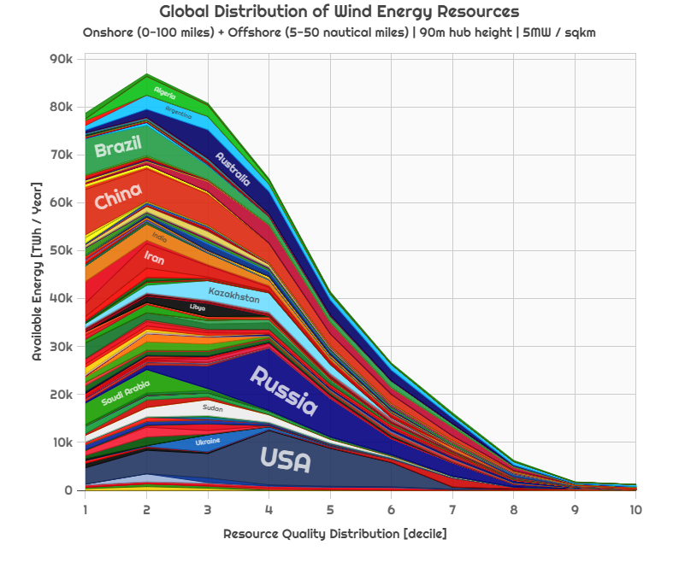
Global distribution of wind energy resources into to resource quality deciles with countries made explicit. source: (Csala 2016), data: (NREL 2011)
The global wind resource distribution approximately follows a Weibull distribution, with higher quality resources being much scarcer than medium to low quality ones. Countries with a large surface area have more extractable energy available from that area. We disaggregate the data in Fig. 1 into onshore (Fig. ???) and off-shore (Fig. ???) resources and convert the resource quality to wind speeds, that the available off-shore wind energy in the XXX wind resource bank 10 m/s speed band in the United Kingdom is 1108 TWh/year, while the total cumulative wind generation in the country was 49TWh in 2017XXX (BEIS 2018). This output covered about 17% of the country’s 2017XXX electricity consumption and an almost 50-50% split between onshore and off-shore wind.
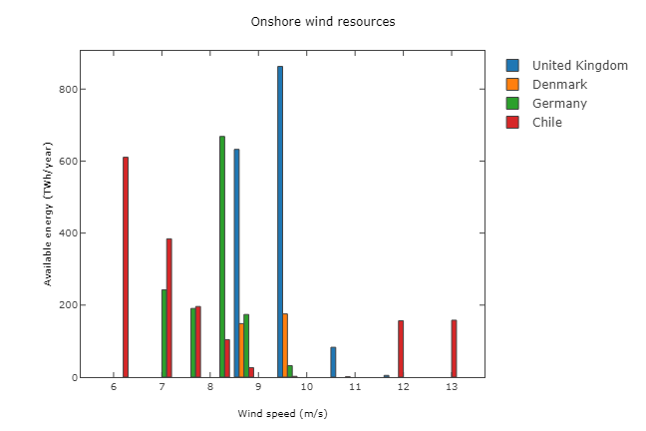
Onshore wind energy resources of selected countries, by available energy and wind speeds
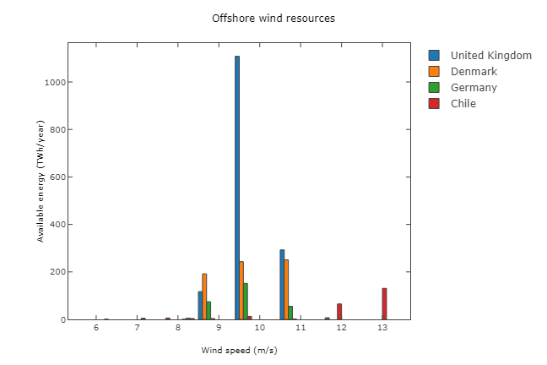
Off-shore wind energy resources of selected countries, by available energy and wind speeds

Wind Energy Projects Evolution
In order to assess how the wind resources have been utilized historically, we use a global wind project database with access provided by the International Renewable Energy Agency (Research and Markets 2017). The database is the most comprehensive listing of individual wind projects. Comparing the database entries to country statistics we find that it covers 50XXX% of the global installed capacity and the way this breaks down by country is shown in Table XXX. It provides information on installed capacities of the projects and their locations using geographic coordinates. Due to winds dependence on geographical morphology, wind resource quality is very localized as shown in Fig. ???. At the same time, the database reported coordinates are not accurate but are given with a precision of ±1km. It therefore requires some additional assumptions to reconcile the project location data (which are not always accurate) with the resource distribution. To do so, we split the region of analysis into a one km² grid. If one or more wind projects are reported inside the area of a given square, all projects are correlated with the best wind resource quality in all of the eight adjacent squares excepting areas with terrain that exceeds a slope of XXX.
In addition, it does not make sense to include countries with very limited capacity for exploring technology diffusion trends. Therefore, we filter the dataset based on two criteria:
- In the early days, most wind parks were research pilots. We therefore set a minimum starting year. This is separate for onshore ( 1990) and offshore turbines (2000)
- Even after this period, we filter out early years, when countries only have a small capacity of wind power installed (less than 10 MW)

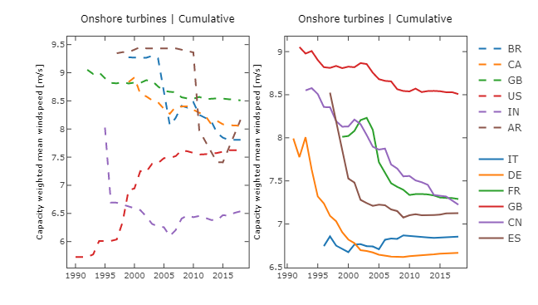
Evolution of capacity weighted mean wind speed of onshore wind turbine projects in selected countries across the world. Left-hand side and right-hand side panels just represent different countries clustered on the same scale.
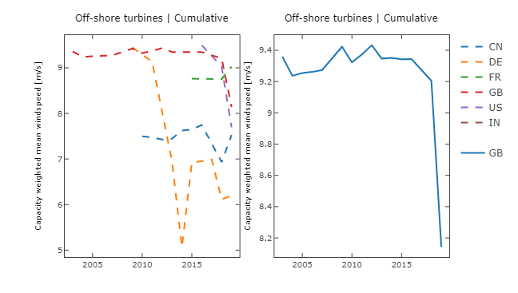
Evolution of capacity weighted mean wind speed of off-shore wind turbine projects in selected countries across the world. The right hand side panel is a zoom-in of the United Kingdom.
Figures ??? and ??? present the evolution of capacity weighted mean wind speeds for onshore of onshore and off-shore wind turbine projects in selected countries across the world. One can clearly observe the exponential decay of the mean wind speeds over time. We note that two phenomena are simultaneously occurring influencing the trends:
- Projects are getting deployed to locations with lower resource quality
- Turbines and hence projects are getting larger over time (hidden in the graph), therefore the larger projects bear a larger role in bringing the weighted mean of the wind speed down. However, this is fair, as the total resource utilization in the country would be proportional to the energy generated, regardless of the slicing of turbines and locations into projects.
We can see that in the onshore case, all countries (even China) follow a very similar decay pattern, and even a similar decay rate, the only outlier is the United States, and that is mostly due to its territorial differences in geography and the differential start of different regions. Examining the US data regionally, it becomes apparent that the intra-state patterns are the same for the states with large wind turbine deployment, such as Iowa, Oklahoma, California and Texas.

Resource utilization
Comparing the energy resource classes data (Section XXX) against the projects data (Section XXX) in order to quantify the wind resource utilization in each country - and reason about the evolution of the mean wind speeds, capacity factors and EROEI in the future.
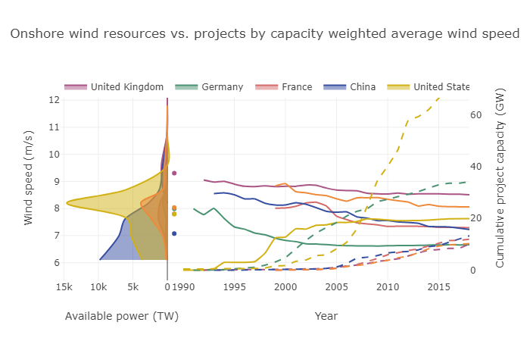
Onshore wind resource utilization for selected countries. The left panel shows the resource distribution of countries, with the dots indicating the weighted means of the distributions. The right panel shows the evolution of the capacity weighted mean project wind speeds (solid lines) next to the cumulative installed project capacities (dashed line - this latter number might not match the total country capacity because of the data availability in the database).
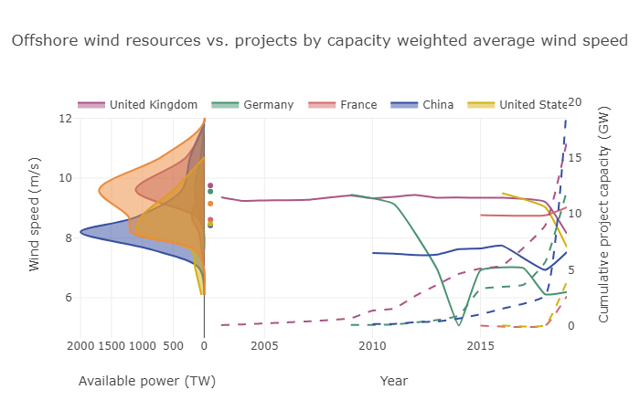
Off-shore wind resource utilization for selected countries. The left panel shows the resource distribution of countries, with the dots indicating the weighted means of the distributions. The right panel shows the evolution of the capacity weighted mean project wind speeds (solid lines) next to the cumulative installed project capacities (dashed line - this latter number might not match the total country capacity because of the data availability in the database).
We can see that in the countries represented, only the best projects hit the mean wind speeds, and they constantly decay from there (except the United States). This puts a severe limitation on the EROEI estimations that utilize purely the available energy resources as their baseline calculation for available energy. However, because of the vastness of resources in the resource class closest to the mean, rule–of thumb approaches using just the mean resource class of the country might be surprisingly accurate.

Methods
Methods provided in the supplementary material.

Conclusions
In this paper we analyzed the resource utilization of wind turbine projects deployed at locations across the world. We find that leading countries with significant wind generation capacity deployed, such as Germany or Denmark have started exhausting their prime sites offering the best in-country wind resources and, especially as projects started to get larger in size on average, the mean wind speed of the locations where wind turbine projects are deployed decreases exponentially over time. Only the best projects (likely the first commercial pilots) are deployed to the sites with the average resource quality, all the rest gets deployed to locations that exponentially decay in quality over time (as cumulative deployment increases and projects also get larger).
We find that this decrease is present for both on-shore and off-shore project and that it correlates with the wind resource distribution of the country. We must also mention that countries with vast territories, such as United States, the situation is much more nuanced. This also leads to a exponentially decaying energy return on energy investment of wind turbine projects. One must therefore take this into consideration when designing long-germ sustainable energy transitions for countries, as well as globally.

Acknowledgements
The authors would like to thank the support of IRENA in securing access to the wind energy projects database.

Data access
All code used to produce the results of this paper and interactive plots are publicly available on GitHub at: https://nbviewer.jupyter.org/github/csaladenes/eroei-drift/blob/master/parser-plotter-clean.ipynb

References
IPCC. 2018. “Global Warming of 1.5 ºC”. https://www.ipcc.ch/sr15/about/content-map/. https://www.ipcc.ch/sr15/about/content-map/.
Tollefson, Jeff. 2018. “IPCC Says Limiting Global Warming to 1.5 C Will Require Drastic Action”. Nature 562 (7726): 172–73. https://doi.org/10.1038/d41586-018-06876-2.
Haberl, Helmut, Marina Fischer-Kowalski, Fridolin Krausmann, Joan Martinez-Alier, and Verena Winiwarter. 2009. “A Socio-Metabolic Transition towards Sustainability? Challenges for Another Great Transformation”. Sustainable Development 19 (1): 1–14. https://doi.org/10.1002/sd.410.
Gielen, Dolf, Francisco Boshell, and Deger Saygin. 2016. “Climate and Energy Challenges for Materials Science”. Nature Materials 15 (2): 117–20. https://doi.org/10.1038/nmat4545.
Grubler, Arnulf. 2012. “Energy Transitions Research: Insights and Cautionary Tales”. Energy Policy 50 (November): 8–16. https://doi.org/10.1016/j.enpol.2012.02.070.
Peters, Glen P., Robbie M. Andrew, Tom Boden, Josep G. Canadell, Philippe Ciais, Corinne Le Quéré, Gregg Marland, Michael R. Raupach, and Charlie Wilson. 2012. “The Challenge to Keep Global Warming below 2 C”. Nature Climate Change 3 (1): 4–6. https://doi.org/10.1038/nclimate1783.
Child, Michael, Otto Koskinen, Lassi Linnanen, and Christian Breyer. 2018. “Sustainability Guardrails for Energy Scenarios of the Global Energy Transition”. Renewable and Sustainable Energy Reviews 91 (August): 321–34. https://doi.org/10.1016/j.rser.2018.03.079.
Vuuren, Detlef P. van, Elke Stehfest, David E. H. J. Gernaat, Maarten van den Berg, David L. Bijl, Harmen Sytze de Boer, Vassilis Daioglou, et al. 2018. “Alternative Pathways to the 1.5C Target Reduce the Need for Negative Emission Technologies”. Nature Climate Change 8 (5): 391–97. https://doi.org/10.1038/s41558-018-0119-8.
Delucchi, Mark A., and Mark Z. Jacobson. 2012. “Response to A Critique of Jacobson and Delucchis Proposals for a World Renewable Energy Supply by Ted Trainer”. Energy Policy 44 (May): 482–84. https://doi.org/10.1016/j.enpol.2011.10.058.
Jacobson, Mark Z., Mark A. Delucchi, Guillaume Bazouin, Zack A. F. Bauer, Christa C. Heavey, Emma Fisher, Sean B. Morris, Diniana J. Y. Piekutowski, Taylor A. Vencill, and Tim W. Yeskoo. 2015. “100% Clean and Renewable Wind Water, and Sunlight (WWS) All-Sector Energy Roadmaps for the 50 United States”. Energy & Environmental Science 8 (7): 2093–2117. https://doi.org/10.1039/c5ee01283j.
Rogelj, Joeri, Gunnar Luderer, Robert C. Pietzcker, Elmar Kriegler, Michiel Schaeffer, Volker Krey, and Keywan Riahi. 2015. “Energy System Transformations for Limiting End-of-Century Warming to below 1.5 C”. Nature Climate Change 5 (6): 519–27. https://doi.org/10.1038/nclimate2572.
Trainer, Ted. 2019. “Some Questions Concerning the Blakers Et Al. Case That Pumped Hydro Storage Can Enable 100% Electricity Supply”. Energy Policy 128 (May): 470–75. https://doi.org/10.1016/j.enpol.2018.12.063.
Gielen, Dolf, Francisco Boshell, Deger Saygin, Morgan D. Bazilian, Nicholas Wagner, and Ricardo Gorini. 2019. “The Role of Renewable Energy in the Global Energy Transformation”. Energy Strategy Reviews 24 (April): 38–50. https://doi.org/10.1016/j.esr.2019.01.006.
Durmaz, Tunç. 2018. “The Economics of CCS: Why Have CCS Technologies Not Had an International Breakthrough?”. Renewable and Sustainable Energy Reviews 95 (November): 328–40. https://doi.org/10.1016/j.rser.2018.07.007.
Palmer, Graham. 2018. “A Biophysical Perspective of IPCC Integrated Energy Modelling”. Energies 11 (4): 839. https://doi.org/10.3390/en11040839.
Kaya, Abdulla, Denes Csala, and Sgouris Sgouridis. 2017. “Constant Elasticity of Substitution Functions for Energy Modeling in General Equilibrium Integrated Assessment Models: a Critical Review and Recommendations”. Climatic Change 145 (1-2): 27–40. https://doi.org/10.1007/s10584-017-2077-y.
Geels, Frank W. 2018. “Disruption and Low-Carbon System Transformation: Progress and New Challenges in Socio-Technical Transitions Research and the Multi-Level Perspective”. Energy Research & Social Science 37 (March): 224–31. https://doi.org/10.1016/j.erss.2017.10.010.
Raugei, Marco. 2019. “Net Energy Analysis Must Not Compare Apples and Oranges”. Nature Energy 4 (2): 86–88. https://doi.org/10.1038/s41560-019-0327-0.
Rye, Craig D., and Tim Jackson. 2018. “A Review of EROEI-Dynamics Energy-Transition Models”. Energy Policy 122 (November): 260–72. https://doi.org/10.1016/j.enpol.2018.06.041.
Carbajales-Dale, Michael, Charles J. Barnhart, Adam R. Brandt, and Sally M. Benson. 2014. “A Better Currency for Investing in a Sustainable Future”. Nature Climate Change 4 (7): 524–27. https://doi.org/10.1038/nclimate2285.
Deng, Shinuo, and George R. Tynan. 2011. “Implications of Energy Return on Energy Invested on Future Total Energy Demand”. Sustainability 3 (12): 2433–42. https://doi.org/10.3390/su3122433.
Teske, Sven, Kriti Nagrath, Tom Morris, and Kate Dooley. 2019. “Renewable Energy Resource Assessment”. In Achieving the Paris Climate Agreement Goals, 161–73. Springer International Publishing. https://doi.org/10.1007/978-3-030-05843-2_7.
Sgouridis, Sgouris, Denes Csala, and Ugo Bardi. 2016. “The Sower’s Way: Quantifying the Narrowing Net-Energy Pathways to a Global Energy Transition”. Environmental Research Letters 11 (9): 094009. https://doi.org/10.1088/1748-9326/11/9/094009.
Sgouridis, Sgouris, and Denes Csala. 2014. “A Framework for Defining Sustainable Energy Transitions: Principles Dynamics, and Implications”. Sustainability 6 (5): 2601–22. https://doi.org/10.3390/su6052601.
Kubiszewski, Ida, Cutler J. Cleveland, and Peter K. Endres. 2010. “Meta-Analysis of Net Energy Return for Wind Power Systems”. Renewable Energy 35 (1): 218–25. https://doi.org/10.1016/j.renene.2009.01.012.
Lopez, A., B. Roberts, D. Heimiller, N. Blair, and G. Porro. 2012. “U.S. Renewable Energy Technical Potentials: A GIS-Based Analysis”. Office of Scientific and Technical Information (OSTI). https://doi.org/10.2172/1047328.
NREL. 2019. “Wind Data | Geospatial Data Science | NREL”. https://www.nrel.gov/gis/data-wind.html. https://www.nrel.gov/gis/data-wind.html.
King, Lewis C., and Jeroen C. J. M. van den Bergh. 2018. “Implications of Net Energy-Return-on-Investment for a Low-Carbon Energy Transition”. Nature Energy 3 (4): 334–40. https://doi.org/10.1038/s41560-018-0116-1.
Davidsson, Simon, Mikael Höök, and Göran Wall. 2012. “A Review of Life Cycle Assessments on Wind Energy Systems”. The International Journal of Life Cycle Assessment 17 (6): 729–42. https://doi.org/10.1007/s11367-012-0397-8.
Dupont, Elise, Rembrandt Koppelaar, and Hervé Jeanmart. 2018. “Global Available Wind Energy with Physical and Energy Return on Investment Constraints”. Applied Energy 209 (January): 322–38. https://doi.org/10.1016/j.apenergy.2017.09.085.
NREL. 2011. “Wind Resources by Class and Country At 50m - OpenEI DOE Open Data”. https://openei.org/doe-opendata/dataset/wind-resources-by-class-and-country-at-50m. https://openei.org/doe-opendata/dataset/wind-resources-by-class-and-country-at-50m.
DoE. 2008. “20 Percent Wind Energy by 2030”. https://www1.eere.energy.gov/wind/pdfs/42864.pdf. https://www1.eere.energy.gov/wind/pdfs/42864.pdf.
Csala, Denes. 2016. “A Data-Driven Dynamic Net-Energy Analysis of Global and National Sustainable Energy Transition Paths”. PhD thesis, https://www.academia.edu/27857565/A_data-driven_dynamic_net-energy_analysis_of_global_and_national_sustainable_energy_transition_paths. https://www.academia.edu/27857565/A_data-driven_dynamic_net-energy_analysis_of_global_and_national_sustainable_energy_transition_paths.
BEIS. 2018. “Renewables Statistics”. https://assets.publishing.service.gov.uk/government/uploads/system/uploads/attachment_data/file/766383/Renewables.pdf. https://assets.publishing.service.gov.uk/government/uploads/system/uploads/attachment_data/file/766383/Renewables.pdf.
Research, and Markets. 2017. “Worldwide Wind Farms Database”. https://www.researchandmarkets.com/research/34khqx/worldwide_wind. https://www.researchandmarkets.com/reports/4060504/worldwide-wind-farms-database.

