TENOFOVIR INDUCED FANCONI SYNDROME IN A MIDDLE AGE AFRICAN FEMALE FROM KENYA, EAST AFRICA: CASE REPORT AND BRIEF LITERATURE REVIEW
Fredrick Otieno
Nareeba Shallot
Grace Mkanjala
Ann Wangari
Vashti Nyangau
TENOFOVIR INDUCED FANCONI SYNDROME IN A MIDDLE AGE AFRICAN FEMALE FROM KENYA, EAST AFRICA: CASE REPORT AND BRIEF LITERATURE REVIEW.
Authors: Fredrick Odhiambo¹, Grace Mwangeka¹, Shallot Nareeba¹, Vashti Nyakebati², Ann Njambi²
ABSTRACT
This is a case presentation of a 50-year-old African female who had been on a Tenofovir based regimen for twelve years and developed Fanconi syndrome. she recovered after discontinuation of the Tenofovir Disoproxil Fumarate (TDF).
KEY CLINICAL MESSAGE
This case presentation highlights the need to routinely monitor renal function in patients on Tenofovir Disoproxil Fumarate (TDF) due to its side effect of proximal tubule dysfunction.
INTRODUCTION
Tenofovir Disoproxil Fumarate (TDF) is one of the newest and more tolerable backbone of highly active antiretroviral therapy (HAART) in the class of nucleotide reverse transcriptase inhibitor (NRTI). In 2016, World Health Organization (WHO) published a consolidated guideline that recommended Tenofovir based regimen as the first line for adults and adolescents and henceforward this regimen has been extensively rolled out11ReferencesWHO (2018, January 1). Updated recommendations on the first line and second line antiretroviral regimens and post exposure prophylaxis and recommendations on early infant diagnosis of HIV. Despite its excellent safety profile and tolerability TDF is known to cause proximal tubule renal dysfunction. TDF renal tubulopathy can manifest as Fanconi syndrome (FS), Acute kidney injury or chronic kidney disease22Verhelst D, Monge M, MeynardJL, et al. Fanconi syndrome and renal failure induced by tenofovir: a first case report, Am J Kidney Dis , 2002, vol. 40(pg. 13313). Here, we present the case of a middle age African female on Tenofovir based regimen who developed Fanconi syndrome after 12 years of Tenofovir based HAART.
CASE REPORT
We present a case of a 50-year-old black African female on management of HIV for the last 12 years who presented to our hospital with complaints of longstanding generalized body aches and bone pains for a duration of 2 years. These symptoms got worse 3 weeks prior to admission and were associated with muscle weakness of both the upper and lower limbs. In addition, she had joint pains worsened by activity but not associated with stiffness. A year prior to admission she suffered a trivial fall without a fracture that rendered her unable to walk. She denied any of history of cough, weight loss, night sweats, back pain or paraesthesia. Moreover, she had normal bladder and bowel control without polydipsia, polyuria or even polyphagia.
Our patient was initiated on HAART in 2011 and has been on drugs with excellent adherence since then. She was on TDF/3TC/EFV, however in 2019 she was transferred to TDF/3TC/DTG as part of a Nationwide optimization program.
She has a history of pulmonary TB treatment 13 years ago but no history of any other opportunistic infection, hypertension or diabetes.
General exams revealed a middle-aged female who was alert and responsive, groaning and moaning in pain. She was wasted with a BMI of 17.8 kg/m² and a weight of 48 Kgs. There was no pallor, jaundice, dehydration, oedema or lymphadenopathy. Her vital signs were within the normal ranges. On musculoskeletal exams she had reduced muscle bulk, reduced muscle power graded at 3/5 and tenderness on palpation of the muscles and along the long bones. Range of motion of the right hip joint was also restricted. The other systemic exams were normal.
Laboratory investigations done at admission revealed reduced GFR at 35.80 ml/min/1.73m² (CKD- EPI) with raised creatinine levels of 152.58 umol/l. Her Calcium and Uric acid levels were low at 1.8 mmol/l and 2.26 mg/dl respectively. She had normal HBA_{1c} of 4.6% with a normal random blood sugar of 6.7 mmol/L. Abnormal urinalysis findings that included glycosuria of 250mg/dl, proteinuria of 100 mg/dl and urine pH of 7.0. She had normal full hemogram and electrolytes, and a negative Rheumatoid factor.
KUB ultrasound was normal, but the Bone survey x-rays (attached) revealed features of osteoporosis and osteoarthritis of the Hip joints.
A diagnosis of Fanconi syndrome secondary to Tenofovir nephrotoxicity was made based on clinical symptoms of generalized body aches and bone pains and supporting laboratory findings of elevated creatinine levels, proteinuria, glycosuria, hypouricemia, osteoporosis and a urine pH of >5.
Our patient was then switched from TDF based regimen to an Abacavir based one, Abacavir/Lamivudine/ Dolutegravir. Serial creatinine levels were done, See table 1 .
Day | Admission | Day 10 | Day 25 | Day 81
Creatinine levels | 152.58 umol/l | 126.2 umol/l. | 118.7 umol/l. | 110umol/l.
Table 1: Creatinine trends
She had progressive reduction in the creatinine levels and repeat of urinalysis 11 weeks later revealed clearance of the proteinuria and glycosuria, normal calcium levels of 2.25 mmol/l and Improvement in muscle power and activities of daily living. She was now able to walk with support using a walker.
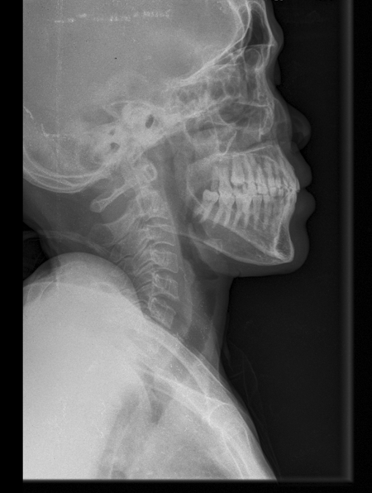
X-ray 1:Skull
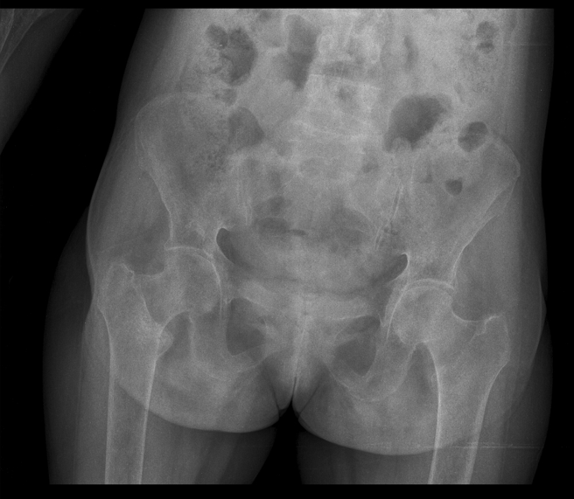
X-ray 2: Pelvic
DISCUSSION
FS is a proximal tubule dysfunction that results in normoglycemic glycosuria, as well as urinary loss of phosphate, calcium, uric acid, amino acids, bicarbonates, and tubular proteins 11Izzedine H, Launay-Vacher V, Isnard-Bagnis C, Deray G. Drug-induced Fanconi’s syndrome, Am J Kidney Dis, 2003, vol. 41 (pg. 292-309). Tenofovir can cause complete or partial Fanconi syndrome. Majority of cases present as partial with an elevation in creatinine levels, hypophosphatemia and glycosuria 22Izzedine H, Hulot JS, Vittecoq D, et al. Long-term renal safety of tenofovir disoproxil fumarate in antiretroviral-naive HIV-1-infected patients: data from a double-blind randomized active-controlled multicentre study, Nephrol Dial Transplant, 2005, vol. 20 (pg. 743-6). Patients on TDF based regimen are at 5 times greater risk of developing chronic kidney disease in comparison to patients on a non-TDF based regimen. This rapid decline of estimated GFR mostly occur in the first 2-3 years of treatment33Jirayu Visuthranukul, T. R. (2021). Incidence Rate and Time to Occurrence of Renal Impairment and Chronic Kidney Disease among Thai HIV-infected Adults with Tenofovir Disoproxil Fumarate Use. Open Aids Journal, 73-80..The prevalence of renal dysfunction induced by TDF is estimated at 5.6%, and the risk is increased with advanced age, low BMI, low baseline CD4 count, hypertension and diabetes44Nagalingeswaran Kumarasamy, S. S. (2018). Prevalence and factors associated with renal dysfunction in patients on tenofovir disoproxil fumarate-based antiretroviral regimens for HIV infection in Southern India.Journal of Virus Eradication, 4 (1), 37-40. Retrieved from https://doi.org/10.1016/S2055-6640(20)30245-4.. Severe nephrotoxicity to warrant discontinuation has been reported in 1% patients yearly55Fux, C. A., Simcock, M., Wolbers, M., Bucher, H. C., Hirschel, B., Opravil, M., Vernazza, P., Cavassini, M., Bernasconi, E., Elzi, L., Furrer, H., & Swiss HIV Cohort Study (2007). Tenofovir use is associated with a reduction in calculated glomerular filtration rates in the Swiss HIV Cohort Study. Antiviral therapy , 12 (8), 1165–1173..) Africans with pre-existing renal disease and advanced age are at a greater risk of statistically significant TDF associated renal function decline66Mtisi, T.J., Ndhlovu, C.E., Maponga, C.C. et al. Tenofovir-associated kidney disease in Africans: a systematic review. AIDS Res Ther 16 , 12 (2019). https://doi.org/10.1186/s12981-019-0227-1. Concomitant protease inhibitor use has also been suggested to contribute to development of TDF associated nephrotoxicity77Ryan D. Cooper and others, Systematic Review and Meta-analysis: Renal Safety of Tenofovir Disoproxil Fumarate in HIV-Infected Patients, Clinical Infectious Diseases , Volume 51, Issue 5, 1 September 2010, Pages 496–505, https://doi.org/10.1086/655681. Other factors including low body weight and low CD4 cell count have been linked to increased susceptibility of TDF tubulopathy in some individuals88Nelson, M. R., Katlama, C., Montaner, J. S., Cooper, D. A., Gazzard, B., Clotet, B., Lazzarin, A., Schewe, K., Lange, J., Wyatt, C., Curtis, S., Chen, S. S., Smith, S., Bischofberger, N., & Rooney, J. F. (2007). The safety of tenofovir disoproxil fumarate for the treatment of HIV infection in adults: the first 4 years. AIDS (London, England) , 21 (10), 1273–1281. https://doi.org/10.1097/QAD.0b013e3280b07b33. The diagnostic criteria for TDF related Fanconi syndrome include normoglycemic glycosuria, proteinuria and hypophosphatemia with phosphaturia 99Rao, M., Dadey, L., Glowa, T., & Veldkamp, P. (2021). Fanconi Syndrome Leading to Hypophosphatemic Osteomalacia Related to Tenofovir Use. Infectious disease reports , 13 (2), 448–453. https://doi.org/10.3390/idr13020044 that can be screened for, through urine and blood tests. Reliance on elevations in eGFR and urine albumin/creatinine ratio, may lead to missed diagnoses due to their poor sensitivity as markers of proximal tubular function1010Mothobi NZ, Masters J, Marriott DJ. Fanconi syndrome due to tenofovir disoproxil fumarate reversed by switching to tenofovir alafenamide fumarate in an HIV-infected patient. Therapeutic Advances in Infectious Disease . 2018;5(5):91-95. doi:10.1177/2049936118785497.
Approximately half of the patients attain partial or full recovery of renal function after 1 year of TDF discontinuation, defined as >70% of pre- TDF creatinine clearance with majority of major markers of proximal tubulopathy resolving within 8 weeks of drug discontinuation1111Samir K. Gupta, A. M.-G. (2014, March). Fanconi Syndrome Accompanied by Renal Function Decline with Tenofovir Disoproxil Fumarate: A Prospective, Case-Control Study of Predictors and Resolution in HIV-Infected Patients. PLOS ONE, 9(3), 1-7. Retrieved from https://journals.plos.org/plosone/article/file?id=10.1371/journal.pone.0092717&type=printable. However, full reversibility of TDF –related renal toxicity is not always the rule1212Wever, K., van Agtmael, M. A., & Carr, A. (2010). Incomplete reversibility of tenofovir-related renal toxicity in HIV-infected men. Journal of acquired immune deficiency syndromes (1999) , 55 (1), 78–81. https://doi.org/10.1097/QAI.0b013e3181d05579. Early switching of TDF in patients with proximal renal tubulopathy has been associated with better chances of complete renal recovery as well as low levels of urine dipstick proteinuria at the time of discontinuation1313Patamatamkul, S., Songumpai, N., Payoong, P., Katavetin, P., & Putcharoen, O. (2022). Early switching of tenofovir disoproxil fumarate (TDF) in HIV-infected patients with TDF-induced nephrotoxicity: a prospective study. HIV research & clinical practice , 23 (1), 99–106..
This case illustrates a patient from an underserved region of a Low Middle-Income Country on Tenofovir based regimen for 12 years. She has excellent adherence as confirmed by the consistent undetectable viral load. However, she is unable to afford annual renal function tests as recommended by HAART guidelines1414Izzedine H, Hulot JS, Vittecoq D, et al. Long-term renal safety of tenofovir disoproxil fumarate in antiretroviral-naive HIV-1-infected patients: data from a double-blind randomized active-controlled multicentre study, Nephrol Dial Transplant, 2005, vol. 20 (pg. 743-6). It follows a trivial fall with persistent and worsening body and bone pains that the patient gets to be admitted. Further work up revealed normoglycemic glycosuria, increase in creatinine with declining glomerular filtration rate (GFR), proteinuria, hypouricemia, hyperchloremia, hypocalcemia and osteopenia. These laboratory findings are in keeping with FS where 5 out of 7 nondiabetic patients biopsied for Tenofovir nephrotoxicity had glycosuria with increased serum creatinine1515Herlitz LC, Mohan S, Stokes MB, Radhakrishnan J, D’Agati VD, Markowitz GS. Tenofovir nephrotoxicity: acute tubular necrosis with distinctive clinical, pathological, and mitochondrial abnormalities. Kidney International. 2010;78(11):1171–1177. Inability to do Arterial Blood Gases and phosphates in the resource limited regions further stifles the ability to clinch the diagnosis earlier1616Badiou S, Merle De Boever C, Terrier N, Baillat V, Cristol JP, Reynes J. Is tenofovir involved in hypophosphatemia and decrease of tubular phosphate reabsorption in HIV-positive adults? Journal of Infection. 2006;52(5):335–338.. The bone pain and generalized body aches are possibly a consequence of osteomalacia, which is a late manifestation of proximal tubulopathy secondary to phosphate wasting and/calcitriol deficiency, since calcitriol is synthesized by the mitochondria in the proximal tubules1717Perrot S, Aslangul E, Szwebel T, Caillat-Vigneron N, Le Jeunne C. Bone pain due to fractures revealing osteomalacia related to tenofovir-induced proximal renal tubular dysfunction in a human immunodeficiency virus-infected patient. Journal of Clinical Rheumatology. 2009;15(2):72–74 .
The proposed risk factors in this case includes and is not limited to prolonged TDF use1818Woodward C, Hall A, Williams I, Tenofovir-associated renal and bone toxicity. HIV Med 2009;10(8):482-7, low body weight and advanced age1919Nelson MR, Katlama C, Montaner JS, et al. The safety of tenofovir disoproxil fumarate for the treatment of HIV infection in adults: the first 4 years. AIDS. 2007;21(10):1273–1281.. The patient symptoms and renal function markedly improved following TDF discontinuation. 6 weeks later, she had no glycosuria, proteinuria, hypocalcemia and had reduced creatinine levels. Alexandre Karras et al2020Karras A, Lafaurie M, Furco A, Bourgarit A, Droz D, Sereni D, Legendre C, Martinez F, Molina JM. Tenofovir-related nephrotoxicity in human immunodeficiency virus-infected patients: three cases of renal failure, Fanconi syndrome, and nephrogenic diabetes insipidus. Clin Infect Dis. 2003 Apr 15;36(8):1070-3. doi: 10.1086/368314. Epub 2003 Apr 4. PMID: 12684922. reported that most of laboratory values in TDF tubulopathy returned to normal following its discontinuation.
In conclusion, we would like to emphasize the need for routine monitoring of renal function of patients on TDF based regimen for nephrotoxicity, even years after initiation of drugs. On any occasion TDF tubulopathy signs are recognized, the drug should be stopped to prevent further complications.
Hosted file
Table.docx available at https://authorea.com/users/665786/articles/666830-tenofovir-induced-fanconi-syndrome-in-a-middle-age-african-female-from-kenya-east-africa-case-report-and-brief-literature-review
Hosted file
Figures.docx available at https://authorea.com/users/665786/articles/666830-tenofovir-induced-fanconi-syndrome-in-a-middle-age-african-female-from-kenya-east-africa-case-report-and-brief-literature-review

