On adsorption fluctuations during deposition of monolayer thin films
Olga Jakšić, ​CMT-ICTM,
vera_marinova
Adsorption and desorption processes that take place in repeated pulses of atomic layer deposition of thin films, are basically stochastic in nature. So far, various tools have been developed for analytical and numerical investigations of fluctuation kinetics of adsorption in time domain and fluctuation dynamics of adsorption in frequency domain. We present here review of these tools for the example of ozone adsorption on Graphene.
The interest in Graphene, a 2-dimensional (2D) material formed of carbon monolayers, is still high because of its preeminent mechanical, electrical and optical properties favorable in nano- and optoelectronic device applications and successful methods for obtaining good quality graphene films have already been achieved [1]. Apart from obtaining graphene films, chemical vapour deposition (CVD) and atomic layer deposition (ALD) are deposition techniques utilized for growing layers on graphene [2] and here we focus on ozone adsorption on graphene because it is illustrative: it binds through different mechanisms (physisorption, chemisorption) modeled with different desorption energy, or with different orientations modeled with different molecular surface projection areas [3].
Adsorption-desorption process hasbeen modeled as the pseudo first order reaction and as the second order reaction. The domain of the applicability of both models in practical situations is determined, concerning the typical numerical values for realistic physical parameters of the system [4]. For both models along with the deterministic analysis [5], the stochastic analysis has been performed in a classical way [6], based on a foundations of probability theory, and in an approximate way, based on the Langevin method [7] [8]. Additionally, stochastic simulation algorithms have been used for surpassing the constrains of theoretical models [9].
A software package, designed in MathWorks MATLAB environment, based on these theoretical models and simulation algorithms has been developed in ICTM Centre of Microelectronic Technologies and used for investigations of fluctuations in adsorption phenomena.
The main purpose of this presentation is to argue the possibility of using noise spectroscopy as a tool for characterization of various aspects of adsorption process.
Fig ??? shows root of power spectral density of refractive index change fluctuations (in case adsorption is monitored optically) for ozone adsorption on graphene, where ozone is treated as a binary mixture constituted of two fractions of ozone, one being physisorbed (with desorption energy of 0.25eV) the other being chemisorbed (with desorption energy of 0.33eV) on the surface.
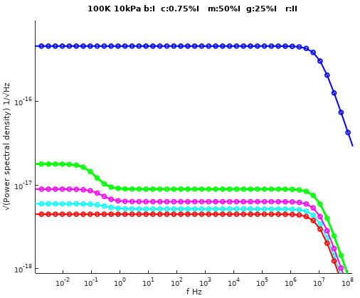
Root of power spectral density of refractive index change for ozone adsorption on graphene at temperature 100 K and overall pressure 10kPa for various compositions of physisorbed (denoted as I) and chemisorbed (II) amounts of adsorbate molecules.
Power spectral density has typical Lorentzian form and presence of two knees in spectrum implies possible different species in adsorbate mixture. Position of knees is strongly influenced by system parameters (temperature, pressure) but also by adsorbate parameters (desorption energy, molecular mass, refractive index, surface density of adsorbed molecules) which makes noise spectroscopy suitable method for characterization of ALD process (after taking special concern on proper calibration in experimental set up).

Acknowledgements
This work has been supported by the Serbian Ministry of Education and Science through the project TR 32008 and by the Bulgarian Ministry through DCOST 01/15. The collaboration is a result of activities conducted within HERALD COST Action MP1402.

References
Lai, Y.-C., Rafailov, P.M., Vlaikova, E., et al. Chemical vapour deposition growth and Raman characterization of graphene layers and carbon nanotubes. Journal of Physics: Conference Series, (2016).
[2]Park, Y.H., Kim, M.H., Kim, S.B., et al. Enhanced Nucleation of High-k Dielectrics on Graphene by Atomic Layer Deposition. Chemistry of Materials 28, 20 (2016), 7268–7275.
[3]Lee, G., Lee, B., Kim, J., and Cho, K. Ozone Adsorption on Graphene: Ab Initio Study and Experimental Validation. The Journal of Physical Chemistry C, (2009), 14225–14229.
[4]Jakšić, O., Čupić, Ž., Jakšić, Z., Randjelović, D., and Kolar-Anić, L. Monolayer Gas Adsorption in Plasmonic Sensors: Comparative Analysis of Kinetic Models. Russ. J. Phys. Chem. A 87, 13 (2013), 2134–2139.
[5]Jakšić, O.M., Randjelović, D.V., Jakšić, Z.S., Čupić, Ž.D., and Kolar-Anić, L.Z. Plasmonic sensors in multi-analyte environment: Rate constants and transient analysis. Chem. Eng. Res. Des. 92, (2014), 91–101.
[6]Jakšić, O.M., Jakšić, Z.S., Čupić, Ž.D., Randjelović, D.V., and Kolar-Anić, L.Z. Fluctuations in transient response of adsorption-based plasmonic sensors. Sensors Actuators B Chem. 190, (2014), 419–428.
[7]Jakšić, O., Jakšić, Z., and Matović, J. Adsorption–desorption noise in plasmonic chemical/biological sensors for multiple analyte environment. Microsyst. Technol. 16, 5 (2010), 735–743.
[8]Jakšić, Z., Jakšić, O., and Matović, J. Performance limits to the operation of nanoplasmonic chemical sensors: noise-equivalent refractive index and detectivity. J. Nanophotonics 3, 1 (2009), 31770.
[9]Gillespie, D.T. Stochastic simulation of chemical kinetics.. Annu. Rev. Phys. Chem. 58, (2007), 35–55.

