Unsafe Care and Fake News in Freeman-Burian syndrome
Mikaela I Poling
Craig R Dufresne
For rare conditions, avoiding hastily publishing case reports, conducting a thorough literature search, and ensuring the patient’s presentation aligns with accepted diagnostic criteria are each essential. Failure to heed the above can lead to serious inaccuracies, as illustrated by four articles we reviewed in the past year.
Correspondence: Mikaela I Poling, 8501 Arlington BLVD, Ste 420, Fairfax, VA 22031, USA; Tel. +1 703-207-3065; Fax +1 703-207-2002; E-mail: research@duplastics.com
Author Contributions: Both authors contributed equally.
Acknowledgments: The authors wish to thank CM Poling for proofreading, and M Pócket, W Cloud, B Poling, D Nickell, and L Kesling and his team for technical assistance.
Conflict of Interest: The authors have no financial or other competing interests to disclose.
Funding: This work was unfunded.
Word Count: 1,445 (Body); 47 (Key Clinical Message)

Letter
We read with great interest the article by Sato Boku, Sento, Hasegawa, Tsutsumi, Kamimura, So, Kako, and Sobue, “Anesthetic management of a patient with Freeman-Sheldon syndrome undergoing oral surgery: a case report.”[1-2] It is encouraging to see this exquisitely rare condition discussed in the literature. Unfortunately, this article[1-2] contains significant flaws (Fig 1), apparently resulting from the authors’ omission of recent literature, especially clinical recommendations for anesthesia management.[3-8] As Freeman-Sheldon syndrome, now Freeman-Burian syndrome (FBS),[9] is an exquisitely rare condition, little is known about it. Many who believe they have encountered it in clinical practice are eager to publish their experience, despite the perils.
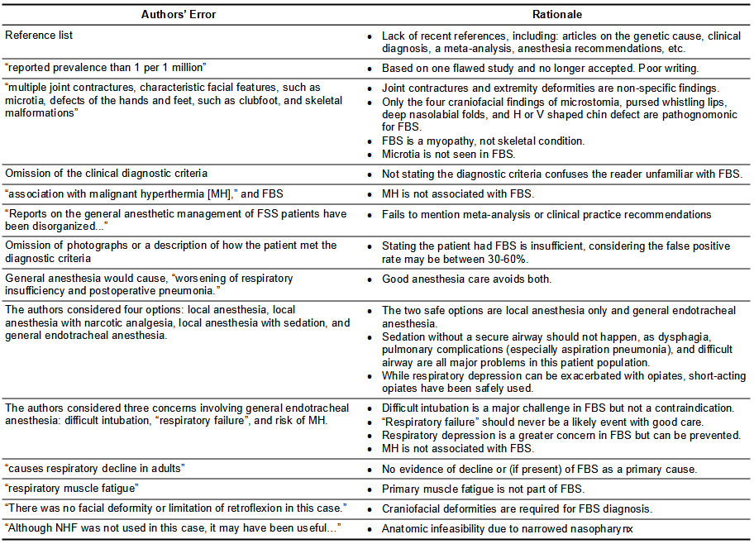
Major errors in case report of Freeman-Burian syndrome published in June 2021 and rationale.
Most areas of concern seemed to be related to an insufficient search of recent literature on Freeman-Sheldon syndrome, now Freeman-Burian syndrome (FBS).[3] For example, the authors omitted seminal articles that defined the clinical and genetic diagnosis,[4-5] molecular physiology,[6-8] the only meta-analysis on FBS,[9] and a clinical recommendation series that includes evaluation, anesthesia care, and dental and orofacial treatment[10-12]. Unfortunately, the authors cite[1-2] only one recent article, which was one of twelve flawed published since 2020[13] to which we responded[14]. As FBS is an exquisitely rare condition, little is known about it. Many who believe they have encountered it in clinical practice are eager to publish their experience. Special care is required in selective articles from the literature on FBS, as much of it contains oft repeated fallacies.
The unsubstantiated FBS frequency of 1:1 million, derived from a retrospective database study of UK patients with skeletal dysplasias, was cited[1-2,15]. FBS is often misdiagnosed, making it inadvisable to accept a recorded FBS diagnosis without objective patient data.[9] This study’s frequency for FBS is no longer accepted, and the prevailing estimate is that 200-300 individuals worldwide may have FBS.[16]
Sato (Boku) et al. describe patients as having, “multiple joint contractures, characteristic facial features, such as microtia, defects of the hands and feet, such as clubfoot, and skeletal malformations.”[1-2] External ear position variances may be seen in FBS, but microtia is not seen in FBS.[9] Otherwise, the description is mostly true for most patients, while remaining misleading. Only the craniofacial features (microstomia, pursed whistling lips, deep nasolabial folds, and H or V shaped chin defect) are required in the diagnostic criteria are pathognomonic for FBS.[4-5,9] Distal extremity contractures are non-diagnostic findings in FBS and common in many syndromic and non-syndromic entities.[4,9,16] The authors also do not state[1-2] the accepted clinical diagnostic criteria[4] that have been shown to be strongly correlated with molecular diagnosis[5]. Not directly stating the diagnostic criteria can confuse the reader unfamiliar with FBS.
FBS is a congenital craniofacial syndrome of myopathic origin that frequently involves findings outside the craniofacial region (spine and extremities), though FBS has had many classifications since its first description in 1938 and independent confirmation in 1962.[17-19] Contrary to Sato (Boku) et al., “skeletal malformations” are secondary effects of the primary myopathic process of fibrose tissue replacement of normal muscle fibers.[16] This fibrose tissue acts as constricting bands, the way collagen behaves in severe burns.[16] These findings are consistent with in vitro molecular myophysiology observations showing problems with the metabolic process for contraction and extreme muscle stiffness that reduces muscular work and power.[5-7] Misunderstanding of etiology in FBS has led to inappropriate treatment plans, especially surgeries, and has resulted in tragic, lifelong impairments.[9,16,20]
The authors referred to a risk of, “association with malignant hyperthermia (MH),” and FBS.[1-2] The potential association of MH and FBS was based on a single report of two cases.[21] Some patients with FBS do, indeed, develop hyperpyrexia during general anesthesia, but it has also been observed to be resolved by administration of ibuprofen.[11] These hyperpyrexia events, which may include tachycardia and increased muscle rigidity, have also been seen in settings where an MH protocol was followed and in non-operative stress situations, such as physical or mental stress beyond the individual’s baseline.[11] It is, now, believed these hyperpyrexia are not MH events and that MH is not associated with FBS or the DAs.[11]
The authors write that, “Reports on the general anesthetic management of FSS patients have been disorganized.”[1-2] While it is true that anesthesia case reports have been spotty and of varying quality, this is not a unique phenomenon.[9] There are only two published studies of FBS, neither of which addressed anesthesia in any detail.[4-5] There is, however, a meta-analysis of individual patient data extracted from rigorously evaluated case reports and anesthesia clinical practice recommendations.[9,11] Both of these articles consolidate the evidence-base for anesthesia care of FBS patients in detail.[9,11]
Without photographs or a detailed description of how the patient met the diagnostic criteria, it is not certain the patient described had FBS. Stating the patient had FBS is insufficient, considering the false positive diagnosis rate may be between 30-60%.[9] Near the end of the article, the authors remark that, “There was no facial deformity… in this case,”[1-2] making it unlikely the patient descried had FBS. Four main craniofacial deformities (microstomia, pursed whistling lips, deep nasolabial folds, and H or V shaped chin defect) are required for diagnosis,[4-5,9] and all patients present with an assortment of additional common but not required craniofacial stigmata[9-10].
The authors assert that general anesthesia would cause, “worsening of respiratory insufficiency and postoperative pneumonia.”[1-2] Though the risk is greater for post-operative respiratory complications in FBS patients, properly managed general anesthesia certainly does not directly cause post-operative respiratory distress and pneumonia.[11] Nonetheless, patients require care from experienced providers, ideally in tertiary referral centers.[11] Astute anesthesia and post-anesthesia care for patients with FBS, as outlined in the clinical practice recommendations, is specifically directed toward avoiding post-operative respiratory sequelae.[11]
In their management decision-making, the authors considered four options: local anesthesia, local anesthesia with narcotic analgesia, local anesthesia with sedation, and general anesthesia.[1-2] Expressly because of the need to ensure a secure airway to prevent aspiration pneumonia, the two safe options are local anesthesia only, where the patient is fully alert without impaired cognition and able to protect their own airway; and general anesthesia, where the patient’s airway is secured via orotracheal intubation or a surgical airway.[11-12] The authors acknowledged the pulmonary concerns[1-2,22] but paradoxically wished to avoid invasive airway management in a sedated patient undergoing oral surgery, which is a major risk to patient safety in FBS and should not happen[1-2]. Local anesthesia with narcotic analgesia would not be an option either. As correctly observed by Sato (Boku) et al., respiratory depression can be exacerbated with opiates, but short-acting options exist and have been safely used in this syndrome.[11] In our view, the bigger risk is the cognitive effect of the narcotics when used in an awake FBS patient for procedural pain control for oral surgery.[11-12]
Sato (Boku) et al. outlined their three concerns with general anesthesia: difficult intubation, “respiratory failure”, and risk of MH—seemingly as justification for considering general anesthesia contraindicated in FBS or for their case, at least.[1-2] Difficult intubation is a major challenge in FBS requiring considerable skill but is accomplished under the proper conditions when needed.[11] The other two concerns are flatly illogical. “Respiratory failure” should never be a likely event with good care.[11] While respiratory depression is a greater concern in FBS than for the general patient population, preventing it is a major goal for all anesthesia care.[11] As mentioned above, MH is not associated with FBS.[11]
Sato (Boku) et al. write, “[FBS] causes respiratory decline in adults.”[1-2] There is no evidence supporting either a decline in respiratory function or of FBS being a primary cause in any decline observed. While FBS may limit healthy physical activity necessary for maintaining respiratory function status, lifestyle and ageing are expected to be main contributors to any observed decline, as they would be in the general population.[20] They also refer to, “respiratory muscle fatigue.”[1-2] As discussed previously, FBS results in the formation of white fibrous tissue constricting bands within normal muscle and complete muscle replacement by white fibrous tissue.[16] Primary muscle fatigue is not part of FBS.
Finally, the authors consider nasal high-flow (NHF) oxygen cannulae in FBS and write, ““Although NHF was not used in this case, it may have been useful….”[1-2] Though NHF has an important role in critical care and other settings, its use in this patient population probably would be impractical, due to anatomically restricted airflow in the nasopharynx of most FBS patients that would preclude efficient oxygenation. For this reason, nasal airways and nasal intubation also are ineffective airway management methods in many FBS patients. Orotracheal intubation or a surgical airway are the most reliable techniques for providing effective airway protection and positive-pressure support.[11]
FBS is a rare complex craniofacial syndrome that has much “fake news” written about it. As illustrated in the present article, the literature search is not a skill restricted to the preserve of academicians. Indeed, there can be a strong connection between the quality of a literature search and clinical reasoning displayed in patient care, especially in care of patients with rare conditions.
REFERENCES
- Sato (Boku) A, Sento Y, Hasegawa T, Tsutsumi K, Kamimura Y, So M, Kako E, Sobue K. Anesthetic management of a patient with Freeman-Sheldon syndrome undergoing oral surgery: a case report. Clin Case Rep. 2021;9(6):e04358. Published 2021 Jun 9. doi:10.1002/ccr3.4358
- Sato (Boku) A, Sento Y, Hasegawa T, Tsutsumi K, Kamimura Y, So M, Kako E, Sobue K. Anesthetic management of a patient with Freeman-Sheldon syndrome undergoing oral surgery: A case report. Authorea. April 13, 2021. doi:10.22541/au.161831534.42337279/v1
- Poling MI, Dufresne CR. Revisiting the many names of Freeman-Sheldon syndrome. J Craniofac Surg. 2018;29(8):2176–2178. doi:10.1097/SCS.0000000000004802
- Stevenson DA, Carey JC, Palumbos J, Rutherford A, Dolcourt J, and Bamshad MJ. Clinical characteristics and natural history of Freeman-Sheldon syndrome. Pediatrics. 2006;117 (3):754-762. doi:10.1542/peds.2005-1219
- Toydemir RM, Rutherford A, Whitby FG, Jorde LB, Carey JC, Bamshad MJ. Mutations in embryonic myosin heavy chain (MYH3) cause Freeman-Sheldon syndrome and Sheldon-Hall syndrome. Nat Genet. 2006;38(5):561-5. doi: 10.1038/ng1775
- Racca AW, Beck AE, McMillin MJ, Korte FS, Bamshad MJ, Regnier M. The embryonic myosin R672C mutation that underlies Freeman-Sheldon syndrome impairs cross-bridge detachment and cycling in adult skeletal muscle. Hum Mol Genet. 2015;24(12):3348-58. doi:10.1093/hmg/ddv084
- Bell KM, Kronert WA, Guo Y, Rao D, Huang A, Bernstein SI, and Swank DM. The muscle mechanical basis of Freeman-Sheldon syndrome. Biophysical J. 2016;110(3):14a. doi:10.1016/j.bpj.2015.11.134
- Walklate J, Vera C, Bloemink MJ, Geeves MA, Leinwand L. The most prevalent Freeman-Sheldon syndrome mutations in the embryonic myosin motor share functional defects. J Bio Chem. 2016;291(19):10318-10331. doi:10.1074/jbc.M115.707489
- Poling MI, Dufresne CR, Chamberlain RL. Findings, Phenotypes, Diagnostic Accuracy, and Treatment in Freeman-Burian Syndrome. J Craniofac Surg. 2020;31(4):1063-1069. doi:10.1097/SCS.0000000000006299
- Poling MI, Dufresne CR, Portillo AL. Identification and recent approaches for evaluation, operative counseling, and management in patients with Freeman-Burian syndrome: principles for global treatment. J Craniofac Surg. 2019;30(8):2502–2508. doi:10.1097/SCS.0000000000005968
- Poling MI, Dufresne CR. Freeman-Burian syndrome. Anästh Intensivmed. 2019;60(1):S8-S17. doi:10.19224/ai2019.S008
- Poling MI, Dufresne CR. Identification and Recent Approaches for Evaluation and Management of Dentofacial and Otolaryngologic Concerns for Patients With Freeman-Burian Syndrome: Principles for Global Treatment. J Craniofac Surg. 2020;31(3):787-790. doi:10.1097/SCS.0000000000006155
- Kamal G, Shah SB, Gupta A. Anesthesia Challenges in the Management of Freeman-Sheldon Syndrome: Report of Two Cases and Literature Review. AANA J. 2020;88(1):35-38. PMID: 32008616
- Poling MI, Dufresne CR. Letter. AANA J. 2020;88(5):54.
- Wynne-Davies R, Gormley J. The prevalence of skeletal dysplasias: an estimate of their minimum frequency and the number of patients requiring orthopaedic care. J Bone Joint Surg Br. 1985;67-B(1):133-137. PMID: 3155744
- Poling MI, Dufresne CR, Chamberlain RL. Freeman-Burian syndrome. Orphanet J Rare Dis. 2019;14(1):14. doi:10.1186/s13023-018-0984-2
- Poling MI, Dufresne CR. Head first, not feet first: Freeman-Sheldon syndrome as primarily a craniofacial condition. Cleft Palate-Craniofac J. 2018;55(5):787-788. doi:10.1177/1055665617753482
- Freeman EA, Sheldon JH. Cranio-carpo-tarsal dystrophy: undescribed congenital malformation. Arch Dis Child. 1938;13:277-283. doi:10.1136/adc.13.75.277
- Burian F. [The “whistling face” symptom in the polyvalent syndrome]. Acta Chir Orthop Traumatol Cech. 1962;29:481-483. PMID: 14017018
- Poling MI, Dufresne CR, McCormick RJ. Identification and Recent Approaches for Evaluation and Management of Rehabilitation Concerns for Patients with Freeman-Burian Syndrome: Principles for Global Treatment. J Ped Genet. 2020;09(03):158-163. doi:10.1055/s-0040-1710339
- Jones R, Dolcourt JL. Muscle rigidity following halothane anesthesia in two patients with Freeman-Sheldon syndrome. Anesthesiology. 1992;77(3):599-600. doi:10.1097/00000542-199209000-00031
- MacLeod P, Patriquin H. The whistling face syndrome—cranio-carpo-tarsal dysplasia. Report of a case and a survey of the literature. Clin Pediatr (Phila). 1974;13(2):184-9. doi:10.1177/000992287401300213

