HEALTH INSURANCE PROVIDED BY GOVERNMENT VS PRIVATE SECTOR IN INDIA
Dr. Vedica Sethi

HEALTH INSURANCE PROVIDED BY GOVERNMENT VS PRIVATE SECTOR IN INDIA

Overview
1.Introduction………………………………………………………………………………………..4-5
1.1 Difference between life insurance and health insurance
1.2 Importance of health insurance
2.Types of health insurance………………………………………………………………………….5-8
2.1 Individual health insurance
2.2 Family health insurance floater
2.3 Senior citizen health insurance
2.4 Critical illness health insurance
2.5 Maternity health insurance
2.6 Group health insurance
2.7 Preventive healthcare
2.8 Personal accident insurance
3.Government health insurance scheme…………………………………………………………….8-10
3.1 Rashtriya swasthiya bima yojana
3.2 Central government health scheme
3.2 Universal health insurance scheme
3.3 Employment state insurance scheme
3.4 Ayushman bharat yojana
4. Private health insurance scheme………………………………………………………………….10-12
4.1 Bajaj allianz tax gain plan.
4.2 Apollo munich maxima plan.
4.3 Max bupa hearbeat platinum plan.
4.4 Cigna ttk pro health plan.
5.Understanding and awareness of public regarding insurance…………………………………12-14
5.1.Factors that frustrate the growth of private sector health insurance.
5.2.Pricing hurdles in out-patient insurance.
6.Innovative ideas on government health sector and private health sector ……………………14-16
7.Conclusion…………………………………………………………………………………………16

References………………………………………………………………………..17

Abstract

Background:
Healthcare is significant for each individual on the planet, on account of this each nation should focus on wellbeing, because of increment pace of sickness and ailments.
In India medical coverage part is an undiscovered market, still it has crying needs. There is colossal potential for this part. The medical coverage suppliers are not satisfying this interest. After 1999 the privatization of protection area, the protection segment has developed in past decade. By and by there are 25 medical coverage suppliers, in that four are with open area and twenty one private medical coverage suppliers. The piece of the overall industry of open segment is 60 rates while the rest with other private players.
This paper inspects the present status of medical coverage in India, advancement in health care coverage area and difficulties looked by it. It additionally investigates the job of both open and private medical coverage players to arrive at most extreme inclusion in health care coverage.
Aim:
To aim of this study is to provide information and assess the current status of government and private sector insurance with regard to coverage of India citizen.

Materials and Methods:
The study is a retrospective review of current healthcare insurance policies and a comparison between the private and public insurances and their status of projection The primary focal point of the present survey would be on the legislature and private medical coverage part with a focus on the indian resident and different hindrances looked by the administration and private medical coverage division.
Conclusion:
Private health insurance is firmly being upheld and accepted is of developing thought by our nation than government health insurance. The Medical coverage assumes an exceptionally significant job in limiting the monetary weight of poor because of sickness and illnesses. With our nation expecting two fold digit development throughout the following five years its healthcare that will assume a significant job in giving a not so youthful and enthusiastic workforce to the nation. The government policy plan has just underscored the requirement for and has progressively sorted out medical coverage inclusion all together give minimum monetary related insurance to an enormous Indian populace. Notwithstanding, it isn’t the main choice.
INTRODUCTION:
Health insurance is a kind of protection inclusion that pays for restorative, careful, brought about by the guaranteed. Health insurance can repay the safeguarded for costs caused from ailment or damage, or pay the consideration supplier legitimately. It is frequently remembered for business advantage bundles as a methods for tempting quality workers, with premiums halfway secured by the business yet regularly likewise deducted from representative checks. [11“Health Insurance,” December 24, 2019.] The expense of medical coverage premiums is deductible to the payer, and the advantages got are tax-exempt.

1.1 Difference between Life insurance vs Health insurance
Extra security and Health protection are not quite the same as one another. In Life, you get benefits simply after death of the protected (or at development as on account of Endowment strategy). [22“Life Insurance vs Medical Insurance: What’s The Difference?”]
Nonetheless, in Health protection, insurance agencies give you money related assistance when you are hospitalized or when you guarantee for spending on medications and other related spending.

1.2 Importance of health insurance
For each person in india, medical coverage has become a need. It gives hazard inclusion against use which is brought about by unexpected health related crises. Today, when the therapeutic expansion rates are so high, neglecting to hold a sufficient wellbeing spread can demonstrate expensive monetarily.
India is without a doubt one of the quickest developing economy on the planet, however on the opposite side it is additionally a home to numerous sicknesses. On account of advancement in restorative science, in India numerous infirmities are treatable however what squeezes your pocket is the expense to treat those illnesses. Many get this need cooked by their manager’s wellbeing spread; anyway that isn’t the changeless arrangement. The business’ medical advantages or protection spread endures just till the time you are working in the organization once you quit you lose all the collected advantages and inclusion as well. Likely, at that point your age could be over 30 years so odds of premium climb wins, in addition to your previous sicknesses stay revealed at the hour of purchasing the protection. Henceforth, it’s significant in India that individuals purchase a medical coverage intend to verify their medicinal needs.
1.3 History of health insurance in india
Propelled in 1986, the health insurance industry has become fundamentally for the most part because of advancement of economy and general mindfulness. As indicated by the World Bank, by 2010, over 25% of India’s populace approached some type of health insurance. There are independent wellbeing safety net providers alongside government supported health insurance suppliers. As of not long ago, to improve the mindfulness and diminish the hesitation for purchasing medical coverage, the General Insurance Corporation of India and the Insurance Regulatory and Development Authority (IRDA) had propelled a mindfulness battle for all sections of the populace.[33“Private Health Insurance Act 2007.”]
Propelled in 2007, the National Health Insurance Program (Rashtriya Swasthya Bima Yojana-RSBY) is driven by the Ministry of Health and was received by 29 states in 2014. It is subsidized 75% by the administration and 25% by the states. The laborer and 4 of his wards profit by medical coverage on the off chance that they are not secured by any framework and live beneath the neediness line. RSBY recipients are required to pay a yearly enlistment charge of INR 30 for emergency clinic inclusion up to INR 30,000 every year for each family.
September 25th, 2018, the Indian government declared the dispatch of another medical coverage for the least fortunate residents. Indian Prime Minister, Narendra Modi reported that the new framework is required to arrive at in excess of 500 million individuals and is classified ”Modicare”. The change is still in progress and means to introduce all inclusive government disability in the nation.

2.TYPES OF HEALTH INSURANCE IN INDIA

2.1 Individual Health Insurance
As the name recommends, Individual wellbeing plans are made for singular policyholders. The premiums may be low under such plans, yet there are an assortment of variables that add to the cost of a strategy. Past ailments, age, area, and so on are a couple of the parameters that impact the premium.
Ratherthanpurchasingseparatearrangementsforeachpart,afamilyfloaterplancoversthewholefamilyunderonearrangement.Ordinarily,guardiansandkids(upto2youngsters)canbesecuredunderthisarrangement.Afewbackupplansevengiveinclusiontoupto15relatives.Undersuchplans,thewholeprotectedissharedbyalltheincludedrelatives.Despitethefactthatfamilyfloaterplanshaveahigherpremiumthansingularplans,thevalueisasyetlessexpensivewhencontrastedwiththecostsengagedwithpurchasinganalternatearrangementforeverypart.[11Ilangovan,“HEALTHINSURANCEININDIA.”]

2.3 Senior Citizen Health Insurance
Intended to take into account the requirements of the senior residents, such plans are just for the ones who are 60 years of age or more. Senior resident plans for the most part accompany limits. In spite of the fact that solitary a couple of safety net providers give such strategies, they may request a therapeutic registration before selling the arrangement. Additionally, these arrangements may cost significantly higher than the wellbeing covers for more youthful buyers as senior residents are progressively inclined to sicknesses and diseases.

2.4 Critical Illness Health Insurance
Basic disease plans spread perilous ailments. Malignant growth, coronary episode, organ transplant, kidney disappointment, and so forth., are a couple of the ailments secured under such arrangements. A basic sickness spread is particularly helpful if the guaranteed has a past filled with certain basic diseases in the family.

2.5 Maternity Health Insurance
Maternity plans are intended to cover ladies who are anticipating a youngster. It covers the costs acquired in the pre-natal stage, conveyance, and post-natal stage. Both the mother and the infant are secured under such plans. Maternity plans can likewise be purchased as a rider to a current essential strategy.

2.6 Group Health Insurance
Such plans are normally offered by bosses and are intended to incorporate and avoid individuals as they join and leave the organization. Gathering wellbeing arrangements are commonly low in premiums because of the decreased dangers included. Such plans additionally permit mercy as far as covering previous ailments in addition to other things.

2.7 Preventive Healthcare
A preventive medicinal services strategy covers the costs acquired during medications/measures taken to counteract a specific ailment, sickness, or malignant growth. Yearly registration and screening tests are not many of the administrations that are secured under preventive human services.

2.8 Personal Accident Insurance
Individual mishap designs explicitly spread the costs identified with unanticipated mishaps. Such arrangements give pay in instances of disablement, demise, damage, or debilitation brought about by street, rail, water, or air mishaps.[11“Types Of Health Insurance Plans In India.”]

3.GOVERNMENT HEALTH INSURANCE SCHEMES

3.1 Rashtriya Swasthiya Bima Yojana:
The Ministry of Labor and Employment of the Indian Government propelled the Rashtriya Swasthiya Bima Yojana with an end goal to give medical coverage to the individuals who are Below Poverty Line. People safeguarded under the plan get spread against restorative costs (predominantly hospitalization) to the degree of Rs.30,000. The enrollment expenses for the Rashtriya Swasthiya Bima Yojana are Rs.30 which the recipients should pay, and the Central and State governments make the top notch installment to the medical coverage supplier. By and large, the state governments pick the plans by means of a procedure of offering. Under the plan, up to 5 individuals from the family can be secured, including the leader of the family and his/her life partner alongside a limit of 3 wards. Probably the greatest advantage of the Rashtriya Swasthiya Bima Yojana is the cashless hospitalization office, if treatment is profited at one of the system medical clinics recorded under the plan.
Helping the BPL family units and laborers having a place with the uncategorized parts to benefit security against restorative costs in case of a wellbeing hazard.
To give the qualified people simple entry to better human services offices with moderate hospitalization costs.
3.2 Central Government Health Scheme:
The Central Government Health Scheme offered by the Government of India gives therapeutic protection to Central Government representatives alongside their wards. Retired people are additionally qualified for this plan. To profit this protection, people must dwell in urban communities that are secured under the Central Government Health Scheme. Focal government wellbeing plan dispensaries, or health focuses as they are additionally called, are available in various urban communities the nation over with the goal that recipients can get to Unani, Homeopathic, Ayurveda, Allopathic, Sidha, and Yoga framework meds.

3.3 Universal Health Insurance Scheme:
The point of the Universal Health Insurance Scheme is to offer human services access to poor families in India. 4 open division general insurance agencies worked together to make this plan accessible to Indian residents. Under the Universal Health Insurance Scheme, the protected individual and his/her family is qualified for a repayment of Rs.30,000 for therapeutic costs caused in the event of hospitalization. If there should arise an occurrence of the unplanned downfall of the provider of the family, this plan offers Rs.25,000 to the group of the person as pay. Moreover, the group of the person, in such cases, will likewise get Rs.50 consistently for 15 days after the destruction of the provider. The plan is perfect for families that are Below Poverty Line. The charges for this plan are Rs.200 for an individual, Rs.300 for families with up to 5 individuals, and Rs.400 for families with 7 individuals.[11“National Health Insurance Schemes National Health Portal Of India.”]

3.4 Employment State Insurance Scheme:
The Employment State Insurance Scheme was intended to offer multi-dimensional human services security to representatives and their families. The plan gives total human services to the safeguarded individual just as his/her wards. The plan likewise gives money related focal points to the guaranteed and his/her family. A recipient is qualified for money benefits if there is transitory or lasting disablement of the protected and he/she loses his/her acquiring capacity. Generally, an association or a plant with at least 10 representatives can pick the Employment State Insurance Scheme for its workers. Representatives who acquire under Rs.21,000 every month should pay 1.75% of their wages towards the plan, while the business will contribute 4.75%.
3.5 Ayushman Bharat Yojana or Pradhan Mantri Jan Arogya Yojana:
This National Health Protection Scheme covers in excess of 10 crore poor families crosswise over India, offering an inclusion of up to Rs.5 lakh per family per annum. The plan’s advantages reaches out to all pieces of India and those secured under the Ayushman Bharat Yojana can profit cashless advantages at any of the empanelled emergency clinics crosswise over India. This plan offers spread to practically 40% of the Indian masses and covers all optional just as a few tertiary hospitalisations.22“India’s Government Launches a Vast Health-Insurance Scheme - Modicare.”

4.PRIVATE HEALTH INSURANCE SCHEMES
PHI in India started with the foundation of General Insurance Corporation (GIC).]Private wellbeing safety net providers perceive India as a potential market because of its expanding obtaining power, developing interest for human services, a growing aggressive private medicinal services market, and rising paces of ceaseless sickness. Looking at this rewarding business opportunity, number of outside protection firms have put resources into India during the most recent couple of years. Be that as it may, in a nation like India, giving protection is an unsafe business adventure because of a low degree of protection mindfulness just as poor social insurance framework in provincial territories. Predominantly the white collar class populace is focused by private wellbeing safety net providers because of this benefit situated methodology. The expense of protection approaches for working class families go from Rs 4000 for every part and covering just in-persistent treatment for a limit of Rs 400000. There is more prominent wellbeing divergence and rising wellbeing costs for the poor because of this restricted inclusion (in-persistent) and focusing on especially this pay gathering, which serves to undermine national wellbeing value objectives. There is plentiful hypothetical premise and experimental proof from different pieces of the globe that private protection drives up medicinal services use. Additionally, in Indian setting, where PHI basically contracts with urban-based corporate clinics, it is probably going to expand cost. Pundits call for guideline of advantage bundles, limitations on hazard choice systems, and more noteworthy insurance of clients.[11“Top 5 Health Insurance Plans in India You May Consider - Moneycontrol.Com.”]
4.1 Bajaj Allianz Tax Gain Plan
This is a family floater medical coverage arrangement offered by Bajaj Allianz that spreads hospitalization costs just as OPD costs.
Approach holder can profit incredible tax reductions under Section 80D of the Income Tax. Safeguarded cashless office is given under the Tax Gain plan through 5000+network clinics in India.
Simple and speedy case settlement of OPD costs.
The costs took care of under this incorporate expense of false teeth, scenes, props,
dental treatment and methods, and so forth.
Emergency vehicle charges upto Rs 1000 are secured under this arrangement.

4.2 Apollo Munich Maxima Plan
Apollo Munich offers the Maxima Health Insurance plan that spreads Out Patient Department costs too. It offers cashless office for OPD costs from approved analytic focuses, drug stores, dental consideration focuses and optical consideration focuses. [22“Private Health Insurance Companies National Health Portal Of India.”]
An individual is qualified for section at an early age of 91 days and the most extreme age is 65 years for picking up entry.Factors which are considered for deciding premium are-age of the safeguarded and if the approach is taken for a family and the age of the oldest guaranteed member.Cost of dental treatment and methods, cost of eyewear, contact focal points, portable hearing assistants, and so forth., are likewise secured under this arrangement. Every one of these advantages can be profited under Maxima Health Insurance Plan. Under this arrangement different out-patients benefits are likewise included like specialist’s meeting, drug store costs, master administrations (for certain dental medicines, exhibitions and contact focal points just), cost brought about for analytic tests, wellbeing registration benefits for the protected who is over 18 years old.Maternity benefits-These incorporate spread for costs acquired when childbirth.50% of the OPD spread will be conveyed forward to the following strategy time frame in the event that out-quiet treatment isn’t profited during an approach year.
4.3 Max Bupa Heartbeat Platinum Plan
Max Bupa Heartbeat Platinum Plan, is a far reaching singular/family floater plan that offers a base aggregate safeguarded worth Rs. 15, 00,000. For OPD claims made under this strategy, the most extreme point of confinement is Rs. 30,000
Maternity benefits incorporate spread for costs caused when labor, spread for the infant, immunizations during the primary year, kid care spread, etc. This arrangement doesn’t put a limitation on the time of passage, i.e., there is no base/most extreme age for entry. If the OutPatient treatment spread isn’t used during an approach year, 80% of a similar will be conveyed forward to the following strategy period.[33“Top 5 Health Insurance Plans in India You May Consider - Moneycontrol.Com.”]The age of the oldest guaranteed part in the family is considered to decide the premium.This arrangement additionally offers extraordinary tax breaks to the approach holder, as gave under Section 80D of the Income Tax.

4.4 Cigna TTK ProHealth Accumulate Plan
The Cigna TTK ProHealth Accumulate Plan offers OPD spread for outpatient treatment, optical consideration and dental treatment, interview charges, drug store bills, etc. This approach likewise gives an ”Individual Health Wallet” in which policyholders can keep their assets they have aggregated that can be utilized to pay OPD costs. [44“Health Insurance.”]
The approach gives a base front of worth Rs. 5, 50,000-Rs. 25, 00,000.The Cigna TTK ProHealth Accumulate Plan-Personal wellbeing wallet advantage alternative accessible for sums worth Rs. 20,000, Rs. 15,000, Rs. 10,000 and Rs. 5,000.There is no expiry of the non-used cash collected in the wallet. This sum is conveyed forward during arrangement renewal. An extra advantage of 5% climb on the sum accessible in the wallet can likewise be profited by the strategy holder. You can likewise benefit reward focuses by taking part in health programs that can be balanced against your premium.

5.Understanding and awareness of public regarding insurance
Late reports recommend that open mindfulness and comprehension of medical coverage in India is poor. In any case, overall population attention to medical coverage in Kerala and in some different parts in India is expanding because of the endeavors of private health care coverage specialists. Absence of fundamental instruction and ”culture” are seen as ”obstructions” because of which individuals experience issues in overseeing cash and wellbeing and trouble in learning this new innovation. Poor and less taught individuals living in both the provincial and urban territories, counsel private specialists more than government professionals and spend about twice as much on treatment from them than from government experts. This thing has prompted the extending of neediness in both country and urban zones, pushing the a great many individuals into destitution every year. As indicated by ongoing studies and field works completed in India, comprehension of the entitled advantages and benefits stays confounding not exclusively to poor people and ignorant individuals yet in addition to the informed white collar class residents. This could be because of special dialects of the protection dealers that is hard to comprehend for the overall population having a place with various instructive foundations.[55“Public Awareness and Knowledge of the National Health Insurance in South Africa.”]

5.1. Factors that frustrate the growth of private sector health insurance
1. There are sure factors that have reduced the development of private medical coverage before and are probably going to have an impact in the close future.
2. Absence of mindfulness in elevating medical coverage to the overall population on the loose
3. Non-accessibility of dependable information and epidemiological data on the illness example and treatment cost that is required for structuring medical coverage item particulars
4. Danger of unfriendly determination of individuals with prior diseases and undesirable people settle on the inclusion
5. Spirit and confidence danger have had negative ramifications on the protection business
6. Absence of actuarial information for the advancement of new item
7. Absence of in fact talented labor that has sound information in the innovative work exercises related with restorative parts of the medical coverage and well-prepared staff to meet the desires for the customers
8. Trouble and coordination with social insurance suppliers in regards to preparing and settlement of cases
9. Absence of nonpartisan bodies to do ”Accreditation and Categorization” of medicinal services suppliers.[66“Healthcare in India.”]

5.2.Pricing hurdles in out-patient insurance
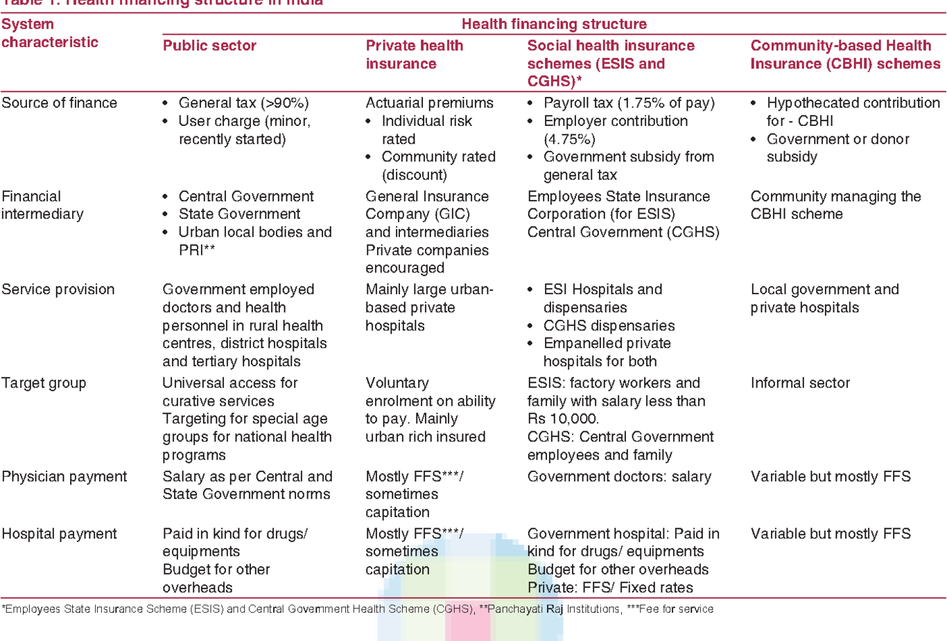
As indicated by late reports, a few safety net providers have purchased out-persistent (OP) spread under cashless plan for those emergency clinics that are connected with that specific insurance agency. Notwithstanding, many accept that it would take some time before OPD spread gets basic as an item classification in private wellbeing insurance.Some organizations broaden OP spread under cashless plan by installment of some extra premiums. Guarantee the board would not be a simple undertaking if OP turns into an undeniable contribution under medical coverage. [11Oyekale, “Factors Influencing Households’ Willingness to Pay for National Health Insurance Scheme (NHIS) in Osun State, Nigeria.”]This is on the grounds that there are visit visits to a doctor (in the event of way of life infection) in the event of OP spread while hospitalization is certainly not an incessant occasion and prompts one-time guarantee settlement. Some different issues like nonappearance of a national brand in the OP space be it dental, eye or even indicative, controlling cheats in issues relating in charging and consistency in administration for claims evaluation and installment are jumps in regularizing the OP cover.

The pros and cons of public health insurance.
Public health insurance is surely more affordable than its private counterpart, as it often requires no co-pays or deductibles, and has lower administrative costs than private health insurance.[22Ilangovan, “HEALTH INSURANCE IN INDIA.”]
However, public health insurance is at the same time less flexible, as policyholders are often given a limited selection of medical service providers. This is because a lot of medical establishments still refuse to accept government-sponsored health insurance plans. Furthermore, even if a therapy is deemed necessary, it may not be reimbursed by public health insurance.

The pros and cons of private health insurance
Private health insurance policies are more flexible than group policies, and give the policyholders more options as to which doctor or medical facility to visit. There are also more plan choices on the market, so policyholders have more plans and a wider network of providers to choose from.
Having said that, private health insurance plans have a heftier price tag than public health insurance. Furthermore, unlike public health insurance, private health insurance requires you to pay a monthly/yearly premium, which is not something everyone can afford.
6. Discussion: Innovative ideas on government health sector and private health sector.
Modernization of center inheritance frameworks, new protection trades and changing plans of action (stage and shared) characterized the year. They will keep on doing as such as bearers receive advanced systems… Juggling the assault of new development and seeing how it tends to be utilized to make a focused edge rapidly can be unsettling. Be that as it may, these problematic powers ought to be viewed as the impetus essential for the sort of emotional change required to spike development and new protection items.
The main problems to address:
1. Internal processes of insurance companies are often too complicated.
2. Insurants are not satisfied with their service providers. [11Aggarwal, Kapoor, and Gupta, “Health Insurance: Innovation and Challenges Ahead.”]
Reclassifying Traditional Ways of Claims and Policy Management in the Age of Digital Insurance
1. Other than AI-driven robotization, claims the board gets affected by a more extensive range of programming arrangements.
2. Here is a case of the advanced business standard. Expect an insurance agency working in the human services fragment.
3. Guarantee the board programming robotizes data trade among protection and social insurance supplier frameworks.
4. In the event that the organization manages various little private practices – which still work with paper reports – the import is streamlined by picture acknowledgment calculations that digitize the archives.
5. The framework computes inclusion and installment for each guarantee as indicated by set strategies.
6. The framework forms assert and send them to an extortion identification module.
7. When the cases are affirmed, insurants get their installments. [11Townsend, “Eleven Ideas For Healthcare Innovation.”]
8. The approach the executives programming must be the incorporated piece of the framework so as to give business clients instruments to oversee compromises, tweak business rationale, oversee arrangement rights, and so forth.
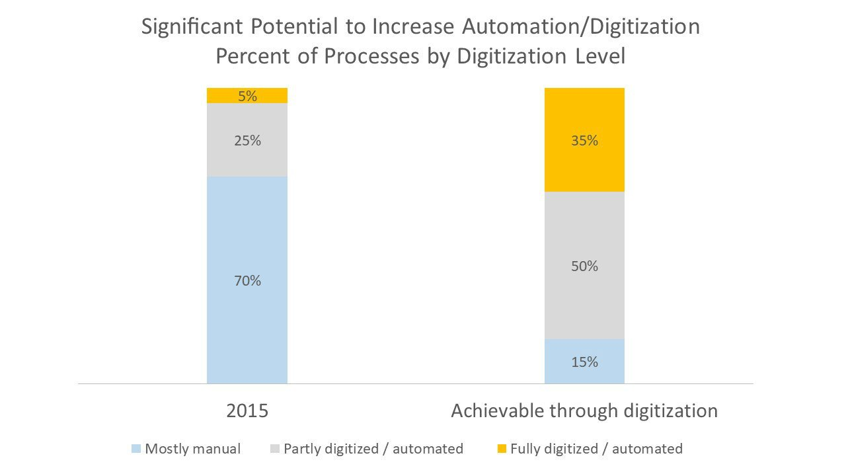
[11“Insurance Technology: 11 Innovation Ideas to Transform Insurance Company AltexSoft.”]

7.Conclusion
India, a nation with generally created economy and a significant white collar class populace, offers most appropriate condition for the advancement of government and private medical coverage. At present, just a minor job is played by private medical coverage in human services framework yet it is step by step picking up significance. Private medical coverage is absolutely not by any means the only other option or a definitive arrangement that can manage disturbing social insurance challenges in India. In any case, it is a choice that is firmly being supported and getting developing thought by our nation’s strategy creators. In this manner, the inquiry isn’t if this apparatus will be utilized later on however whether it will be applied to the best of its capability to address the developing and approaching needs of the medicinal services arrangement of the nation. The fundamental test is to see that poor and the feeble are profited as far as better inclusion (both inpatient and out-patient) and wellbeing administrations at lower costs without negative parts of cost increment and abuse of techniques and innovation in arrangement of social insurance.
A critical challenge in years to come is how to address competitive dynamics between private and public realms, so that public sector facilities are not stripped of resources that are given to the private sector as subsidies, and so that the ability of public clinics and hospitals to retain skilled healthcare workers is not compromised, especially as both types of systems attempt to coexist in the healthcare delivery environment of low- and middle-income countries. These findings are consistent with earlier findings of an “infrastructure inequality trap” in some countries, in which government funding is increasingly attracted towards private hospitals and away from the public sector hospitals. This occurs when private patients can afford to pay for greater infrastructure at private hospitals. Those hospitals then report greater “absorptive capacity” for future funds, and higher numbers of healthcare personnel, thereby attracting more funding from government institutions, shifting budgets away from public sector facilities that struggle to maintain human and physical infrastructure.

References
1. “Health Insurance.” In Wikipedia , December 24, 2019. https://en.wikipedia.org/w/index.php?title=Health_insurance&oldid=932185937.
2. “Life Insurance vs Medical Insurance: What’s The Difference?” Accessed January 4, 2020. https://www.comparehero.my/insurance/articles/difference-between-life-insurance-and-medical-insurance.
3. “Private Health Insurance Act 2007.” Accessed January 3, 2020. https://www.legislation.gov.au/Details/C2019C00126.
4. Ilangovan, Kumar. “HEALTH INSURANCE IN INDIA: THE ROLE OF PUBLIC AND PRIVATE HEALTH INSURANCE PROVIDERS,” 2014.
5. https://www.outlookindia.com/outlookmoney/. “Types Of Health Insurance Plans In India.” Accessed January 4, 2020. https://www.outlookindia.com/outlookmoney/insurance/types-of-health-insurance-plans-in-india-2973.
6. “National Health Insurance Schemes National Health Portal Of India.” Accessed January 4, 2020. https://www.nhp.gov.in/national-health-insurance-schemes_pg.
7. “India’s Government Launches a Vast Health-Insurance Scheme - Modicare.” Accessed January 4, 2020. https://www.economist.com/asia/2018/09/27/indias-government-launches-a-vast-health-insurance-scheme.
8. “Top 5 Health Insurance Plans in India You May Consider - Moneycontrol.Com.” Accessed January 4, 2020. https://www.moneycontrol.com/news/business/personal-finance/top-5-health-insurance-plans-in-india-you-may-consider-2524403.html.
9. “Private Health Insurance Companies National Health Portal Of India.” Accessed January 4, 2020. https://www.nhp.gov.in/private-health-insurance-schemes_pg.
11. GIBL.IN. “Health Insurance:Online Medical Insurance Plans in India 2019.” Accessed January 4, 2020. https://www.gibl.in/health-insurance/.
12. “Public Awareness and Knowledge of the National Health Insurance in South Africa.” Accessed January 4, 2020. https://www.ncbi.nlm.nih.gov/pmc/articles/PMC4646437/.
13. “Healthcare in India.” In Wikipedia , December 30, 2019. https://en.wikipedia.org/w/index.php?title=Healthcare_in_India&oldid=933241252
14. Oyekale, Abayomi Samuel. “Factors Influencing Households’ Willingness to Pay for National Health Insurance Scheme (NHIS) in Osun State, Nigeria.” Studies on Ethno-Medicine 6, no. 3 (December 1, 2012): 167–72. https://doi.org/10.1080/09735070.2012.11886435.
16. Aggarwal, Aanchal, Nupur Kapoor, and Anchal Gupta. “Health Insurance: Innovation and Challenges Ahead.” Health Insurance , n.d., 6.
17. Townsend, Mike. “Eleven Ideas For Healthcare Innovation.” Medium, January 22, 2018. https://tincture.io/eleven-ideas-for-healthcare-innovation-461d70b21fe6.
18. “Insurance Technology: 11 Innovation Ideas to Transform Insurance Company AltexSoft.” Accessed January 4, 2020. https://www.altexsoft.com/blog/finance/insurance-technology-7-disruptive-ideas-to-transform-traditional-insurance-company/.

