Test private
Timothy Lethbridge
Miguel Garzon
I am testing to see what it is like to create a private article
Adding a block of code.
public static String javaSynatx;
- Test
- Test2
- (Lethbridge 2014) another citation (Badreddin, Sturm, and Lethbridge 2014) yet another citation

Top level
blah blah

Second section
abnchd this is a test para
another test para

Deeper stuff
This is more
And more

More and more
further stuff
More and more
A | BB | CCC | D
1 | 35 | 754 | 82
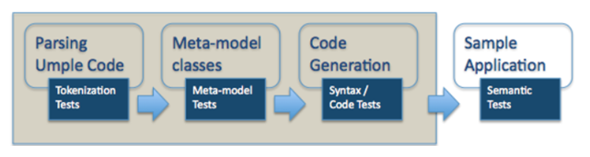
architecture (Garzón and Garzón 2001)
Added text here
This seems to be a new document block, and seems to be independently editable, which is good. I wonder if you can split a section after creation.
I am going to add some code
This is the code More and more and yet more
OK done with the code
Now a quotation
There is the quotation
OK This is a link to Umple which is a really good tool
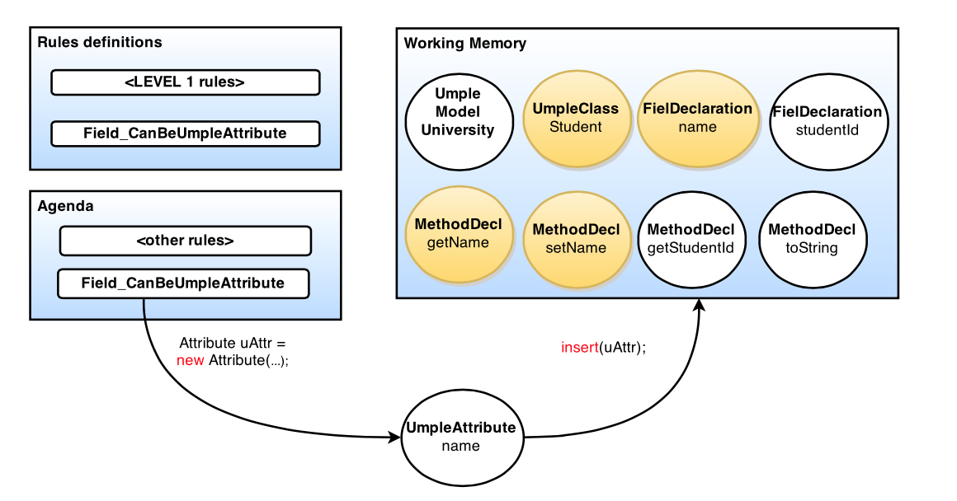
This is the caption of the figure. Wow really cool
I am now adding another block to the article. I am going to paste some text from Word.
I want to split the document here. Cant figure out how
Steering Committee members are expected to attend the Steering Committee meeting (in person or electronically) at each CSEE&T. Members who miss two consecutive meetings at CSEE&T without giving sufficient cause are considered withdrawn from the Committee, subject to review by the Steering Committee. Members who do not attend CSEE&T in person for three years in a row will also normally be asked to withdraw.
I am going to add some more text
This time I will do it while Miguel is editing to see if it messes up the two authors as they work together

References
Lethbridge, Timothy C. 2014. “Teaching Modeling Using Umple: Principles for the Development of an Effective Tool”. In 2014 IEEE 27th Conference on Software Engineering Education and Training (CSEE&T). IEEE. doi:10.1109/cseet.2014.6816777.
Badreddin, Omar, Arnon Sturm, and Timothy C. Lethbridge. 2014. “Requirement Traceability: A Model-Based Approach”. In 2014 IEEE 4th International Model-Driven Requirements Engineering Workshop (MoDRE). IEEE. doi:10.1109/modre.2014.6890829.
Garzón, León, and M. Luisa Garzón. 2001. Origins of Life and Evolution of the Biosphere 31 (1/2). Springer Science + Business Media: 3–13. doi:10.1023/a:1006664230212.

