Extracting organ-specific radiobiological model parameters from clinical data for radiation therapy planning of head and neck cancers
Edwin E. Quashie
Purpose: Different radiation therapy (RT) strategies, e.g., conventional fractionation, hypofractionation, stereotactic body radiotherapy (SBRT), adaptive RT, and re-irradiation are often used to treat head and neck cancers. Combining and/or comparing these strategies require to calculate biological effective dose (BED). The purpose of this study is to develop a practical process to extract organ-specific radiobiologic model parameters that may be used for BED calculations in individualized RT planning for head and neck cancer.
Methods: The dose volume constraint data for 12 organs at risk (OAR) corresponding to no grade $≥$3 toxicity for SBRT, hypofractionated and convectional fractionation treatments were compiled from various sources such as TG101, QUANTEC and clinical trial database. These data cover 10 fractionation schemes. A linear-quadratic-linear (LQ-L) model was used to extract model parameters (e.g., $α/β$, $γ/α$ and $d_{t}$) from fitting the Iso-BED curves of those dose volume constraints for the OARs using an in-house python code. The obtained model parameters were integrated into a practical workflow in MIM software. Their practicality was tested for treatment planning of re-irradiation.
Results: The LQ-L model fitted the data well as indicated by smooth transition curves from SBRT to conventional fractionation data. The organ-specific model parameters were obtained, for example, $α/β$=2.57Gy, $γ/α$=9.07Gy and $d_{t}$=7.65Gy, and $α/β$=2.34Gy, $γ/α$=9.67Gy and $d_{t}$=6.80Gy for spinal cord and brainstem, respectively. The composite dose plans for retreatment of head and neck cancers with considering the obtained model parameters show up to 10% difference in physical dose constraints from traditional EQD2 method with $α/β$=3.0Gy.
Conclusion: A practical process was developed to obtain organ-specific radiobiological model parameters from clinical data and was shown to generate more clinically relevant model parameters for calculating BED distributions compared to those extracted from cell line survival data. The practicality of the obtained parameters was demonstrated in creating composite plans for retreatment.

Introduction
The response of normal tissues and tumors to radiation therapy (RT) has been a main concern to the radiation oncology community for many decades and several research papers have discussed in details these challenges ( ref). The reason being that RT is prescribed to treat tumor cells which is a benefit but exposed normal tissues to radiation during the course of treatment is a detriment to the patient. For instance in Ref blah, they discussed blah blah and in Ref blah2, they talk about blah blah. The biologic effect of these normal tissues to RT depend largely on the total dose (D) and the fractional dose (d) of the prescribed treatment. Other factors that are equally important are dose rate and the overall treatment time.
how dose rate affect biologic effect.
how overall treatment time affect biologic effect.
Many models blah blah
There are several radiobiological models proposed to predict radiation response
The LQ model is used to describe the survival fraction () of clonogenic or stem cells as a function of radiation dose per fraction () given as:
$$SF=e^{−(αd+βd^{2})}$$
where $α$ is the log${}_{e}$ cell kill per $Gy$ of the linear component ($d$) and $β$ is the log${}_{e}$ cell kill per $Gy$ of the quadractic component ($d^{2}$). They both represents the intrinsic radiosensitivity of the irradiated cells.
We applied Eq. ??? to mammalian cells exposed to sparsely ionizing x-rays up to a radiation dose of $16 Gy$ as shown in fig. ???. This survival data was digitized from the famous radiobiology book (Hall and Giaccia 2018) (figure 3.3). It is seen that linear part, $e^{−αd}$, fits the initial part (broad shoulder) of the data up to $4 Gy$ with $α=xx$ [CHECK] and widely overestimates the rest of the data. The quadratic part, $e^{−βd^{2}}$, mostly overestimates (much better than it’s counterpart) up to $12 Gy$ [CHECK].
The combination of these two curves (LQ model) fits the experimental data up to $8 Gy$[CHECK] with an $α$ and $β$ values of $3 Gy$ and $4 Gy$ respectively.
When the linear and quadratic curves intersect ($e^{−αd}=e^{−βd^{2}}$), the $αd$ and $βd^{2}$ components of cell killing are equal. This intersection dose is called $α/β$ ratio with units in $Gy$.
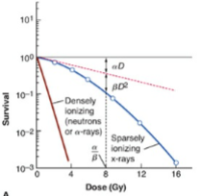
A plot of survival curve for mammalian cells exposed to radiation. The survival fraction is plotted on a logarithm scale and dose is plotted on the linear scale. The LQ model fits nicely on the experimental data.
The $α/β$ which is the ratio of the two parameters is the measure of the cells sensitivity to dose fractionation. A higher $α/β$ ratio means the cells are less sensitive to the sparing effect of fractionation and the more linear the survival curve is whereas a lower $α/β$ (i.e., $β$ is higher relative to $α$) the higher the sensitivity to fractionation scheme and more curved the () curve.
Biologically effective dose (BED) is a characteristic dose value that is important in understanding tumor and organs at risk (OAR) response to different RT treatment modalities and fractionation schemes. The BED is defined as the total dose required to give the same log cell kill as the schedule being studied, at an infinitely low dose-rate or with infinitely small fractions well spaced out; now with an overall time factor for repopulation during continued irradiation. (Fowler 2010)[CHECK AND REWRITE].
From Eq. ???, for $n$ fractions, the survival fraction becomes;
$$−ln SF=αnd+βnd^{2},$$
the quantity ($αnd+βnd^{2}$) is the biological effect, $E$.
In the case where the total dose $D$ ($nd$) is delivered in $n$ fractions of size $d$, the formula of BED based on the LQ model is as follows:
$$BED=\frac{E}{α}=nd\left(1+\frac{d}{α/β}\right)$$
Talk about limitation of LQ; what some papers have said about other LQ correction - Astrahan paper
-multitarget (MT) model
-park et. al. paper (LQ and MT model)
How it will affect the BED calculations
Talk about a/b=3 for late response tissues and a/b=10 for early response tissues [CHECK WHICH SECTION TO PUT THIS INFO
The main goal of this study is to develop a practical process to extract organ-specific radiobiologic model parameters that may be used for BED calculations in individualized and retreatment RT planning for head and neck cancer [CHECK-ONLY HEAD AND NECK?].

Methods
In order to understand the biological effective of organs to radiotherapy, different kinds of models have been developed REF. In this work, we will discuss three of these models namely; (i) LQ model, (ii) LQ-L model (3 parameters) and (iii) LQ-L model (4 parameters)
As the fractional dose increases, the survival curve does not only exhibits linear-quadractic behavior but rather a linear-quadractic-linear (LQ-L) behavior (Guerrero and Li 2004; Carlone, Wilkins, and Raaphorst 2005). To overcome the limitation of underestimation of survival at high fractional doses, Park et al. (Park et al. 2008) proposed an alternative method called universal survival curve (USC) model which fits survival data at high-dose range without losing the strengths of LQ model around the shoulder. The USC model encompasses both the LQ model and the multitarget (MT) model.
In this study we use the modified LQ-L model proposed by Astrahan (Astrahan 2008) which employed a more efficient form of the bipartite method proposed by Park et al. (Park et al. 2008).
Talk about the difference between Astrahan and Park model.
When we apply the bipartite form to a multi-fraction survival curve in Eq. ???, then
$$SF=\left\{\begin{matrix}e^{−(αd+βd^{2})} & for d<d_{T} \\ e^{−(αd_{T}+βd_{T}^{2}+γ(d−d_{T}))} & for d≥d_{T}\end{matrix}\right.$$
where $γ$ is the log${}_{e}$ cell kill per $Gy$ for the final linear portion of the survival curve and $d_{T}$ is the transition dose into the linear portion of the survival curve at high doses.
Also applying the bipartite form to Eq. ???, the BED is given as;
$$BED=\left\{\begin{matrix}nd\left(1+\frac{d}{α/β}\right) & for d<d_{T} \\ \\ nd_{T}\left(1+\frac{d}{α/β}\right)+n\frac{γ}{α}(d−d_{T}) & for d≥d_{T}\end{matrix}\right.$$
where $γ/α$ can be described quantitatively as [CHECK-what to ’name’ put here].
We can rearrange Eq. ??? to obtain:
$$\text{D} = \begin{cases}
\frac{\text{BED}} {\large \left(1 + \frac{d}{\alpha/\beta}\right)} & \text{for $d < d_T$} \\\\
\frac{\text{BED}} {\large \left[ \frac{\gamma}{\alpha} + \frac{d_T^2}{d(\alpha/\beta)} + \frac{d_T}{d} - \frac{\gamma}{\alpha}\frac{d_T}{d} \right]} & \text{for $d \ge d_T$}
\end{cases}$$
We can estimate the radiobiological model parameters, $α/β$, $γ/α$, $d_{T}$ and $BED$ from Eq. ??? when we plot of $D$ (total dose) versus $d$ (fractional dose). This curve is called an isoBED curve. In this study we obtained these parameters for five different OARs, namely; spinal cord, brachial plexus, esophagus, rectum, duodenum and great vessels.
We obtained clinical volume-dose constraint data from literature for these OARs from several sources such as TG101, The Quantitative Analysis of Normal Tissue Effects in the Clinic (QUANTEC), High Dose per Fraction, Hypofractionated Treatment Effects in the Clinic (HyTEC) and clinical trial database which corresponds to no grade$≥$3 toxicity of that particular organ.

Results and Discussion
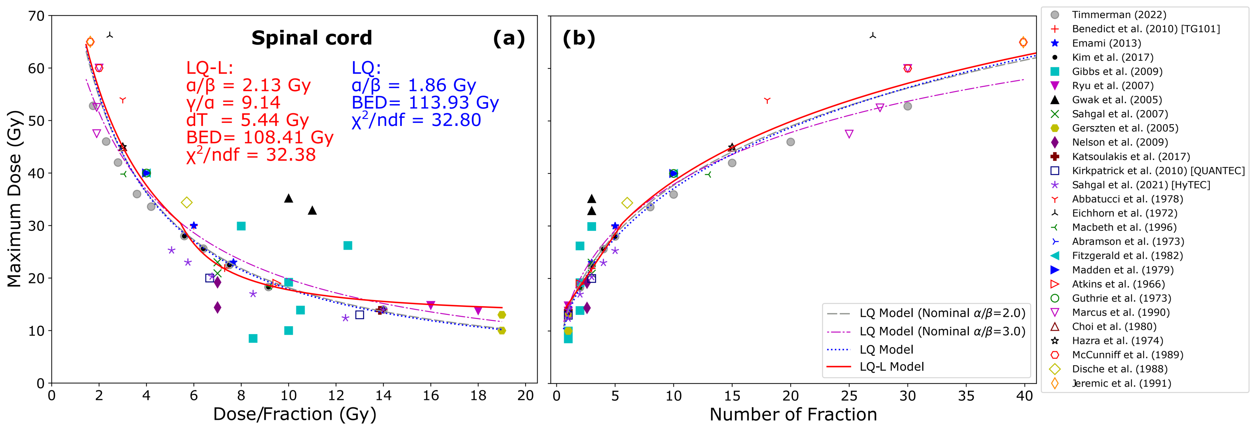
This is a caption
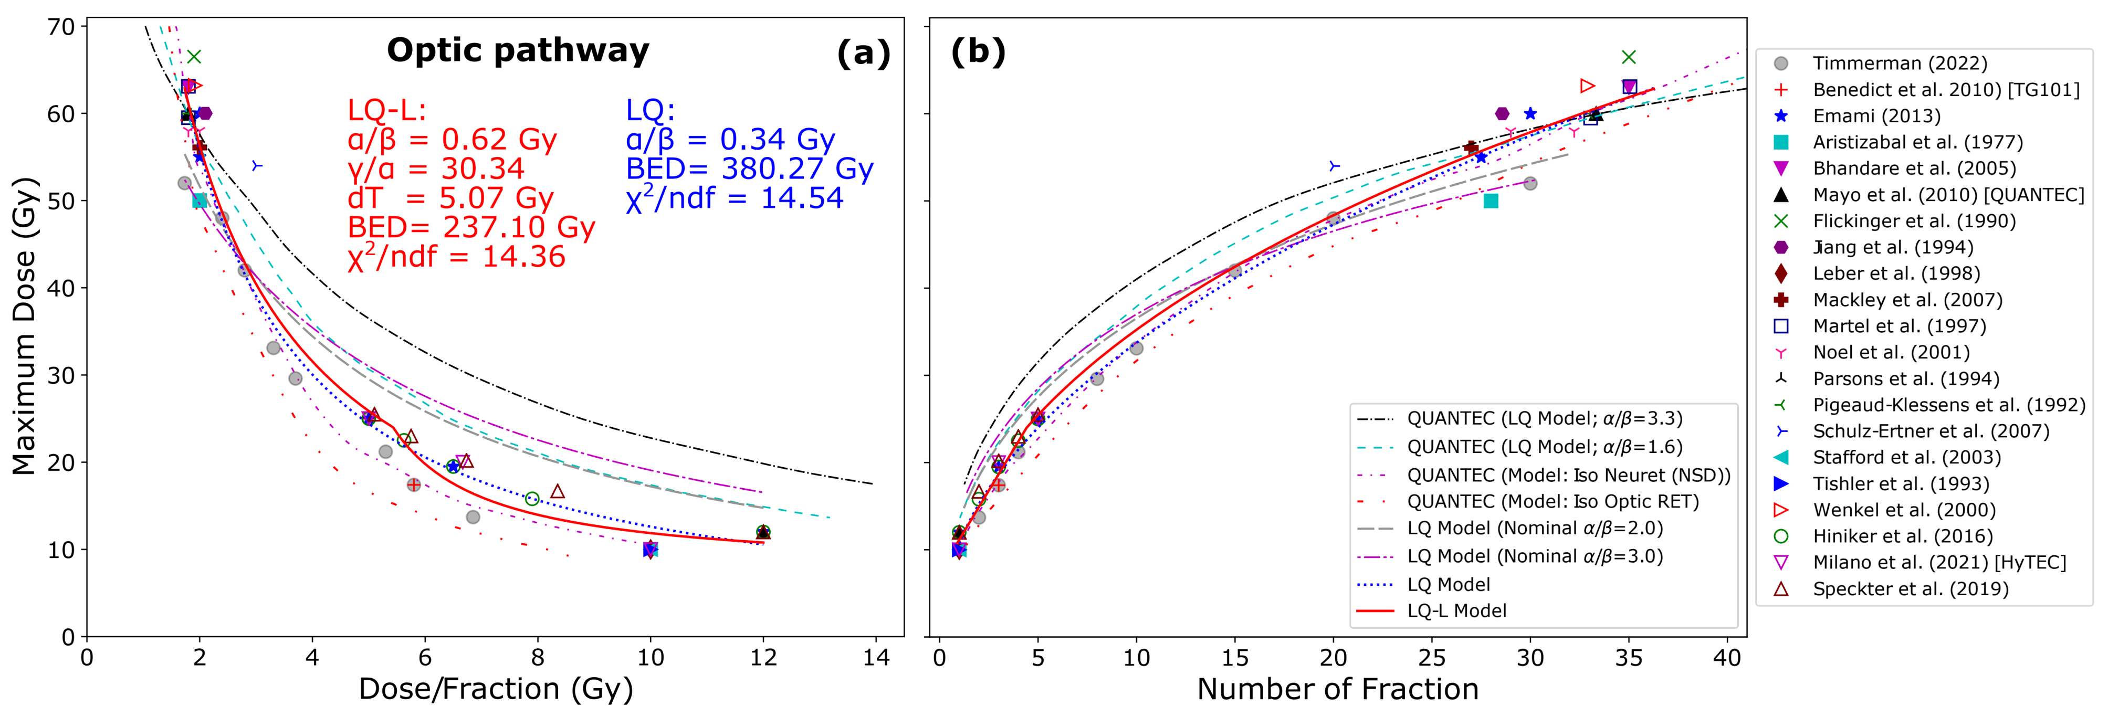
This is a caption
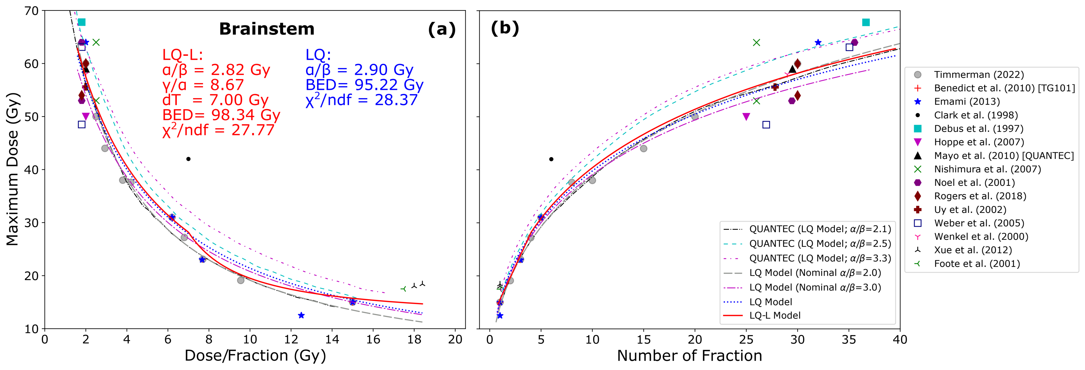
This is a caption
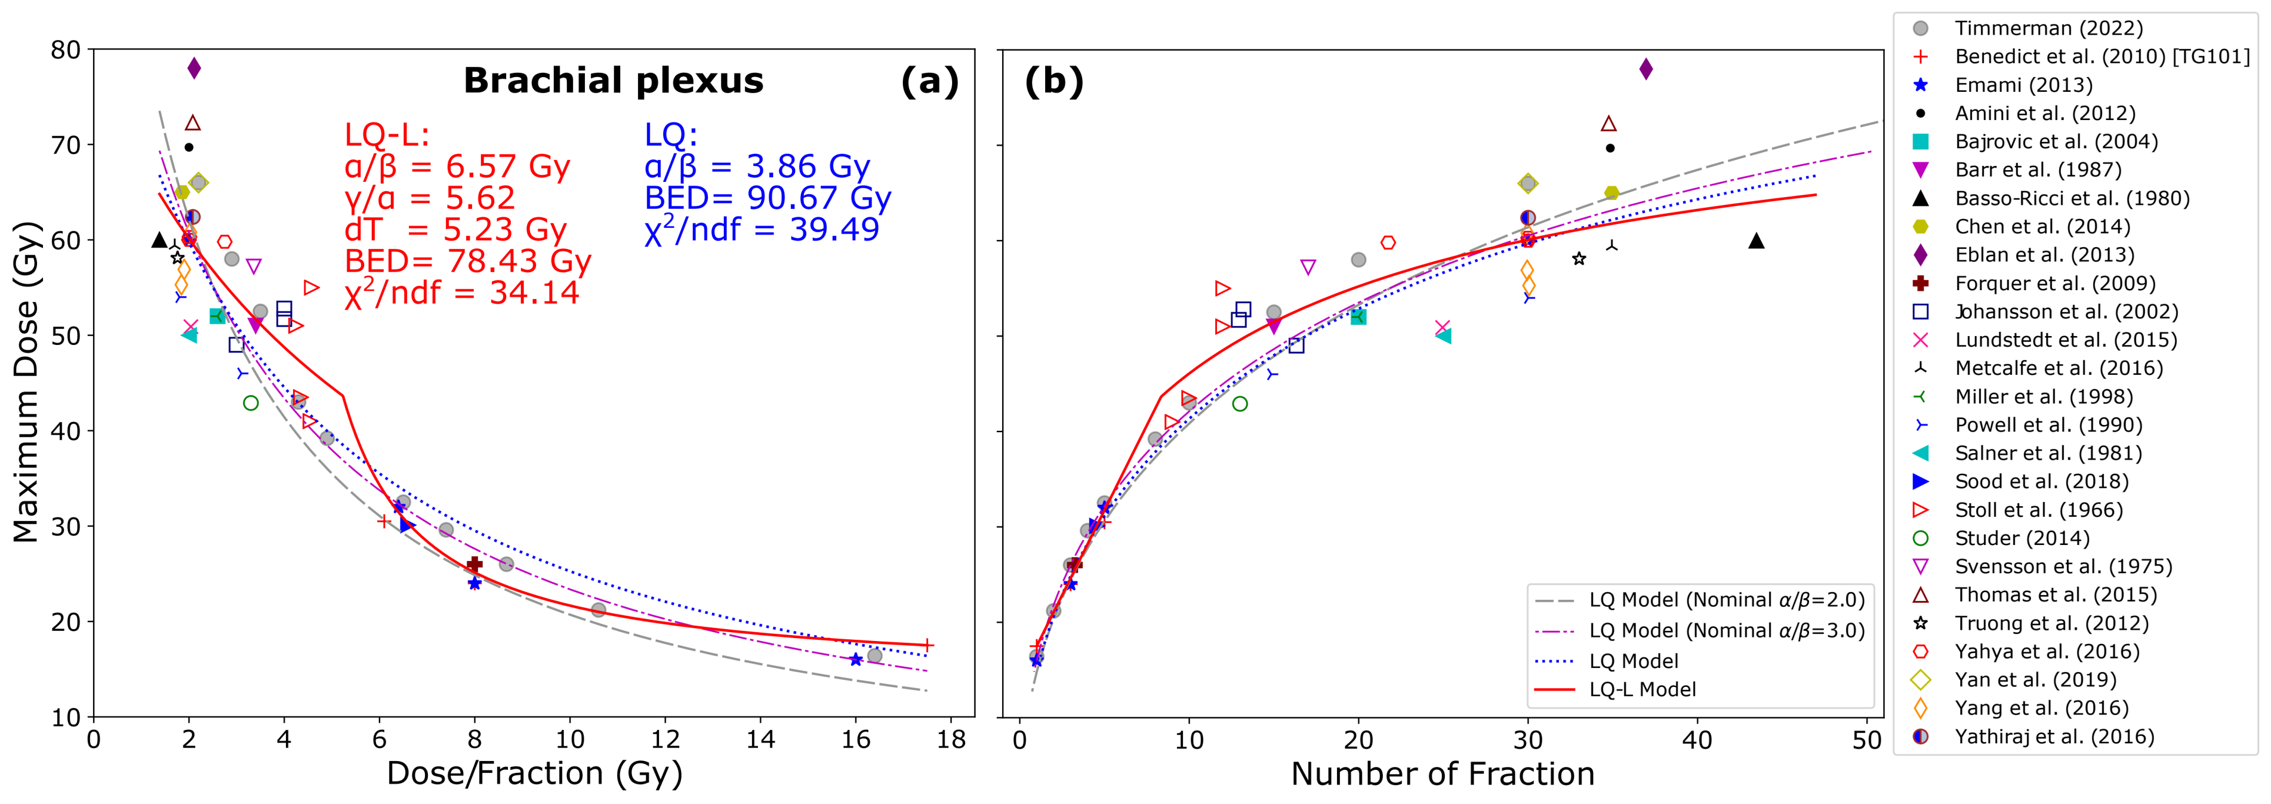
This is a caption
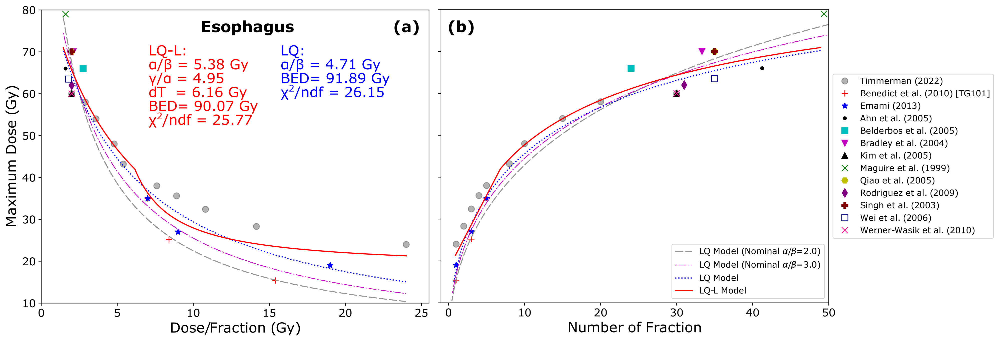
This is a caption

Conclusion
We developed a practical method to obtain organ-specific radiobiological model parameters from clinical data using LQ-L model. These BED model parameters have shown to generate more clinically relevant model parameters for calculating BED distributions compared those extracted from cell line survival data. The practicality of the parameters was demonstrated in creating composite plans for retreatment.

Acknowledgements
This work is partially supported by Manteia Med.
In Ref. (missing citation) it was found that hydrogen dimers in free electron gas (jellium) yields a constructive or destructive interference effects in $S_{e}$ depending on their kinetic energy arising from the combined dynamic screening of the two moving nuclei. Their calculations show that the dimer whose symmetry axis is parallel to the velocity vector shows a much more interference effects than the dimer with perpendicular orientation due to the wake created by the proton traveling ahead. A peculiarity of this behavior is observed for $LiH$ in free electron gas (missing citation), where the energy loss of the molecule is larger when jellium density decreases.

References
Hall, Eric J., and Amato J. Giaccia. 2018. Radiobiology for the Radiologist. LWW; 8th edition.
Fowler, J F. 2010. “21 Years of Biologically Effective Dose”. The British Journal of Radiology 83 (991): 554–68. https://doi.org/10.1259/bjr/31372149.
Guerrero, M, and X Allen Li. 2004. “Extending the LinearQuadratic Model for Large Fraction Doses Pertinent to Stereotactic Radiotherapy”. Physics in Medicine and Biology 49 (20): 4825–35. https://doi.org/10.1088/0031-9155/49/20/012.
Carlone, Marco, David Wilkins, and Peter Raaphorst. 2005. “The Modified Linear-Quadratic Model of Guerrero and Li Can Be Derived from a Mechanistic Basis and Exhibits Linear-Quadratic-Linear Behaviour”. Physics in Medicine and Biology 50 (10): L9–L13. https://doi.org/10.1088/0031-9155/50/10/l01.
Park, Clint, Lech Papiez, Shichuan Zhang, Michael Story, and Robert D. Timmerman. 2008. “Universal Survival Curve and Single Fraction Equivalent Dose: Useful Tools in Understanding Potency of Ablative Radiotherapy”. International Journal of Radiation OncologyBiologyPhysics 70 (3): 847–52. https://doi.org/10.1016/j.ijrobp.2007.10.059.
Astrahan, Melvin. 2008. “Some Implications of Linear-Quadratic-Linear Radiation Dose-Response with Regard to Hypofractionation”. Medical Physics 35 (9): 4161–72. https://doi.org/10.1118/1.2969065.

