Exam 2
xian chen
Q1 (a)
By the Bayes’ rule,
$P[x]=\sum_{i=1}^{J}{P}[x|y=i]P[y=i]=\sum_{i=1}^{J}{f_{X}}(x|y=i)π_{i}$
$$\begin{matrix}P[y=i|x] & =\frac{P[x|y=i]P[y=i]}{P[x]} \\ & =\frac{f_{X}(x|y=i)P[y=i]}{P[x]} \\ & =\frac{e^{−\frac{1}{2}{\left(x−μ_{i}\right)}^{⊤}Σ_{i}^{−1}\left(x−μ_{i}\right)}π_{i}}{(2π)^{p/2}det{\left(\sum_{i}{}\right)}^{1/2}}/P[x]\end{matrix}$$
(b) Since the denominator $P[x]$ and $(2π)^{p/2}$ do not depend on i, we can write them as a constant
$$P[y=i|x]=C*f_{X}(x|y=i)π_{i}=\frac{Cπ_{i}}{det{\left(\sum_{i}{}\right)}^{1/2}}e^{−\frac{1}{2}{\left(x−μ_{i}\right)}^{⊤}Σ_{i}^{−1}\left(x−μ_{i}\right)}$$
Take the log of both sides, we have
$$logP[y=i|x]=logC+logπ_{i}−\frac{1}{2}{\left(x−μ_{i}\right)}^{T}{Σ_{i}}^{−1}\left(x−μ_{i}\right)−\frac{1}{2}log|Σ_{i}|$$
Thus,
$$\begin{matrix}δ_{i}(x) & =−\frac{1}{2}{\left(x−μ_{i}\right)}^{T}{Σ_{i}}^{−1}\left(x−μ_{i}\right)−\frac{1}{2}log|Σ_{i}|+logπ_{i} \\ & =−\frac{1}{2}x^{T}Σ_{i}^{−1}x+x^{T}Σ_{i}^{−1}{\overset{^}{μ}}_{i}−\frac{1}{2}{\overset{^}{μ}}_{i}^{T}Σ_{i}^{−1}{\overset{^}{μ}}_{i}−\frac{1}{2}log\left|Σ_{i}\right|+logπ_{i}\end{matrix}$$
(c)
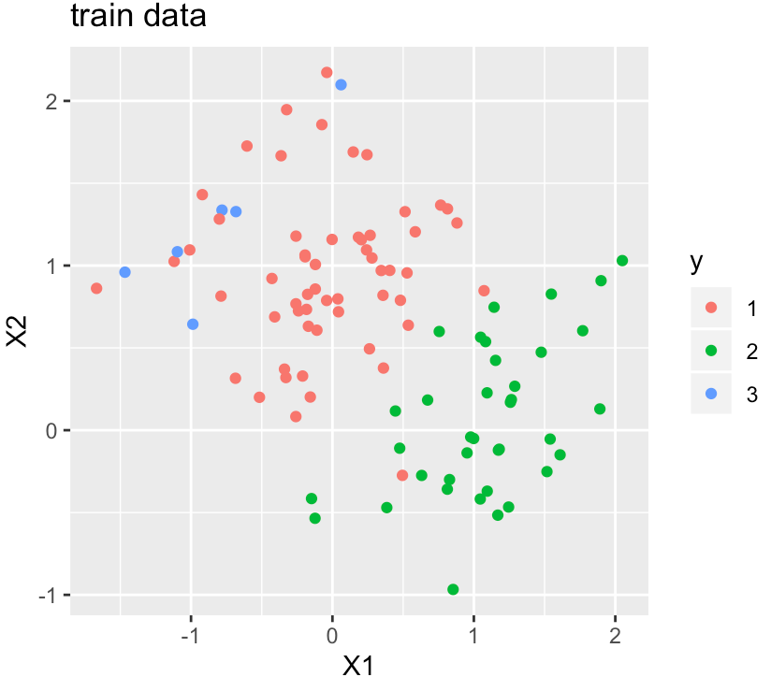
(e) Estimate sample mean and sample covariance for each class given the training data
$${\overset{^}{π}}_{j}=n_{j}/n, {\overset{^}{μ}}_{j}=\frac{1}{n_{j}}\sum_{x_{i}∈C_{j}}{x_{i}}, {\overset{^}{Σ}}_{j}=\frac{1}{n_{j}−1}\sum_{x_{i}∈C_{j}}{\left(x_{i}−{\overset{^}{μ}}_{j}\right)}{\left(x_{i}−{\overset{^}{μ}}_{j}\right)}^{T}$$
where $j∈(1,2,3)$.
Thus, we have
$$\overset{^}{π_{1}}=0.57,\overset{^}{π_{2}}=0.37,\overset{^}{π_{3}}=0.06$$
$${\overset{^}{μ}}_{1}=(−0.053,0.953)^{T},{\overset{^}{μ}}_{2}=(1.082,0.05067374)^{T},{\overset{^}{μ}}_{3}=(−0.825,1.241)^{T}$$
$$Σ_{1}=\left[\begin{matrix}0.502 & −0.219 \\ −0.219 & 0.460\end{matrix}\right], Σ_{2}=\left[\begin{matrix}0.608 & −0.159 \\ −0.159 & 0.421\end{matrix}\right], Σ_{3}=\left[\begin{matrix}2.181 & 1.965 \\ 1.965 & 1.816\end{matrix}\right]$$
The desicion boundary of QDA is given by $δ_{1}(x)=δ_{2}(x)=δ_{3}(x)$.
(f) Scatter plot of the training data with labels
QDA: When n increased from 100 to 1000, the number of data points with predicted labels of 3 and 2 increased while the number of data points with predicted labels of 1 decreased.

$$\overset{^}{π_{1}}=0.606,\overset{^}{π_{2}}=0.284,\overset{^}{π_{3}}=0.11$$
$${\overset{^}{μ}}_{1}=(−0.024,0.979)^{T},{\overset{^}{μ}}_{2}=(1.026,0.006)^{T},{\overset{^}{μ}}_{3}=(−1.157,0.923)^{T}$$
$$Σ_{1}=\left[\begin{matrix}0.534 & 0.326 \\ 0.326 & 0.500\end{matrix}\right], Σ_{2}=\left[\begin{matrix}0.554 & 0.402 \\ 0.402 & 0.535\end{matrix}\right], Σ_{3}=\left[\begin{matrix}1.376 & 1.296 \\ 1.296 & 1.323\end{matrix}\right]$$

