Exam 1
xian chen
Question1 (a)
$x_{i}=\left[\begin{matrix}cos\left(\frac{4i−3}{10}π\right) \\ sin\left(\frac{4i−3}{10}π\right)\end{matrix}\right]$
$x_{1}=(0.9510565,0.309017)^{T}$
$x_{2}=(6.123233995736766e−17,1.0)^{T}$
$x_{3}=(−0.9510565162951535,{0.3090169943749475}^{T}$
$x_{4}=(−0.5877852522924732,−0.8090169943749473)^{T}$
$x_{5}=(0.5877852522924729,−0.8090169943749476)^{T}$
$X_{(5×2)}=\left[\begin{matrix}0.95 & 0.31 \\ 0 & 1.0 \\ −0.95 & 0.31 \\ −0.59 & −0.81 \\ 0.59 & −0.81\end{matrix}\right]$ $y_{(5×1)}=\left[\begin{matrix}1 \\ 1 \\ 1 \\ −1 \\ −1\end{matrix}\right]$
Since $H^{(t)}=\left\{x|β_{0}^{(t)}+x^{⊤}β_{1}^{(t)}=0\right\}$, $β_{0}^{(0)}=−0.5$ and $β_{1}^{(0)}=\left[\begin{matrix}0 \\ 1\end{matrix}\right]$, we have $0X1+X2=0.5→X2=0.5$.
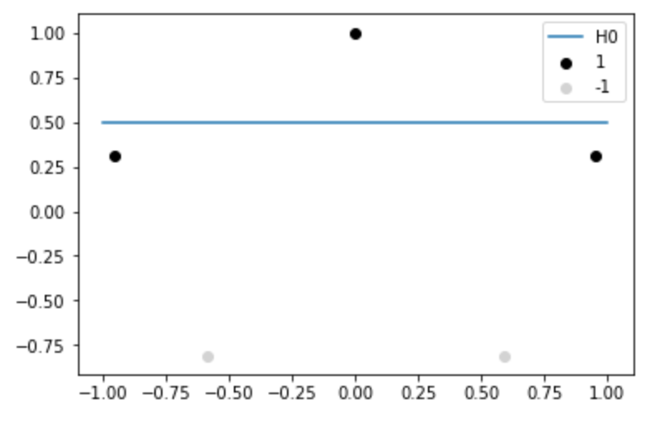
(b) We know that signed-distance of any point x to a hyperplane is $d(x_{i},H)=\frac{x_{i}^{T}β+β_{0}}{∥β∥}$.
Hence, $d(x_{i},H^{(0)})=\frac{x_{i}^{T}β_{1}^{(0)}+β_{0}^{(0)}}{∥β_{1}^{(0)}∥}$.
$d(x_{1},H^{(0)})=−0.19$
$d(x_{2},H^{(0)})=0.5$
$d(x_{3},H^{(0)})=−0.19$
$d(x_{4},H^{(0)})=−1.31$
$d(x_{5},H^{(0)})=−1.31$
(c)
From part(b), we know $x_{1}$ and $x_{2}$ are misclassified because $d(x_{1},H^{(0)})<0$ and $d(x_{3},H^{(0)})<0$ but $y_{1}=y_{3}=+1$.
Thus, $M^{(0)}$ contains $x_{1}$ and $x_{3}$.
(d)
The sum of unsigned distances of misclassified data points is given by
$$D\left(β,β_{0}\right)=−\sum_{i∈M}{y_{i}}\left(x_{i}^{⊤}β+β_{0}\right)$$
Thus, for $β_{0}=β_{0}^{(0)},β_{1}=β_{1}^{(0)}$ and $M=M^{(0)}$,
$$\begin{matrix}D(β_{1}^{(0)},β_{0}^{(0)}) & =−y_{1}(x_{1}β_{1}^{(0)}+β_{0}^{(0)})−y_{3}(x_{3}β_{1}^{(0)}+β_{0}^{(0)}) \\ & =0.38\end{matrix}$$
(e)
Given $\left(\begin{matrix}β \\ β_{0}\end{matrix}\right)←\left(\begin{matrix}β \\ β_{0}\end{matrix}\right)+ρ\left(\begin{matrix}y_{i}x_{i} \\ y_{i}\end{matrix}\right)$ and $ρ=0.5$,
$$\begin{matrix}\left(\begin{matrix}β_{1}^{(1)} \\ β_{0}^{(1)}\end{matrix}\right) & =\left(\begin{matrix}β_{1}^{(0)} \\ β_{0}^{(0)}\end{matrix}\right)+0.5\left(\begin{matrix}y_{1}x_{1} \\ y_{1}\end{matrix}\right) \\ & =\left(\begin{matrix}0 \\ 1 \\ −0.5\end{matrix}\right)+0.5\left(\begin{matrix}0.95 \\ 0.31 \\ 1\end{matrix}\right) \\ & =\left(\begin{matrix}0.475 \\ 1.155 \\ 0\end{matrix}\right)\end{matrix}$$
Hence, $β_{0}^{(1)}=0$ and $β_{1}^{(1)}=\left[\begin{matrix}0.475 \\ 1.155\end{matrix}\right]$.
(f)
Since $H^{(1)}=\left\{x|β_{0}^{(1)}+x^{⊤}β_{1}^{(1)}=0\right\}$, where $β_{0}^{(1)}=0$ and $β_{1}^{(1)}=\left[\begin{matrix}0.475 \\ 1.155\end{matrix}\right]$, we have $0.475*X1+1.155*X2=0→X2=−0.475*X1/1.155$.
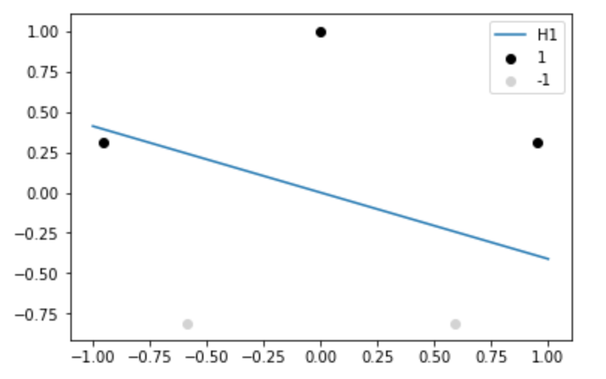
(g)
The signed-distance of any point x to a hyperplane is $d(x_{i},H)=\frac{x_{i}^{T}β+β_{0}}{∥β∥}$.
Hence, $d(x_{i},H^{(1)})=\frac{x_{i}^{T}β_{1}^{(1)}+β_{0}^{(1)}}{∥β_{1}^{(1)}∥}$.
$d(x_{1},H^{(1)})=0.65$
$d(x_{2},H^{(1)})=0.92$
$d(x_{3},H^{(1)})=−0.08$
$d(x_{4},H^{(1)})=−0.97$
$d(x_{5},H^{(1)})=−0.52$
(h)
Only $x_{3}$ is misclassified because $d(x_{3},H^{(1)})<0$ while $y_{3}=+1$.
Thus, $M^{(1)}$ contains $x_{3}$.
(i)
The sum of unsigned distances of misclassified data points is given by
$$D\left(β,β_{0}\right)=−\sum_{i∈M}{y_{i}}\left(x_{i}^{⊤}β+β_{0}\right)$$
Thus, for $β_{0}=β_{0}^{(1)},β_{1}=β_{1}^{(1)}$ and $M=M^{(1)}$,
$$\begin{matrix}D(β_{1}^{(1)},β_{0}^{(1)}) & =−y_{3}(x_{3}β_{1}^{(1)}+β_{0}^{(1)}) \\ & =0.09\end{matrix}$$
We can see that sum of unsigned distances of misclassified data points is decreased.
(j)
Given $\left(\begin{matrix}β \\ β_{0}\end{matrix}\right)←\left(\begin{matrix}β \\ β_{0}\end{matrix}\right)+ρ\left(\begin{matrix}y_{i}x_{i} \\ y_{i}\end{matrix}\right)$ and $ρ=0.5$,
$$\begin{matrix}\left(\begin{matrix}β_{1}^{(2)} \\ β_{0}^{(2)}\end{matrix}\right) & =\left(\begin{matrix}β_{1}^{(1)} \\ β_{0}^{(1)}\end{matrix}\right)+0.5\left(\begin{matrix}y_{3}x_{3} \\ y_{3}\end{matrix}\right) \\ & =\left(\begin{matrix}0.475 \\ 1.155 \\ 0\end{matrix}\right)+0.5\left(\begin{matrix}−0.95 \\ 0.31 \\ 1\end{matrix}\right) \\ & =\left(\begin{matrix}0.475 \\ 1.155 \\ 0\end{matrix}\right)\end{matrix}$$
Hence, $β_{0}^{(2)}=0.5$ and $β_{1}^{(2)}=\left[\begin{matrix}0 \\ 1.31\end{matrix}\right]$.
(k)
Since $H^{(2)}=\left\{x|β_{0}^{(2)}+x^{⊤}β_{1}^{(2)}=0\right\}$, where $β_{0}^{(2)}=−0.5$ and $β_{1}^{(2)}=\left[\begin{matrix}0 \\ 1.31\end{matrix}\right]$, we have $0*X1+1.31*X2+0.5=0→X2=−0.5/1.31=−0.38$.
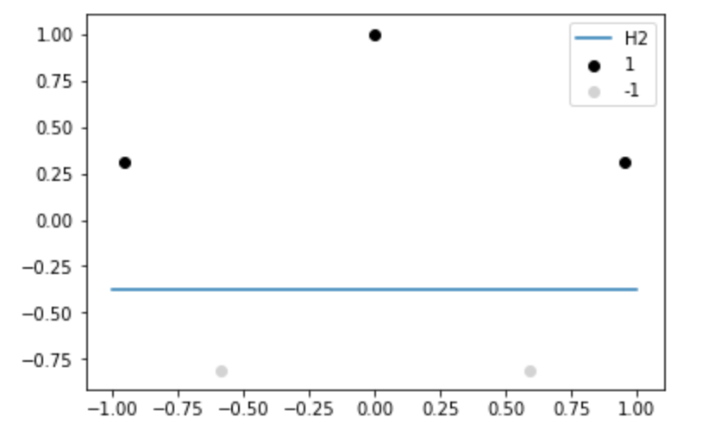
(l)
The signed-distance of any point x to a hyperplane is $d(x_{i},H)=\frac{x_{i}^{T}β+β_{0}}{∥β∥}$.
Hence, $d(x_{i},H^{(2)})=\frac{x_{i}^{T}β_{1}^{(2)}+β_{0}^{(2)}}{∥β_{1}^{(2)}∥}$.
$d(x_{1},H^{(2)})=0.69$
$d(x_{2},H^{(2)})=1.38$
$d(x_{3},H^{(2)})=0.69$
$d(x_{4},H^{(2)})=−0.43$
$d(x_{5},H^{(2)})=−0.43$
(m)
Since the signed-distance of x1,x2 and x3 from $H^{2}$ are greater than 0 and the signed-distance of of x4 and x5 from $H^{2}$ are smaller than 0, all data points are correctly classified.
Thus, $M^{(2)}$ is empty.
Question2 (a)
$\begin{matrix}y & =Xβ+(c.v) \\ & =X_{β}+X⋅v⋅c\end{matrix}$
since $Xv=0$, we have $y=Xβ+(c.v)=X_{β}$. Thus, $β+c.v$ also satisfies the linear equation $y=Xβ$, for any $c∈R$.
(b)
If the columns of $X$ are linearly independent, then $v=0$ satisfies $Xv=0$ $v∈R^{p}$.
(c)
If the columns of $X$ are not linearly independent($p>n$), then there are can be many solutions for $v$. $X_{1}v=X_{11}v_{1}+X_{12}v_{2}+...+X_{1p}v_{p}=0$, not all $v_{i}$ needs to be zero.

