PGCAP reflective essay
Daphne
My previous teaching experience consisted almost exclusively of project supervision and small-group tutorials, with student-teacher ratios of at most three to one. At York, I supervise a 4th year student project and am also partially responsible for running a workshop (’Big Data Biology’) for about 150 second-year undergraduate students. In this required course, students independently work on up to three different ‘projects’ through a step-by-step guide, while multiple faculty members and teaching assistants are available to answer questions. At the end of the module, the students must write a short essay critically evaluating the data analysis used in one of the projects.
Small group teaching is personalised, and so can respect individual learning styles (V1). However, it is difficult to scale this format of teaching given the current staffing levels and growth in student numbers (V4). In contrast to personalised tuition, large modules that are part of an overarching departmental curriculum are inherently less flexible because they must meet specific learning objectives and adhere to standardised teaching formats. The way in which I incorporate research-based teaching techniques (V3) into my teaching practice are constrained by the teaching format, but I still strive to achieve maximum student engagement and learning, while improving equality of educational opportunities for all learners (V2). I will describe how my teaching strategies differ between one-to-one and large group teaching settings, across four aspects of teaching:
First, I will describe how I consider the individual needs of my students in the design of my coursework (V1), utilising educational theory about ‘threshold concepts’ (V3).
Next, I will address how the York pedagogy (V4) drives the teaching methods I use in the classroom.
Then, I will describe how I use the seven principles of effective feedback (V3) to improve student engagement with learning, and suggest a change to the assessment to be more in line with the wider aims of the Department of Biology and the needs of the broader society (V4).
Finally, I will address how I adapt the learning environment to provide equal opportunities for all learners (V2), using learning technologies to overcome the physical constraints of the space.
Design of course material:
Students come to university with a different set of life experiences and mindsets, and this influences the way they engage with the material and develop into deep learners (HAGGIS, 2003). When I supervise a student project, I always try to discuss the interests and goals of the student and adjust the project accordingly. For instance, I discovered that my project student has a personal connection with someone with asthma, so I included a data set from an asthmatic lung as a project component. Also, she needed to boost her confidence– she was knowledgable, articulate, and a fast-learner, but she was unsure if she was capable of becoming a competent bioinformatician (her ultimate career goal). Once I learned that she had developed skills in a technique called ‘Principle Component Analysis’ (PCA) over her summer internship, I incorporated this technique in the first phase of her project, to help build her confidence before launching into more challenging approaches. This did not quite work as planned, because I had not thoroughly evaluated her depth of understanding of PCA, so that portion of the project took much longer than intended. Nevertheless, she now rightfully considers herself as an ‘expert’ in PCA and has helped her fellow students when it was taught as part of a course.
It is impossible to have this degree of personalisation when designing content for a workshop. Indeed, part of the reason I was tasked with developing new content is that student feedback from the previous year suggested ecology-focussed students did not find the course engaging. The first draft of my project was peer reviewed by two faculty members.
One faculty member stated that I should have more open-ended questions that required the student to search for the answer themselves, because in the previous year some students had copy-pasted the code without understanding what they were doing. One challenge with addressing this concern was that my project was initially structured to be cumulative– if a student could not answer a particular question, then they would have been unable to continue. To counter this, I re-designed the project to have multiple entry points.
The other faculty member stated that I needed to lower the level of difficulty of some aspects of the project. For instance, some of the students had not yet grasped the concept of extracting a column of data from a table, so I would need to explain this. This was a big surprise, because students had already done modules in R programming– I would have expected that this would be taught in the first class and reinforced throughout.
Having an intuitive understanding of data structures is a ‘threshold concept’ that is required for a student to be able to view programming as a ‘game’ or a ‘language’. This meets the definition of a threshold concept because it is ‘transformative’ and ‘irreversible’– once someone has an intuitive understanding of data structures they will think of programming in a different way and will not be able to ‘unlearn it’. Additionally, it is ‘integrative’, because it will become obvious that many kinds of problems can be solved in the same way (McCormick, 2008).
One way of evaluating whether the York Biology R programming curriculum is successful in delivering this threshold concept is to observe how a good student solves problems with R several years after taking the courses, as my project student had done. When she approached a coding problem (related to her project) that could be solved by two lines of code using the threshold concept, her initial reaction was to Google to find a solution. Also, she had never been told the names of the different kinds of data structures, so it had seemed arbitrary to her whether things were referred to with double or single brackets, by one or two indices, etc.
I learned that example-based teaching may not be enough to help students overcome a threshold concept– sometimes the idea or theory needs to be explicitly explained and emphasised as important. Even though it is beyond the specific learning outcomes of the workshop, I decided to include a section in the project that explicitly explained the different data structures and provided extra examples and exercises to help the students grapple with the concept (Fig 1,2). I tried explaining to my project student about the different data structures explicitly, and it seemed to improve her research productivity. However, I worry that the description I added to the module will be insufficient to help the workshop students overcome the threshold concept, as it is presented only in a written format which students are not required to engage with. I would have liked to incorporate a question that explicitly tests whether they understood data structures in their final assessment, but unfortunately this was not possible, because it would not align with the learning objectives of the course and would be difficult to incorporate given the assessment format (essay).

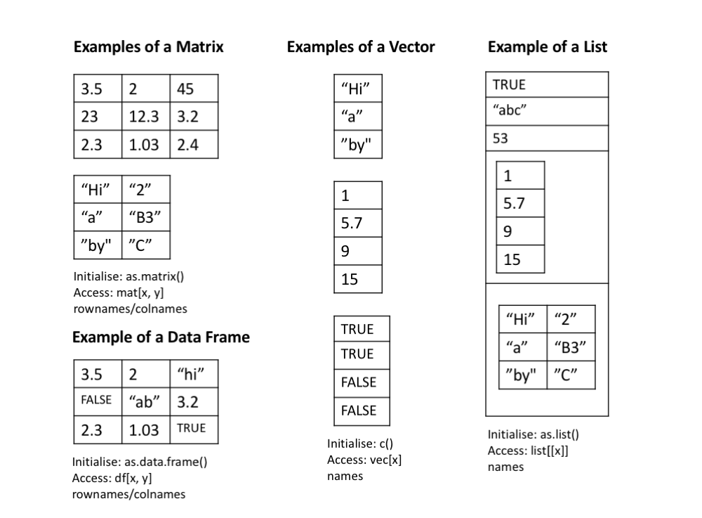
A figure from my explanation of the threshold concept of ‘data structures’
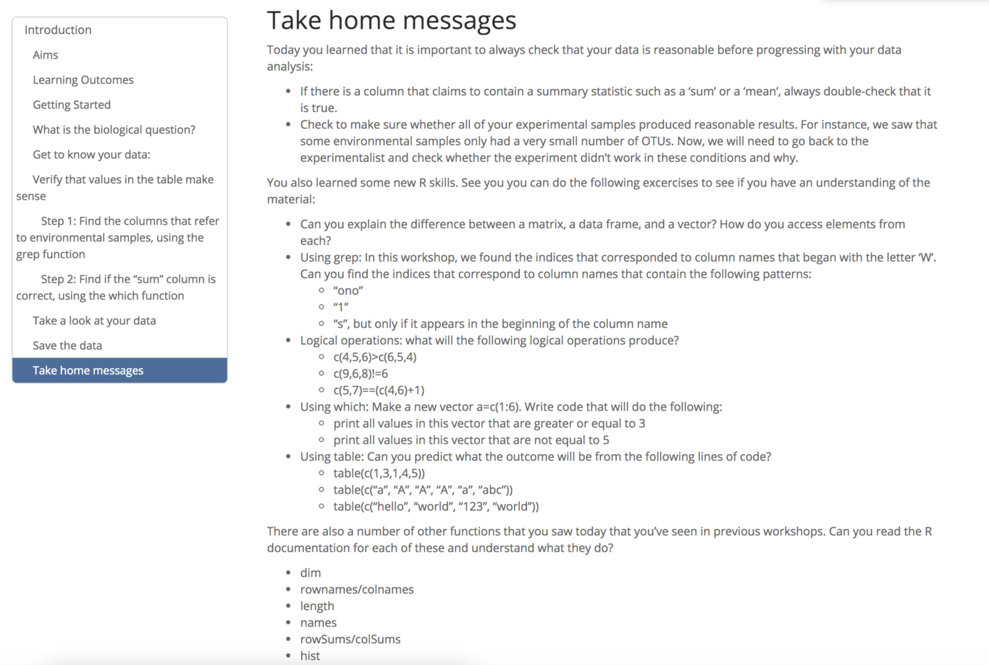
Even though I could not include questions to directly assess the learning objectives in the final assessment, I tried to include ‘optional’ questions to allow students to self-evaluate their level of understanding at the end of each lesson.

Teaching method:
Three important aspects of the York pedagogy include: (i) clear learning objectives (P2) (ii) design of independent student work (P4) and (iii) quality staff-student contact (P5).
One-to-one tuition is effective at achieving (ii) and (iii), as students develop their ideas through independent research and meet weekly with staff for a personalised discussion. Sometimes, the learning objectives of the research project can be nebulous (’creativity in overcoming obstacles’ and ‘clear communication of complex ideas’). Also, I did not clearly articulate them in the beginning of the project. After realising this, I have orally outlined the learning objectives to the student, but I think it would be better to articulate these on the first day in both oral and written formats.
In contrast, in the larger workshop, it is easier to define clear learning objectives in the beginning of each lesson (Fig 3), but very difficult to balance independent student work and quality staff-student contact. My workshop takes ‘student-led’ learning to the extreme– students work through projects independently and dictate the nature of staff-student interactions.
I did not feel this was effective. Mostly, students asked questions about how to use a computer (how to copy-paste, move files between folders, etc) or wanted us to look for typing mistakes (incorrect capitalisation or spelling). Without staff contact, students would have wasted time doing simple computer tasks unrelated to the learning objectives. However, this does not seem to be an effective use of staff-student contact, because these interactions are repetitive and do not teach the students any ideas or concepts. In periods without many student queries, I tried to ask students questions to stretch their understanding of the material, but I found that students did not seem to enjoy these interactions– they wanted to finish their assignments and leave as soon as possible. There were long periods of time where the instructors sat around without any student interaction. There may be a way to overcome this barrier and encourage students to want to engage with ideas, but I could not identify an effective strategy given the structure of the workshop and assessment.
For some of the students that finished early, I asked them ‘does this mean you enjoy coding?’. They responded with a definite ‘no’, and stated that they felt like they can work through the step-by-step guides, but would never be able to do a data analysis themselves. Given this feedback, I would have preferred to have some opportunity for the students to be explicitly taught some concepts. I would have arranged this workshop like a ‘flipped classroom’ (DeLozier & Rhodes, 2016), providing video lectures for students to view at home (using lecture capture and replay) to teach essential concepts (data types, loops, if statements), amounting to less than 10% of the GCSE-level computer science curriculum. I think that this would raise the level of discourse in the workshops, because students would have the language to ask more interesting questions.

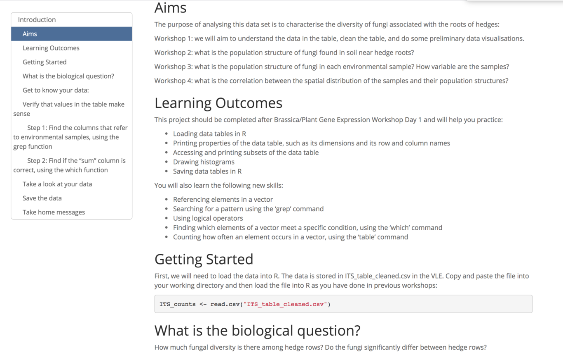
An example of the learning objectives, clearly articulated at the beginning of each Workshop.

Assessment:
Many principles of effective feedback (Nicol & Macfarlane-Dick, 2006) are more easily incorporate into one-to-one than large group teaching assessments.
For instance, project students are assessed on their ability to deliver a presentation that critically analyses a journal article, with their project supervisor providing formative feedback prior to the final assessment. I encouraged a ‘dialog’ around the formative feedback by engaging in a discussion at the end of my student’s presentation, before e-mailing her detailed notes (Fig 4). The positive comments were designed to ‘improve her motivation and self-esteem’ (blue). The ‘room for improvement’ section was meant to be ‘high quality’, in that it was very personal and in depth, but also linked clearly to the criteria that were being assessed (purple). I included questions that she should consider as she prepares for her next presentation (red), in order to ‘facilitate self-assessment’. I offered her a chance to practice the Q&A session again (green) to ‘provide opportunities to close the gap’. Next time, I would have provided her with exemplars, so she would have a clearer idea of what good performance entails. Additionally, I would have prioritised my comments, so that they would be easier to digest. Once I observe her final presentation, I will be able to assess how well she absorbed the formative feedback, which I will use to improve my teaching practice.
However, it is much more difficult to provide effective feedback to a large group of students in a workshop. Marking about 150 final essays is already an extremely time consuming task, so in the previous year there had not been a formative assessment and some students complained that they didn’t understand the requirements. This year, I helped design a formative assessment: we will ask students to write a minute-paper performing a critical analysis of a specific figure, which students will peer-review against the assessment criteria. While this activity was designed to produce peer dialog around feedback and encourage self-reflection (Nicol & Macfarlane-Dick, 2006), there are a number of issues with this approach. Firstly, the minute-paper assignment– while related to critical analysis of data visualisation– is also very different to the final essay, where students are expected to coherently reflect on multiple data visualisations and at least one statistical analysis technique. Secondly, because the feedback is from peers, rather than faculty, the feedback quality might not be high (the blind leading the blind). Thirdly, this experience isn’t accessible– students who prefer to work through the projects at home instead of in the workshop setting would not have the same experience.
Additionally, there is a need to reflect on whether the final assignment is designed to evaluate the learning objectives of the course (validity). The assignment asks students to critically analyse a data analysis pipeline that they are provided with, rather than to build one from scratch. If our aim is to teach the students to effectively analyse a data set, then students should have to test these skills directly by analysing a new dataset (without step-by-step instructions). This might be too difficult for second year undergraduates, so a potential compromise would be to provide a guide for analysing a new data set that includes substantial gaps that students must fill in. In other words, the current assignment tests the students’ ability to assess the quality of a data analysis pipeline, but my proposed assessment would require them to turn a ‘sloppy’ data analysis pipeline into an exemplary one, forming the students into self-regulated learners (Zimmerman, 2015).
Relatedly, we need to consider why we want students to learn how to analyse data in R, both in terms of the departmental curriculum and the wider world (V4). While critical analysis of a data analysis pipeline is an important skill, the ability to effectively develop a data analysis pipeline is even more important, because it gives students additional tools to apply to their remaining coursework/final-year projects and helps fill the need for practical ‘data science’ skills in the workforce.

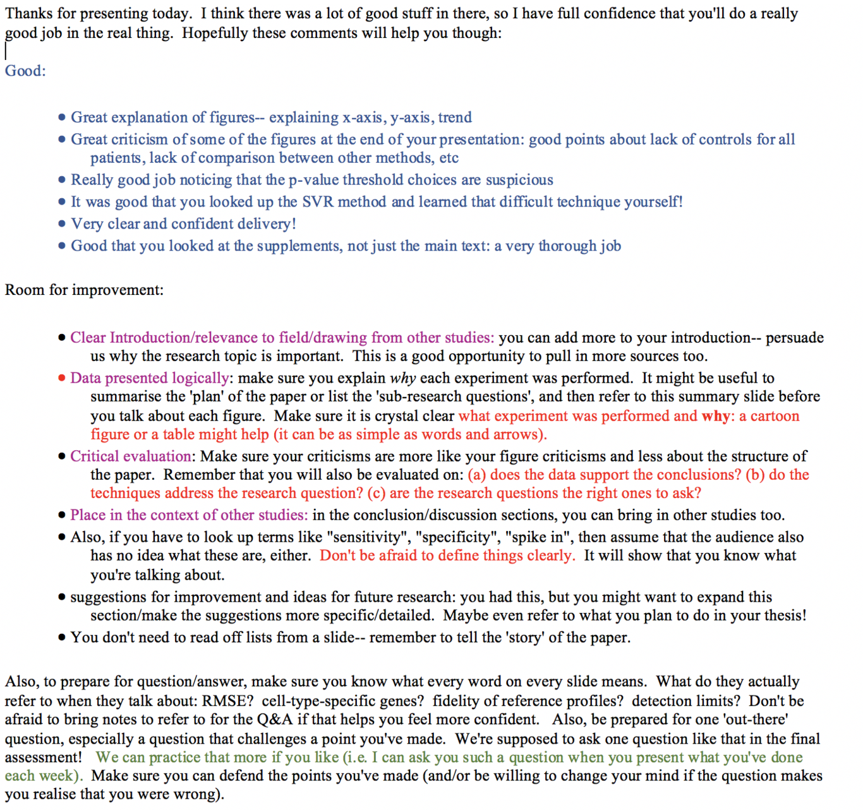
This is the formative assessment of the student’s journal club presentation. This was articulated directly to the student and then sent via e-mail. For the purposes of linking the feedback to the 7 principles of effective feedback, I have colour-coded the text here.
Learning environment
The learning environment is extremely important for improving accessibility and equality of student opportunity. On previous occasions, I have had to make adjustments to projects to accommodate students’ responsibilities as primary carers or grieving periods. This is more easily done in a one-to-one teaching setting, because it is easier to develop an informal rapport with the students, so I can have the space to accommodate their needs without sacrificing the quality of their research projects. I felt that part of the reason why these students felt comfortable communicating with me was because of the physical space– I worked in an open plan office where my desk was no better than theirs and where we could have informal interactions over lunch and coffee breaks. Unfortunately, I did not have a desk for my York project student (until recently), so I had to use technology to create a more comfortable environment for the student. In order to increase her confidence at meetings, I asked her to record a weekly diary of her progress using a tool called Authorea– an online document similar to Google Docs but that enables easier incorporation of code snippets and images, and higher quality commenting. This enabled her to organise an agenda for our weekly meetings and take charge of her learning. Currently, all her project figures are on the Authorea document, providing evidence that this tool is easy enough to use habitually.
Similarly, I do not have much control over the physical space of the workshop, but accessibility can be improved with learning technologies. The step-by-step project guidelines are written in R Markdown, so that text, code, and images can be incorporated seamlessly together (taking on board best practices discovered by the other faculty on this module). By expressing the same ideas in multiple formats side-by-side, the content can be more accessible to a wide range of learners (Fig 5). Since the R Markdown is available online as a web page, the projects are available to access in any setting, so students can work in an environment that fits their needs. For instance, a student might need a quite work environment or may need to fit the project around other commitments, such as caring responsibilities or a job. In addition, because they are publicly available, learners who are not part of the University of York can access the content, increasing the opportunity for learners beyond higher education institutions. Because the course has different kinds of people to ask for help (faculty, teaching assistants, peers), students are more likely to find at least one source of guidance that they are comfortable with.
Students working remotely can ask questions on Google hangouts and the VLE discussion forum. In order to encourage people to use Google hangouts, the instructors provide chocolates (including vegan and gluten-free alternatives) to those who provide useful comments (Fig 6). This is a slightly contrived strategy that encourages the very eager students, but might put off those who are more shy.
However, there are some challenges with the distributed nature of the course. In particular, if a student is lost and they are afraid to ask for help, then they can easily ‘disappear’ without anyone noticing. No one will know if a student is not showing up because they prefer to work from home or because they are too intimidated by the course material. Additionally, there is a risk that some students impede the learning of others– sometimes if students informally work together through a project, the faster student will find all the answers while the others follow passively, which is not good for student learning because it does not provide the space for the other students to grapple with the problems themselves. It is difficult to find the right balance between encouraging students to help one another and creating this kind of negative learning environment. It can also be impossible to track these kind of behaviours if they occur outside the confines of the workshop room.

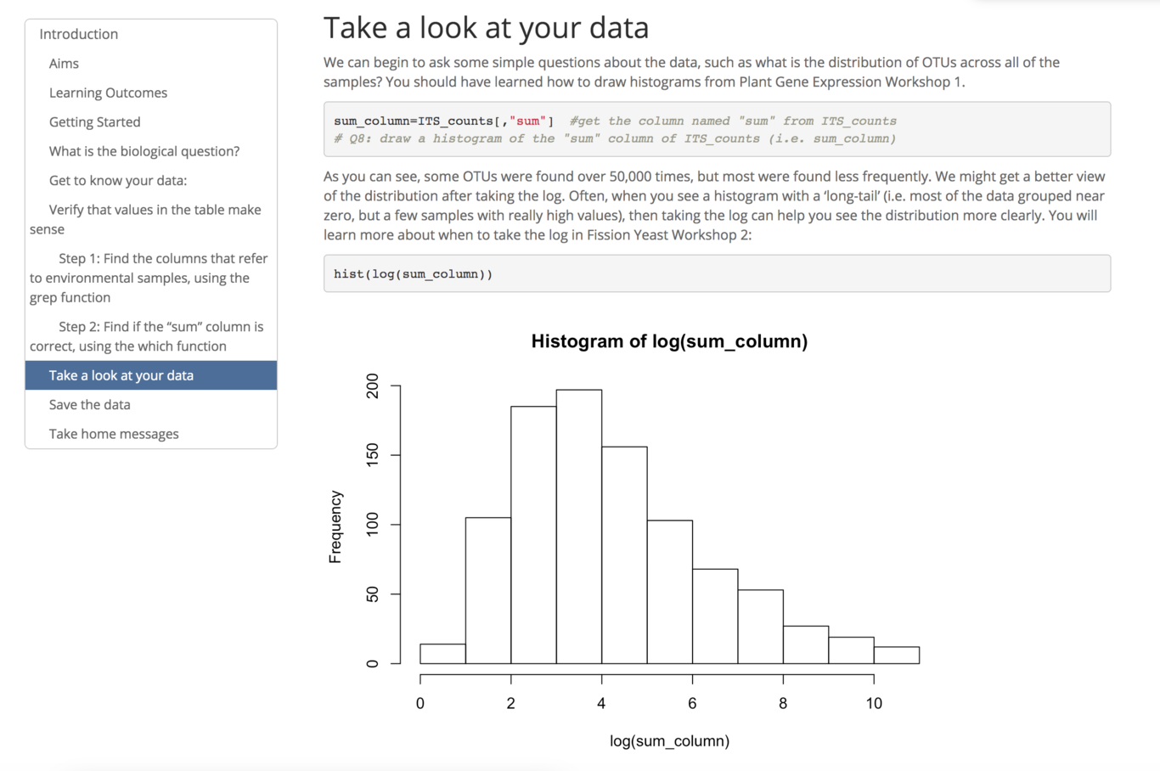
An example of code/text/images side-by-side in R Markdown.
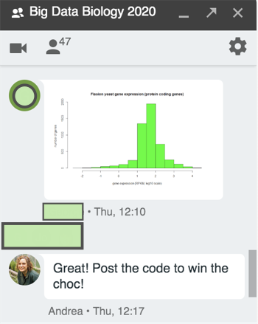
An example of encouraging student engagement with Google hangouts, using chocolate as a reward. This also demonstrates that approximately a third of students (47) have registered for the Google hangout discussion.

References
. (2003). British Educational Research Journal, 29(1), 89–104. https://doi.org/10.1080/0141192032000057401
Threshold Concepts and Troublesome Knowledge. (2008). In Threshold Concepts within the Disciplines (pp. 51–58). SENSE PUBLISHERS. https://doi.org/10.1163/9789460911477_005
Flipped Classrooms: a Review of Key Ideas and Recommendations for Practice. (2016). Educational Psychology Review, 29(1), 141–151. https://doi.org/10.1007/s10648-015-9356-9
Formative assessment and self-regulated learning: a model and seven principles of good feedback practice. (2006). Studies in Higher Education, 31(2), 199–218. https://doi.org/10.1080/03075070600572090
Self-Regulated Learning: Theories Measures, and Outcomes. (2015). In International Encyclopedia of the Social & Behavioral Sciences (pp. 541–546). Elsevier. https://doi.org/10.1016/b978-0-08-097086-8.26060-1

