Gravitational Wave Scalogra
Faraz Khaleghi
In this exercise we are going to fit a first-derivative Gaussian function to the gravitational wave time-series data from LIGO in order to calculate correlation and find the best scale for the fitted wavelet in different time and also a universal correlation maximum.

Stocastic Process - Professor Rahimi-Tabar

Introduction
We have the LIGO signals over the course of 16 seconds and we are going to fit first-derivative Gaussian function normalized to one with the formulation $Ψ\left(u\right) = \frac{−\left(\frac{x−u}{s}\right)}{e^{−0.5}}e^{−\frac{{\left(\frac{x−u}{s}\right)}^{2}}{2}}$ for every point on the time-series. Every 4096 points equals to one second. Here we have the time-series figure:
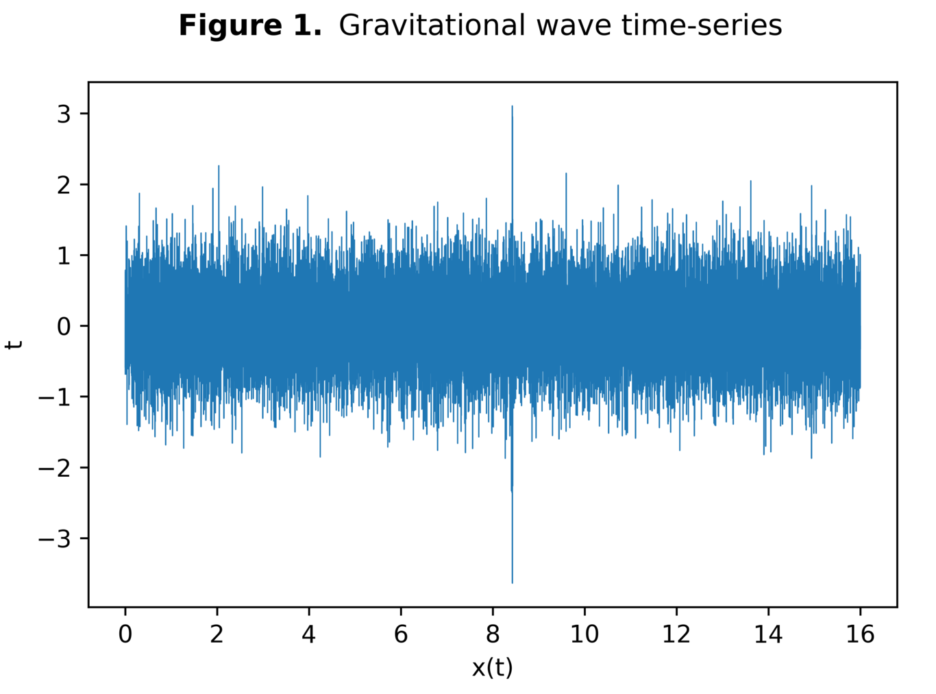

Scalogram
in this section we will have the figure showing the intensity of the correlation by color for different steps and scales in the vicinity of the universal maximum correlation. There will be another figure in the zip file showing correlation over complete range of time which is too big to fit in this letter.
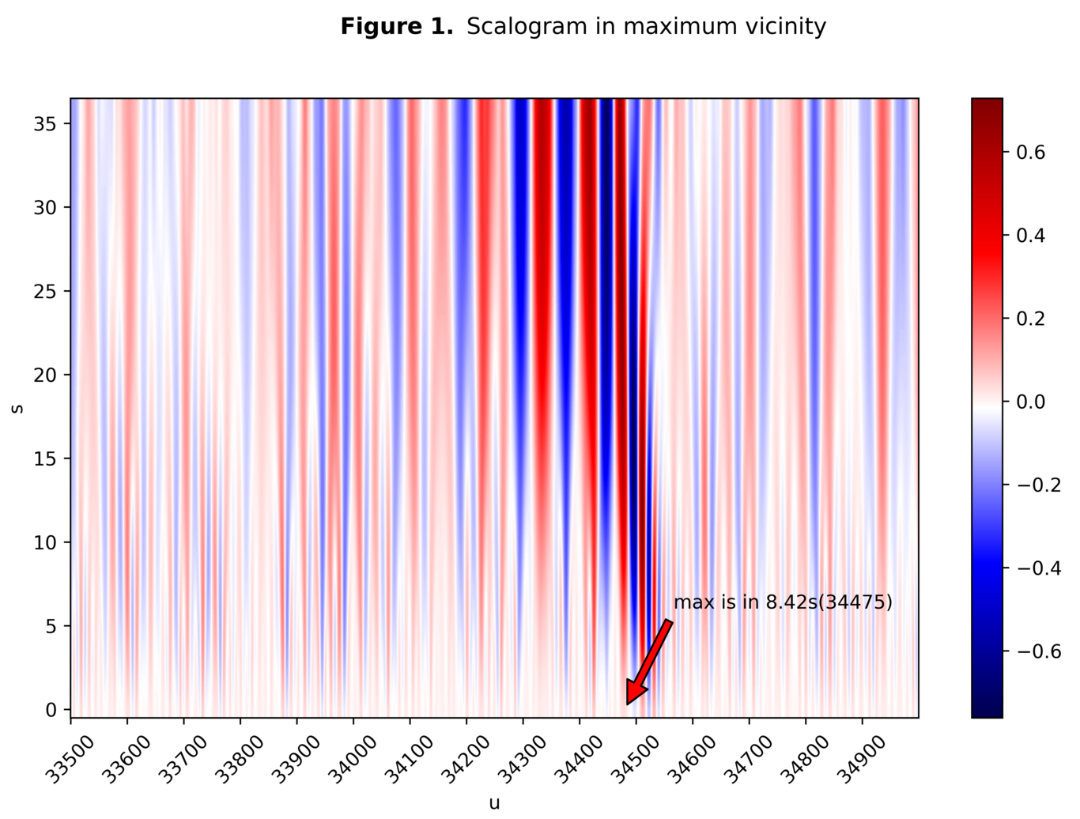

Code
Code for python is also attached in the zip file and is summarized here:
with open(r'C:\Users\Faraz\Desktop\Downloads\GW150914_H.txt')as f:
pd_data = pd.read_csv(f)
np_data = np.array(pd_data)
data = []
for i in range(pd_data.size):
data.append(np_data[i][0])
x = np.array(data)
x = x - np.mean(x)
sps = 4096 # steps-per-second
t = np.linspace(start=0.0, stop=x.size/sps, num=x.size)
s = 0.0010
ustep = 34510
def GD(t, ustep, s):
# Gaussian first-derivative scaled to one
global u
u = float(ustep)/sps
return -(t-u)/s*np.exp(-((t-u)/s)**2/2)/np.exp(-0.5)
correlation = [list([]) for _ in xrange(37)]
for i in tqdm(range(30, x.size-30, 1)):
for j in range(3, 40):
correlation[j-3].append(np.mean(GD(t, i, float(j)/10000)[i-30:i+30]*x[i-30:i+30]))

