IEEE Journal of Photovoltaics Template
Dileep V Raj
Cost-effective, parallel-grid embedded dye sensitized solar mini-modules were fabricated successfully by utilizing reduced graphene oxide (rGO) and rGO-silver (rGO-Ag) nanocomposites as grid current collectors. The pure rGO grid embedded dye sensitized solar mini-module showed a maximum power conversion efficiency of 4.09 % with improved fill factor, circumvented iodide/triiodide electrolyte corrosion and reduced the module power loss significantly. Electrochemical impedance spectroscopy studies revealed that the 1:1 wt% ratio rGO-Ag nanocomposite grid improved the module’s electron diffusion length, mobility and average lifetime, and produced a higher open circuit voltage (Voc) as compared to the pure silver grid in dye sensitized solar mini-modules.
Dileep V Raj : IEEE Journal of Photovoltaics Template

Introduction
Over the past two decades, one of the major solar energy utilization technologies, dye-sensitized solar cells (DSSCs) have attracted a wide scientific attention since after introduced by O’Regan and Gratzel in 1991,[1] due to their high performance, technical superiority such as feasibility of working under diffused light, adapting to the market requirements of different sectors like building-integrated photovoltaics (BIPVs), chargers for domestic electronic products (laptops, mobile phones) and low fabrication costs.[2,3] Also, in the recent past years, because of intense researches on the development of high efficient dyes, TiO2 mesoporous films with increased surface area, more stable redox active electrolyte systems producing a higher open circuit voltage with TiO2 conduction band, and counter electrodes with higher catalytic activity the maximum power conversion efficiency of DSSCs has been achieved up to 13 % at the cell level and 10.7± 0.4 % at the mini-module level.[4,,5] However, for industrial scale DSSC production still some essential factors such as conversion efficiency of large area DSSC, thermal stability of redox electrolyte, metal oxide nanostructures of photoanode, sensitizing dye and the types of interconnection grids employed in the module fabrication need to be optimized further for achieving higher module level performance.[6] Therefore, different module structures have been proposed and used for the fabrication of large area DSSCs with improved performances. Notably the module structures such as Z-type module,[7] W-type module,[8] monolithically interconnected module (series connected) and parallel connected module[9] in large area DSSCs are familiar in the literature. Among these module structures, the first three types of modules connect each dye sensitized solar strip/cell in a series to produce a high open circuit voltage. However, to obtain high output current density, dye sensitized solar strips connected in parallel using various metal grid collectors are usually preferred. Also, depending on the use, each module structure can add its own advantages when compared to the other type structures. In case of portable electronic applications, parallel connection is desirable due to the large current requirements.[10] Moreover, for the inexpensive integration of large area DSSCs in all portable electronic devices charging applications, parallel grid connected modules are mostly preferred than the other type module structures. For industrial production of large scale modules, monolithic interconnect module has been proven to offer significant advantages over the other designs.[11] In large monolithic modules, it is also observed that the losses associated with conducting glass substrate are high, as a result the fill factor and conversion efficiency produced by the modules are still poor.[12] In order to enhance the current collection, dye sensitized solar modules are usually made with different metal current collectors as interconnection grids, which significantly reduce the ohmic and other resistive losses of the photoanode. In most cases silver is being used as a interconnect/grid material due to its excellent electrical conductivity, relatively low cost, easy processability and its ready availability as a paste/ink in the market. Besides, other high conducting transition metals such as aluminum,[13] platinum[14] and nickel[12] have been explored as metal grid materials in the dye sensitized solar modules so far. A number of methods involve in most of these metal grids deposition on to the fluorine doped tin oxide (FTO) substrates employ expensive and high temperature sputtering processes which increased the cost of module fabrication along with complexity of their associated chemical processes. Moreover, most of these metal grids are corrodible in highly reactive iodine/triiodide electrolyte environment which require a protective overcoat. Also, the protection of grid is a prerequisite during the manufacturing of monolithic parallel grid connected dye sensitized solar modules. Therefore, several routes have already been tried successfully sealing the metal grids such as using UV- curable sealant, glass frit and hot pressing of Surlyn sealant to protect them effectively from the corrosive redox electrolytes.[15] All of these methods require additional processing may further delay the economic scale entry of large area DSSCs into the solar PV industry. In this work, we have developed new carbon nanomaterials based grid pastes which composed of a highly conductive rGO (> 40 S/cm) or rGO-silver (rGO-Ag) nanocomposites. Because of the exceptional electrical transport properties of inexpensive carbon nanomaterials such as graphenes, carbon nanotubes and reduced graphene oxides, the range of potential applications of this class of materials has broadened dramatically in recent years, thus introduced many drastic changes in the materials used in electronic industries.[16] Among the highly conductive carbon nanomaterials, reduced graphene oxide and its nanocomposites are chosen as replacements to the silver grid used in DSSCs due to its easy solution processability in many protic solvents. Besides, the carbon nanomaterials based grids are found to be less prone to electrolyte corrosion, formed more stable grids in between solar cells, produced the near matching performance as that of silver grid in mini-modules and notably reduced the preparation costs.
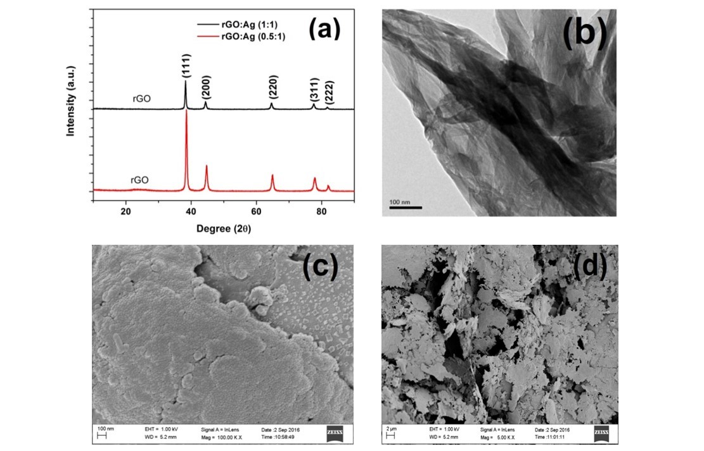
Figure 1. (a) XRD of nanocomposites (b) HRTEM image of rGO and (c, d) SEM images of rGO-Ag nanocomposite.
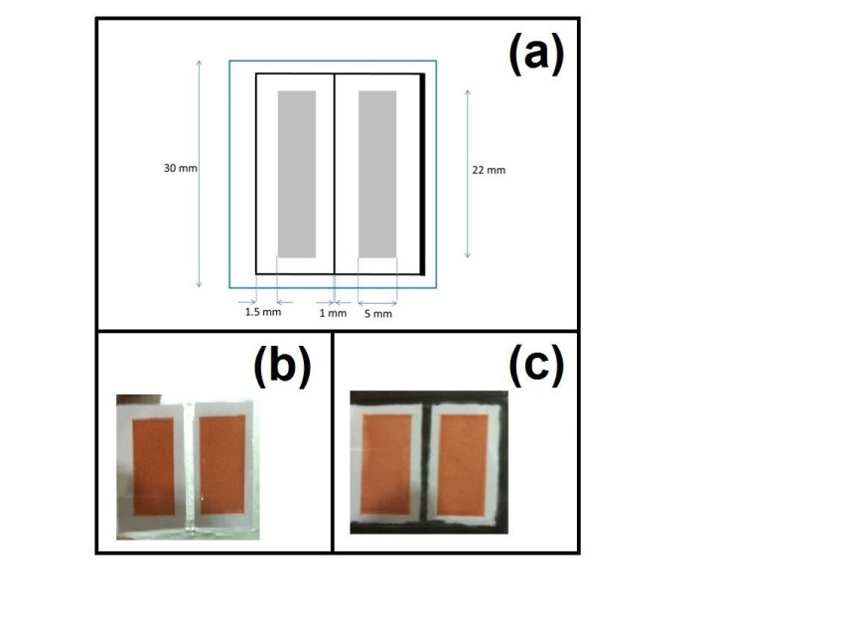
(a) Dimension of two strips mini-module with parallel grid (b) Photoanode of two strips mini-module with silver grid (active area 1.1 cm2) (c) Photoanode of two strips mini-module with rGO-Ag grid (active area 1.1 cm2).

EXPERIMENTAL SECTION

Device fabrication
The fabrication process of a parallel grid connected/embedded DSSC mini-module is illustrated in the Figure S3. The process involves the preparation of following major components: the rGO and rGO-Ag nanocomposite based grid pastes and the photoelectrodes used in the device fabrication.

Preparation of rGO based grid pastes
Reduced graphene oxide was prepared by following the procedure published in our earlier work.[17] As prepared graphene oxide (GO) and reduced graphene oxide (rGO) formation were confirmed by XRD and TEM analyses (supporting information). The rGO was subsequently converted as a paste by following the procedure given below and this paste was deposited as a parallel grid in between the semiconducting oxide strips. Also the rGO grid paste can be printed in the Z- or W- type series interconnection to obtain series connected modules.

Reduced graphene oxide paste preparation
For the effective printing of reduced graphene oxide in the grid application, a smooth and viscous paste was prepared using ethyl cellulose and terpineol. An industrially viable and simple paste making procedure was adopted to obtain the rGO paste as mentioned in the flow diagram in Figure S6. The prepared paste was then stored in an air tight container for future use.

rGO – silver nanocomposite interconnect preparation
Commercial silver paste was procured from Coatex Industries, Pune, India and used as obtained. By mixing different weight proportions of well grinded rGO powder in commercially available Ag paste thoroughly, the electrically conductive paste comprising embodiments were made. Two different proportions of Ag and rGO by varying wt% composition of rGO such as 1:0.5 and 1:1 respectively in the nanocomposite pastes were prepared. The different weight ratios of rGO powder were directly added to the commercial silver paste and mixed in an agate mortar. Each mixture was well grinded for 30 min and then subjected to probe sonication for another 15 min. The prepared nanocomposite grid pastes were then printed as parallel grids on top of FTO.

Preparation of photoanode
Single layer TiO2 film and grid connections were accordingly screen-printed on the FTO glass (Dyesol, 14-18 ohm/Sq) with custom made designs. Screen printable TiO2 pastes were purchased from Dyenamo, Sweden and Dyesol (greatcell solar) Corporation, Australia, and used as obtained. The TiO2 paste and nanomaterial grid paste were sequentially printed using a manual screen printer (Dyenamo, Sweden) with custom made mesh as shown in Figure 2. After the TiO2 paste was printed on the FTO glass substrate, the film was subjected to air-dry for 30 minutes at room temperature. The substrate was then sintered for 325°C for 30 min, 375°C for 30 min, 450°C for 30 min and 500°C for 30 min. The gradual heating avoided the formation cracks in the TiO2 films during the sintering process. The grid paste was then printed on the FTO glass as per the design. The printed grids were subjected to air-drying followed by sintering in varying temperature from 75°C to 250°C for 10 min. As a protective overcoat layer for RGO and nanocomposite grids, Surlyn sheet (Dupont) was used. Surlyn was hot melted using a hot presser at 80°C on top of the RGO and nanocomposite grids to protect it from the corrosive electrolyte and dye soaking. Finally dye impregnation was done by soaking the prepared photoelectrode in a 0.4 mM N719 [cis-di-isothiocyanato-bis (2,2-bipyridyl-4,4-dicaboxylato) ruthenium(II) bis(tetrabutylammonium)] ethanol solution for 24 hours to obtain the mini-module photoanode.

Preparation of photocathode
Photocathode was prepared by using a pre-cleaned FTO with an area equal to that of working photoanode. Using spray coating technique, H2PtCl6 solution was spread uniformly on the FTO surface. After air drying, at 400°C the spray coated film was heat treated. The nanomaterial interconnect was not printed on the photocathode side, even though it could have enhanced the efficiency further, to understand the effect of grids were printed exclusively on the photoanode. To facilitate the redox electrolyte injection process, the injection holes were predrilled on the FTO before making the photocathode.

DSSC mini-module fabrication
The mini-modules photoanode and photocathode were sandwiched together using Surlyn film in a hydraulic hot-press machine at 120 °C for 5 min and then allowed to cool in ambient air. It Both the electrodes were sealed tightly by the melted film. A redox electrolyte composition of 0.5 M LiI, 0.05 M I2 and 0.5 M 4-tert butyl pyridine in acetonitrile was injected in between the sealed electrodes via a predrilled hole and simultaneously applying a mild vacuum on another hole in the photocathode. Finally the holes were covered with a Surlyn film and a cover glass and laminated with photocathode using hydraulic hot-press machine to obtain the dye sensitized solar mini-modules as shown in the Figures S4.

RESULTS AND DISCUSSION

Morphological properties of rGO and rGO-Ag grids
The as prepared rGO-Ag nanocomposite grids morphology and crystal structure were confirmed by the X-ray diffraction and microscopic analyses. Fig. 1(a) shows the powder XRD patterns of rGO-Ag nanocomposites. The XRD patterns of rGO-Ag composites showed a weak, broad rGO peak centered around 23.5° along with sharp diffraction peaks for (111), (200), (220), (311) and (222) (JCPDS card No. 87-0720) planes of the silver nanocrystals. The rGO showed broad peak around 26° (2 value) different from the GO characteristic peak normally observed at 10.50° indicating the rGO with increased inter-planar d spacing from 0.34 nm to 0.94 nm.[17,18] However the shift in the rGO peak can be accounted to the changes in inter-planar spacing of stacked graphene layers of rGO during rGO-Ag nanocomposite formation.[19] Figure 1(b) shows the HRTEM image of pure rGO revealing the formation of folded sheet-like structures with thickness ranging in a few nm due to the random aggregation of graphene sheets. This folded sheet-like rGO was then used for the preparation of rGO-Ag nanocomposite grid pastes (supporting information) and printed on to the FTO as parallel grids showing sheet-like morphologies of nanocomposites. Moreover, the rGO was mixed in two different wt% ratios (1:1 and 0.5:1) with silver paste to prepare rGO-Ag nanocomposites, and both the nanocomposites showed similar morphological features in the FESEM microscopic analysis. Figure 1(c, d) show the FESEM images of rGO-Ag composites indicating the Ag nanocrystals are uniformly spread on to the rGO sheets of few microns length. One of the reasons for uniform distribution of Ag nanocrystals on to the rGO in rGO-Ag nanocomposites was the strong chemical interactions between the Ag nanocrystals and remnant COOH groups of rGO which can lead to the attachment of layer of Ag nanocrystals on the rGO surface.[18]

Current density – voltage characterization
In order to study the influence of different grid materials on the photovoltaic performance of dye sensitized solar modules, mini-modules of two different active areas 1.1 cm2 and 0.6 cm2 were fabricated using their respective photoanodes as depicted in Figure 2 and Figure S4 respectively, by following the process steps showed in the Figure S3 (supporting information). Figure 3 shows the J–V curves of parallel grid connected mini-modules recorded in one sun illumination conditions and their corresponding photovoltaic parameters computed are shown in Table 1. From the graphs and table, the short-circuit current density measured were found increasing from 13.34 mA/cm2 for the pure rGO grids connected mini-module to 17.98 mA/cm2 for the 1:1 rGO-Ag nanocomposite grids connected mini-module. Moreover the fill factor of pure rGO grids connected module reduced from 0.43 to 0.33 in 1:1 rGO-Ag nanocomposite grids connected mini-module due to corrosion of Ag nanocrystals by the electrolyte beyond Surlyn overcoat protection and increased the resistive losses. The poor fill factor was prohibiting a better J-V performance of rGO-Ag grid connected mini-modules considerable extent and largely affected their power output.
The poor fill factor was mainly associated with the resistance parameters of the strips/cells in the module. Unlike conventional silicon solar cells, each and every junction associated with the DSSC can produce different resistance parameters. Thus the total series resistance of dye sensitized solar mini-module is represented as Rseries, and the Rseries is associated with many sub-resistances[20] which are,
RMeasurement Loss is the resistance between the measuring clips and resistance associated with wires including the DC cable losses. Sheet resistance of the conducting substrate is RFTO. The resistance associated with the grid is denoted by Rgrid. Similarly, RElectrolyte and RPlatinum are respective resistance associated with those layers. The series resistance can influence the fill factor drop and the power loss in the overall mini-module combined with grids. This can be expressed as,[21]
Where, J0 is the current at maximum power point, V0 is the voltage at maximum power point, D is distance between interconnection (6 mm), Rseries is the series resistance associated with the packed module, and A is cross sectional area of interconnections (0.06 mm2). The main reason for power loss is the presence of Rseries, which consists of many sub-resistances. The resistance parameters RMeasurement, RElectrolyte
and RPlatinum are associated to the interfacial properties and are same in solar cells and in modules, but Rgrid and RFTO will vary based on the geometry and size of the module. Resistivity of the interconnected grid materials is represented as ρgrid. These parameters could affect the fill factor significantly. Moreover, adherence and protection of grids printed on to the FTO layer is also a crucial factor in obtaining a better fill factor. In case of rGO grid it was found that, the adherence to the FTO surface was poor even after sintering due to the formation rGO flakes by aggregation. The rGO grid paste mixed with suitable binder capable of avoiding aggregation and binding the rGO to FTO layer tightly could resolve this issue substantially and improve the grid stability. For rGO-Ag composite grids, it was also found that, the corrosive iodide/triiodide electrolyte removed the silver nanocrystals slowly and resulted in the poor fill factor, reduced the performance of their parallel grid connected modules. To prevent this, the Ag and rGO-Ag nanocomposites grids were laminated with two layers of Surlyn film resulted in some improvements in the module performance but increased inter-electrode distance (gap between photoanode and photocathode). The electron mobility was affected considerably by this increase and fill factor was also affected. According to the Ohm’s law, as current flow in the circuit increases the ohmic losses also increase, which can subsequently reduce the module performance and fill factor. Moreover, from the J-V comparison curves (Figure 3) and Table 1, the improvement in fill factor upon introducing rGO grids in to the mini-modules are evident, which could be due to the reduced internal resistance of the mini-module which enhanced the charge transport. Moreover the power loss value calculated for the Ag grid based mini-module (387.72 Ω2cm-3) was found higher than the pure rGO grid based mini-module (228.30 Ω2cm-3) of similar size and active area revealed that the poor corrosion resistance and increased resistive losses of Ag-grid connected cells during the power generation, even after Surlyn lamination. Though considerable challenges were faced for coating rGO based nanomaterial grids in dye sensitized solar mini-modules the overall parallel grid connected modules had shown good photovoltaic performance as compared to the module without grid. Notably the power conversion efficiency of dye sensitized mini-module without grid connections had considerably increased from 3.61% to 5.22% when the rGO-Ag or Ag were employed as grids. Furthermore, the photovoltaic performances of mini-modules with rGO, silver grids and without grid were compared. Based on the comparison the following trends were observed, in a highly conducting rGO grid connected mini-module Jsc, Jmax were found better than the mini-module without grid and produced almost same Vmax. Therefore the maximum power produced by the rGO grid connected module was superior to the module without grid. However, the Jsc, Jmax values obtained were inferior to that of Ag, rGO-Ag grids based mini-modules’ Jsc, Jmax values, while the Vmax was found to be higher for rGO grid connected mini-module. When Ag was introduced in rGO matrix the conductivity of the composite increased, as a result rGO-Ag nanocomposite grids enhanced the Jsc of their mini-modules. The upscaling of DSSC to commercial platform had been reported to generate many challenges, mainly due to the corrosive liquid iodine/triiodide electrolyte.[22] Metal grids prone to corrosion by electrolyte posing fabrication challenges would be subdued by the noncorrosive high conducting carbon nanomaterials. The rGO and rGO-Ag grids were found to be un- / less- corroded as compared to the silver grid when exposed to corrosive iodide/triioide redox electrolyte environment.

Electrochemical Impedance Spectroscopy
Electrochemical Impedance Spectroscopy (EIS) study was carried out to understand charge transfer dynamics in the parallel grid connected two strips photoanodes using different grid materials. Figure 4 shows the EIS Nyquist plot of dye sensitized mini-module made of different grid materials recorded under dark and fitted with an equivalent circuit to calculate the different resistance parameters listed in the Table 2. The DSSC Nyquist plot usually consists of three arcs in the high, medium and low frequency domains. These arcs at high, medium and low frequency domains are attributed to charge transfer at the photocathode-electrolyte interface, charge transfer at the grid embedded photoanode-electrolyte interface and ion diffusion process associated with the electrolyte, respectively.
through mesoporous TiO2 film (Rt) with thickness is ‘L’.[23] Also the Rct obtained from the middle arc can be related to the mean electron life time (τn), electron mobility (µ) and other parameters.[24] The maximum frequency (fmax) in the EIS bode plot (supporting information) for charge recombination region in the second semicircle can be used to calculate the mean electron life time (τn) with following equation,
Using the Rt and Rct values, the mean electron transit time (T d) can be obtained from the correlation
In equivalent circuit, at an applied potential above open circuit voltage (Voc), the middle arc is generated by the chemical capacitance of porous TiO2 in parallel with charge-transfer resistance between TiO2 and redox electrolyte which are represented as combination of interfacial charge transfer resistance (Rct) and the charge transport resistance of electrons .
Where Ln is the electron diffusion length in the photoanode of dye sensitized solar mini-module, L is the thickness of photoanode and Dn is diffusion constant. Moreover to calculate the electron mobility (μ) in the min-module, the Einstein’s relation mentioned in the eq. (7) has been employed using known values such as elementary charge of electron (e), absolute temperature in Kelvin (T) and Boltzmann constant (KB).
By using the above equations, the diffusion constants, electron mobilities and other related parameters of mini-modules calculated are listed in the Table 2. From the Table 2, EIS parameters of various mini-modules estimated have revealed a higher μ for the module with 1:1 Ag:rGO grid than that of modules embedded with other grids, showing a favorable electron mobility through a longer distance with less diffusive hindrance in the nanocomposite. The interfacial charge transport resistance (Rct) is decreased to almost one third for silver grids embedded mini-module as compared to the mini-module without grid. This is due to the increased recombination kinetics by the silver grids interactions with corrosive electrolyte even after an effective sealing of grids using Surlyn sealant. This also indicates silver grids require a very tight sealing and must be completely isolated from the exposure of redox electrolyte. However, when rGO is mixed with the silver in large proportions the silver and iodide/triiodide interactions are reduced dramatically and consequently the charge recombination in the mini-module found decreased. Moreover the charge transport resistance is decreased significantly in rGO-Ag composite grids embedded modules, which in result increased the electron diffusion length to Ln = 124.15 µm as compared to the pure rGO or Ag grids embeddded mini-modules. These results clearly indicate that the highly conducting rGO and rGO-Ag nanocomposite based grids do not require scrupulous protection from corrosive electrolyte as similar to silver metal grids. Moreover the rGO/graphene nanomaterials based grids can perform equal or comparable to silver grids in the dye sensitized solar modules. In addition by increasing the rGO weight % content in the rGO-Ag nanocomposite grids, the module electron diffusion length (Ln), electron mobility (μ), and average life time has improved, at the same time the short circuit current density has dropped small extent as compared to the Ag grids when used in the mini-module. Furthermore, these results suggest that the high short circuit current density can be obtained from the mini-module with rGO-Ag grids as compared to the mini-module with pure rGO grids, by the addition of considerable amount of silver, this can increase the μ and Ln, for more charge collections at the photoanode to generate more current.

Conclusions
In summary parallel-type grid connected dye sensitized solar mini-modules using highly conducting reduced graphene oxide (rGO), reduced graphene oxide-Ag (rGO-Ag) nanocomposites and silver as interconnection grids were fabricated and their photovoltaic performances were compared. The J-V analysis revealed that the rGO-Ag nanocomposite grids embedded dye sensitized solar mini-modules showed the maximum power conversion efficiency (PCE) of 4.55 % comparable to the Ag grids based mini-module PCE of 5.22%, and showed a better electron lifetime and diffusion length. When the rGO weight content of rGO-Ag nanocomposites in grids was increased the mini-module electron diffusion length (Ln), electron drift mobility (μ), and average life time found improved and the short circuit current density was dropped only a little extend as compared to the Ag grids in their respective dye sensitized solar mini-modules. These results confirmed that the replacement of expensive silver grids with inexpensive carbon nanomaterials with high conductivity will be very useful in the cost-effective fabrication of large area DSSCs, and suitable for reducing the costs of fabrication of electronic circuits/products by the similar applications.
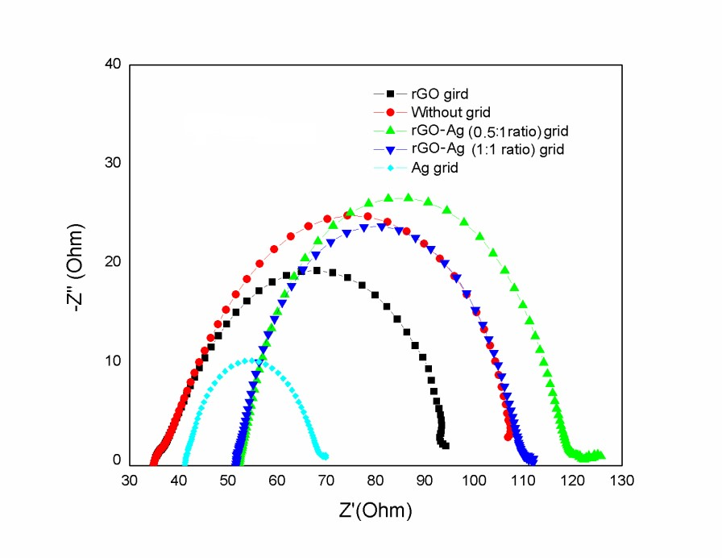
EIS Nyquist plots of dye sensitized mini-modules embedded with various grids recorded under dark.
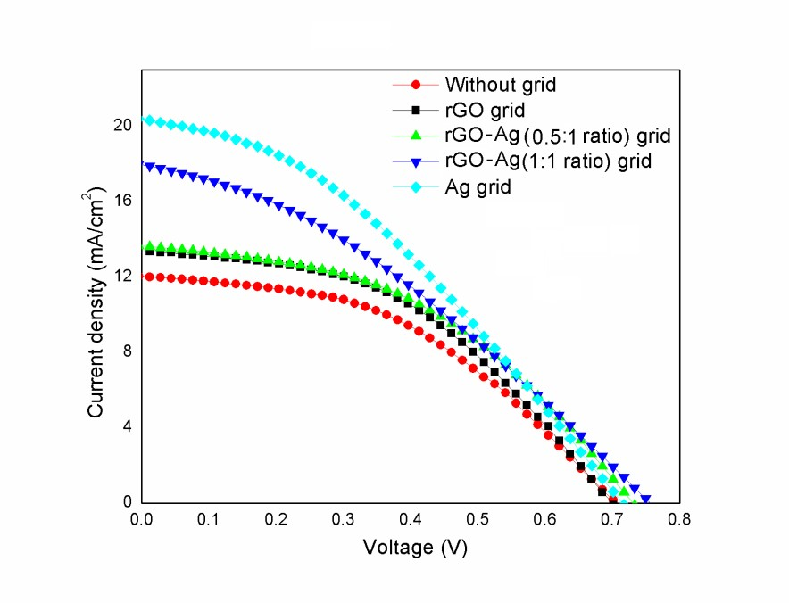
Photovoltaic J-V comparison curves for the parallel connected dye sensitized solar mini-modules with various grids (active area 0.6 cm2).

Dileep V Raj is with Department of Electrical and Electronics Engineering

