AASTex (v6.1) example article for Authorea
Hyunki Min
This $x^{2}$ example manuscript is intended to serve as a tutorial and template for authors to use when writing their own AAS Journal articles with Authorea. The manuscript includes a history of AASTeX and documents the new features in the previous version, 6.0, as well as the new features in version 6.1. This manuscript includes figure and table examples to illustrate these new features. Authorea features a rich text editor so that you can write in LaTeX, Markdown, or rich text and render directly on the web. Authorea supports and renders the vast majority of LaTeX notation needed for AAS Journal articles. A few features provided by AASTex v6.1. that are not available in Authorea have been listed in this document. Authors are welcome replace the text, tables, figures, and bibliography with their own and submit the resulting manuscript to the AAS Journals peer review system. The first lesson in the tutorial is to remind authors that the AAS Journals, the Astrophysical Journal (ApJ), the Astrophysical Journal Letters (ApJL), and Astronomical Journal (AJ), all have a 250 word limit for the abstract. If you exceed this length the Editorial office will ask you to shorten it.

Introduction
LaTeX is a document markup language that is particularly well suited for the publication of mathematical and scientific articles (Lamport 1994). LaTeX was written in 1985 by Leslie Lamport who based it on the TeX typesetting language which itself was created by Donald E. Knuth in 1978. In 1988 a suite of LaTeX macros were developed to investigate electronic submission and publication of AAS Journal articles (“Baas, 21, 780” 1989). Shortly afterwards, Chris Biemesdefer merged these macros and more into a LaTeX2.08 style file called AASTeX. These early AASTeX versions introduced many common commands and practices that authors take for granted today. Substantial revisions were made by Lee Brotzman and Pierre Landau when the package was updated to v4.0. AASTeX v5.0, written in 1995 by Arthur Ogawa, upgraded to LaTeX 2e which uses the document class in lieu of a style file. Other improvements to version 5 included hypertext support, landscape deluxetables and improved figure support to facilitate electronic submission. AASTeX v5.2 was released in 2005 and introduced additional graphics support plus new mark up to identifier astronomical objects, datasets and facilities.
In 1996 Maxim Markevitch modified the AAS preprint style file, aaspp4.sty, to closely emulate the very tight, two column style of a typeset Astrophysical Journal article. The result was emulateapj.sty. A year later Alexey Vikhlinin took over development and maintenance. In 2001 he converted emulateapj into a class file in LaTeX 2e and in 2003 Vikhlinin completely rewrote emulateapj based on the APS Journal’s RevTEX class.
During this time emulateapj gained growing acceptance in the astronomical community as it filled an author need to obtain an approximate number of manuscript pages prior to submission for cost and length estimates. The tighter typeset also had the added advantage of saving paper when printing out hard copies.
Even though author publication charges are no longer based on print pages the emulateapj class file has proven to be extremely popular with AAS Journal authors. An informal analysis of submitted LaTeX manuscripts in 2015 revealed that $∼$65% either called emulateapj or have a commented emulateapj classfile call indicating it was used at some stage of the manuscript construction. Clearly authors want to have access to a tightly typeset version of the article when corresponding with co-authors and for preprint submissions.
When planning the next AASTeX release the popularity of emulateapj played an important roll in the decision to drop the old base code and adopt and modify emulateapj for AASTeX v6.+ instead. The change brings AASTeXinline with what the majority of authors are already using while still delivering new and improved features. AASTeX v6.0 and v6.1 were written by Amy Hendrickson and released in January and October 2016, respectively.
The rest of this article provides information and examples on how to create your own AAS Journal manuscript with v6.1. Special emphasis is placed on how to use the full potential of AASTeX v6+. The next section describes the different manuscript styles available and how they differ from past releases. Section ??? describes how tables and figures are placed in a LaTeX document. Specific examples of tables, Section ???, and figures, Section ???, are also provided. Section ??? discusses how to display math and incorporate equations in a manuscript. The last section, ???, shows how recognize software and external data as first class references in the manuscript bibliography. An appendix is included to show how to construct one and provide some information on how article charges are calculated. Additional information is available both embedded in the comments of this LaTeX file and in the online documentation at http://journals.aas.org/authors/aastex.html.

Manuscript styles
The default style in AASTeX v6.1 is a tight single column style, e.g. 10 point font, single spaced. The single column style is very useful for article with wide equations. It is also the easiest to style to work with since figures and tables, see Section ???, will span the entire page, reducing the need for address float sizing.

Floats
Floats are non-text items that generally can not be split over a page. They also have captions and can be numbered for reference. Primarily these are figures and tables but authors can define their own. LaTeX tries to place a float where indicated in the manuscript but will move it later if there is not enough room at that location, hence the term “float”. Authors are encouraged to embed their tables and figures within the text as they are mentioned. Please do not place the figures and text at the end of the article as was the old practice. Editors and the vast majority of referees find it much easier to read a manuscript with embedded figures and tables. Depending on the number of floats and the particular amount of text and equations present in a manuscript the ultimate location of any specific float can be hard to predict prior to compilation. It is recommended that authors not spend significant time trying to get float placement perfect for peer review. The AAS Journal’s publisher has sophisticated typesetting software that will produce the optimal layout during production.
c|cc 1991 & 600 & 100
1992 & 650 & 105
1993 & 550 & 103
1994 & 450 & 110
1995 & 410 & 112
1996 & 400 & 114
1997 & 525 & 115
1998 & 590 & 116
1999 & 575 & 115
2000 & 450 & 103
2001 & 490 & 90
2002 & 500 & 88
2003 & 450 & 90
2004 & 460 & 88
2005 & 440 & 79
2006 & 350 & 77
2007 & 325 & 70
2008 & 320 & 65
2009 & 190 & 68
2010 & 280 & 70
2011 & 275 & 68
2012 & 150 & 56
2013 & 140 & 55

Tables
Tables can be constructed with LaTeX’s standard table environment or the AASTeX’s deluxetable environment. The deluxetable construct handles long tables better but has a larger overhead due to the greater amount of defined mark up used set up and manipulate the table structure. The choice of which to use is up to the author. Examples of both environments are used in this manuscript. Table ??? is a simple deluxetable example that gives the approximate changes in the subscription costs and author publication charges from 1991 to 2013. Tables longer than 200 data lines and complex tables should only have a short example table with the full data set available in the machine readable format. The machine readable table will be available in the HTML version of the article with just a short example in the PDF. Authors are required to indicate to the reader where the data can be obtained in the table comments. Suggested text is given in the comments of Table ???. Authors are encouraged to create their own machine readable tables using the online tool at http://authortools.aas.org/MRT/upload.html.
ccCrlc[b!] 2012-03-26 &amp; 56012.997 &amp; $\sim 0.{$^{\prime\prime}$}5$ &amp; H$α$ &amp; NOT
2012-03-27 &amp; 56013.944 &amp; $1.{$^{\prime\prime}$}5$ &amp; grism &amp; SMARTS
2012-03-28 &amp; 56014.984 &amp; $\nodata$ &amp; F814M &amp; HST
2012-03-30 &amp; 56016.978 &amp; $1.{$^{\prime\prime}$}5\pm0.25$ &amp; B&amp;C &amp; Bok

General figures
Authors can include a wide number of different graphics with their articles in GIF, PNG, JPG, EPS or portable document format (PDF). These range from general figures all authors are familiar with to new enhanced graphics that can only be fully experienced in HTML. The later include animations, figure sets and interactive figures. Figure ??? is an example which uses the data from Table ???. Figure ??? shows the Swift/XRT X-ray light curves of a recurrent novae.
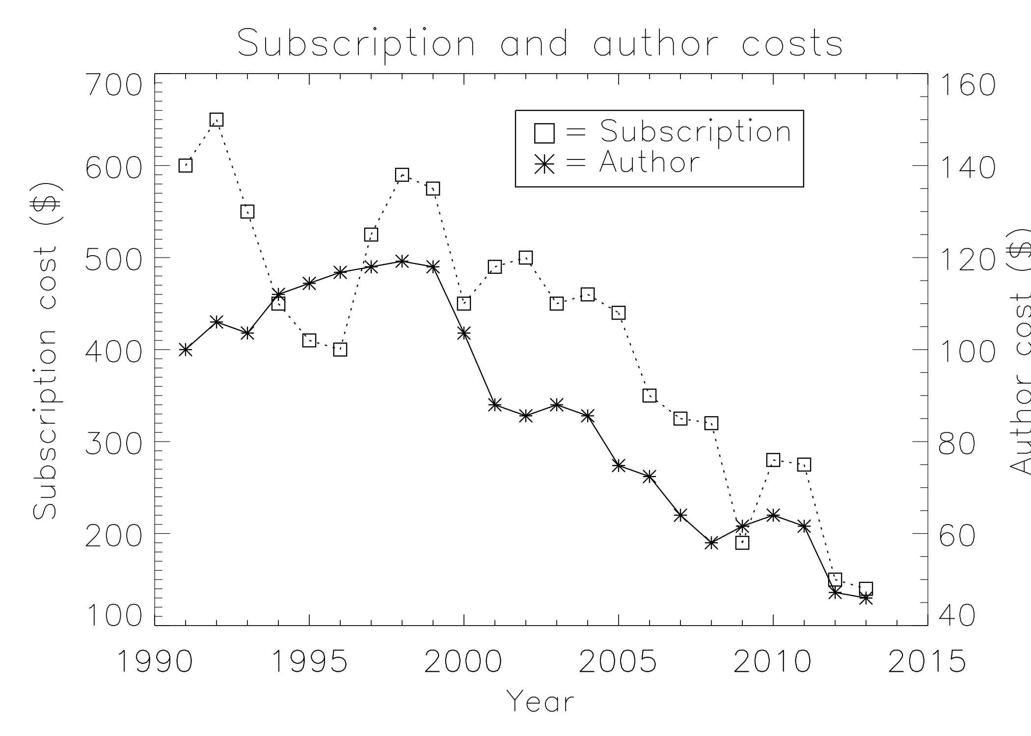
This is a caption
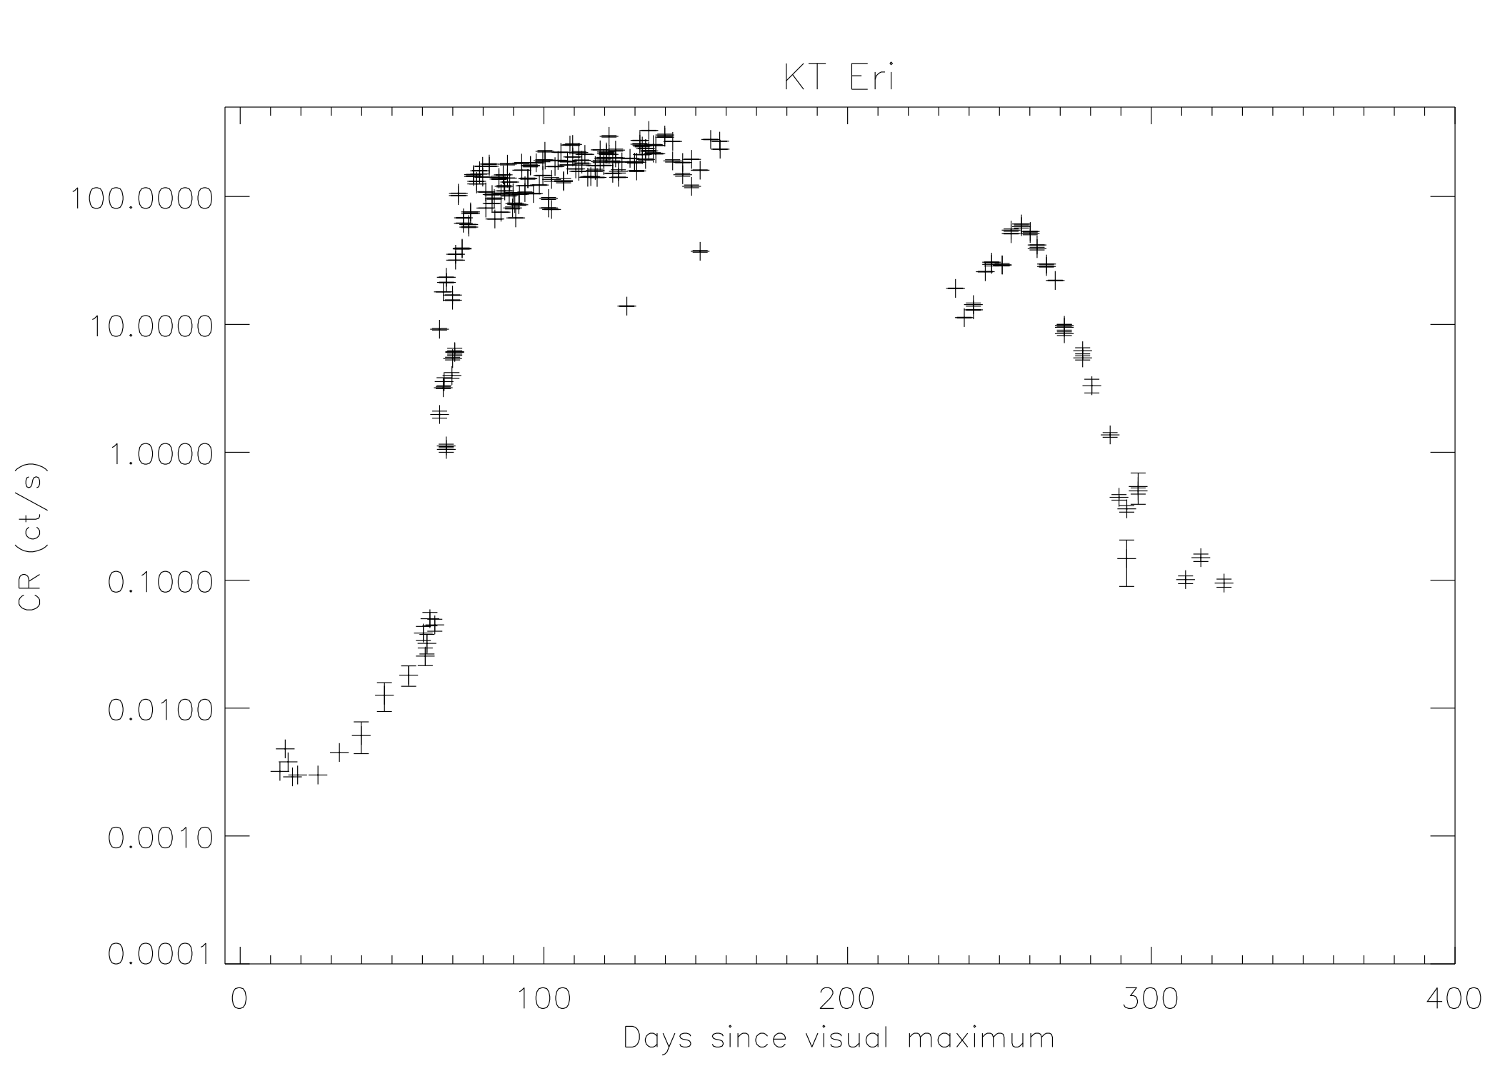
The Swift/XRT X-ray light curve for the first year after outburst of the suspected recurrent nova KT Eri. At a maximum count rate of 328 ct/s, KT Eri was the brightest nova in X-rays observed to date.
Authors are encouraged to use an online tool at http://authortools.aas.org/FIGSETS/make-figset.html to generate their own specific figure set mark up to incorporate into their LaTeX articles.

Animations
Authors may include animations in their articles. A single still frame from the animation should be included as a regular figure to serve as an example. The associated figure caption should indicate to the reader exactly what the animation shows and that the animation is available online.
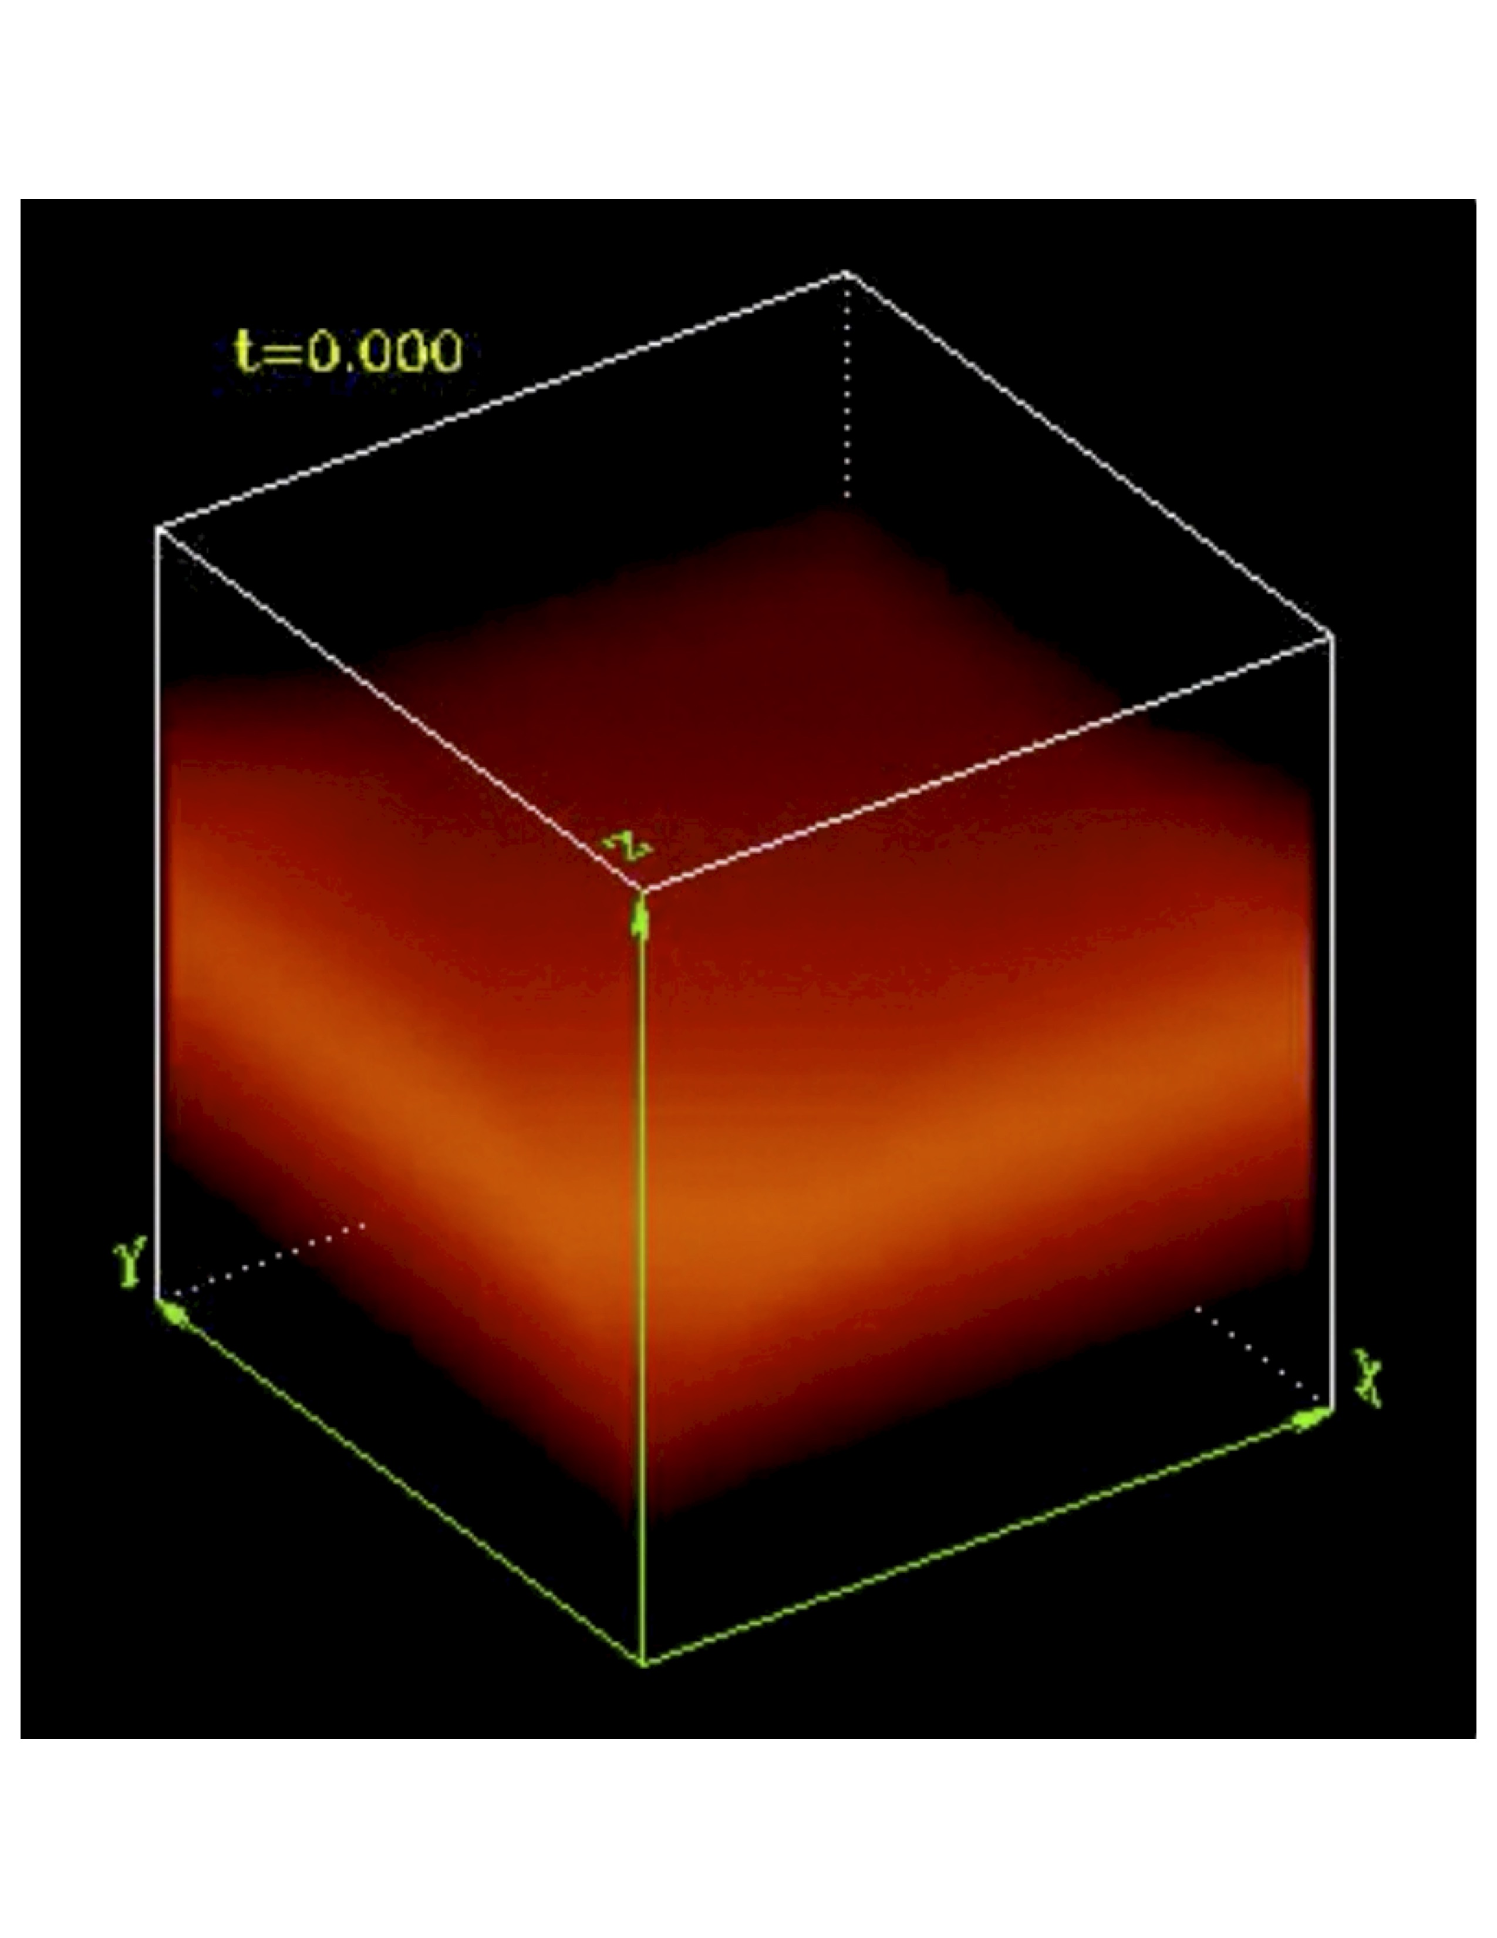
Example image from the animation which is available in the electronic edition.

Interactive figures
Interactive figures give the reader the ability to manipulate the information contained in an image which can add clarity or help further the author’s narrative. These figures consist of two parts, the figure file in a specific format and a javascript and html frame work that provides the interactive control. An example of an interactive figure is a 3D model. The underlying figure is a X3D file while x3dom.js is the javascript driver that displays it. An author created interface is added via a html wrapper. The first 3D model published by the AAS Journals using this technique was (“Apj, 793, 127” 2014). Authors should consult the online tutorials for more information on how to construct their own interactive figures.
As with animations authors should include a non-interactive regular figure to use as an example. The example figure should also indicate to the reader that the enhanced figure is interactive and can be accessed online.

Displaying mathematics
Mathematics can be displayed either within the text, e.g. $E=mc^{2}$, or separate from in an equation. In order to be properly rendered, all inline math text has to be declared by surrounding the math by dollar signs ($). A complex equation example with inline math as part of the explanation follows.
$$\overline{v}(p_{2},σ_{2})P_{−τ}{\overset{^}{a}}_{1}{\overset{^}{a}}_{2}⋯{\overset{^}{a}}_{n}u(p_{1},σ_{1}),$$
where $p$ and $σ$ label the initial $e^{±}$ four-momenta and helicities $(σ=±1)$, ${\overset{^}{a}}_{i}=a_{i}^{μ}γ_{ν}$ and $P_{τ}=\frac{1}{2}(1+τγ_{5})$ is a chirality projection operator $(τ=±1)$. This produces a single line formula. LaTeX will auto-number this and any subsequent equations. If no number is desired then the equation call should be replaced with displaymath .

Software and third party data repository citations
The AAS Journals would like to encourage authors to change software and third party data repository references from the current standard of a footnote to a first class citation in the bibliography. As a bibliographic citation these important references will be more easily captured and credit will be given to the appropriate people.
The first step to making this happen is to have the data or software in a long term repository that has made these items available via a persistent identifier like a Digital Object Identifier (DOI). A list of repositories that satisfy this criteria plus each one’s pros and cons are given at https://github.com/AASJournals/Tutorials/tree/master/Repositories.

Appendix information
Appendices can be broken into separate sections just like in the main text. The only difference is that each appendix section is indexed by a letter (A, B, C, etc.) instead of a number. Likewise numbered equations have the section letter appended. Here is an equation as an example.
$$I=\frac{1}{1+d_{1}^{P(1+d_{2})}}$$
Appendix tables and figures should not be numbered like equations. Instead they should continue the sequence from the main article body.

Author publication charges
Finally some information about the AAS Journal’s publication charges. In April 2011 the traditional way of calculating author charges based on the number of printed pages was changed. The reason for the change was due to a recognition of the growing number of article items that could not be represented in print. Now author charges are determined by a number of digital “quanta”. A single quantum is 350 words, one figure, one table, and one enhanced digital item. For the latter this includes machine readable tables, figure sets, animations, and interactive figures. The current cost is $27 per word quantum and $30 for all other quantum type.

Rotating tables
The process of rotating tables into landscape mode is slightly different in AASTeXv6.1. Instead of the rotate command, a new environment has been created to handle this task. To place a single page table in a landscape mode start the table portion with \begin\{rotatetable\} and end with \end\{rotatetable\} . Tables that exceed a print page take a slightly different environment since both rotation and long table printing are required. In these cases start with \begin\{longrotatetable} and end with \end\{longrotatetable} . Table ??? is an example of a multi-page, rotated table. While in the Authorea article view it looks like a normal table, it renders in lanscape mode when exported to PDF.
lllrrrrrrll CI Aql & 8.83 (1) & 2451665.5 (1) & 32 (2) & 2300 (3) & 0.8$±0.2$ (4) & 1.2e+22 & 0.62 (4) & 6.25$±5$ (4) & N & Y
CSS081007 & & 2454596.5 & & & 0.146 & 1.1e+21 & 1.77 (5) & 4.45$±1.95$ (6) & &
GQ Mus & 7.2 (7) & 2445352.5 (7) & 18 (7) & 1000 (8) & 0.45 (9) & 3.8e+21 & 0.059375 (10) & 4.8$±1$ (9) & N (7) &
IM Nor & 7.84 (11) & 2452289 (2) & 50 (2) & 1150 (12) & 0.8$±0.2$ (4) & 8e+21 & 0.102 (13) & 4.25$±3.4$ (4) & N & Y
KT Eri & 5.42 (14) & 2455150.17 (14) & 6.6 (14) & 3000 (15) & 0.08 (15) & 5.5e+20 & & 6.5 (15) & N & M
LMC 1995 & 10.7 (16) & 2449778.5 (16) & 15$±2$ (17) & & 0.15 (203) & 7.8e+20 & & 50 & &
LMC 2000 & 11.45 (18) & 2451737.5 (18) & 9$±2$ (19) & 1700 (20) & 0.15 (203) & 7.8e+20 & & 50 & &
LMC 2005 & 11.5 (21) & 2453700.5 (21) & 63 (22) & 900 (23) & 0.15 (203) & 1e+21 & & 50 & M (24) &
LMC 2009a & 10.6 (25) & 2454867.5 (25) & 4$±1$ & 3900 (25) & 0.15 (203) & 5.7e+20 & 1.19 (26) & 50 & N & Y
SMC 2005 & 10.4 (27) & 2453588.5 (27) & & 3200 (28) & & 5e+20 & & 61 & &
QY Mus & 8.1 (29) & 2454739.90 (29) & 60: & & 0.71 (30) & 4.2e+21 & & & M &
RS Oph & 4.5 (31) & 2453779.44 (14) & 7.9 (14) & 3930 (31) & 0.73 (32) & 2.25e+21 & 456 (33) & 1.6$±0.3$ (33) & N (34) & Y
U Sco & 8.05 (35) & 2455224.94 (35) & 1.2 (36) & 7600 (37) & 0.2$±0.1$ (4) & 1.2e+21 & 1.23056 (36) & 12$±2$ (4) & N & Y
V1047 Cen & 8.5 (38) & 2453614.5 (39) & 6 (40) & 840 (38) & & 1.4e+22 & & & &
V1065 Cen & 8.2 (41) & 2454123.5 (41) & 11 (42) & 2700 (43) & 0.5$±0.1$ (42) & 3.75e+21 & & 9.05$±2.8$ (42) & Y (42) &
V1187 Sco & 7.4 (44) & 2453220.5 (44) & 7: (45) & 3000 (44) & 1.56 (44) & 8.0e+21 & & 4.9$±0.5$ (44) & N &
V1188 Sco & 8.7 (46) & 2453577.5 (46) & 7 (40) & 1730 (47) & & 5.0e+21 & & 7.5 (39) & &
V1213 Cen & 8.53 (48) & 2454959.5 (48) & 11$±2$ (49) & 2300 (50) & 2.07 (30) & 1.0e+22 & & & &
V1280 Sco & 3.79 (51) & 2454147.65 (14) & 21 (52) & 640 (53) & 0.36 (54) & 1.6e+21 & & 1.6$±0.4$ (54) & Y (54) &
V1281 Sco & 8.8 (55) & 2454152.21 (55) & 15:& 1800 (56) & 0.7 (57) & 3.2e+21 & & & N &
V1309 Sco & 7.1 (58) & 2454714.5 (58) & 23$±2$ (59) & 670 (60) & 1.2 (30) & 4.0e+21 & & & &
V1494 Aql & 3.8 (61) & 2451515.5 (61) & 6.6$±0.5$ (61) & 1200 (62) & 0.6 (63) & 3.6e+21 & 0.13467 (64) & 1.6$±0.1$ (63) & N &
V1663 Aql & 10.5 (65) & 2453531.5 (65) & 17 (66) & 1900 (67) & 2: (68) & 1.6e+22 & & 8.9$±3.6$ (69) & N &
V1974 Cyg & 4.3 (70) & 2448654.5 (70) & 17 (71) & 2000 (19) & 0.36$±0.04$ (71) & 2.7e+21 & 0.081263 (70) & 1.8$±0.1$ (72) & N &
V2361 Cyg & 9.3 (73) & 2453412.5 (73) & 6 (40) & 3200 (74) & 1.2: (75) & 7.0e+21 & & & Y (40) &
V2362 Cyg & 7.8 (76) & 2453831.5 (76) & 9 (77) & 1850 (78) & 0.575$±0.015$ (79) & 4.4e+21 & 0.06577 (80) & 7.75$±3$ (77) & Y (81) &
V2467 Cyg & 6.7 (82) & 2454176.27 (82) & 7 (83) & 950 (82) & 1.5 (84) & 1.4e+22 & 0.159 (85) & 3.1$±0.5$ (86) & M (87) &
V2468 Cyg & 7.4 (88) & 2454534.2 (88) & 10: & 1000 (88) & 0.77 (89) & 1.0e+22 & 0.242 (90) & & N &
V2491 Cyg & 7.54 (91) & 2454567.86 (91) & 4.6 (92) & 4860 (93) & 0.43 (94) & 4.7e+21 & 0.09580: (95) & 10.5 (96) & N & M
V2487 Oph & 9.5 (97) & 2450979.5 (97) & 6.3 (98) & 10000 (98) & 0.38$±0.08$ (98) & 2.0e+21 & & 27.5$±3$ (99) & N (100) & Y (101)
V2540 Oph & 8.5 (102) & 2452295.5 (102) & & & & 2.3e+21 & 0.284781 (103) & 5.2$±0.8$ (103) & N &
V2575 Oph & 11.1 (104) & 2453778.8 (104) & 20: & 560 (104) & 1.4 (105) & 3.3e+21 & & & N (105) &
V2576 Oph & 9.2 (106) & 2453832.5 (106) & 8: & 1470 (106) & 0.25 (107) & 2.6e+21 & & & N &
V2615 Oph & 8.52 (108) & 2454187.5 (108) & 26.5 (108) & 800 (109) & 0.9 (108) & 3.1e+21 & & 3.7$±0.2$ (108) & Y (110) &
V2670 Oph & 9.9 (111) & 2454613.11 (111) & 15: & 600 (112) & 1.3: (113) & 2.9e+21 & & & N (114) &
V2671 Oph & 11.1 (115) & 2454617.5 (115) & 8: & 1210 (116) & 2.0 (117) & 3.3e+21 & & & M (117) &
V2672 Oph & 10.0 (118) & 2455060.02 (118) & 2.3 (119) & 8000 (118) & 1.6$±0.1$ (119) & 4.0e+21 & & 19$±2$ (119) & & M
V351 Pup & 6.5 (120) & 2448617.5 (120) & 16 (121) & & 0.72$±0.1$ (122) & 6.2e+21 & 0.1182 (123) & 2.7$±0.7$ (122) & N &
V382 Nor & 8.9 (124) & 2453447.5 (124) & 12 (40) & 1850 (23) & & 1.7e+22 & & & &
V382 Vel & 2.85 (125) & 2451320.5 (125) & 4.5 (126) & 2400 (126) & 0.05: (126) & 3.4e+21 & 0.146126 (127) & 1.68$±0.3$ (126) & N &
V407 Cyg & 6.8 (128) & 2455266.314 (128) & 5.9 (129) & 2760 (129) & 0.5$±0.05$ (130) & 8.8e+21 & 15595 (131) & 2.7 (131) & & Y
V458 Vul & 8.24 (132) & 2454322.39 (132) & 7 (133) & 1750 (134) & 0.6 (135) & 3.6e+21 & 0.06812255 (136) & 8.5$±1.8$ (133) & N (135) &
V459 Vul & 7.57 (137) & 2454461.5 (137) & 18 (138) & 910 (139) & 1.0 (140) & 5.5e+21 & & 3.65$±1.35$ (138) & Y (140) &
V4633 Sgr & 7.8 (141) & 2450895.5 (141) & 19$±3$ (142) & 1700 (143) & 0.21 (142) & 1.4e+21 & 0.125576 (144) & 8.9$±2.5$ (142) & N &
V4643 Sgr & 8.07 (145) & 2451965.867 (145) & 4.8 (146) & 4700 (147) & 1.67 (148) & 1.4e+22 & & 3 (148) & N &
V4743 Sgr & 5.0 (149) & 2452537.5 (149) & 9 (150) & 2400 (149) & 0.25 (151) & 1.2e+21 & 0.281 (152) & 3.9$±0.3$ (151) & N &
V4745 Sgr & 7.41 (153) & 2452747.5 (153) & 8.6 (154) & 1600 (155) & 0.1 (154) & 9.0e+20 & 0.20782 (156) & 14$±5$ (154) & &
V476 Sct & 10.3 (157) & 2453643.5 (157) & 15 (158) & & 1.9 (158) & 1.2e+22 & & 4$±1$ (158) & M (159) &
V477 Sct & 9.8 (160) & 2453655.5 (160) & 3 (160) & 2900 (161) & 1.2: (162) & 4e+21 & & & M (163) &
V5114 Sgr & 8.38 (164) & 2453081.5 (164) & 11 (165) & 2000 (23) & & 1.5e+21 & & 7.7$±0.7$ (165) & N (166) &
V5115 Sgr & 7.7 (167) & 2453459.5 (167) & 7 (40) & 1300 (168) & 0.53 (169) & 2.3e+21 & & & N (169) &
V5116 Sgr & 8.15 (170) & 2453556.91 (170) & 6.5 (171) & 970 (172) & 0.25 (173) & 1.5e+21 & 0.1238 (171) & 11$±3$ (173) & N (174) &
V5558 Sgr & 6.53 (175) & 2454291.5 (175) & 125 (176) & 1000 (177) & 0.80 (178) & 1.6e+22 & & 1.3$±0.3$ (176) & N (179) &
V5579 Sgr & 5.56 (180) & 2454579.62 (180) & 7: & 1500 (23) & 1.2 (181) & 3.3e+21 & & & Y (181) &
V5583 Sgr & 7.43 (182) & 2455051.07 (182) & 5: & 2300 (182) & 0.39 (30) & 2.0e+21 & & 10.5 & &
V574 Pup & 6.93 (183) & 2453332.22 (183) & 13 (184) & 2800 (184) & 0.5$±0.1$ & 6.2e+21 & & 6.5$±1$ & M (185) &
V597 Pup & 7.0 (186) & 2454418.75 (186) & 3: & 1800 (187) & 0.3 (188) & 5.0e+21 & 0.11119 (189) & & N (188) &
V598 Pup & 3.46 (14) & 2454257.79 (14) & 9$±1$ (190) & & 0.16 (190) & 1.4e+21 & & 2.95$±0.8$ (190) & &
V679 Car & 7.55 (191) & 2454797.77 (191) & 20: & & & 1.3e+22 & & & &
V723 Cas & 7.1 (192) & 2450069.0 (192) & 263 (2) & 600 (193) & 0.5 (194) & 2.35e+21 & 0.69 (195) & 3.86$±0.23$ (196) & N &
V838 Her & 5 (197) & 2448340.5 (197) & 2 (198) & & 0.5$±0.1$ (198) & 2.6e+21 & 0.2975 (199) & 3$±1$ (198) & Y (200) &
XMMSL1 J06 & 12 (201) & 2453643.5 (202) & 8$±2$ (202) & & 0.15 (203) & 8.7e+20 & & 50 & &

References
Lamport, L. 1994. “Latex: A Document Preparation System, 2nd Edition (Boston, Addison-Wesley Professional”.
1989.
2011.
2014.

http://www.latex-project.org/
see Section ??? in the Appendix for more details about how current article costs are calculated.

