COOKIES
charles iovine
kiersten konrardy
nicholas.hust
marc.dalce
mackenzie.failing

- There are many different types of cookies
- Cookies are yummy
- Whats your fav cookie?
- Chinese cookies_ come with a fortune
- bananas are egg substitutes
- Lactoast intolerant- no cookies
- cookies were invented in 1937 (chclte. chip)
- The word cookie comes from the dutch, early 18th century
- Cookies track you on the internet, make sure you eat more cookies.

Table of contents
- SUGAR COOKIES
- OATMEAL COOKIES
- CHOCOLATE CHIP COOKIES
- OREO’S COOKIES
- GINGER COOKIES

HEADING

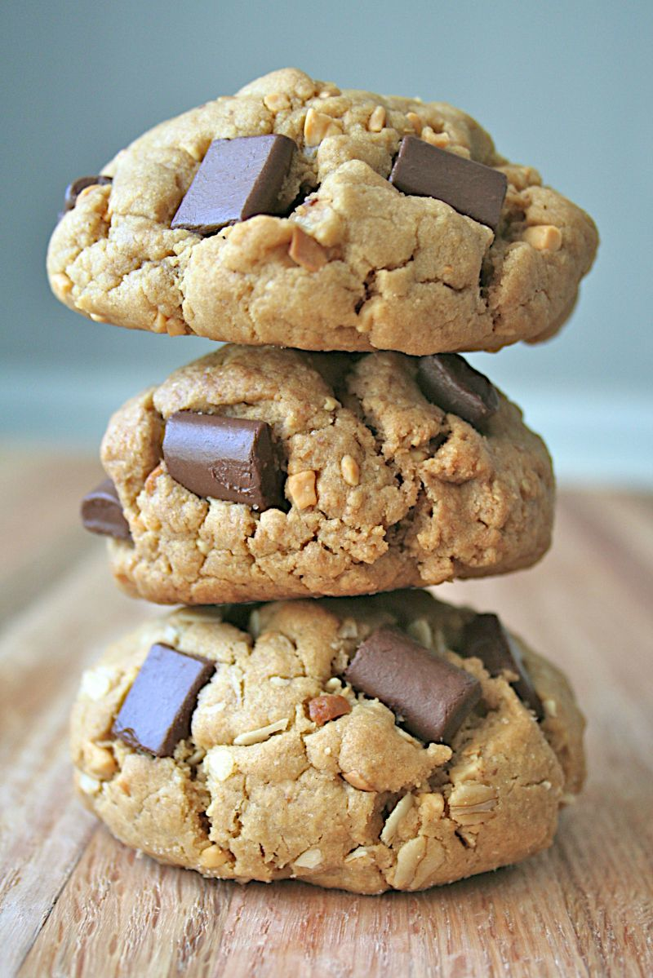
This is a caption

Graph
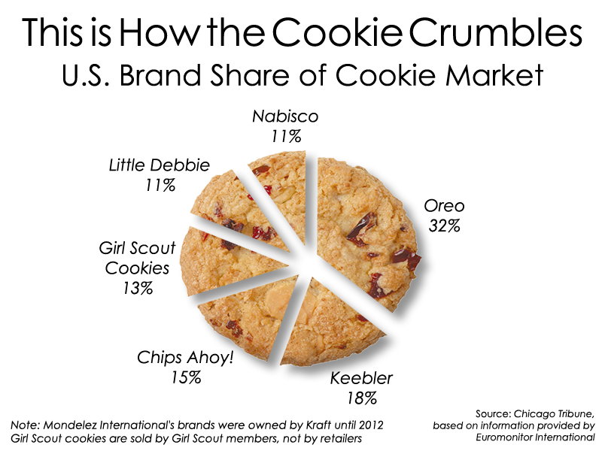
This is a caption
Chart
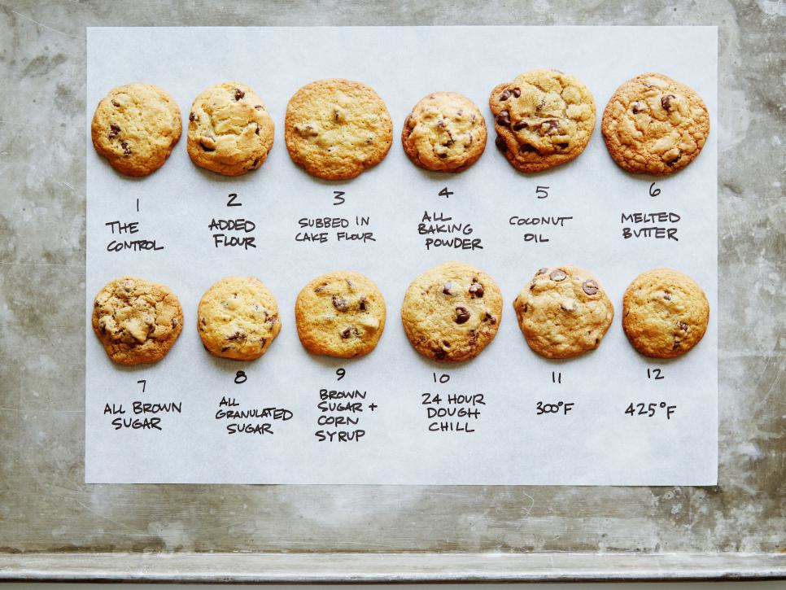
This is a caption

WORKS CITED
JFRIONFR
FBRJIW
FBDFGDRGDCOOKIESHXFHXFHFTHICKONESDHXFGHHZH
me

