Chinese Physics B Template
谭铭瑞
Carrier behavior in CuInS2 thin films on the and microsecond time scales is discussed in detail. The transient absorption data shows that the photo-generated carriers rapidly relax accompanied by energy change. The photo-generated charge carriers are extracted by a bias electric field (E) in the nanosecond transient system; moreover, E would improve the efficiency of photon conversion to charge carriers and enhance the velocity of extracted charge carriers. In addition, there is a threshold of illumination intensity in the extraction process of charge carriers in the CuInS2 thin film. There is carrier recombination if the illumination is higher than the threshold. The corresponding loss further increases with illumination intensity, and the recombination percentage is almost independent of E. The results are useful to further understand the characteristics of carriers in the CuInS2 thin film and are important for the operation of the corresponding devices.

Introduction
Metal sulfide thin films are bulk semiconductor films that have attracted much attention recently because of their many excellent advantages. Examples include CuS$, Cu2S$, ZnS$, CdS$, SnS$, FeS2$, Sb2S3$, CuAlS2$, Cu2BaS2$, CuInS2$, and Cu2ZnSnS4$. The synthesis process is easy to control and tune$ $, and the performance of the film is better than nanocrystal films. This is influenced by the surface ligands of the nanocrystal$. Therefore, metal sulfide thin films have huge potential in the fields of optoelectronic devices, including photo-voltage and photoconductive devices.
CuInS2 is a representative metal sulfide thin film with many superior characteristics, such as optimal bandgaps$, a large absorption coefficient$, and low toxicity$ . To further develop optoelectronic devices based on the CuInS2 thin films, studies of charge carrier behavior are important, including charge carrier generation, mobility, and recombination mechanisms. However, understanding of the carrier dynamics in the CuInS2 thin films remains limited and requires further study. These materials have an amorphous structure$ $, and the corresponding photo-physical properties have some difference with the nanocrystals. In addition, the carrier behavior in the inorganic semiconductor film is complicated and is affected by many factors. A single test method is not sufficient to analyze this process.
Here, we simultaneously applied femtosecond transient absorption and nanosecond transient photocurrent to test the carrier behavior in the CuInS2 thin films. Finally, we hope to further understand the carrier behavior occurring in the CuInS2 film and find intrinsic physical characteristics that are independent of the external condition.
Lorem ipsum dolor sit amet, consectetur adipiscing elit [1]. Cras egestas auctor molestie. In hac habitasse platea dictumst. Duis turpis tellus, scelerisque sit amet lectus ut, ultricies cursus enim. Integer fringilla a elit at fringilla. Lorem ipsum dolor sit amet, consectetur adipiscing elit. Nulla congue consequat consectetur. Duis ac mi ultricies, mollis ipsum nec, porta est. ${}_{12}^{4}C_{2}^{5+}$

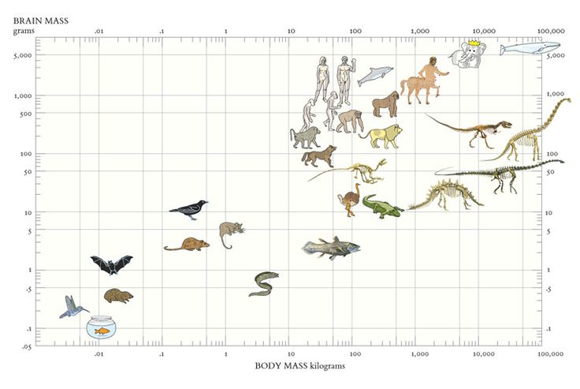
Pellentesque suscipit risus massa, non vestibulum libero euismod feugiat. In hac habitasse platea dictumst. Maecenas rutrum lobortis lobortis. Vestibulum convallis porttitor sem ac ultricies.
Mauris nec massa leo. Mauris ac diam auctor nisl imperdiet porta. Sed sit amet neque eget nisi dictum placerat. Duis sit amet pellentesque odio. Cras scelerisque sem a consectetur vehicula. Aliquam interdum luctus fringilla. Nunc sollicitudin, lorem in semper viverra, dui nisi sodales sem, ut condimentum erat leo eget arcu. Donec pharetra aliquam metus, non pulvinar tellus interdum a. Mauris a ante pharetra, mollis enim in, eleifend erat. Pellentesque suscipit risus massa, non vestibulum libero euismod feugiat. In hac habitasse platea dictumst. Maecenas rutrum lobortis lobortis. Vestibulum convallis porttitor sem ac ultricies. Mauris volutpat fringilla nisl blandit semper. Proin nec iaculis sem. Aenean neque ipsum, pretium a faucibus non, tincidunt ut sapien [2]; [3] .
Nunc a aliquet sem, eget aliquet purus. Vestibulum ac placerat mauris. Proin sed dolor ac justo semper iaculis. Donec varius, nibh sit amet finibus tristique, sapien ante interdum odio, et pretium sapien libero nec massa. In hac habitasse platea dictumst. Donec vel augue ac sapien imperdiet pretium. Maecenas gravida risus id ultricies dignissim. Maecenas gravida felis quis dolor faucibus, sed maximus lorem tristique. Nam hendrerit quam quis ante porta posuere. Fusce finibus maximus orci at porttitor. Nulla tempor ex a porttitor consequat. Quisque quis tempor eros. Donec nisi mauris, sollicitudin in dapibus eu, interdum ultricies quam Fig ???.

Section
Nunc a aliquet sem, eget aliquet purus. Vestibulum ac placerat mauris. Proin sed dolor ac justo semper iaculis. Donec varius, nibh sit amet finibus tristique, sapien ante interdum odio, et pretium sapien libero nec massa. In hac habitasse platea dictumst. Donec vel augue ac sapien imperdiet pretium. Maecenas gravida risus id ultricies dignissim. Maecenas gravida felis quis dolor faucibus, sed maximus lorem tristique $e^{iπ}+1=0$

Acknowledgements
Lorem ipsum dolor sit amet, consectetur adipiscing elit. Cras egestas auctor molestie. In hac habitasse platea dictumst. Duis turpis tellus, scelerisque sit amet lectus ut, ultricies cursus enim. Integer fringilla a elit at fringilla. Lorem ipsum dolor sit amet, consectetur adipiscing elit. Nulla congue consequat consectetur. Duis ac mi ultricies, mollis ipsum nec, porta est.

References
Zinszer K, Morrison K, Verma A and Brownstein J S 2017 Spatial Determinants of Ebola Virus Disease Risk for the West African Epidemic. PLoS Curr 9
[2] Zhou J, Xue Z, Du Z, Melese T and Boyer P D 1988 Relationship of tightly bound ADP and ATP to control and catalysis by chloroplast ATP synthase Biochemistry 27 5129–35
[3] Boyer P D 1998 Energy Life, and ATP (Nobel Lecture) Angewandte Chemie International Edition 37 2296–307

