DNA adductomics: Toward applications in biological effect assessment and environmental monitoring
Hitesh V. Motwani
Elena Gorokhova
March 12, 2024
Environmental contaminants induce adverse effects across biological levels, necessitating precise assessment tools. DNA adducts, which are chemical modifications to DNA, provide crucial insights into genomic effects and find broad applications in environmental toxicology and related fields. Liquid chromatography coupled with mass spectrometry (LC-MS) and, lately, with high-resolution mass spectrometry (HRMS), has emerged as the forefront technique for detecting and quantifying DNA adducts. HRMS allows comprehensive screening of adducts from diverse exposure classes, yielding detailed insights into modification types, chemical structures, and exposure diagnostics. This approach surpasses the constraints of classical assays, providing a superior omics perspective for understanding the impacts of contaminants on DNA. This opinion paper delves into the cutting-edge field of environmental adductomics, highlighting the emerging role of DNA adductome analysis in effect-based methods for monitoring and environmental health assessment. Discussed are target and non-target approaches for adduct identification, monitoring support and regulatory utilization, and showcasing the recent experience in surveying pollution impacts on DNA adductomes in wildlife. We suggest that DNA adductomics is a technologically mature, mechanism-based novel approach ready for adoption in environmental research and monitoring to facilitate a comprehensive assessment of environmental impacts.

Background
Effect-based monitoring and assessment. Conventional monitoring of hazardous chemicals in the environment focuses on specific priority substances, capturing only a fraction of these chemicals, and often missing those below detection limits that contribute to biological effects ¹. This approach, therefore, falls short in assessing subtle and complex impacts in diverse environmental conditions. Effect-based methods are crucial for directly evaluating biological impacts in environmental monitoring and status assessment ². By measuring responses at molecular or organismal levels, these methods enable early detection, identification of mixture effects, and a holistic understanding of ecosystem health ³. However, a lack of suitable biological data and uncertainties in ecological risk assessments pose challenges. There is an urgent demand for predictive tools, and the diverse capabilities of OMICS technologies (including genomics, transcriptomics, proteomics, lipidomics, metabolomics, and adductomics) are garnering attention for their potential to provide effective biomarkers.
DNA adductome monitoring: insights from the Swedish experience. Since 2017, DNA adductome analysis was conducted jointly with the Swedish National Marine Monitoring Program (SNMMP) in the Baltic Sea, using amphipods Monoporeia affinis and Pontoporeia femorata as sentinel species. In the context of SNMMP, the prevalence of embryo aberrations in sediment-dwelling amphipods serves as a key indicator of pollution effects. This indicator is based on the high sensitivity of embryo development to chemical exposure, leading to the manifestation of diverse developmental aberrations observable in gravid females ^{4,5} used to assess the biological effects of contaminants in the Baltic Sea ⁶. The measured embryo aberration rate serves as a specific health condition when evaluating the female DNA adductome, establishing baselines, and identifying biomarkers linked to an elevated risk of developmental disorders. Furthermore, the association between exposure and specific adductome profile can be categorized based on pollution loads in sediment at monitoring sites. Here, drawing from this experience, we offer insights into how DNA adductome can enhance the current effect-based assessment of biological effects in environmental monitoring.

DNA adductomics: advancing environmental monitoring
OMICS-based ecosurveillance. Current discussions center on integrating OMICS-based technologies into ecosurveillance monitoring frameworks. This integration aims to capture the comprehensive biological responses of ecosystems under perturbation ^{7,8}. These technologies and the data they provide have already enhanced our grasp of how environmental chemicals impact ecosystems and human health. However, despite progress, most environmental OMICS are currently in the data collection phase, with crucial gaps in linking toxicity data with OMICS endpoints ⁹. Future efforts are expected to address real environmental challenges, focusing on issues like chemical mixture toxicity, biomarker identification, baseline variability, and the development of approaches for deriving environmental quality standards from the OMICS data ^{10,11,12} towards more effective risk monitoring, and sustainable natural resource utilization ⁷.
DNA adductome - an exposome component. Adductomics, an emerging research field, provides structural insights into chemical exposures and serves as a platform for discovering biomarkers to identify both the occurrence of exposure and associated effects. DNA adductomics, one of the newest OMICS techniques, is particularly well suited for assessing exposure and effects of environmental contaminants ¹³ and elucidating genotoxic and epigenetic changes due to chemical stressors. However, whereas the DNA adductome approach is well-established in human toxicology due to its direct relevance to human health ^{14,15}, its use in environmental studies has been limited despite the wide acceptance of DNA adducts as exposure biomarkers in wildlife.
DNA adducts are well-established biomarkers in (eco)toxicology. They are chemical modifications occurring when certain chemicals bind covalently to DNA molecules (Figure 1). Unrepaired DNA adducts can disrupt DNA structure and function, potentially leading to mutations and adverse biological effects ¹⁶. These adducts are associated with health issues, reproductive toxicity, genotoxicity, and epigenetic alterations in humans and wildlife. For the last 50 years, DNA adducts have been used as biomarkers of exposure in environmental toxicology, where the focus has mainly been on the adducts derived from polycyclic aromatic hydrocarbons (PAHs) in fish and mussels as exposure biomarkers ^{17,18}. In environmental toxicology, PAHs have been most commonly linked to DNA adduct formation ^{19,20,21}, both in the laboratory and in field observations after oil spills. However, other contaminants have also been found to induce DNA modifications ^{22,23}. Also, in amphipods, abundant epigenetic DNA modifications have been associated with contaminated environments ²⁴ and females that carry embryos with various developmental disorders ²⁵. Thus, ample evidence supports the informative value of detecting and quantifying DNA adducts in biological samples for assessing contaminant exposure and genomic effects.

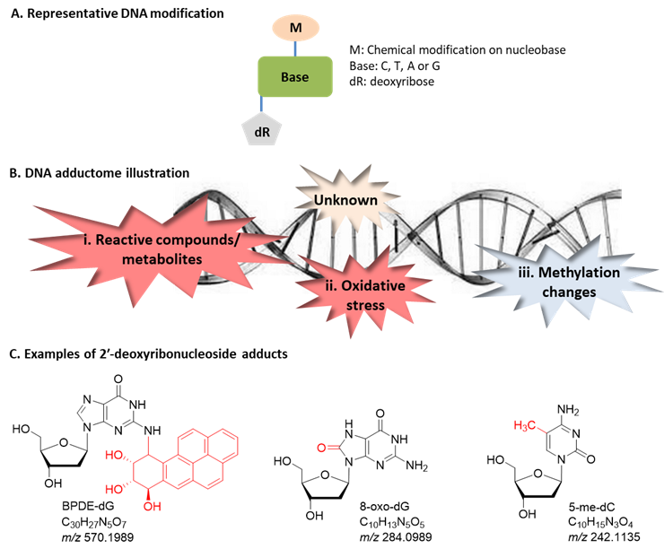
The adductome refers to the complete set of chemical DNA modifications, known as adducts, illustrated by a representative modification in (A) and depicted as a whole in (B). These alterations stem from various processes: i. Binding of nucleophilic sites on the nucleobases ²⁶ with electrophilic reactive compounds, e.g., diol epoxide metabolites of benzo[a]pyrene (BPDE), leading to DNA-BPDE adduct (measured as BPDE-dG ²⁷). ii. Reactive oxygen species (ROS) giving oxidized adducts; most common is oxidation on C8 position of guanine (measured as 8-oxo-dG ²⁵). ROS can also lead to oxidation of lipids, giving lipid peroxidation (LPO) products that can bind to DNA giving DNA-LPO adducts ²⁸. If unrepaired, adducts from electrophilic species and ROS can lead to mutagenesis increasing the risk of genotoxic effects. iii. Epigenetic changes such as methylation of 5C-cytosine (measured as 5-me-dC ²⁵); these are non-genotoxic, but with possible developmental effects. iv. Unknown adducts observed using non-targeted analysis, yet to be structurally identified ²⁴. 2′-Deoxyribonucleoside adducts (modification to the DNA marked in red) exemplified in (C), with respective molecular formula and calculated mass-to-charge (m/z) ratio of their protonated molecular ions.
Traditional analytical methods for DNA adducts. The detection of DNA adducts has commonly been conducted using immunochemical ²⁹ and ³²P-postlabelling ³⁰ assays. Although useful, these assays do not provide chemical or structural information about the adducts to trace back to specific exposures. Moreover, these techniques have significant limitations: the immunochemical method is not sensitive enough to detect DNA adducts at trace levels and requires an antibody to each chemical. Albeit highly sensitive, ³²P-postlabelling entails the use of radioactive phosphorus, posing safety concerns and regulatory challenges ³¹. Additionally, the method is labor-intensive and further complicated by highly variable labeling efficiency ³². Presently, researchers must adhere to stringent safety protocols for handling radioactive materials and waste disposal, resulting in a gradual decline in laboratories willing to conduct these measurements. Moreover, key limitations include the scarcity of information on the detected DNA adduct structure and occasional co-migration of adducts on the thin layer chromatography plate ³³. These challenges collectively impede the chemical structural characterization and identification of the adducts.
A novel approach to measure old biomarker. Nowadays, one of the most powerful techniques for detecting and quantifying DNA adducts is liquid chromatography-mass spectrometry (LC-MS). Using high-resolution mass spectrometry (HRMS), sensitive and selective analytical methods for detecting and identifying DNA adducts in the genome have been developed ³⁴ and successfully applied in human health research ^{31,35} and ecotoxicological ^{25,24} diagnostics of adverse effects due to chemical exposure. Instead of analyzing a few adducts from a specific chemical exposure (i.e., bottom-up approach), HRMS gives the possibility to screen for DNA adducts from multiple classes of exposure, an “adductomics” approach. Thus, this is a new OMICS approach, with both target and non-targeted analytical methods available to comprehensively investigate the adductome via screening for all known and unknown adducts in the genome (i.e., top-down approach). Various modification types, e.g., bulky PAH-adducts, methylation and oxidation, can be analyzed in a single sample by HRMS, including the determination of their chemical structures, which is useful for exposure diagnostics ^{14,15}. Thus, the current capacity for DNA adduct characterization is superior to the classical assays, advocating this OMICS approach to detect and monitor the biological effects of contaminants ²⁴.

Methodology
Using various cell types and matrices, several DNA adductomics methods based on LC-HRMS have been developed for applications in human toxicology ^{36,37,38}. These developments are poised to be applicable to any biological sample and allow proposing a workflow for low- and high-mass DNA adduct analysis in wildlife as a part of ecotoxicological surveillance ²⁴.
Test organisms. Any plant or animal tissue is suitable for the analysis, including the whole body (for small-sized planktonic and benthic animals as well as embryos), blood, liver and muscle tissues. If fertilized eggs or embryos are present in small specimens, they should be dissected out and either analyzed separately or not included in the female DNA samples to avoid the natural ontogenetic variability in the epigenetic DNA modifications related to embryogenesis ²⁵. In fish, liver and muscle tissues are commonly used as test tissues, and more work is needed to identify target tissues and organs for specific adducts if we are to improve the diagnostic properties of the method.
Brief methodological description. The workflow consists of three primary steps (Figure 2):
- DNA extraction and enzymatic digestion, which yield the 2′-deoxyribonucleoside adducts and unmodified 2′-deoxyribonucleosides, follow the established protocol ²⁵. A sample (specific tissues or a whole body for small organisms) is homogenized using a method of choice. For DNA extraction, we recommend a fast and easy method using Chelex 100, an ion exchange resin serving as a chelating agent in binding polyvalent metal ions ³⁹, which yields a high amount of DNA ⁴⁰. Briefly, a suspension of Chelex 100 is added to the sample homogenate and heated to release nucleic acids. After centrifugation, the resulting supernatant is utilized for digestion. Commonly, the enzymatic digestion is applied using nuclease P1 and snake venom phosphodiesterase I, releasing 5’-mono-phosphate nucleosides, which are dephosphorylated by alkaline phosphatase yielding the nucleosides for analysis, i.e., 2′-deoxyribonucleoside adducts and unmodified 2′-deoxyribonucleosides ²⁵. The digested samples can be stored at −20 °C until analysis by LC-HRMS.
- Liquid chromatography HRMS analysis and data processing, including the bottom-up (targeted) and the top-down (untargeted) approaches. The bottom-up approach targets anticipated DNA adducts from known or expected exposure agents. Consequently, the common drawback of this approach is that adducts from unknown chemical exposure and endogenous processes may not be captured. Therefore, the comprehensive characterization of the adducts induced by known and unknown exogenous exposures and by secondary biological responses leading to adduct formation (endogenous exposure) requires a top-down adductomics approach. Typically, reversed phase chromatography coupled to an Orbitrap HRMS instrumentation in the positive ionization mode can be used for this purpose, employing data-dependent acquisition with an inclusion list or data-independent acquisition; note that MS-based methods for DNA adductomics analysis are reviewed elsewhere ⁴¹. The resulting high-resolution accurate mass (HRAM) data allows for increased selectivity due to the ability to differentiate the adduct ion signals from isobaric background ions. Screening for DNA adducts takes advantage of the common structural feature of 2′-deoxyribonucleosides, which is a deoxyribose moiety bound to the nucleobase through a glycosidic bond. The product ion spectra of 2′-deoxyribonucleoside adducts include cleavage of the glycosidic bond with a neutral loss of deoxyribose and leading to protonated nucleobase adducts ⁴². The accurate mass measurements further provide sufficient information to determine the molecular formula of the adduct analytes, which are useful in the structural characterization of the adducts and identifying the chemical exposure leading to the adduct formation. The mass of the adduct indicates its structure and identifies the chemical. This strategy identifies the modified nucleobase and the covalently bound chemical but does not identify the modified gene. Recently, open-source databases ^{43,44} and software ^{45,46} were developed to support adduct identification and characterization by processing large and complex MS files for non-targeted adduct detection. In particular, an open-source software nLossFinder for peak screening ⁴⁶ and non-targeted DNA adduct detection based on the characteristic neutral loss (deoxyribose moiety, 116.0474 Da) with high mass accuracy (± 5 ppm) and without any prior knowledge of the adducts. To reduce false positives, data filtering is performed using retention time alignment, accurate mass window, MS/MS fragments and any associated metadata available. The output data are normalized peak areas for specific adducts that can be used for the downstream statistical evaluations (Figure 3). More specifically, the measured MS-peak area of each adduct is normalized to that of 2′-deoxyguanosine from the same LC-HRMS run, which circumvents differences in DNA concentration between the individual samples and for any DNA loss during sample preparation. The data format is typically a matrix, with adduct relative abundance and samples (i.e., individuals) given in columns and rows or vice-versa.
- Statistical analysis for the DNA adductome of each sentinel species used for monitoring purposes should include the following steps: (1) screening the output data to exclude non-varying adducts; (2) identification of the background variability; and (3) evaluation of the test samples against the background variability (i.e., reference state). Similar to metabolomics biomarkers, the task is to reduce the high-dimensional data to only a small number of statistically significant features, that are often chemically identified—where each feature corresponds to a mass-to-charge ratio, retention time, and intensity. However, currently, there are no established methods for deriving environmental quality standards from the OMICS data ^{10,11,12}; therefore, different approaches should be evaluated and compared using data for different species and environmental settings.
.
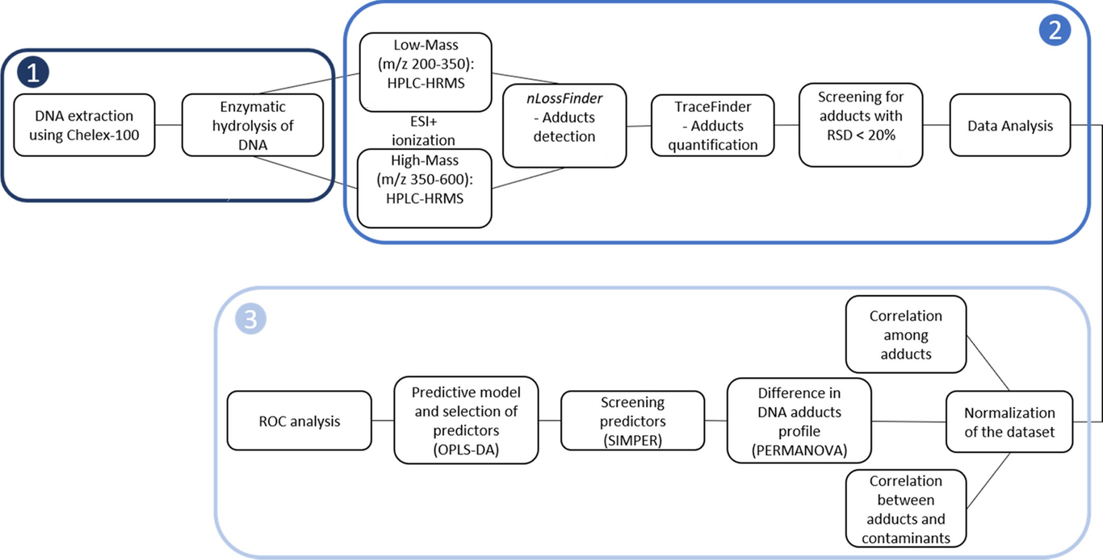
Workflow of the DNA adductome analysis, including sample preparation (1), HRMS analysis and data processing (2), and an example of a statistical evaluation (3) performing permutational multivariate analysis of variance (PERMANOVA), similarity percentage analysis (SIMPER), orthogonal partial least squares discriminant analysis (OPLS-DA), and receiver operating characteristic (ROC) analysis to link specific adducts to the chemical exposure. Modified from ²⁴.
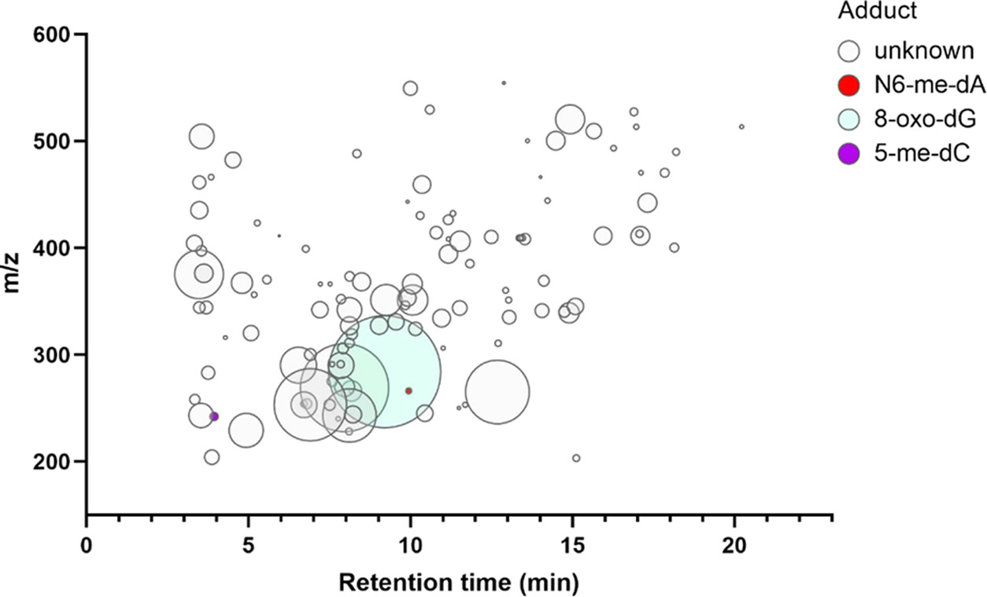
An example of the output data for the relative peak intensity for characterised and uncharacterised DNA adducts identified in the adductome of the amphipod Monoporeia affinis, a sentinel species in the Swedish National Marine Monitoring Programme. The data represent the adductome profile of a single individual. Modified from ⁴⁷
Quality assurance (QA) and quality control (QC) of adductomics analysis. QA and QC protocols should be followed to control and minimize fluctuations and biases that can affect the LC-HRMS adductomics workflow and data quality. The QA and QC guidelines developed for metabolomics ^{48,49,50} are applicable in assessing system performance and reporting the adductomics data due to the conceptual similarities in the techniques and workflows. Availability of reference standards corresponding to various 2′-deoxyribonucleoside adducts spanning over a wide range of chromatographic retention times and mass-to-charge ratios (m/z) is crucial to evaluate the performance of the analytical system in terms of mass error, shift in chromatographic retention time, peak shape and MS-fragmentation efficiency. Other important parameters to ensure the reliability and accuracy of analytical results are instrument calibration, method validation, evaluation of quality control samples, data quality assessment, batch-to-batch consistency, as well as personnel training and documentation. By implementing a comprehensive QC/QA program, laboratories can enhance the reliability, reproducibility, and validity of the adductome data, which are essential for the consistency of the environmental assessment and comparability of the results in longitudinal data sets.
Statistical considerations, targets and background variability for exposure assessment. To establish the baseline variability of the DNA adductome for a target tissue/species (and, possibly, a population), replicate samples of single specimens for each assessment site are needed. Based on our experience with amphipods, about 15-20 individuals per site are sufficient when only females in the reproductive stage are considered ²⁵. However, species with a larger or lower inter-individual variability in unimpacted sites may require a larger sample size.
Before evaluating data in relation to the contaminants and other health parameters, some QC checks are conducted, using, e.g., Principal Component Analysis (PCA) as a checkpoint to screen for outlier data points and obtain a global perspective of the data ⁵¹. All single adducts are evaluated for variability and those showing less than 1 % variation across the samples are omitted from the further analyses. Also, adducts that are present in less than 5 % of the samples are omitted.
The data are evaluated using two-tier diagnostics with standard multivariate approaches for omics data ⁵².
- First, the primary adductome data output is used to (1) define the variability of the data originating from unimpacted sites and/or healthy specimens (i.e., the target space in the multivariate ordination; Figure 4); (2) assess the predicted class membership or score to evaluate if the test sample aligns with the background samples; and (3) estimate the proportion of the test samples that do not align with the background samples. For that, a Partial Least Squares-Discriminant Analysis (PLS-DA), a supervised method that combines aspects of PCA and discriminant analysis, and, in particular, its upgraded version called OPLS-DA (orthogonal PLS-DA) is recommended (Figure 4B). For the environmental status assessment, we suggest applying the following principle: if more than 50% of the test samples from a site/area are classified as not belonging to the reference group, the site is considered as deviating significantly from the unimpacted state in terms of the DNA adduct composition and relative abundance.
- Second, the test samples that do not align with the reference adductome for the species/population in question are subjected to the analysis of individual variability of the influential adducts; the latter are identified by the PLS-DA model and ROC (Receiver Operating Curve) analysis (Figure 5). Once the PLS/OPLS-DA model is built, the VIP (variable influence of projection) measure can be obtained for the adducts based on their association with the identified predictive components. Each of these adducts may permit the identification of exposures to certain hazardous chemicals in the environment with a unique diagnostic value. For each individual adduct, the same principle as for many other biomarkers ⁵³ can be used by defining the background assessment criteria (BAC) as the 90th percentile of the relative abundance of this adduct in the areas regarded as less polluted reference areas. Bootstrapping (100 000 runs) can be used to derive mean, median and 90th percentile values. The significant deviations of the influential adducts from the corresponding BAC values should be reported to facilitate the interpretation of the overall DNA adductome response.

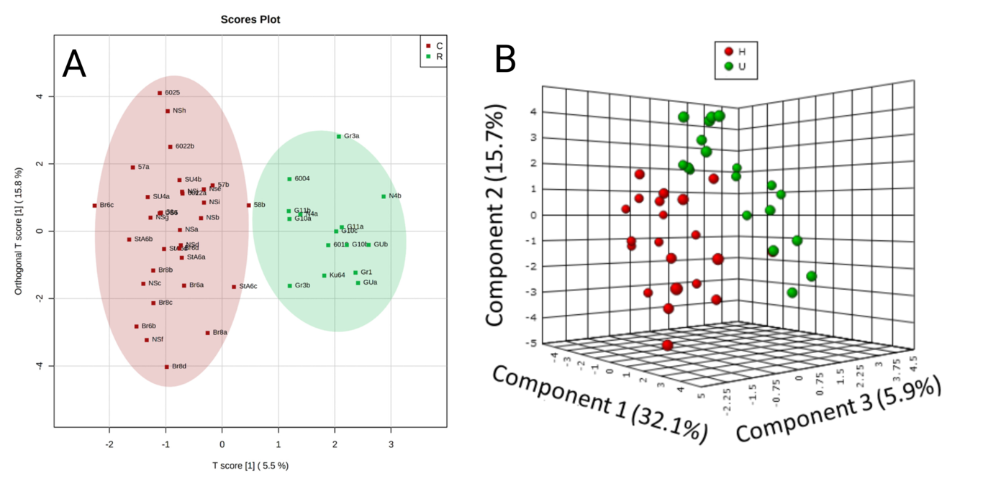
An example of PLS-DA for DNA adductome profile in the amphipod Monoporeia affinis from different sites in the Baltic Sea (A); modified from ²⁴. The data points represent the samples collected in the stations classified as contaminated (C; red) or reference (R; green); the labels indicate the station codes. In this example, none of the samples collected from the contaminated stations aligned with the ordination space of the reference samples. The B-panel shows a separation based on the DNA adductome between field-collected females carrying different proportions of embryos with developmental aberrations and classified as Healthy (H: aberration frequency is less than 5 %) and Unhealthy (U: up to 60 %); modified from ²⁵.
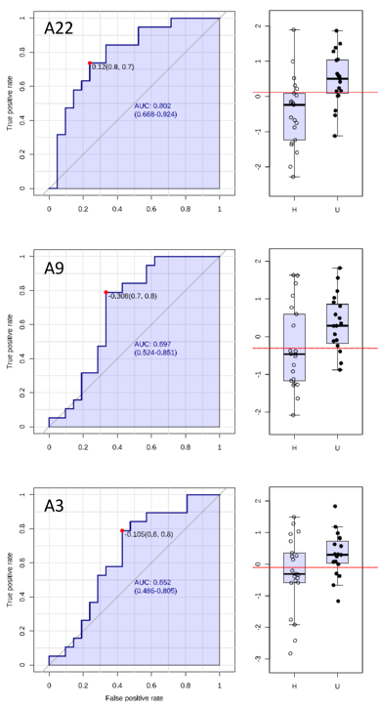
An example of the single adduct evaluation using the area under the receiver operating characteristic (ROC) curve (AUC) logistic regression approach for discrimination between the amphipod females with low (H: Healthy) and high (U: unhealthy) embryo aberration frequency. For each of the three discriminating adducts, the left panel shows the AUC confidence interval, true positive and false positive rates, and confidence interval (CI), the right panel shows the normalized values for the adducts in healthy and unhealthy individuals. AUC logistic regression approach identified adducts A22 ( N⁶-Methyl-2′-deoxyadenosine, N⁶-me-dA; AUC = 0.802), A9 (uncharacterized adduct; AUC = 0.697), and A3 (5-Methyl-2′-deoxycytidine, 5-me-dC; AUC = 0.652) to have the greatest specificity and sensitivity in relation to the developmental pathologies in these amphipods. The logistic regression based on these adducts had 80 and 85 % classification accuracy for predicting unimpacted and impacted animals, respectively; modified from ²⁵.

Looking ahead
DNA adductomics is a new research area that offers structural insights into chemical modifications of the nucleic acids and a platform for the discovery of exposure and effect biomarkers. One of the main challenges for introducing DNA adductome analysis in environmental monitoring is the complexity and variability of environmental exposures. Moving forward, we need to prioritize the structural identification of these modifications, establishing connections between candidate DNA adducts and potential causative chemicals or metabolites. Moreover, identifying potential exposures to elucidate responses across various species is crucial. Simultaneously, experimental studies are essential to validate the relationships between specific adducts, exposure agents, and health outcomes, which requires controlled exposure systems to establish critical levels of adduct biomarkers based on toxicity data.
In a recent development, we introduced a novel approach for concurrent RNA and DNA adductomics utilizing a single injection on LC-Orbitrap HRMS instrumentation ⁵⁴, with the simultaneous detection of RNA adducts, measured through modified ribonucleosides, and DNA adducts, measured through modified 2′-deoxyribonucleosides. RNA molecules play multiple roles in cellular function, serving not only as genetic materials but also providing structural support and catalyzing essential functions within cells. Similar to DNA and due to the nucleophilicity of their nucleobases, RNA molecules are susceptible to reacting with electrophilic species, leading to adduct formation. In cases of toxic adduction, the adducted RNA has been associated with a variety of diseases in humans ⁵⁵. However, despite being evident and detectable, the physiological and pathological functions of RNA adduction remain poorly understood and virtually nothing is known about pathological responses in non-mammalian species. To validate the efficacy of this multi-adductomics workflow, we conducted a proof-of-principle study ⁵⁴, demonstrating its application in the analysis of amphipod RNA and DNA adducts. The discovery of new RNA modifications opens new venues in understanding their biological significance for transcriptome and the impact of contaminants on the adductome, which can support future applications of specific adducts as molecular biomarkers in environmental monitoring. Thus, analyzing both DNA and RNA in adductome studies would provide a more comprehensive understanding of the molecular impacts of exposure to various agents and on different time scales.
Regional monitoring programmes should consider the diverse analytical goals (targeted or untargeted), varying DNA amounts in the sentinel species, distinct DNA adduct levels, and considerations like the nature of adducts (hydrophobic vs hydrophilic) and instrument availability when designing the sampling scheme. Consequently, thoughtful consideration of these factors is essential to determine the most suitable approach for a given context. Continued improvements in mass spectrometry and other analytical techniques will enhance the sensitivity, selectivity, and speed of DNA adduct detection. To this end, centralized facilities allow for efficient use of resources, both in terms of equipment and personnel. This can lead to cost-effectiveness and a more streamlined approach to handling the complexities associated with DNA adduct analysis. Moreover, designated facilities are more likely to adhere to recognized standards and guidelines in DNA adduct analysis, and compliance with established protocols enhances the credibility and acceptance of the generated data in scientific and regulatory contexts. Finally, centralized facilities often encourage collaboration among researchers, laboratories, and institutions. This collaborative environment facilitates the exchange of knowledge, expertise, and best practices, driving forward the field of environmental DNA adductomics.

Conclusions
Environmental omics, including nucleic acid adductomics, can provide valuable biomarkers for assessing exposure to environmental contaminants and effects. It is applicable to virtually any organism possessing DNA and requires only a few micrograms of DNA per sample. Incorporating DNA adductomics into the existing biomarker batteries would be a much-needed tool for the early detection of genome-level alterations in wildlife and represent a significant advancement in environmental health assessment.
The DNA adductomics workflow described here demonstrates that the technology is ready to integrate DNA adductome screening in large-scale environmental monitoring targeting wildlife. We can screen and process data for low-mass adducts, such as epigenetic marks or oxidative adducts, and high-mass bulky adducts, providing a broad range of detectable adducts for environmental assessment. Open-source databases and software are available, allowing the screening of individual samples even for small-bodied animals with high mass accuracy and at reasonable costs. Additionally, the raw files are routinely archived and can be re-processed at any time to obtain more information from a single sample.
In environmental monitoring programmes, opting for designated facilities for DNA adduct analysis where the analytical process is conducted by skilled professionals using cutting-edge equipment, software, and databases. Relying on designated facilities ensures data accuracy, reliability, and archival and thus promotes data consistency and comparability across different regions, species and monitoring initiatives. All of these aspects are crucial for the success of monitoring initiatives aimed at assessing DNA modifications due to environmental exposures.

References
(1) Vermeulen, R.; Schymanski, E. L.; Barabási, A.-L.; Miller, G. W. The Exposome and Health: Where Chemistry Meets Biology. Science 2020, 367 (6476). https://doi.org/10.1126/science.aay3164.
(2) Neale, P. A.; Escher, B. I.; de, B. M. L.; Dechesne, M.; Dingemans, M. M. L.; Enault, J.; Pronk, G. J.; Smeets, P. W. M. H.; Leusch, F. D. L. Application of Effect-Based Methods to Water Quality Monitoring: Answering Frequently Asked Questions by Water Quality Managers, Regulators, and Policy Makers.. Environ Sci Technol 2023, 57, 6023–6032.
(3) Parmar, T. K.; Rawtani, D.; Agrawal, Y. K. Bioindicators: the Natural Indicator of Environmental Pollution. Frontiers in Life Science 2016, 9 (2). https://doi.org/10.1080/21553769.2016.1162753.
(4) Reutgard, M.; Eriksson Wiklund, A.-K.; Breitholtz, M.; Sundelin, B. Embryo Development of the Benthic Amphipod Monoporeia Affinis as a Tool for Monitoring and Assessment of Biological Effects of Contaminants in the Field: A Meta-Analysis. Ecological Indicators 2014, 36. https://doi.org/10.1016/j.ecolind.2013.08.021.
(5) Sundelin, B.; A.-K., E. Malformations in Embryos of the Deposit-Feeding Amphipod Monoporeia Affinis in the Baltic Sea. Marine Ecology Progress Series 1998, 171, 165–180.
(6) Löf, M.; Sundelin, B.; Bandh, C.; Gorokhova, E. Embryo Aberrations in the Amphipod Monoporeia Affinis as Indicators of Toxic Pollutants in Sediments: A Field Evaluation. Ecological Indicators 2016, 60. https://doi.org/10.1016/j.ecolind.2015.05.058.
(7) Beale, D. J.; Jones, O. A. H.; Bose, U.; Broadbent, J. A.; Walsh, T. K.; van, de K. J.; Bissett, A. Omics-Based Ecosurveillance for the Assessment of Ecosystem Function, Health, and Resilience.. Emerg Top Life Sci 2022, 6, 185–199.
(8) Bahamonde, P. A.; Feswick, A.; Isaacs, M. A.; Munkittrick, K. R.; Martyniuk, C. J. Defining the Role of Omics in Assessing Ecosystem Health: Perspectives from the Canadian Environmental Monitoring Program.. Environ Toxicol Chem 2016, 35, 20–35.
(9) Machuca-Sepúlveda, J.; Miranda, J.; Lefin, N.; Pedroso, A.; Beltrán, J. F.; Farias, J. G. Current Status of Omics in Biological Quality Elements for Freshwater Biomonitoring.. Biology (Basel) 2023, 12.
(10) Henke, A. N.; Chilukuri, S.; Langan, L. M.; Brooks, B. W. Reporting and Reproducibility: Proteomics of Fish Models in Environmental Toxicology and Ecotoxicology. Sci Total Environ 2023, 912, 168455.
(11) Machuca-Sepúlveda, J.; Miranda, J.; Lefin, N.; Pedroso, A.; Beltrán, J. F.; Farias, J. G. Current Status of Omics in Biological Quality Elements for Freshwater Biomonitoring. Biology (Basel) 2023, 12.
(12) Ebner, J. N. Trends in the Application of Omics to Ecotoxicology and Stress Ecology. Genes (Basel) 2021, 12.
(13) Lockridge, O. Overview of Adductomics in Toxicology.. Curr Protoc 2023, 3, e672.
(14) Balbo, S.; Turesky, R. J.; Villalta, P. W. DNA Adductomics. Chem Res Toxicol 2014, 27, 356–366.
(15) Villalta, P. W.; Balbo, S. The Future of DNA Adductomic Analysis. Int J Mol Sci 2017, 18.
(16) Phillips, D. H.; Arlt, V. M. Genotoxicity: Damage to DNA and Its Consequences. In Molecular, Clinical and Environmental Toxicology; Birkhäuser Basel, 2009; pp 87–110. https://doi.org/10.1007/978-3-7643-8336-7_4.
(17) Pampanin, D. M.; Brooks, S. J.; Grøsvik, B. E.; Le, G. J.; Meier, S.; Sydnes, M. O. DNA Adducts in Marine Fish as Biological Marker of Genotoxicity in Environmental Monitoring: The Way Forward. Mar Environ Res 2017, 125, 49–62.
(18) Dolcetti, L.; Zuanna, L. D.; Venier, P. DNA Adducts in Mussels and Fish Exposed to Bulky Genotoxic Compounds. Mar Environ Res 2002, 54, 481–486.
(19) Skarphédinsdóttir, H.; Ericson, G.; Svavarsson, J.; Naes, K. DNA Adducts and Polycyclic Aromatic Hydrocarbon (PAH) Tissue Levels in Blue Mussels (Mytilus Spp.) from Nordic Coastal Sites.. Mar Environ Res 2007, 64, 479–491.
(20) Amat, A.; Pfohl-Leszkowicz, A.; Burgeot, T.; Castegnaro, M. DNA Adducts as a Biomarker of Pollution: Field Study on the Genotoxic Impact. Evolution of the Erika Oil Spill on Mussels (Mytilus Edulus) over a Period of Eleven Months. Polycyclic Aromatic Compounds 2004, 24 (4–5). https://doi.org/10.1080/10406630490472338.
(21) Meier, S.; Karlsen, Ø.; Le, G. J.; Sørensen, L.; Sørhus, E.; Pampanin, D. M.; Donald, C. E.; Fjelldal, P. G.; Dunaevskaya, E.; Romano, M.; et al. DNA Damage and Health Effects in Juvenile Haddock (Melanogrammus Aeglefinus) Exposed to PAHs Associated with Oil-Polluted Sediment or Produced Water.. PLoS One 2020, 15, e0240307.
(22) Guilherme, S.; Gaivão, I.; Santos, M. A.; Pacheco, M. DNA Damage in Fish (Anguilla Anguilla) Exposed to a Glyphosate-Based Herbicide – Elucidation of Organ-Specificity and the Role of Oxidative Stress. Mutation Research/Genetic Toxicology and Environmental Mutagenesis 2012, 743 (1–2). https://doi.org/10.1016/j.mrgentox.2011.10.017.
(23) Manzetti, S. Ecotoxicity of Polycyclic Aromatic Hydrocarbons, Aromatic Amines, and Nitroarenes through Molecular Properties. Environmental Chemistry Letters 2012, 10, 349–361.
(24) Martella, G.; Gorokhova, E.; Sousa, P. F. M.; Tretyakova, N. Y.; Sundelin, B.; Motwani, H. V. DNA Adductomics for the Biological Effect Assessment of Contaminant Exposure in Marine Sediments. Environ Sci Technol 2023, 57, 10591–10603.
(25) Gorokhova, E.; Martella, G.; Motwani, N. H.; Tretyakova, N. Y.; Sundelin, B.; Motwani, H. V. DNA Epigenetic Marks Are Linked to Embryo Aberrations in Amphipods. Sci Rep 2020, 10, 655.
(26) Motwani, H. V.; Eriksson, L.; Göpfert, L.; Larsen, K. Reaction Kinetic Studies for Comparison of Mutagenic Potency between Butadiene Monoxide and Glycidamide.. Chem Biol Interact 2018, 288, 57–64.
(27) Motwani, H. V. DNA as an in Vitro Trapping Agent for Detection of Bulky Genotoxic Metabolites. Journal of Chromatography B 2020, 1152. https://doi.org/10.1016/j.jchromb.2020.122276.
(28) Łuczaj W, S. E. DNA Damage Caused by Lipid Peroxidation Products. Cell Mol Biol Lett. 2003, 8(2):391-413..
(29) Müller, R.; Adamkiewicz, J.; Rajewsky, M. F. Immunological Detection and Quantification of Carcinogen-Modified DNA Components.. IARC Sci Publ 1982, 463–479.
(30) Poirier, M. C.; Santella, R. M.; Weston, A. Carcinogen Macromolecular Adducts and Their Measurement.. Carcinogenesis 2000, 21, 353–359.
(31) BH, Y.; Guo, J.; Bellamri, M.; Turesky, R. J. DNA Adducts: Formation, Biological Effects, and New Biospecimens for Mass Spectrometric Measurements in Humans. Mass Spectrom Rev 2020, 39, 55–82.
(32) Totsuka, Y.; Fukutome, K.; Takahashi, M.; Takahashi, S.; Tada, A.; Sugimura, T.; Wakabayashi, K. Presence of N2-(Deoxyguanosin-8-Yl)-2-Amino-3,8-Dimethylimidazo[4,5-f]Quinoxaline (DG-C8-MeIQx) in Human Tissues. Carcinogenesis 1996, 17 (5), 1029–1034. https://doi.org/10.1093/carcin/17.5.1029.
(33) Phillips, D. H.; Arlt, V. M. The 32P-Postlabeling Assay for DNA Adducts. Nature Protocols 2007, 2 (11). https://doi.org/10.1038/nprot.2007.394.
(34) Hemeryck, L. Y.; Moore, S. A.; Vanhaecke, L. Mass Spectrometric Mapping of the DNA Adductome as a Means to Study Genotoxin Exposure, Metabolism, and Effect. Analytical Chemistry 2016, 88 (15). https://doi.org/10.1021/acs.analchem.6b00863.
(35) Totsuka, Y.; Watanabe, M.; Lin, Y. New Horizons of DNA Adductome for Exploring Environmental Causes of Cancer. Cancer Sci 2021, 112, 7–15.
(36) Balbo, S.; Hecht, S. S.; Upadhyaya, P.; Villalta, P. W. Application of a High-Resolution Mass-Spectrometry-Based DNA Adductomics Approach for Identification of DNA Adducts in Complex Mixtures.. Anal Chem 2014, 86, 1744–1752.
(37) Guo, J.; Villalta, P. W.; Weight, C. J.; Bonala, R.; Johnson, F.; Rosenquist, T. A.; Turesky, R. J. Targeted and Untargeted Detection of DNA Adducts of Aromatic Amine Carcinogens in Human Bladder by Ultra-Performance Liquid Chromatography-High-Resolution Mass Spectrometry.. Chem Res Toxicol 2018, 31, 1382–1397.
(38) Hemeryck, L. Y.; Van, H. T.; Vossen, E.; De, S. S.; Vanhaecke, L. DNA Adductomics to Study the Genotoxic Effects of Red Meat Consumption with and without Added Animal Fat in Rats.. Food Chem 2017, 230, 378–387.
(39) Walsh, P. S.; Metzger, D. A.; Higushi, R. Chelex 100 as a Medium for Simple Extraction of DNA for PCR-Based Typing from Forensic Material. BioTechniques 10(4): 506-13 (April 1991). Biotechniques 2013, 54, 134–139.
(40) Phillips, K.; McCallum, N.; Welch, L. A Comparison of Methods for Forensic DNA Extraction: Chelex-100® and the QIAGEN DNA Investigator Kit (Manual and Automated). Forensic Sci Int Genet 2012, 6, 282–285.
(41) Guo, J.; Turesky, R. J. Emerging Technologies in Mass Spectrometry-Based DNA Adductomics.. High Throughput 2019, 8.
(42) Balbo, S.; Turesky, R. J.; Villalta, P. W. DNA Adductomics.. Chem Res Toxicol 2014, 27, 356–366.
(43) La, B. G.; Nommesen, K. D.; Cuparencu, C.; Stanstrup, J.; Dragsted, L. O. A Comprehensive Database for DNA Adductomics.. Front Chem 2022, 10, 908572.
(44) Guo, J.; Turesky, R. J.; Tarifa, A.; DeCaprio, A. P.; Cooke, M. S.; Walmsley, S. J.; Villalta, P. W. Development of a DNA Adductome Mass Spectral Database. Chemical Research in Toxicology 2020, 33 (4). https://doi.org/10.1021/acs.chemrestox.0c00031.
(45) Walmsley, S. J.; Guo, J.; Murugan, P.; Weight, C. J.; Wang, J.; Villalta, P. W.; Turesky, R. J. Comprehensive Analysis of DNA Adducts Using Data-Independent WSIM/MS(2) Acquisition and WSIM-City.. Anal Chem 2021, 93, 6491–6500.
(46) Sousa, P. F. M.; Martella, G.; Åberg, K. M.; Esfahani, B.; Motwani, H. V. NLossFinder-A Graphical User Interface Program for the Nontargeted Detection of DNA Adducts. Toxics 2021, 9.
(47) Martella, G. DNA Adductomics: Method Development and Integration in Biological Effect Monitoring. PhD thesis, http://su.diva-portal.org/smash/record.jsf?pid=diva2%3A1752375&dswid=-6434, 2023.
(48) Dudzik, D.; Barbas-Bernardos, C.; García, A.; Barbas, C. Quality Assurance Procedures for Mass Spectrometry Untargeted Metabolomics. a Review.. J Pharm Biomed Anal 2018, 147, 149–173.
(49) Broadhurst, D.; Goodacre, R.; Reinke, S. N.; Kuligowski, J.; Wilson, I. D.; Lewis, M. R.; Dunn, W. B. Guidelines and Considerations for the Use of System Suitability and Quality Control Samples in Mass Spectrometry Assays Applied in Untargeted Clinical Metabolomic Studies. Metabolomics 2018, 14, 72.
(50) Beger, R. D.; Dunn, W. B.; Bandukwala, A.; Bethan, B.; Broadhurst, D.; Clish, C. B.; Dasari, S.; Derr, L.; Evans, A.; Fischer, S.; et al. Towards Quality Assurance and Quality Control in Untargeted Metabolomics Studies. Metabolomics 2019, 15, 4.
(51) Anwardeen, N. R.; Diboun, I.; Mokrab, Y.; Althani, A. A.; Elrayess, M. A. Statistical Methods and Resources for Biomarker Discovery Using Metabolomics. BMC Bioinformatics 2023, 24, 250.
(52) Brereton, R. G. Multivariate Classification Models. Journal of Chemometrics 2021, 35 (12). https://doi.org/10.1002/cem.3332.
(53) Hylland, K.; Robinson, C. D.; Burgeot, T.; Martínez-Gómez, C.; Lang, T.; Svavarsson, J.; Thain, J. E.; Vethaak, A. D.; Gubbins, M. J. Integrated Chemical and Biological Assessment of Contaminant Impacts in Selected European Coastal and Offshore Marine Areas. Mar Environ Res 2017, 124, 130–138.
(54) Martella, G.; Motwani, N. H.; Khan, Z.; Sousa, P. F. M.; Gorokhova, E.; Motwani, H. V. Simultaneous RNA and DNA Adductomics Using Single Data-Independent Acquisition Mass Spectrometry Analysis.. Chem Res Toxicol 2023, 36, 1471–1482.
(55) Zhou, M.; Wang, D. O.; Li, W.; Zheng, J. RNA Adduction Derived from Electrophilic Species in Vitro and in Vivo.. Chem Biol Interact 2022, 351, 109748.

