Understanding Brainwaves and effect of music on Brainwaves: a Review
Mahaveer Suthar
The purpose of this paper is to provide a clear Understanding of Brainwaves and effect of music on Brainwaves. This paper provides a brief description of what Brainwaves are? And a study of types of Brainwaves and their benefits. This paper also gives details of studies related to Effect of music on Brainwaves.

1.Introduction
At the root of all our thoughts, emotions and behaviours is the communication between neurons within our brains. Brainwaves are produced by synchronised electrical pulses from masses of neurons communicating with each other. Brainwaves are detected using sensors placed on the scalp. They are divided into bandwidths to describe their functions, but are best thought of as a continuous spectrum of consciousness; from slow, loud and functional - to fast, subtle, and complex. Our brainwaves change according to what we’re doing and feeling. When slower brainwaves are dominant we can feel tired, slow, sluggish, or dreamy. The higher frequencies are dominant when we feel wired, or hyper-alert.

2.Understanding Brainwaves

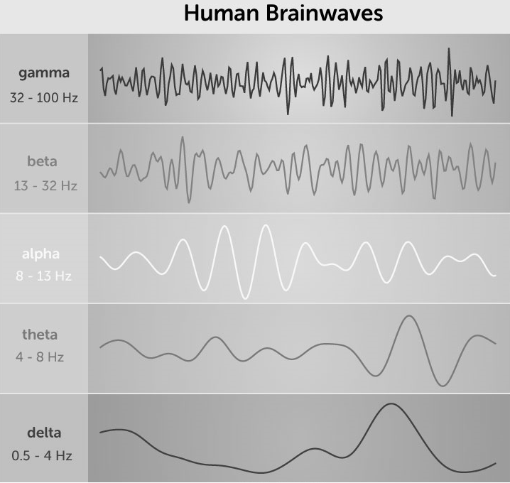
Chart of Gamma, Beta, Alpha, Theta, and Delta Brainwaves[1](“Chart of Brainwaves”, n.d.)

THE 5 MAIN TYPES OF BRAINWAVE FREQUENCIES
Different patterns of brainwaves can be recognized by their amplitudes and frequencies. Brainwaves can then be categorized based on their level of activity or frequency. It’s important to remember, though, that brainwaves are not the source or the cause of brain states, or of our experiences of our own minds – they’re just some of the detectable reflections of the complex processes in the brain that produce our experience of being, thinking, and perceiving.
- Slow activity refers to a lower frequency and high amplitude (the distance between two peaks of a wave). These oscillations are often much larger in amplitude (wave depth). Think: low, the deep beat of a drum.
- Fast activity refers to a higher frequency and often smaller amplitude. Think: high pitched flute.
I. GAMMA BRAINWAVES
- Frequency: 32 – 100 Hz
- Associated state: Heightened perception, learning, problem-solving tasks
- Gamma brainwaves are the fastest measurable EEG brainwaves and have been equated to ‘heightened perception’, or a ‘peak mental state’ when there is simultaneous processing of information from different parts of the brain. Gamma brainwaves have been observed to be much stronger and more regularly observed in very long-term meditators including Buddhist Monks. [2],[3]
II. BETA BRAINWAVES
- Frequency: 13-32 Hz
- State: Alert, normal alert consciousness, active thinking
- Beta brainwaves are easiest to detect when we’re busy thinking actively. [2],[3]
III. ALPHA BRAINWAVES
- Frequency: 8-13 Hz
- State: Physically and mentally relaxed
- Alpha brainwaves are some of the most easily observed and were the first to be discovered. They become detectable when the eyes are closed and the mind is relaxed. They can also often be found during activities such as:
- Yoga
- Just before falling asleep
- Being creative and artistic [2],[3]
IV. THETA BRAINWAVES
- Frequency: 4-8 Hz
- State: Creativity, insight, dreams, reduced consciousness
- According to Professor of Sydney University, “previous studies have shown that theta waves indicate deep relaxation and occur more frequently in highly experienced meditation practitioners. The source is probably frontal parts of the brain, which are associated with monitoring of other mental processes.”
- Most frequently, theta brainwaves are strongly detectable when we’re dreaming in our sleep (think, the movie Inception), but they can also be seen during :
- Deep meditation
- Daydreaming
When we’re doing a task that is so automatic that the mind can disengage from it e.g. brushing teeth, showering. Research has also shown a positive association of theta waves with memory, creativity and psychological well-being. [2],[3],[4],[5]
V. DELTA BRAINWAVES
- Frequency: 0.5-4 Hz
- State: Sleep, dreaming
- These are the slowest of all brainwaves and are strongest when we are enjoying a restorative sleep in a dreamless state. This is also the state where healing and rejuvenation are stimulated, which is why it’s so crucial to get enough sleep each night. [2],[3],[4],[5]

BENEFITS OF INCREASING DELTA BRAINWAVES
State of empathy - Delta brainwaves can provide you with the ability to read other peoples emotions and determine their feelings at unconscious levels. In healthy amounts, delta brainwaves cause a person to have an advanced state of empathy, understanding, and compassion for others. If you are always able to relate to others and can “read other people’s minds,” you probably have more delta than the average person. If you find yourself getting into trouble for not being considerate enough or for “stepping on other people’s toes,” you may have less overall delta brainwave activity. [6]
Advanced healing of body and mind - The delta brainwave rhythm is known to completely rejuvenate, replenish, and heal the entire body and brain. The delta brainwave revives the body after a hard day by regenerating necessary chemicals while a person is asleep. Due to the deepest levels of relaxation that the delta brainwave provides, the body and mind are easily able to restore themselves after minor stress, a rigorous workout, or after boosting your brain power. [6]
Human Growth Hormone (H.G.H.) Release - The delta brainwave is associated with the stimulation of the pituitary gland, which in-turn, is able to release humangrowth-hormone — commonly referred to as H.G.H. It doesn’t release enough for you to skyrocket in height and weight. The delta brainwave will not provide adults with a second version of puberty. With that said, there is evidence that it does release slight amounts of H.G.H. in certain individuals. If you are looking to increase your H.G.H., you should definitely consider using delta brainwave entrainment and evaluate how it works out for you! [6]

THE BENEFITS OF INCREASING THETA BRAINWAVES
Sleep and Dreaming - Theta brain waves are slow and relaxing brainwaves that are usually associated with us when we sleep and are dreaming. Located in the right hemisphere of the brain, they usually arise when we are dreaming, sleepy, emotional, relaxed or daydreaming. Although we all possess theta brain waves, they are most commonly accessible for people that struggle with ADD, or those that dream in a very relaxed state. Artists are known to have frequent theta brain waves as well as any other highly creative individual. Whenever we are really and truly relaxed, dreaming in a deep slumber or creatively thinking, we may be utilizing theta brain waves. [6]
Musicians, sculptors and artists - Since theta brain waves operate at a much slower rate, there are many benefits to our emotional state of mind. It’s unlikely that many adults will experience theta brain waves during their waking hours, but many children two and under experience it on an ongoing basis. Children have the ability to feel relaxed at all times (except when they cry) but as adults, our brain is usually experiencing alpha or beta brain waves. When we sleep and are totally relaxed, we can easily experience theta brain waves. Musicians, sculptors and artists of many genres are able to experience more theta brain waves than other individuals. This is because they tap into theta brain waves as a way to become creative when there ‘artistic juices’ have run out . [6]

HOW CAN ONE INCREASE ANY TYPE OF BRAINWAVE
Through Meditation - The goal of many meditation practices is to increase the amount of slower brainwave patterns. Usually, after practice, meditators are able to become consciously aware in the alpha, and possibly the theta brainwave ranges. It takes a rigorous amount of meditation and dedication to become consciously aware during the delta brainwave state. After you gain a lot of meditation experience, you can eventually learn how to shift your brainwaves from the beta range, through the pleasant calmness of alpha, into the extraordinary theta range. If you get lucky, you’ll eventually cultivate awareness in the delta range. Experienced meditators are able to recognize and control their state of awareness and brainwaves. Like any practice, the more you do it, the better your chances of passing through the alpha brainwave range, into theta, and from theta into the delta brainwave rhythm. [6]
Conscious Stages
- When we are consciously awake, our brain waves are going at 13-40 Hz, which is known as Beta brain waves.
- When we are mediation or in a deep relaxed state, our Alpha brain waves measure at 7-13 Hz.
- When we are dreaming, our Theta brain waves measure out at 4-7 Hz, which accounts for a deep 8 relaxation that no other level of our brain waves can match. This accounts for many benefits for both of mind and body. [6]

3. Effect of Music on Brainwaves
Music is known to affect different states of the human mind, for example, in calming one’s mind and leading to a blissful state. In this study, the effect of music on the states of human mind is examined by observing the changes in the alpha and beta brainwaves patterns. These changes are compared for ‘attention’ and ‘meditation’ state of mind.
Conducted studies on Music effects -
- The effects of music, especially Mozart’s music, on plants were studied in [7].
- Studies related to subjective reactions to musical stimuli [8]
- The influence of a preceding music on the subject’s music processing [9]
- Music can also reduce the impact of certain diseases such as insomnia, blood pressure, sympathetic nervous system activity, attention deficit disorder/hyperactivity disorder and heart/respiratory rates [10].
- A study on music therapy had established that both the right and left hemispheres of the brain are involved in the music creation and listening [11].
- Another study on the effect of music on the overall well-being of a person, highlighted that self-selection of the music according to the person’s choice is more likely to have a positive effect on the person [12].
- In a study on the effect of sound on EEG, two experiments were performed using the alpha brainwave to examine the effects of Sonata/metal music and rock / ‘Nasyid’ music on 30 subjects [13].
- Other studies involved the cognitive function of the brain in patients with chronic schizophrenia [14]
- Study of sleeping patterns which established that music change the way a person thinks, feels, expresses and uses the brain [15].
- Furthermore, brainwaves are also used to control the physical movement of a wheelchair or a robot which are of immense improvement to the mobility of patients with certain disabilities [16], [17], [18].

4. Conclusion
A Preliminary Study on the Effects of Music on Human Brainwaves shows that listening to live violin music may help in improving a person with left- hand side dominance to increase their right-hand side dominance by increasing balance between both brain hemispheres[19]. Brain waves are relevant to mental health, as abnormalities in brain functioning can influence the development of certain conditions. For example, when certain areas of the brain are over-aroused, an individual may experience anxiety, nightmares or other sleep problems, impulsivity, and aggression. Meditation can increase Theta and Alpha waves which are very important in learning and empathy. Furthermore, research is needed to exactly know which type of Music is beneficial to a certain person for increasing his/her brainwaves.

5. References
[1]Chart of Brainwaves https://i0.wp.com/archesnews.com/wp-content/uploads/2015/12/BrainWaves.jpg
[2] R. G. Morris, M. Fillenz, and A. Dickenson, Neuroscience: Science of the brain. Liverpool: British Neuroscience Association, 1995, ch. 14,p. 39.
[3] J. Robbins, A symphony in the brain: The evolution of the new brainwave biofeedback, revised ed. New York: Grove Press, 2008, ch. 1, pp. 2–3, (context: types of brainwaves).
[4] Buzsáki, G. (2002). Theta Oscillations in the Hippocampus. Neuron, [online] 33(3), pp.325-340. Available at: https://www.sciencedirect.com/science/article/pii/S089662730200586X
[5] White, N. (1999). Theories of the Effectiveness of Alpha-Theta Training for Multiple Disorders. Introduction to Quantitative EEG and Neurofeedback. pp 341-367. Available at: https://www.sciencedirect.com/science/article/pii/B9780122437908500146
[6] Jeffrey L. Fannin, Ph.D. UNDERSTANDING YOUR BRAINWAVES http://drjoedispenza.com/files/understanding-brainwaves_white_paper.pdf
[7] D. Retallack, The sound of music and plants. 1641 Lincoln Blvd.,Santa Monica, CA: DeVorss abd Co. Publishers, 1973, ch. 1, p. 15.
[8] J. L. Walker, “Subjective reactions to music and brainwave rhythms,”Physiological Psychology, vol. 5, no. 4, pp. 483–489, 1977.
[9] S. Koelsch, T. Gunter, A. D. Friederici, and E. Schröger, “Brain indices of music processing: Non-musicians are musical,” Journal of Cognitive Neuroscience, vol. 12, no. 3, pp. 520–541, 2000.
[10] K. Habe, “Neuropsychology of music–a rapidly growing branch of psychology,” in Proceedings of Horizons of Psychology, vol. 19, pp.79– 98, 2010.
[11] A. A. Trevisan and L. Jones, “Brain music system: Brain music therapy based on real-time sonified brain signals,” in Proceedings of IET Seminaron Assisted Living, vol. 1, 2011.
[12] Nusrat and B. A. Bhat, “Effect of music listening on health and wellbeing: A study based on kashmiri population,” International Journal inManagement and Social Science, vol. 3, no. 3, pp. 416–420, 2015.
[13] R. Bhoria and S. Gupta, “A study of the effect of sound on eeg,” International Journal of Electronics and Computer Science Engineering,vol. 2, no. 1, pp. 88–99, 2012.
[14] M. Kwon, M. Gang, and K. Oh, “Effect of the group music therapy on brain wave, behavior, and cognitive function among patients with chronic schizophrenia,” Asian nursing research, vol. 7, no. 4, pp. 168– 174, 2013.
[15] I. Joshua and N. Fauzan, “Brainwave patterns based on musical preferences and sleeping patterns,” Journal of Scientific Research andDevelopment, vol. 2, no. 13, pp. 139–146, 2015.
[16] ] K. H. Solanki and H. Pujara, “Brainwave controlled robot,” International Research Journal of Engineering and Technology (IRJET), vol. 2, pp.609–612, 2015 .
[17] S. Ramesh, K. Harikrishna, and J. K. Chaitanya, “Brainwave controlled robot using bluetooth,” International Journal of Advanced Research in Electrical, Electronics and Instrumentation Engineering, vol. 3, no. 8,pp. 11572–11578, 2014.
[18] L. Thunuguntla, R. N. V. Mohan, and P. Mounika, “Eeg based brain controlled robot,” International Journal of Engineering Research and Applications, vol. 4, no. 4, pp. 195–198, 2014.
[19] V. Straticiuc, I. E. Nicolae, R. Strungaru, T. M. Vasile, O. A. Băjenaru, G. M. Ungureanu, “A preliminary study on the effects of music on human brainwaves”, Electronics Computers and Artificial Intelligence (ECAI) 2016 8th International Conference on, pp. 1-4, 2016.

References
n.d. https://i0.wp.com/archesnews.com/wp-content/uploads/2015/12/BrainWaves.jpg. https://i0.wp.com/archesnews.com/wp-content/uploads/2015/12/BrainWaves.jpg.

