premature graying of hair
sukhvir singh
pigments responsible for hair colour

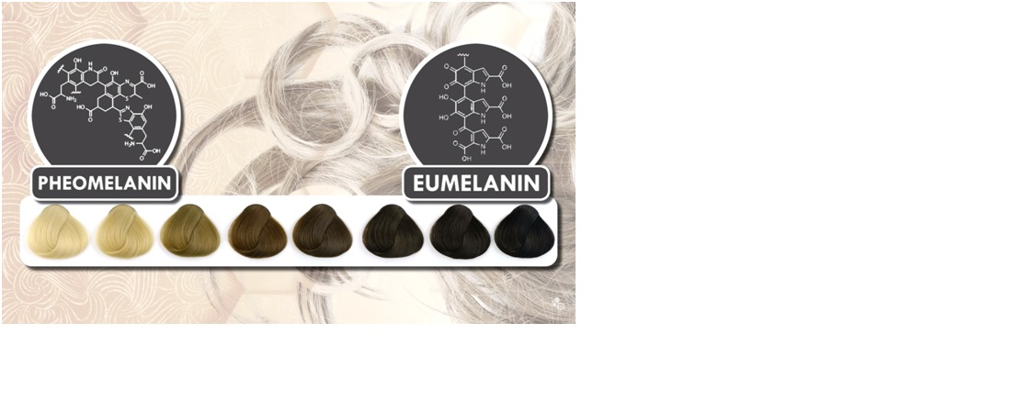
This is a caption

- ADD THOSE TO YOUR EATING HABITS TO GET RID
1)egg whites
2)water
3)fish oil @ 1@ morning 1@night
4)Amla juice @ evening 6 pm
5)almonds
6)fruit juice
7)green vegies

- ———-scalp——–
1)coconut oil+curry leaves –@ oil
2)derma roller
3)head masagger comb

- ——exercise——–
1)runing
2)head stand
3)kapal bhati
4)anulom vilom
5)nail rubbing

