The First Paper
cihat kurt

Introduction
- talk about what improvements are made in this version briefly.
- Write a similar argument as below
Our paper is motivated by the recent publication [98] in which the FDTDM was used to compute the LDR for smoke clusters of up to four mono- mers in order to analyze implications of depolarization lidar observations from the Cloud—Aerosol Lidar and Infrared Pathfinder Satellite Observation (CALIPSO) satel- lite [115]. We extend the analysis of Ref. [98] by con- sidering a more comprehensive and representative set of soot-particle models and using what we believe to be more relevant refractive indices.(Mishchenko et al., 2013)

Method
(Sayeb et al., 2020) The fractal aggregates can be represented numerically by the statistical distribution of their monomers. The fractal scaling law relates the number of monomer in an aggregate, N, to the characteristic size of the aggregate, $R_{agg}$, by the following equation(Ref). :
$$N=k_{0}{\left(R_{agg}\right)}^{D_{f}}$$
where $k_{0}$, the prefactor, and $D_{f}$, the fractal dimension, determine the shape and morphology of the aggregate(Ref). $D_{f}$depends only on the aggregation process, whereas $k_{0}$ also depends on how the size factor, $R_{agg}$, is defined. For instance $R_{agg}$ is commonly defined as the ratio of the gyration radius of the aggregate to the monomer radius ($R_{g}/r_{m})$. In our model, however, we use the maximum distance between the monomers, $R_{max}$, in units of monomer radius. After rearranging the equation 1 and re-writing it in terms of $R_{max}$ one can obtain:
$$R_{max}={\left(\frac{N}{k_{0}}\right)}^{\frac{1}{D_{f}}}$$
In this form, $k_{0}$ takes a value of $0.043$ when $D_{f}$ is 2. [ For comparison to other studies, an approximate relationship with the $R_{max}$ and $R_{g}$ is useful to investigate. (Lattuada et al., 2003) found that the ratio of the minimum radius of a sphere encompassing the aggregate, $R_{s}$, to the gyration radius to be increasing with $N$, and almost approaching to an asymptotic value of 1.6-1.7. Note that $R_{s}=\frac{1}{2}R_{max}+r_{m}$].
In order to calculate the scattering field by a fractal aggregate, the commonly used method is to define a monomer pair-correlation function (which represents in average how many monomers are located at a distance, r, as seen by individual monomers.) Then the static structure factor can be calculated as the Fourier transform of the pair-correlation function. The structure factor is proportional to intensity or the square of the amplitude of the scattering field measured at the detector (Sorensen, 2001; Filippov et al., 2000; Lattuada et al., 2003) .
Hence the intensity of the scattered field in reciprocal space is written as (reference for both double sum and square form)
The below block is for the thesis. It will show in detail how the S(q) is the fourier transform of g(r). It shows that g(r) is the self convoluted density auto correlation function. and from convolution theorem the s(q) becomes the fourier transform of g(r)
$$I\left(q\right) ∼ {\left|\sum_{i}^{N}{ }e^{iq⋅r}\right|}^{2}=\sum_{i}^{N}{\sum_{j}^{N}{ }}e^{iq⋅(r_{i}−r_{j})}$$
And the structure factor of the aggregate is given as (Hasmy et al., 1993)
$$S\left(q\right) =\frac{1}{N^{2}}{\left|\sum_{i=0}^{N}{ }e^{iq⋅r}\right|}^{2}=\frac{1}{N^{2}}\sum_{i}^{N}{\sum_{j}^{N}{ }}e^{iq⋅(r_{i}−r_{j})}$$
where $q$ is the scattering wave vector, and $r_{i}$ and $r_{j}$ are the position vectors of the center of the i^{th} and j^{th} monomers. In case of an elastic scattering, where the amplitude of the incident and the scattered wave vectors, $\left|k_{i}\right| and \left|k_{s}\right|$ are equal, $\left|q\right|=2k_{i}sinθ/2$. The above summation can be represented as (reference)
$$\sum_{i=0}^{N}{ }e^{iq⋅r_{i}}=∫e^{iqr}\sum_{i=0}^{N}{ }δ(r−r_{i})$$
Devam edecek. g(r) n(r) in self convolutioni oldugu gosterilecek. Buradan s(q) otomatik olarak g(r) in fourieri cikacak. Tek fark $1/N^{2}$ $1/N$’e donusuyor
Assagidaki bolum journal icin. Bu bolumde Iq ve Sq sadece amplitude square formunda verilecek. Daha sonra sadece S(q) yada Iq g(r)’in fourier transformu olarak hesaplanabilir denilecek. Referans verilip gecicelek.
$$I\left(q\right) ∼ {\left|\sum_{i}^{N}{ }e^{iq⋅r_{i}}\right|}^{2}$$
And the structure factor of the aggregate is given as (Hasmy et al., 1993)
$$S\left(q\right) =\frac{1}{N^{2}}{\left|\sum_{i=0}^{N}{ }e^{iq⋅r_{i}}\right|}^{2}$$
where $q$ is the scattering wave vector, and $r_{i}$ is the position vector of the center of the i^{th} monomer. In case of an elastic scattering, where the amplitude of the incident and the scattered wave vectors, $\left|k_{i}\right| and \left|k_{s}\right|$ are equal, $\left|q\right|=2k_{i}sinθ/2$. The above summation can be represented as (reference)
The monomer pair-correlation function, $g\left(r\right)$, is defined as the probability of finding a particle pair separated by a distance $r$. This function is calculated as an average for all the monomers in the aggregate and given in a normalized form in a way that normalization becomes
$$\int_{0}^{∞}{g}(r)4πr^{2}dr=N−1$$
Since the eqn.??? implies that
$$g(r_{i})dV(r_{i})=dN(r_{i})$$
where $dV(r_{i})$ is the volume of the i^{th} spherical shell with thickness $dr$, a cumulative pair distribution function, $N(r)$, can be used as the basis of the calculation of $g(r)$.
Once the pair correlation function is calculated the structure factor can be computed as the Fourier transform of the pair-correlation function (Sorensen, 2001).
$$\left< S(\mathbf{q})\right> = \left<\frac{1}{N} \int_{0}^{\infty} e^{i\mathbf{qr}}g(\mathbf{r})d\mathbf{r} \right>$$
The symbol $<.>$ represents angular averaging over the directions of $q$. Since in atmospheric measurements the observed scattering light by the fractal aerosols involve natural directional averaging due to the random orientation of the particles the structure factor given in Eq. ??? should also be averaged overall the solid angle. Thus, assuming isotropy in the aggregate, which is a valid approximation under rotational averaging, the Eq. ??? becomes
$$S(q)=\frac{1}{N}\left(1+N\int_{0}^{∞}{\frac{sinqr}{qr}}g(r)4πr^{2}dr\right)$$
Now talk about the properties of Sq. like S(0) = what and S(inf) = ?. May be give a plot or, dont but give plot of Fc later. Finally close this section and call the other section the numerical calculation

Numerical Calculations
For the convenience of numerical calculations we use the probability distribution of the distances, $f(r_{i})$, and the cumulative distribution of the number of the distances, $N_{c}(r_{i})$, between the monomer pairs as defined by (Tomasko et al., 2008) in the appendix of their paper. The relationships between $f(r_{i})$, $N_{c}(r_{i})$ and $g(r_{i})$ are
$$f(r_{i})=\frac{g(r_{i})dV(r_{i})}{N−1}=dN_{c}(r_{i})$$
Therefore from eqn. ??? and eqn.???, the normalization for $f(r_{i})$ is written as
$$\sum_{i}{f}(r_{i})=1$$
In order to calculate $f(r_{i})$, first, particle-particle distances are stored in an array, $r_{i}$, which ranges from minimum possible distance, $r_{min}$, to maximum distance, $r_{max}$, with a step size of $dr=\frac{1}{8*α}$, where $α$ is the size parameter of the monomers. $r(i)$ is computed in units of monomer radius, $r_{m}$. Hence, minimum possible distance, $r_{min}$, is equal to 2 (in units of $r_{m}$). The maximum distance, $r_{max}$ is determined by the fractal scaling law as given in eqn. ???. The step size is further adjusted for small aggregates, if needed, to ensure that there are at least 100 monomer pairs uniformly separated in the aggregate. The cumulative distribution function for the number of distances between the monomer pairs is computed as (Tomasko et al., 2008):
$$N_{ci}=\frac{\left(1−e^{{\left(−\frac{r_{i}}{R_{1}}\right)}^{D_{f}/N}}\right)\left(1−e^{{\left(−\frac{r_{i}}{R_{2}}\right)}^{d_{cut}}}\right)+2/N}{1+2/N}$$
As seen in eqn. ??? the distance distribution is given in the form of a stretched exponential to apply a cut off to the finite size of the aggregate(Sorensen, 2001; Lattuada et al., 2003). A typical distance distribution in the cumulative form is plotted in .
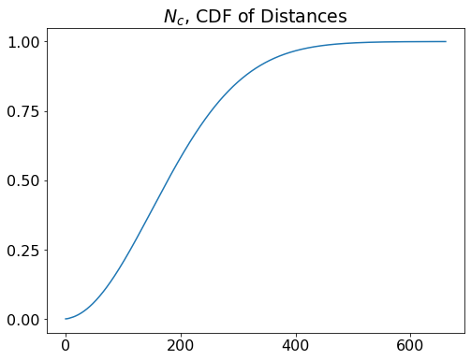
The cumulative distribution function of the number of distances between monomer pairs for an aggregate of 3000 monomers. Notice that x-axis goes up to Rmax/dstep=number of steps.
Substituting $g(r_{i})$ with $f(r_{i})$ in eqn. ??? and changing the integral sign to yields
$$S(q)=\frac{1}{N}\left(1+(N−1)\sum_{i}{f}(r_{i})\frac{sinqr_{i}}{qr_{i}}\right)$$
The structure factor shown in Eq. ??? is normalized in a way that $S(q=0)=1$. The term $\frac{sinqr_{i}}{qr_{i}}$ represents the coherent scattering between the i^{th} monomer pair. The total coherent scattering of all the monomer pairs is computed by the coherent enhancement factor, $F_{c}(θ)$, which is equal to $N^{2}$ times the structure factor (Berry & Percival, 1986). Thus $F_{c}(θ)$ is computed as
$$F_{c}(θ)=N+N(N−1)\sum_{i}{f}(r_{i})\frac{sin\left(2D_{i}sin\left(\frac{θ}{2}\right)\right)}{2D_{i}sin\left(\frac{θ}{2}\right)}$$
where $D_{i}$ is the distance in size parameter units and calculated as $D_{i}=R_{i}×x_{m}$
From the Eqn. (???) and following (Sorensen, 2001), the monomer pairs separated with a distance smaller than $q^{−1}$ scatter the light coherently. Consequently, the intensity of the scattered light by an aggregate with a radius smaller than $q^{−1}$ is proportional to $N^{2}$. In contrast, the Eq. (???) produces wild fluctuations when the distances between the monomer pairs are larger than $q^{−1}$ resulting in destructive interferences. As a result, the intensity of the scattered light by the aggregate becomes proportional to $N$ when all the particle pairs are separated with a distance larger than $q^{−1}$. In our model, the equation for the coherent enhancement factor ( Eq. ???) together with the Eq. (???), successfully model this effect of the monomer distribution relative to the reciprocal value of the scattering wave vector. For instance, as an extreme case when the monomers are packed sparsely, the coherent factor becomes a delta function of $N^{2}$ at $q=0$ (Tomasko et al., 2008). As shown in Fig. (???) the coherent factor peaks at $q=0$ and becomes $N^{2}$. This is because when $θ=0$ all the monomers in the aggregate are located in a region smaller than $q^{−1}$ and, thus, scatter the light coherently. Furthermore, as the monomer number decreases in Fig. (???) the coherency effect dominates up to a larger value of q because of larger relative size of the aggregate in comparison to value of $q^{−1}$ as expected. The black solid line in the Fig. (???) is calculated as $q^{−D_{f}}$ to show that the power law regimes in the $F_{c}$ vs. $q$ curves mostly obey the fractal scaling law given in Eq. ???
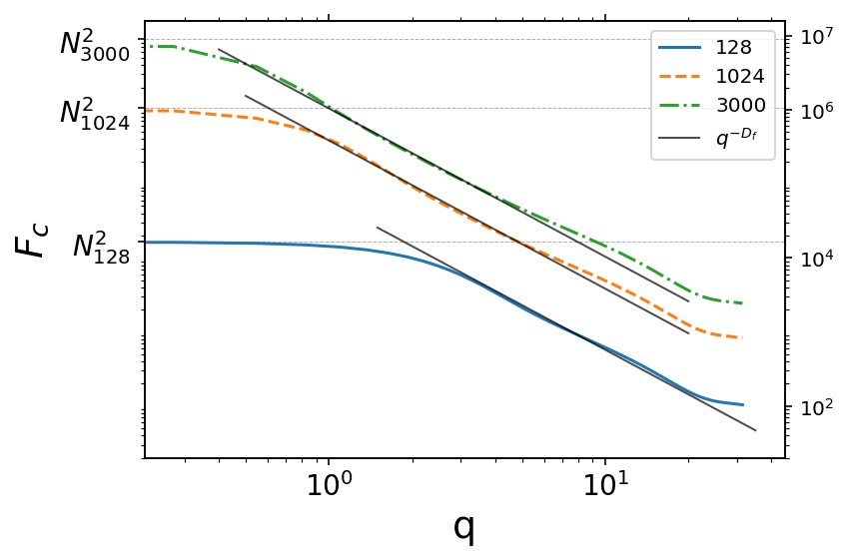
The coherent enhancement factor versus the scattering vector for aggregates with 128, 1024 and 3000 monomers and fractal number $D_{f}=2$. Both of the x and y axes are on the log scale. The black dotted line represents the fractal scaling law given in Eq. (???) and has a slope of $−D_{f}$ on the log-log scale.
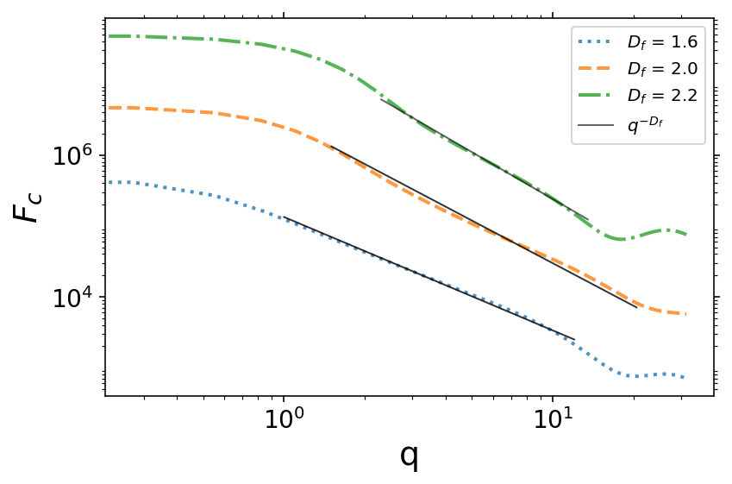
This is a caption

Phase Functions
The coherent enhancement factor, similar to the structure factor is a property of the aggregate and independent of the incident light. It defines how do the scattering fields of all the monomers add up coherently at a detector located in a far-field accounting for the phase differences between the scattered waves by the monomer pairs. The coherent factor does not provide the complete scattering information, however. One needs to calculate all the elements of the phase matrix in order to obtain the complete aggregate scattering information. Under the Rayleigh-Debye-Gans approximation in which the following requirements are met
$$\begin{matrix}[c]\left|m−1\right| <<1\end{matrix} and \begin{matrix}[c]x_{m}\left|m−1\right| <<1\end{matrix}$$
where $m$ is the complex refractive index of the monomers, the elements of the aggregate phase matrix are calculated as the coherent sum of the monomer phase functions (Berry & Percival, 1986), namely
$$P_{ij,agg}=P_{ij,mon}F_{c}(θ)$$
where $P_{ij,agg}$ and $P_{ij,mon}$ are the elements of the aggregate and monomer phase functions respectively. The Eq. (???) suggests that the aggregate scattering is dependent on the monomer phase function and the coherent enhancement due to the structure of the aggregate (Berry & Percival, 1986; Tazaki et al., 2016).
(Berry & Percival, 1986; Tazaki et al., 2016)
Although Eq. (???) can be applied exclusively when the conditions shown in (???) are met for many fractal aerosols in planetary atmospheres, such as soot particles or Titan’s and Pluto’s haze, these conditions for RDG approximation are not met, leading to nontrivial deviation from RDG approximation (Sorensen et al., 2018). Therefore, as a first-order correction to the RDG approximation, here we apply an average attenuation observed by individual monomer. Further revisions to the multiple interactions within the aggregate are made empirically and will be discussed later. With the inclusion of monomer shielding effect, the following three elements of the aggregate phase function are computed as
$$P_{22}(θ)=e^{−τ_{ext}}P_{22,monomer}(θ)F_{c}(θ)+C(θ)$$
$$P_{33}\left(θ\right)=P_{22}\left(θ\right)P_{33,mon}(θ)$$
$$P_{43}\left(θ\right)=P_{22}\left(θ\right)P_{43,mon}(θ)$$
The $C(θ)$ in Eq. (???) represents the empirical corrections and the $e^{−τ_{ext}}$ term is for the attenuation due to the monomer shielding effect, where $τ_{ext}$ is the average extinction optical depth observed by individual monomers. In our model, $P_{22,monomer}$ is calculated by a Mie scattering code instead of calculating it from the Rayleigh approximation.
Paraphrase this: [For corrections to single-scattering calculations, it is useful to calculate average effective optical depths out of the aggregate as seen by individual monomers. These have no physical meaning at size scales comparable to the wavelength of light but give a quasi-physical guide to empirical corrections. Extinction, scattering, and absorption values of tau_out are computed as the average value of the monomer angular cross-section as follows:
tau_coef ¼ X ðF0i=DIST2 i Þ=4=pnðN? 1Þ, (A.7a)
taue_out ¼ tau_coefnCext_mon, (A.7b)
taus_out ¼ tau_coefnCsca_mon, (A.7c)
taua_out ¼ tau_coefnCabs_mon. (A.7d)]

Empirical corrections for multiple scattering
Talk about the T-matrix data we have here. (for the empirical corrections we extended T-matrix runs that were used for the first parameterization model. For every parameter set, we made 25 T-matrix runs with randomly generated aggregate shapefiles.
The first version of the parameterization did not include the empirical corrections for $P_{22}$, represented as $C\left(θ\right)$ in Eq. (???). It was assumed to be valid as it fits well in the range tested by (Tomasko et al., 2008). However, as shown in Fig. (???) without any empirical corrections, $P_{22}$ fails to match the exact model as the parameters are chosen outside the original test limits. On the other hand, there are systematic deviations from the exact model with the change of each parameter. This makes it possible to correct the model statistically for the deviations from the exact calculations. [ It would be great if I can show some examples for the systematic deviation]
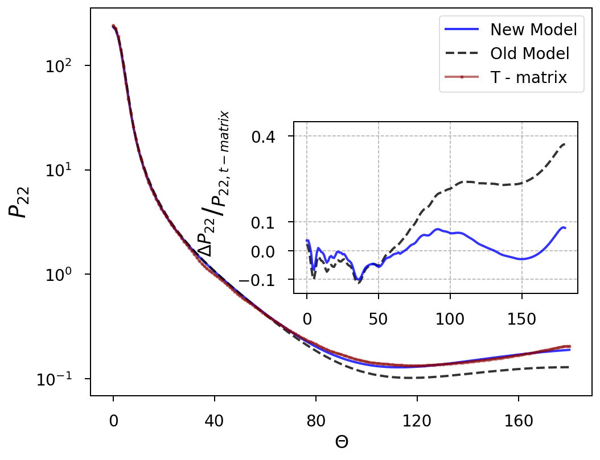
Comparison of our parameterization model to the T-Matrix model for an aggregate with $N=1024, x_{m} =0.64, n_{r}=2.0, n_{i}=0.023$. Solid blue line is the new parameterization model, the dashed line is the one given in the Appendix of (Tomasko et al., 2008).
For the empirical corrections, 𝑃22 is divided into three different scattering regions, which are the forward scattering, side scattering, and the back-scattering regions and four different parameter regimes, namely $N<256 and N≥256 with x_{m}≤0.6 and xm>0.6$. A unique Legendre polynomial for the angular dependency of the deviation from the RDG approximation is fitted for each of the T-matrix runs (Equation 1).
$$P_{22,corr}(θ)=C_{0}P_{0}(θ)+C_{1}P_{1}(θ)+C_{2}P_{2}\left(θ\right)$$
$$C_{k}→C_{k}(N, x_{m}, n_{r}, n_{i}, τ_{sca}, τ_{abs})$$
$P_{0}, P_{1}, and P_{2}$ in Eq. (???) are the first, second and the third term of the Legendre polynomial which are given as
$$\begin{matrix}P_{0}(θ) & =1 \\ P_{1}(θ) & =θ \\ P_{2}(θ) & =\frac{1}{2}(3θ^{2}−1)\end{matrix}$$
The Legendre polynomials in this form are orthogonal in the [-1, 1] window. Therefore, the scattering domain was first mapped into the interval [-1, 1] to calculate the coefficients, $C_{k}$, and then the coefficients were converted to fit the correction in the scattering domain.
Since for every set of parameter choice, there is a unique error function, a single general model can be obtained by fitting a multiple regression model to the coefficients of each Legendre polynomial term as a function of the physical parameters of the aerosols. As shown in Eq. (???) coefficients can be a function of six physical parameters of the aerosol: the number of monomers, monomer size parameter, refractive index of the monomers, and the average optical depths observed by the monomers within the aggregate. A general error function for each three scattering regimes can be written as;
Coefficients are fitted by multiple regressions which are optimized to give the maximum predicted and adjusted $R^{2}$ with the simplest possible models while also maximizing the normality of the residuals of error. The optimization process involves both manually adding and removing parameters based on our expectations on each parameter and automatic statistical algorithms. More details about how the coefficients are fitted and validated are discussed in the Appendix. Table A.1 summarizes the multiple regression statistics.
The angular distribution of a correction function is highly sensitive to the accuracy of its coefficient terms, particularly $C_{1}$and $C_{2}$. While this is a limitation of this method, it also provides a way to validate the reliability of the model by extrapolating to the outside of the tested range. Namely, overfitted or too simple models for the coefficients quickly result in unreasonable phase functions when extrapolated. In summary, each of the regression models for the coefficients is selected based on the standard regression criteria, expert judgment, predicted coefficient of validation method and consistency of the model for extrapolations.
After the empirical corrections model error stays within a 10% limit for the run shown in Fig (???) while the error for the old parametrization model reaches up to 40%. The new model usually performs better than the case
Coefficients are fitted by polynomials via a combination of stepwise regressions and manually adjusting the t to add or remove polynomial terms based on procedure. In order to eliminate the overfitting or
which are optimized to have the minimum possible residual errors and the maximum normality of the distribution of the residual errors. The optimization procedure involves stepwise regression is made in a combination of manual elimination of some polynomial terms and an automated algorithm that uses Gaussian elimination process.
For spherical particles, $P_{22}=P_{11}$ and $P_{44}=P_{33}$ while these terms are not equal for aggregates due to the depolarization caused by cross-polarization within aggregates (Tazaki et al., 2016). Therefore, $P_{11}$ is modeled by adding empirically calculated depolarization, $depol\left(θ\right)$, to $P_{22}$ (Eq. (???)). This method produces $P_{11}$ which fits well with the exact model (See Fig. (x)). $P_{44}$ is calculated in a similar fashion except that the depolarization is scaled to fit at $\theta=0\degree$ and $\theta=180\degree$ because of lack of agreement for the angular dependency of $P_{44}$ with the exact calculations.
$$P_{11}\left(θ\right)=P_{22}\left(θ\right)+depol\left(θ\right)$$
$$P_{44}\left(θ\right)=P_{33}\left(θ\right)+depol\left(θ\right)×(2/π θ−1)$$
The actual angular dependency of the depolarization is difficult to model empirically for aggregates outside the RDG limit. For instance, a modest fit for depolarization calculated by our T-matrix data requires several polynomial terms. Instead, we use a simple empirical model for depolarization which is fairly good inside the tested range and produces valid values when extrapolating to several thousands of monomers. The empirical correction for the depolarization $depol\left(θ\right)$, in Eq. (??? ) and Eq. (???) is calculated as
$$depol(θ)=C_{d1}\frac{F_{m}}{{\left(N−1\right)}^{2/3}}\left(1+\frac{\sin^{2}θ}{1+\cos^{2}θ}\right)$$
where $C_{d1}$ is a constant, the last term inside the parenthesis is the linear polarization for a Rayleigh particle which constraints the angular dependence, and $F_{m}$ is the square of the Lorentz-Lorenz factor which is given by
$$F_{m}={\left|\frac{m^{2}−1}{m^{2}+2}\right|}^{2}$$
A lower limit is set for the depolarization for aggregates with a size parameter smaller than 1.6
$$depol>=C_{d2}\sqrt{F_{m}}τ_{s,out}^{E_{d}}.$$
where $C_{d2}$ and $E_{d}$ are constants. This is required especially for larger aggregates where Eq. (???) sometimes results in slightly weaker depolarization comparing to the exact model. Finally, the depolarization is scaled to $P_{22}\left(π/2\right)$
$$depol\left(θ\right)=depol\left(θ\right)P_{22}\left(π/2\right)\left(1−π/2\right).$$
=

Appendix
Not mention stepwise regression. Change it to expert judgment based on main effect plots and interaction plots of each variable and adjusted and predicted R-sq as well as the normality of the residuals.[ For example, we first conducted best-subset regressions to evaluate the best candidate predictors among those shown in Eq. (???) and some of their non-linear forms, for instance, $e^{τ_{sca}}$ and $N^{−\frac{1}{2}}$. Then using the candidate predictors and including their interaction terms, stepwise regressions are used to obtain the regression equations of the coefficients. While the stepwise regression help simplifying the model it is prone to oversimplify the final model by removing some important parameters. Therefore, by carefully analyzing each model obtained in the stepwise regression process we added or removed some parameters, when needed, based on our expectations and analyzing the main effect and interaction plots for each candidate variable. For example, if the stepwise regression removes the monomer number terms from the final model when fitting the coefficients for the forward scattering we force the model to include it because we know that the monomer number has a strong effect in the forward angles.] Lastly, we tested each selected model for all the coefficients by substituting them in Eq. (???) and extrapolating the P22 up to N = 10^3 monomers and xm = 1.0 along with various refractive index values. Since empirical corrections for P22 calculated in this way is highly sensitive to the accuracies of the multiple regressions for the coefficients in Eq. (???) any over-parameterized or too simple fits for the coefficients result in unreasonable shape in phase functions. This way it was possible to select only the models which not only suffice the statistical criteria discussed above but also produce reasonable extrapolations. A better way to test the model would be to divide the T-matrix data we have into two parts, where 60 to 70% of it could be used to estimate the fits for the coefficients and the rest of it would be used to test their interpolation and extrapolation performance. Unfortunately, our T-matrix data is not sufficiently big to make such a division and used to generate a reliable regression fit at the same time. This is partly because we already divided our T-matrix data into four parts based on different parameter regions in which the parameters have different effects as discussed in …. [ For small N, the interaction between the monomers has more effect in the total? think about it and find references. *For small xm, monomers follow Rayleigh scattering, after xm > 0.6 they start behaving differently than Rayleigh theory predicts. Stop here! This is not the actual reason. More accurately, aggregate scattering starts deviating from Rayleigh Gans Approximation when sp is getting larger because ] However, this stays as a future goal for us. Once we generate a large enough T-matrix runs it will be possible to test the empirical corrections on data that is not used to calculate the model. Although the cross-validation by splitting the T-matrix data was not plausible [ sil burayi: due to the size of the data set and the strong requirement for accurate regression models as discussed above], we use the prediction sum of squares method which is another validation method for regression models. Predicted coefficient of validation, $R_{predict}^{2}$, … (define it here). As shown in Table A.1 [Table of statistics for each model including R^2 values, residual normalization score, either the test method specific scores, like AD or the p-values]. Furthermore, extrapolating to larger monomer numbers is easier since even the largest monomer number does not require significant correction as long as the size parameter is small, such as 0.336 as shown in Fig. XX. The need for empirical corrections increasingly becomes more important as the size parameter increases, but not necessarily change as the monomer size increases. [Give also physical reasoning with a reference]. Besides, the main purpose of our model is to study the planetary aerosols, such as Titan’s and Pluto’s haze particles. Although these particles are likely to consist of up to a few thousands of monomers, their monomer sizes must be less than a tenth of a micrometer because of the strong linear polarization measured both in Titan’s and Pluto’s atmosphere in the visible and infrared channels suggesting small Rayleigh like monomers. Therefore, studying such aggregate aerosols in visible or infrared wavelengths does not require extrapolating to size parameter values beyond the model has been tested for.

Definitions
$$q=k_{i}−k_{s}=2k_{i}sin(θ/2)=\frac{4π}{λ}sin(θ/2)$$
Also
$$q⋅R_{0i} = 2⋅k_{i}R_{0i}sin\left(θ /2\right)$$
$$q=2ksin(θ/2)$$
Thus
$$qR_{i}=2ksin(θ/2)R_{i}=2kr_{i}/r_{m}sin(θ/2)$$
Let $D_{i}=2kr_{m}*R_{i}=2x_{m}R_{i}=2kr_{m}r_{i}/r_{m}$
Distances between monomer pairs are: $D_{i}=R_{0i}r_{m}$ in monomer units
Now in our model, coherent scattering between particle pairs is:
$$F_{i}=\frac{sin\left(2R_{0i}αsin\left(θ/2\right)\right)}{2R_{0i}αsin\left(θ/2\right)}; where α=k_{i}r_{m}$$
After substituting Eq. ??? and $D_{i}$ into Eq. ???, one can get:
$$F_{i}=\frac{sin\left(qD_{i}\right)}{qD_{i}}$$
Now that we have the structure information of the aggregate and the scattering between each monomer pairs, we can calculate the total coherent scattering,$F_{c}$, in the aggregate:
$$F_{c}=N+(N^{2}−N)∑F_{i}⋅F_{0i}$$
$$F_{c}=N+(N^{2}−N)∑\frac{sin\left(qD_{i}\right)}{qD_{i}}⋅F_{0i}$$
Here $F_{0i}$ is the histogram of number of particle pairs versus distances between them. In order to calculate $F_{0i}$, first, particle-particle distances are stored in an array, $R_{0i}$, which ranges from minimum possible distance, $R_{min}$, to maximum distance $D_{max}$, with a step function of $δ_{step}=\frac{1}{8*α}$. The minimum number of step is set to 100 to ensure a minimum of 100 monomer pairs uniformly separated in the aggregate. The cumulative distribution function for the number of distances between the monomer pairs is:
$$N_{ci}=\frac{\left(1−exp{\left(−\frac{R_{0i}}{R_{1}}\right)}^{D_{f}/N}\right)\left(1−exp{\left(−\frac{R_{0i}}{R_{2}}\right)}^{d_{cut}}\right) +2/N}{1+2/N}$$
This function is related to pair correlation function, but in cumulative form. Thus one needs to differentiate $N_{c}$ to obtain $f(r)$ which is in turn related to $g(r)$ as shown in Eqn. ???
(Note that thisThis function is plotted in figure below for an arbitrary N value (2048) ( Not the correct function )

PDF version of this function is the derivative of it.

This is $dN_{c}/dR_{0}$ not $dN_{c}/dn_{step}$ which is F0
This PDF is plotted in the figure below:

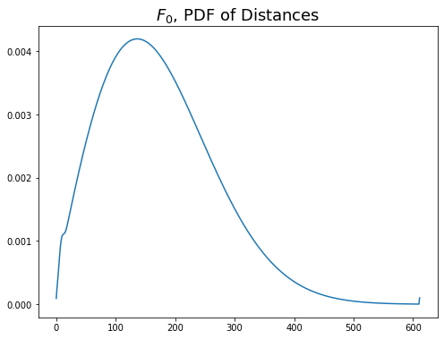
Derivative of Eq.8 (PDF of number of distances ). Same as Fig. 2, x - axis goes up to Rmax/dstep
$F_{c}$ is actually $N^{2}×S(q)$. And
$S_{11}=S_{11,Mie}×N^{2}S(q)$
This is the result of the rayleigh debye gans approximation where the Rayleigh - Gans term is replaced with exact mie term (Tazaki et al., 2016)

Notes
- $F_{c}$, given in Eq. ???, when normalized with $N^{2}$ becomes unity at $θ=0$ where it peaks just like structure factor $S(q)$
Well it is the $N^{2}×Structurefactor$

References
. (2013). Journal of Quantitative Spectroscopy and Radiative Transfer, 123, 135–144. https://doi.org/10.1016/j.jqsrt.2012.11.012
Massive black hole binary inspiral and spin evolution in a cosmological framework. (2020). Monthly Notices of the Royal Astronomical Society, 501(2), 2531–2546. https://doi.org/10.1093/mnras/staa3826
A simple model for the structure of fractal aggregates. (2003). Journal of Colloid and Interface Science, 268(1), 106–120. https://doi.org/10.1016/j.jcis.2003.07.027
Light Scattering by Fractal Aggregates: A Review. (2001). Aerosol Science and Technology, 35(2), 648–687. https://doi.org/10.1080/02786820117868
Fractal-like Aggregates: Relation between Morphology and Physical Properties. (2000). Journal of Colloid and Interface Science, 229(1), 261–273. https://doi.org/10.1006/jcis.2000.7027
Small-angle neutron-scattering investigation of short-range correlations in fractal aerogels: Simulations and experiments. (1993). Physical Review B, 48(13), 9345–9353. https://doi.org/10.1103/physrevb.48.9345
A model of Titans aerosols based on measurements made inside the atmosphere. (2008). Planetary and Space Science, 56(5), 669–707. https://doi.org/10.1016/j.pss.2007.11.019
Optics of Fractal Clusters Such as Smoke. (1986). Optica Acta: International Journal of Optics, 33(5), 577–591. https://doi.org/10.1080/713821987
LIGHT SCATTERING BY FRACTAL DUST AGGREGATES. I. ANGULAR DEPENDENCE OF SCATTERING. (2016). The Astrophysical Journal, 823(2), 70. https://doi.org/10.3847/0004-637x/823/2/70
Light scattering and absorption by fractal aggregates including soot. (2018). Journal of Quantitative Spectroscopy and Radiative Transfer, 217, 459–473. https://doi.org/10.1016/j.jqsrt.2018.05.016

