Effect of increasing conductivity on nitrification rates and microbial function in stream systems
Catherine Cappellin
Brian D. Badgley
Salinization in fresh water systems has significantly impacted microbes’ ability to perform ecosystem services. In this study, changes in nitrification rates across increasing conductivity as well as between two stream systems in Blacksburg, VA, are observed. Variation in nitrification rates were found to increase with conductivity; however, conductivity was ultimately found to be a poor predictor of nitrification efficiency. Overall, the project revealed that pulse salting events have a more predominant effect on nitrification due to the chemical alteration of river sediment than rather than inhibited microbial performance.

Scientific Significance Statement
Across the United States, anthropogenic salt inputs into freshwater systems have drastically altered water chemistry and the rate at which ecosystem services at the microbial level are performed. However, it is still unclear how these microbial functional communities respond to increased water conductivity during pulse salting events. In this study, it was observed that the transformation of nitrogen in the stream system was more strongly affected by the river sediment than from inefficient microbial function at higher water conductivities.

Introduction
Freshwater salinization and cell morphology
Increasing salinity affects ecosystem services like drinking water quality, flooding, and biodiversity. Anthropogenic sources contributing to freshwater salinization are agriculture, urban runoff, resource extraction, and land clearing (Kaushal et al. 2017). Salt inputs release strong base cations that change water pH, alkalinity, and conductivity. Although most research focuses on sodium chloride inputs, it is important to note that other important base cations include magnesium, calcium, and potassium. Typically, as salt concentrations increase, the pH will rise due to an increase in these base cations. The increase in pH shifts the carbonate system equilibrium, which ultimately raises alkalinity. Similarly, the addition of more ions increases the water’s conductivity. On a large scale, these alterations to water chemistry due to salinization lead to problems such as contaminant mobilization and infrastructure corrosion (Kaushal et al. 2017). However, on a smaller scale, these salt inputs also inhibit microbial function. All microbes have different levels of salt tolerances, and once these levels are exceeded, the cell wall of a bacteria will shrivel, making it more difficult for the cell to function. This is due to both osmotic plasmolysis and electrostatic contraction, where osmotic plasmolysis refers to the diffusion of the cell’s cytoplasm and electrostatic contraction as the release of protons outside the cell wall (Marquis 1968).

Salinization and nitrification
One important ecosystem service provided by microorganisms is nitrification, or the conversion of nitrogen into a useable form for uptake. This process involves the oxidation of ammonium (NH4+) by nitrifying bacteria like Nitrosomonas sp. and Nitrococcus sp. to nitrate (NO3-) by Nitrospira sp. (Gonzalez-Silva et al. 2016). Nitrification is an important microbial process because it creates usable forms of nitrogen that plants and other organisms need to survive. Salinization through potash is especially detrimental in this sense because it also increases nutrient loading of the freshwater system. Buildup of nitrogen in freshwater can create eutrophic conditions as well as ecological dead zones (Tong et al. 2015). Therefore, deepening our understanding of nitrification and factors affecting its efficiency are important in the future of engineering water quality and managing nutrient loads in freshwater systems. To date, research has been done to show that increasing salinity inhibits nitrification; however, how these microbial communities respondis still largely unknown.
The aim of this research was to determine how the nitrification rate of a stream system in a minimally disturbed watershed responds to changes in water conductivity as a result of increased salinity, to observe how the nitrifying bacterial groups in the minimally developed stream respond to pulse salting events, and to compare the nitrification rates between two stream systems differing in watershed land use.

Methods
Study design
Two stream locations in Blacksburg, VA, were selected for this study: Pandapas Pond and the Stream Lab site on Stroubles Creek. These sites are known to have different chemical properties and are dominated by different land uses within their watershed. Stroubles Creek receives urban and agricultural runoff, where conductivity typically ranges from (check SLAB). Pandapas Pond is in a mostly undeveloped watershed within Jefferson National Forest, where conductivity ranges between 10-45 uS/cm. For the purpose of this study, the Stream Lab site at Stroubles Creek acted as a reference community already functioning at high conductivity while Pandapas Pond acted as the variable community introduced to high levels of conductivity.
At the Stroubles site, 1L of stream water and about 150 cm³ of stream sediment were collected and at Pandapas Pond, five 1L bottles of water and 750 cm³ of stream sediment were collected. In the lab, the initial conductivities of each water sample were taken. In just the Pandapas Pond water, enzyme grade sodium chloride (NaCl) (product info) was added to each of the liter bottles to create an increasing conductivity gradient (Figure 1).

Nitrification assays
Following a similar procedure outlined in Arango and Tank (2008), samples for each conductivity treatment were run in triplicate, and each sample replicate had a production and a control bottle. The production and control bottles were used to calculate the in nitrification rate of a replicate. Nitrification was inhibited in the production bottles and carried out in the control bottles. For every sample, roughly 25 cm³ sediment was mixed into a 500 mL Nalgene bottle with 50mL of unfiltered stream water. For the production bottles, 10 uL of 10% nitrapyrin in DMSO was added. In the control bottles, only 10 uL of DMSO was added. The nitrapyrin added to the production bottles blocked the microbial cells from oxidizing NH4+ in the container (cite). After the additions to the production and control bottles, the samples were incubated at room temperature on a rotary shaker for 46 hrs at 150 rpm.
After incubation, 25 mL of 2M potassium chloride (KCl) was added to each of the bottles and were shaken for an additional 10 minutes. The K+ ion displaced any NH4+ still held within the sediment. The bottles were then centrifuged at 3000 rpm for 2 minutes and the supernatant was decanted into 50 mL polypropylene Falcon tubes and frozen for future nutrient analysis. About 0.25 g of wet sediment was then collected from each sediment sample and stored in the -80°C for future bacterial community sequencing analysis. The sediment was then freeze dried and the total dry mass (DM) for each sample was recorded.
Nutrient analysis was performed on the supernatant of the samples using Lachat…
Nitrification rates for each sample were then determined by finding the difference between NH4+ concentration in the production and control bottles and dividing by the DM and incubation time (units: ug N g-1 DM day-1).
Statistical Analyses

Results

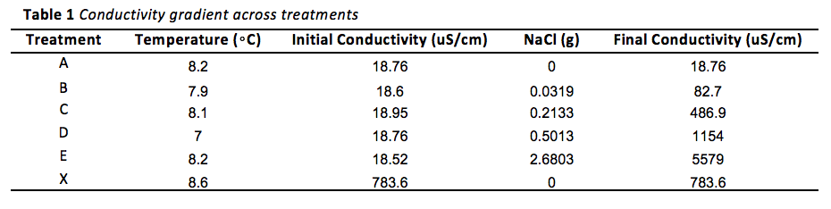
Sorry, working on formatting as a table rather than as a figure
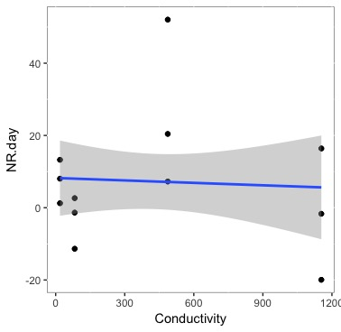
Figure 1. Linear plot showing calculated nitrification rates across increasing water conductivity in Pandapas Pond, excluding Treatment E.
Figure 1
· NR rates do trend down with increasing salt pulse, when excluding the “extreme” conductance
· Variance also increases as conductivity increases
· No significant difference between NR across treatments
· Need more replicates to make data less noisy

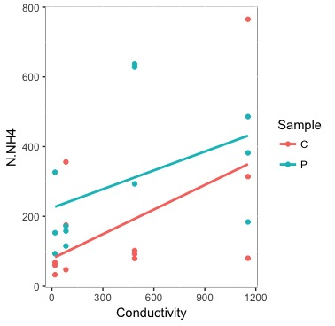
Figure 2a. Linear plot showing ammonium concentrations in the control and production bottles across increasing conductivity at Pandapas Pond, excluding Treatment E.
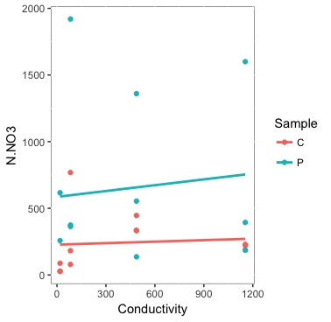
Figure 2b. Linear plot showing nitrate concentrations in the control and production bottles across increasing conductivity at Pandapas Pond, excluding Treatment E.
Figure 2
· NH4 and NO3 show that assays worked—control should have lower concentrations because it was not inhibited by nitrapyrin
· Ammonium concentrations in both containers increased with conductivity—no new nh4 inputs added—salt effect!

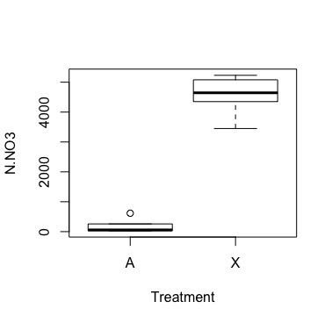
Figure 3a. Boxplot comparing nitrate concentrations at Pandapas Pond and Stroubles Creek.
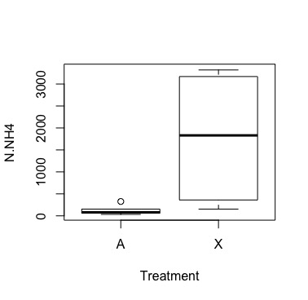
Figure 3b. Bowplot comparing ammonium concentrations at Pandapas Pond and Stroubles Creek.
Figure 3
· SLAB had higher overall nitrification rate, but not significant

· SLAB had significantly higher NH4 and NO3 concentrations—most likely due to differing land use in watersheds

Discussion
· Discuss typical nitrification rates for given watersheds
· Pulse salt events affect river sediment more than bacterial function in the short term
· Cation exchange: sodium (or other cation) during pulse salt events release nh4 from sediments, creating increased nutrient loading downstream
· Problem in creating eutrophication potential
· Implications: Salt TMDLs in freshwater systems could help alleviate nutrient loading and dead zones downstream
· Future: community analyses between sites (qPCR to find abundance of nitrifiers), longterm monitoring with smaller assay volume and more replicates across the pdp sites

Acknowledgements
This work was funded by the Virginia Tech Department of Biological Sciences. This work was supported by Dr. Erin Hotchkiss as well as the 2018 Spring Ecology course.

References

