SYSTEM DEVELOPMENT LIFE CYCLE : MY OPINION
nurul hidayah
NOOR JULIANA
Hi today we would like to give you our opinion about system development life cycle (SDLC). First of all the definition of this system is big picture within which the data design and application development can be mapped out and evaluated. This system development life cycle consist of 5 aspects. First, planning. planning consist of 2 actions which are initial assessment and feasibility. Second, analysis. Analysis consist 3 actions which are user requirement, existing system evaluation and logical system design. Third, detailed system design. Detailed system design consist of one action only which is detailed system specification. fourth, implementation. implementation consist of 2 actions which are coding, testing, debugging and installation, fine tuning. Lastly, maintenance. Maintenance consist of 3 actions which are evaluation, maintenance, and enhancement. From all the five phases, we choose to elaborate about analysis.The analysis phase of the SDLC is in effect a through audit of user requirements.

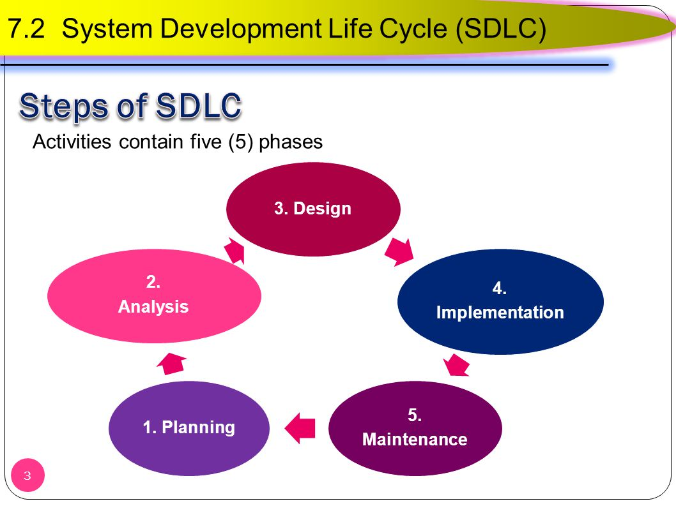
SDLC PHASES
The existing hardware and software systems are also studied during the analysis phase. The result of the analysis should be better understanding of the system’s functional area, actual and potential problems, and opportunities. End users and the system designers must work together to identify processes and uncover potential problem areas. Such cooperation is vital to defining the appropriate performance objectives by which the new system can be judged. Along with s study of user requirement and existing systems, the analysis phase includes the creation of a logical systems design. The logical design must specify the appropriate conceptual model, input, processes, and expected output requirement. When creating a logical design, the designer might use tools as data flow diagram, hierarchical input process output diagram, and entity relationship diagrams. The database data modeling activities take place to discover all entities and their attitudes and the relationships within database. Defining the logical system also functional description of components for process within the database environment. All data transformation are described and documented.

