Protein-protein interaction analysis of 2DE proteomic data of desiccation responsive Xerophyta viscosa leaf proteins
Ryman Shoko

Abstract
A lot of research has focused on investigating mechanisms of vegetative desiccation tolerance in resurrection plants. Various approaches have been used to undertake such research and these include high throuput approaches such as the ‘omics’ - transcriptomics and metabolomics. Proteomics has since become more prefarable than transcriptomics as it it provides a view of the end-point of gene expression. However, most proteomics investigations in literature publish differentially expresses protein lists and attempt to interpret such lists in isolation. This is despite the fact that proteins do not act in isolation. A comprehensive bioinformatics investigation can reveal more information on the desiccation tolerance mechanism of resurrection plants. In this work, a comprehensive bioinformatic analysis of the published proteomic results in Ingle et al. (2007) was carried out. GeneMania was used to carry out protein-protein interaction studies while ClueGo was used to identify GO biological process terms. A preliminary map of protein-protein interactions was built up and these led to the predicted of more proteins that are likely to to be connect to the ones identified by Ingle et al. (2007). Briefly, whereas 2DE proteomics identified 17 proteins as being differentially regulated (4 de novo, 6 up-regulated and 7 down-regulated), GeneMania managed to add 57 more proteins to the network (de novo - 20, up-regulated - 17 and down-regulated - 20). Each protein set has unique GO biological process terms overrepresented in it. This study explores the protein pathways affected by desiccation stress from an interactomic prospective highlighting the importance of advanced bioinformatic analysis.

Introduction
Resurrection plants can survive extreme water loss and survive long periods in an abiotic state and upon watering, rapidly restore their normal metabolism (reviewed inter alia in Farrant, 2007). Understanding the mechanisms of desiccation tolerance (DT) in resurrection plants is important as they are deemed to be an excellent model to study the mechanisms associated with DT. Proteomic profiling offers the opportunity to identify proteins that mediate the pathways involved in the DT mechanisms, when cells are subjected to desiccation stress. A number of proteomics studies have been reported for leaves of some angiosperm resurrection plants during desiccation (Röhrig et al., 2006; Ingle et al., 2007; Jiang et al., 2007; Abdalla et al., 2010; Wang et al., 2010; Oliver et al., 2011; Abdalla and Rafudeen, 2012 etc.).
Since DT involves the integrated actions of many proteins, a systems-level understanding of experimentally derived proteomics data is essential to gain deeper insights into the protection mechanisms employed by resurrection plants against desiccation. In recent years, an increasing emphasis has been put on integrated analysis of gene expression data via protein protein interactions (PPI), which are widely applied in interaction prediction, functional modules identification and protein function prediction.
In this work, PPI analysis is applied to study the proteomics data obtained by Ingle et al. (2007) during the desiccation of Xerophyta viscosa leaves. In their study, using 2DE, they identified 17 desiccation responsive proteins(4 de novo, 6 up-regulated and 7 down-regulated). The aim of the work is to establish if the proteins in each set interact and if they do, the second aim would be to establish if there are any statistically significant GO biological process terms that can be observed in each set.

Methods

Protein lists
The initial protein lists used in PPI analyses in this work were obtained from the 2DE data from Ingle et al. (2007) - (see Table 2 in Ingle et al. (2007)).

Protein-protein integration
The Cytoscape v3.8.1 (Shannon et al., 2003) app GeneMANIA (Warde-Farley et al., 2010), was used to derive the interactome of empirically determined and predicted PPIs of differentially regulated gene lists. Protein lists for ‘up-regulated’, ‘down-regulated’ and ’de novo’ proteins were used as query lists for PPI studies. Arabidopsis thaliana analogs of the desiccation responsive protein sets were used as query genes, and the program was run with default settings.

GO biological process functional enrichment analysis
The Cytoscape app ClueGO v2.5.7 (Bindea et al., 2009) was used for enrichment of GO biological process terms. ClueGO extracts the non-redundant biological information for groups of genes/proteins using GO terms and can conduct cluster – cluster comparisons. In the present study, for input, TAIR identifiers from the extended list of desiccation responsive proteins obtained from GeneMania were used as protein cluster lists and ontology terms were derived from A. thaliana. The ClueGO ‘cluster comparison’ allowed the identification of biological process terms that were unique to each protein/gene list.

Results and discussions

De novo proteins
Whereas the proteomic investigation using 2DE identified only 4 proteins as having been produced de novo in response to desiccation, bioinformatics analysis managed to identify 20 more associated proteins (Fig 1). The interaction network (Fig 1) showed that 3 of the query proteins operated within a network and only one protein, AT1G47980, was not in the network.
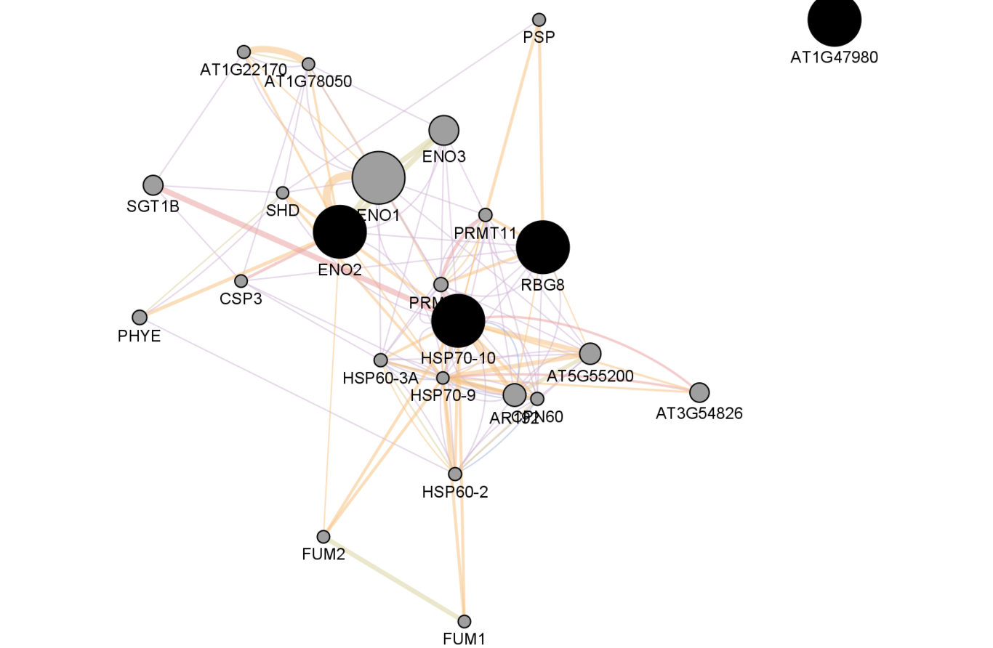
Protein-protein interaction network of de novo proteins constructed by GeneMania. Nodes shown in black are the query proteins.
The notable de novo biological process terms are those relating to protein synthesis and repair (Fig 2). This suggests an induction of synthesis of novel protectant proteins that may be needed in the response to the desiccation stress such as antioxidants. Also, the GO biological process ‘protein refolding’ suggests the repair of proteins that have been misfolded or unfolded as a result of desiccation stress. This process is facilitated by molecular chaperones such as the heat shock proteins (HSPs) (Al-Whaibi, 2011). HSPs play an important role in DT as they tend to accumulate universally in resurrection plants during drying (Ingram and Bartels, 1996; Farrant et al., 2007).

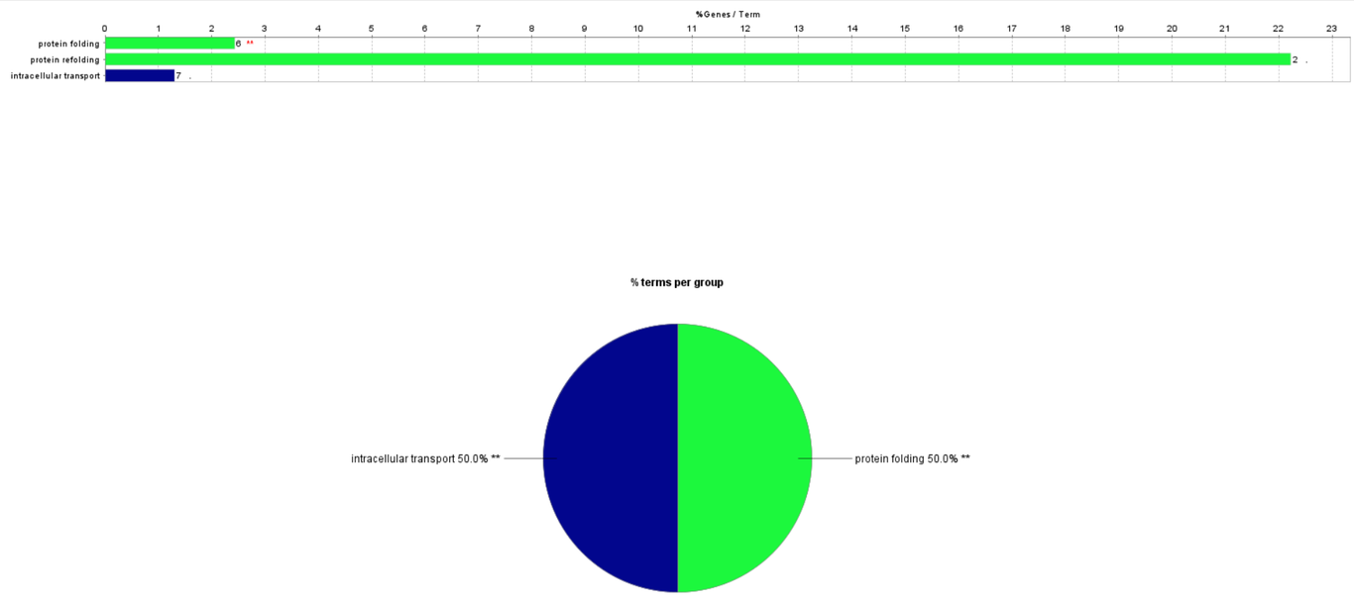
GO Biological process terms associated with the de novo proteins.

Up-regulated proteins
2DE identified 6 proteins as having been up-regulated in response to desiccation. However, network analysis using GeneMania managed to identify 17 more proteins as being connected to the 7 initially identified (Fig 3). The proteins are highly connected in the network indicating a co-ordinated response to desiccation.

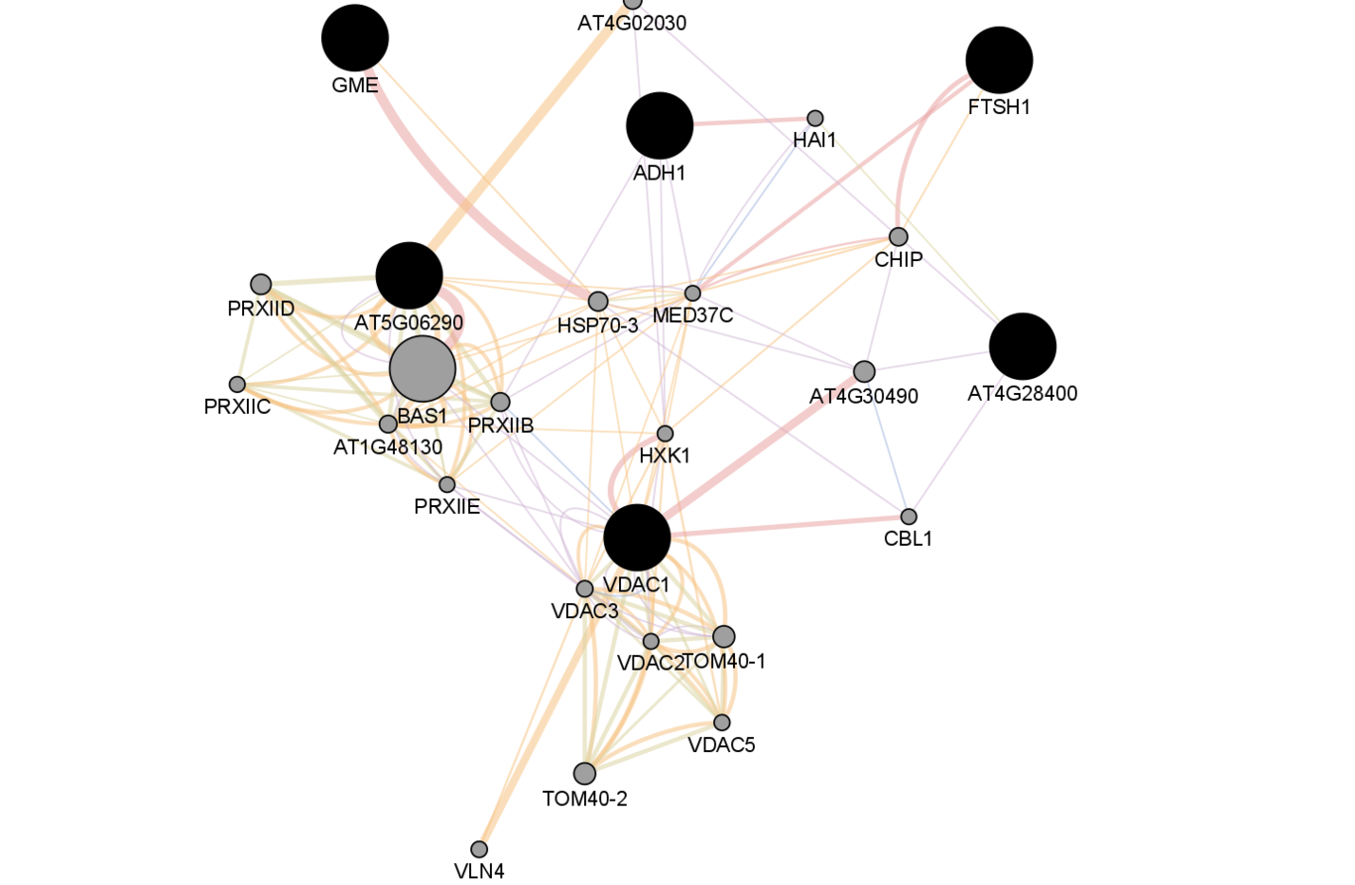
Protein-protein interaction network of up-regulated proteins constructed by GeneMania. Nodes shown in black are the query proteins.
An important protection mechanism in resurrection plants is the up-regulation or induction of free radical scavenging enzymes to quench the reactive oxygen species formed during the desiccation process (Sgherri et al., 1994; Sherwin and Farrant, 1998). These proteins are considered to be ‘house-keeping’ protectants (Illing et al., 2005). As shown in Fig. 4, among the biological processes that were up-regulated in response to desiccation is ‘oxidation-reduction process’. Indeed Ingle et al. (2007) confirmed using western blotting analysis that the antioxidant proteins 2‐Cys‐Prx and GDP‐mannose‐3′, 5′‐epimerase they observed in 2DE were up-regulated in response to desiccation.
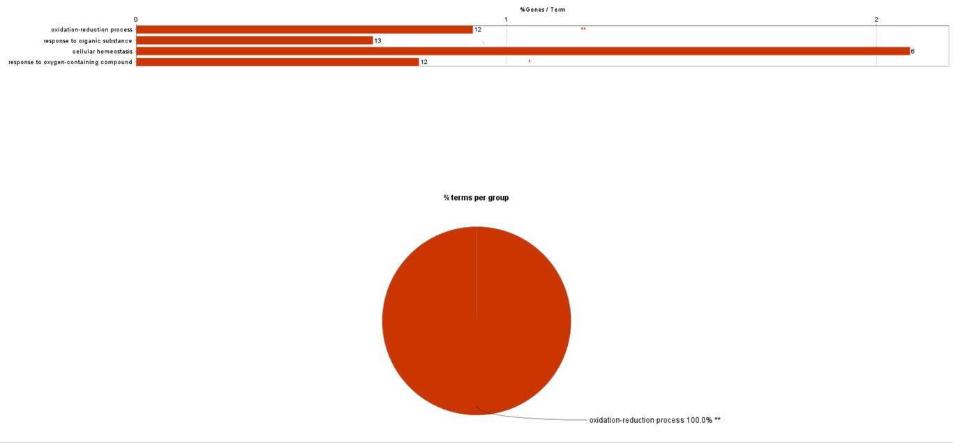
GO Biological process terms associated with the up-regulated proteins.

Downregulated proteins
2DE results from Ingle et al. (2007) identified 7 proteins as down-regulated in response to desiccation, while network analysis added another 20 proteins (Fig. 5). These proteins were connected.

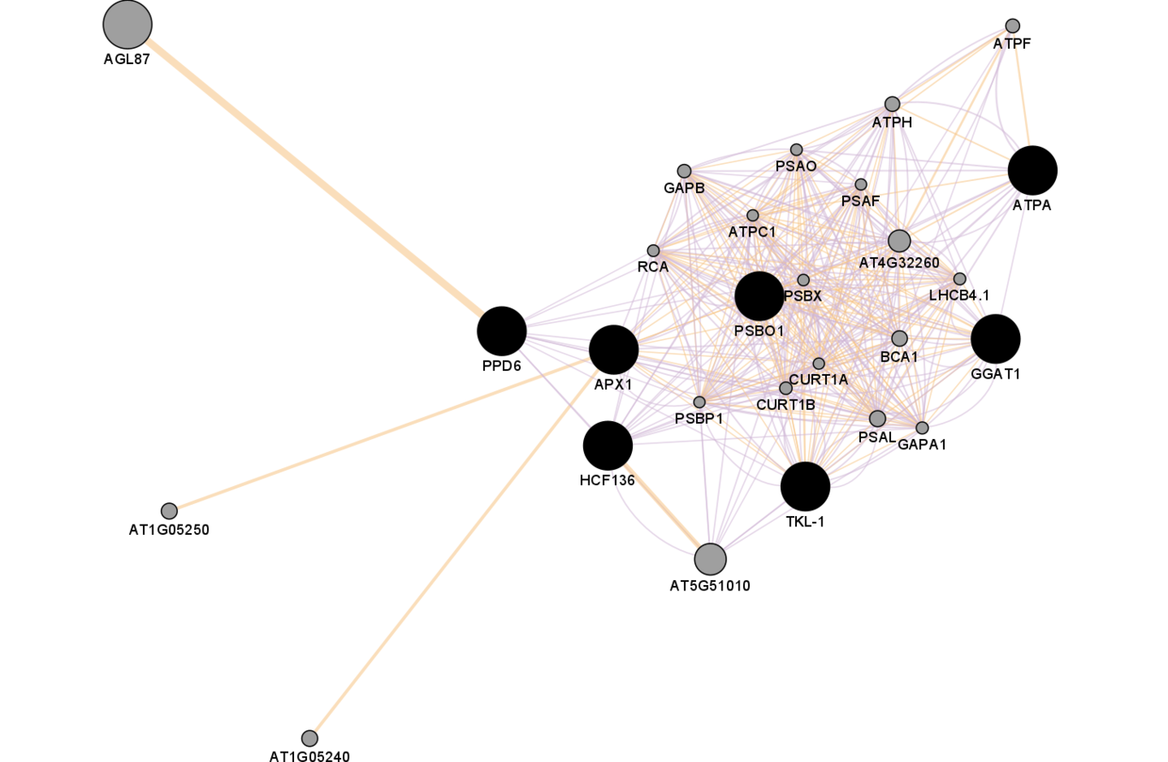
Protein-protein interaction network of down-regulated proteins constructed by GeneMania. Nodes shown in black are the query proteins.
The functional enrichment analysis results show that the biological processes that were significantly downregulated are mainly those involved in photosynthesis (Fig. 6). This expression pattern was confirmed by western blotting of selected proteins in Ingle et al. (2007). This is not surprising given that poikilochlorophyllous plants such as the Xerophyta species are poikilochlorophyllous and thus they lose their chlorophyll and dismantle their thylakoid membranes during drying and then re-synthesize them following rehydration (Sherwin and Farrant, 1996; Sherwin and Farrant, 1998). This strategy helps in achieving significant minimization of photo-oxidative damage and reducing energy costs associated with maintaining the chloroplast structure during desiccation stress (Sherwin and Farrant, 1998; Oliver et al., 2000).

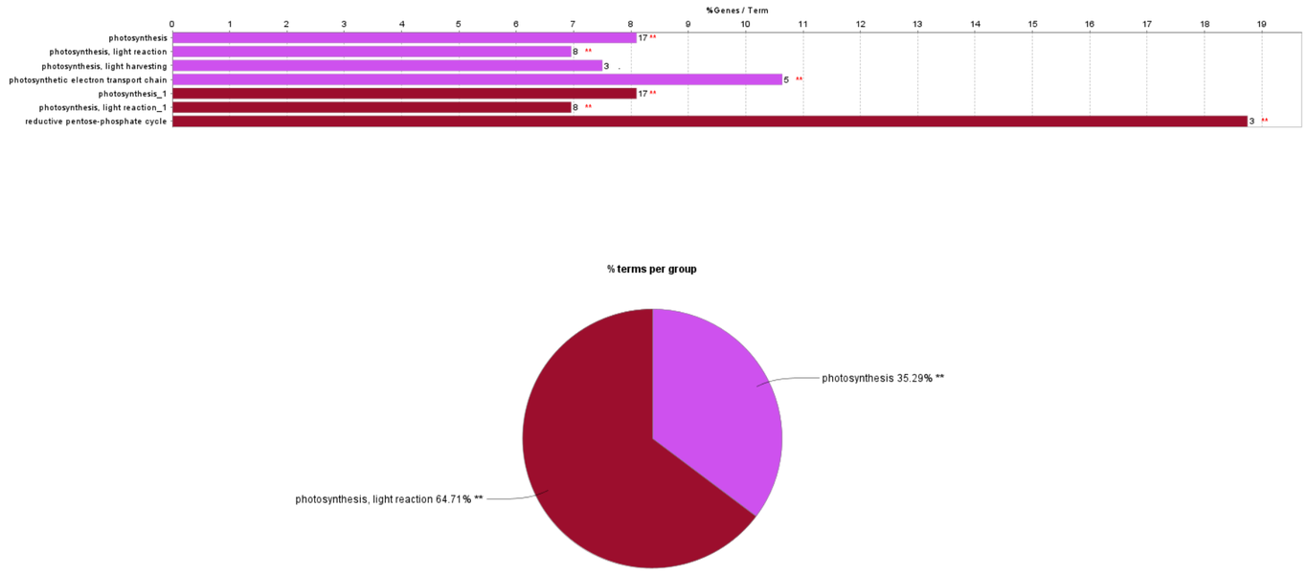
GO Biological process terms associated with the up-regulated proteins.

Conclusion
Given that many proteins carry out their biological functions by the integrated activities of interacting proteins, the aim of this paper was to establish whether the list of proteins previously identified by 2DE proteomics analysis in the work by Ingle et al. (2007) could perform biological interactions. Network analysis can not only predict possible interactions between the proteins in the query list but can also predict associated proteins that act together with the proteins in the query list. The additional protein/gene list can be useful for future biotechnological applications. Results from this work show that proteins in each set (de novo, up-regulated and down-regulated) are mostly connected. PPI analysis identified many other proteins/genes that connect the query proteins together. This has provided a longer list of proteins/genes for each set. Before these added proteins can be of much interest, the differential expression patterns of the predicted associated proteins need wet lab validation. Further, functional enrichment analysis identified statistically significant GO biological process terms that are associated with each set. The approach used in this work is capable of generating novel inferences from resurrection plants proteomics data that has already been published thereby providing more information from data that is yet to be fully exploited.

References
Abdalla KO, Rafudeen MS. Analysis of the nuclear proteome of the resurrection plant Xerophyta viscosa in response to dehydration stress using iTRAQ with 2DLC and tandem mass spectrometry. Journal of Proteomics. 2012 Apr 18;75(8):2361–74.
Bindea G, Mlecnik B, Hackl H, Charoentong P, Tosolini M, Kirilovsky A, et al. ClueGO: a Cytoscape plug-in to decipher functionally grouped gene ontology and pathway annotation networks. Bioinformatics. 2009 Apr 15;25(8):1091–3.
Shannon P, Markiel A, Ozier O, Baliga NS, Wang JT, Ramage D, et al. Cytoscape: a software environment for integrated models of biomolecular interaction networks. Genome Res. 2003 Nov;13(11):2498–504.
Röhrig H, Schmidt J, Colby T, Bräutigam A, Hufnagel P, Bartels D. Desiccation of the resurrection plant Craterostigma plantagineum induces dynamic changes in protein phosphorylation. Plant, Cell & Environment. 2006;29(8):1606–17.
Challabathula D, Bartels D. Desiccation tolerance in resurrection plants: new insights from transcriptome, proteome and metabolome analysis. Front Plant Sci [Internet]. 2013 [cited 2020 Nov 18];4. Available from: https://www.frontiersin.org/articles/10.3389/fpls.2013.00482/full
Wang X, Chen S, Zhang H, Shi L, Cao F, Guo L, et al. Desiccation Tolerance Mechanism in Resurrection Fern-Ally Selaginella tamariscina Revealed by Physiological and Proteomic Analysis. J Proteome Res. 2010 Dec 3;9(12):6561–77.
SHERWIN HW, FARRANT JM. Differences in Rehydration of Three Desiccation-tolerant Angiosperm Species. Annals of Botany. 1996;78(6):703–10.
Farrant JM. Mechanisms of Desiccation Tolerance in Angiosperm Resurrection Plants. In: Plant Desiccation Tolerance [Internet]. John Wiley & Sons, Ltd; 2007 [cited 2020 Nov 25]. p. 51–90. Available from: https://onlinelibrary.wiley.com/doi/abs/10.1002/9780470376881.ch3
Al-Whaibi MH. Plant heat-shock proteins: A mini review. Journal of King Saud University - Science. 2011 Apr 1;23(2):139–50.
Protection mechanisms against excess light in the resurrection plants Craterostigma wilmsii and Xerophyta viscosa SpringerLink [Internet]. [cited 2020 Nov 25]. Available from: https://link.springer.com/article/10.1023/A:1005801610891
Jiang G, Wang Z, Shang H, Yang W, Hu Z, Phillips J, et al. Proteome analysis of leaves from the resurrection plant Boea hygrometrica in response to dehydration and rehydration. Planta. 2007 May;225(6):1405–20.
Oliver MJ, Jain R, Balbuena TS, Agrawal G, Gasulla F, Thelen JJ. Proteome analysis of leaves of the desiccation-tolerant grass, Sporobolus stapfianus, in response to dehydration. Phytochemistry. 2011 Jul 1;72(10):1273–84.
Ingle RA, Schmidt UG, Farrant JM, Thomson JA, Mundree SG. Proteomic analysis of leaf proteins during dehydration of the resurrection plant Xerophyta viscosa. Plant, Cell & Environment. 2007;30(4):435–46.
Proteomic analysis of leaf proteins during dehydration of the resurrection plant Xerophyta viscosa - INGLE - 2007 - Plant, Cell &amp; Environment - Wiley Online Library [Internet]. [cited 2020 Nov 25]. Available from: https://onlinelibrary.wiley.com/doi/full/10.1111/j.1365-3040.2006.01631.x
Abdalla KO, Baker B, Rafudeen MS. Proteomic analysis of nuclear proteins during dehydration of the resurrection plant Xerophyta viscosa. Plant Growth Regul. 2010 Dec 1;62(3):279–92.
Sgherri C, Stevanovic B, Navari‐Izzo F. Role of phenolics in the antioxidative status of the resurrection plant Ramonda serbica during dehydration and rehydration. Physiologia Plantarum. 2004;122(4):478–85.
Signature of Seeds in Resurrection Plants: A Molecular and Physiological Comparison of Desiccation Tolerance in Seeds and Vegetative Tissues1 Integrative and Comparative Biology Oxford Academic [Internet]. [cited 2020 Nov 25]. Available from: https://academic.oup.com/icb/article/45/5/771/624434
Oliver MJ, Tuba Z, Mishler BD. The evolution of vegetative desiccation tolerance in land plants. Plant Ecology. 2000 Nov 1;151(1):85–100.
Warde-Farley D, Donaldson SL, Comes O, Zuberi K, Badrawi R, Chao P, et al. The GeneMANIA prediction server: biological network integration for gene prioritization and predicting gene function. Nucleic Acids Res. 2010 Jul;38(Web Server issue):W214-220.
Ingram J, Bartels D. THE MOLECULAR BASIS OF DEHYDRATION TOLERANCE IN PLANTS. Annu Rev Plant Physiol Plant Mol Biol. 1996 Jun;47:377–403.

