Problemas sobre centroides
Salma Cardoza, Alexia Madahi Reyes-Cobos , Arely Vergara-Pinales, salma
solve the following problems.
Salma Cardoza et al.: Problemas sobre centroides
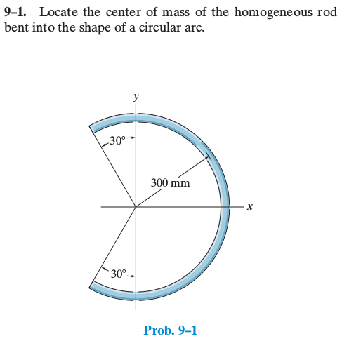
Problem 1

problem 1
$−\frac{2}{3}π,\frac{2}{3}π$
$tilde\left\{x\right\}=r Cos θ$
$y=r Sin θ$
$d L=r d θ$
$d m= P d L$
$\overline{x}=\frac{\int_{−\frac{2π}{3}}^{\frac{2π}{3}}{x} dm}{\int_{−\frac{2π}{3}}^{\frac{2π}{3}}{d}m}$=$\frac{\int_{−\frac{2π}{3}}^{\frac{2π}{3}}{x} P d L}{\int_{−\frac{2π}{3}}^{\frac{2π}{3}}{P} d L}$=$\frac{\int_{−\frac{2π}{3}}^{\frac{2π}{3}}{x} d L}{\int_{−\frac{2π}{3}}^{\frac{2π}{3}}{d} L}$=$\frac{\int_{−\frac{2π}{3}}^{\frac{2π}{3}}{r} Cos θ r dθ}{\int_{−\frac{2π}{3}}^{\frac{2π}{3}}{r}dθ}$=$\frac{r^{2}\int_{−\frac{2π}{3}}^{\frac{2π}{3}}{C}os θ dθ}{\int_{−\frac{2π}{3}}^{\frac{2π}{3}}{d} θ}$=$r Sin θ \int_{−\frac{2π}{3}}^{\frac{2π}{3}}{}$=$\frac{r\left[0.86+0.86\right]}{\frac{4}{3}π}$
=$300m\left(\frac{1.732}{4.188}\right)=124 m$

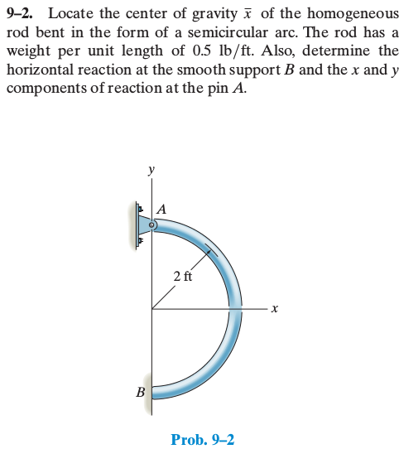
problem 2

problem 2
$\left[\frac{π}{2}, −\frac{π}{2}\right]$
$x=r Cos θ$
$y= r Sen θ$
$dL=rdθ$
$w=\left(0.5\frac{lb}{ft}\right)πft$
$Σfy$
$Ay=w$
$\overline{\left\{x\right\}}=\frac{\int_{l}{r} Cos θ r d θ}{\int_{l}{r}dθ}$=$\frac{r^{2}\int_{−\frac{π}{2}}^{\frac{π}{2}}{C}os θ dθ}{r\int_{−\frac{π}{2}}^{\frac{π}{2}}{d} θ}$=$\frac{2r}{π}$
$B_{x}−A_{x}=0$
$A_{y−w=0}$
$A_{y}=π lb$
$−\overline{\left\{x\right\}}w+4Bx=0$
$−\left(\frac{2r}{π}\right)\left(πlb\right)+4Bx=0$
$\left(4 ft\right)B_{x}=\left(\frac{2r}{π}\right)\left(πlb\right)$
$B_{{}_{x}=1 lb}$
$\frac{w}{L}=0.5\frac{lb}{ft}$
$L=π\left(2ft\right)$
$=πlb$
$B_{x}=A_{x}=1 lb$

Salma Cardoza is with Instituto Tecnológico Superior Zacatecas Occidente
Alexia Madahi Reyes-Cobos is with Instituto Tecnológico Superior Zacatecas Occidente
Arely Vergara-Pinales is with Instituto Tecnológico Superior Zacatecas Occidente
salma is with Instituto Tecnológico Superior Zacatecas Occidente

