Crystal structure of (E)-2-(tert-butylamino)-4-(tert-butylimino)naphthalen-1(4H)-one
Guy Lamoureux
Mónica Alvarado Rojas
leslie.pineda
Guy Lamoureux,ª* Mónica Alvarado-Rojas,ª
a Escuela de Química, Universidad de Costa Rica, 2060 San Pedro, San José, Costa Rica
*Correspondence e-mail: guy.lamoureux@ucr.ac.cr
The title compound, C₁₈H₂₄N₂O, an example of a naphthoquinone imine in a specific tautomeric form, was determined at 100 K and has monoclinic (P21/c) symmetry. This structure is stabilized by a intramolecular H-bond between the N-H and the carbonyl and London attraction between the two tert-butyl groups. The imine C=N bond length at C4 is 1.291 (3) Å , which is shorter than the enamine C—N bond length at C2 [1.353 (3) Å ], indicating that the tautomer shown is the correct structure in the solid state.

Chemical Context
Naphthoquinones (naphthalenediones) form an important part of some pharmacophores in medicinal chemistry. During an exploration of antimalarial drugs, Fieser indicated that aminoiminonaphthoquinones (Fig. 1), although difficult to form, had interesting medicinal properties. Bullock et al. further investigated these compounds as antiprotozoal agents and provided more efficient ways to synthesize a series of these compounds.

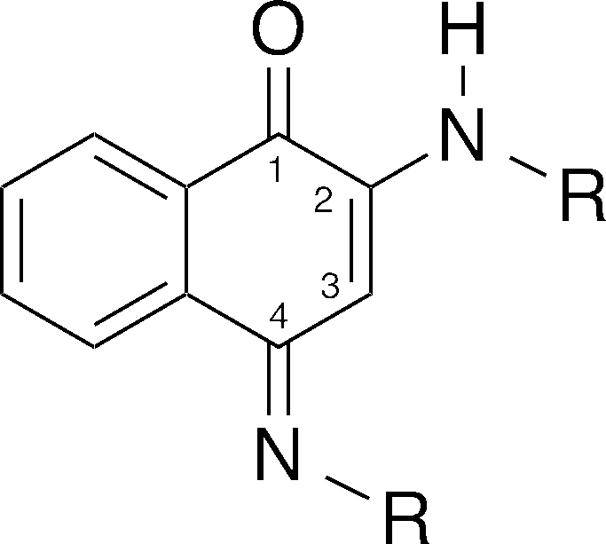
General structure of (E)-2-amino-4-iminonaphthoquinone (R=alkyl group)
Similar structures have been prepared naturally as a hydrolytically stable pigments. Recently, several natural products containing a rigid aminoiminoquinone structure have been isolated and identified: macrophilone A, the makaluvamine, isobatzelline, prianosin, epinardin and discorhabdin families, and waykayin. These alkaloid secondary metabolites from marine organisms were found to possess cytotoxic antitumor properties. It is reported that the aminoiminoquinone system may contribute to the cytotoxic activity.
Although the structure depicted in Figure 1 was thought to be the most stable, there was evidence for multiple equilibria of these compounds in solution (Fig. 2). For example, in the case of the methyl derivative (R = Me), NMR evidence at room temperature shows a mixture of tautomers. This equilibrium, especially the possibility of tautomers, is important since the biological activity of these compounds depends on which tautomer is more stable.

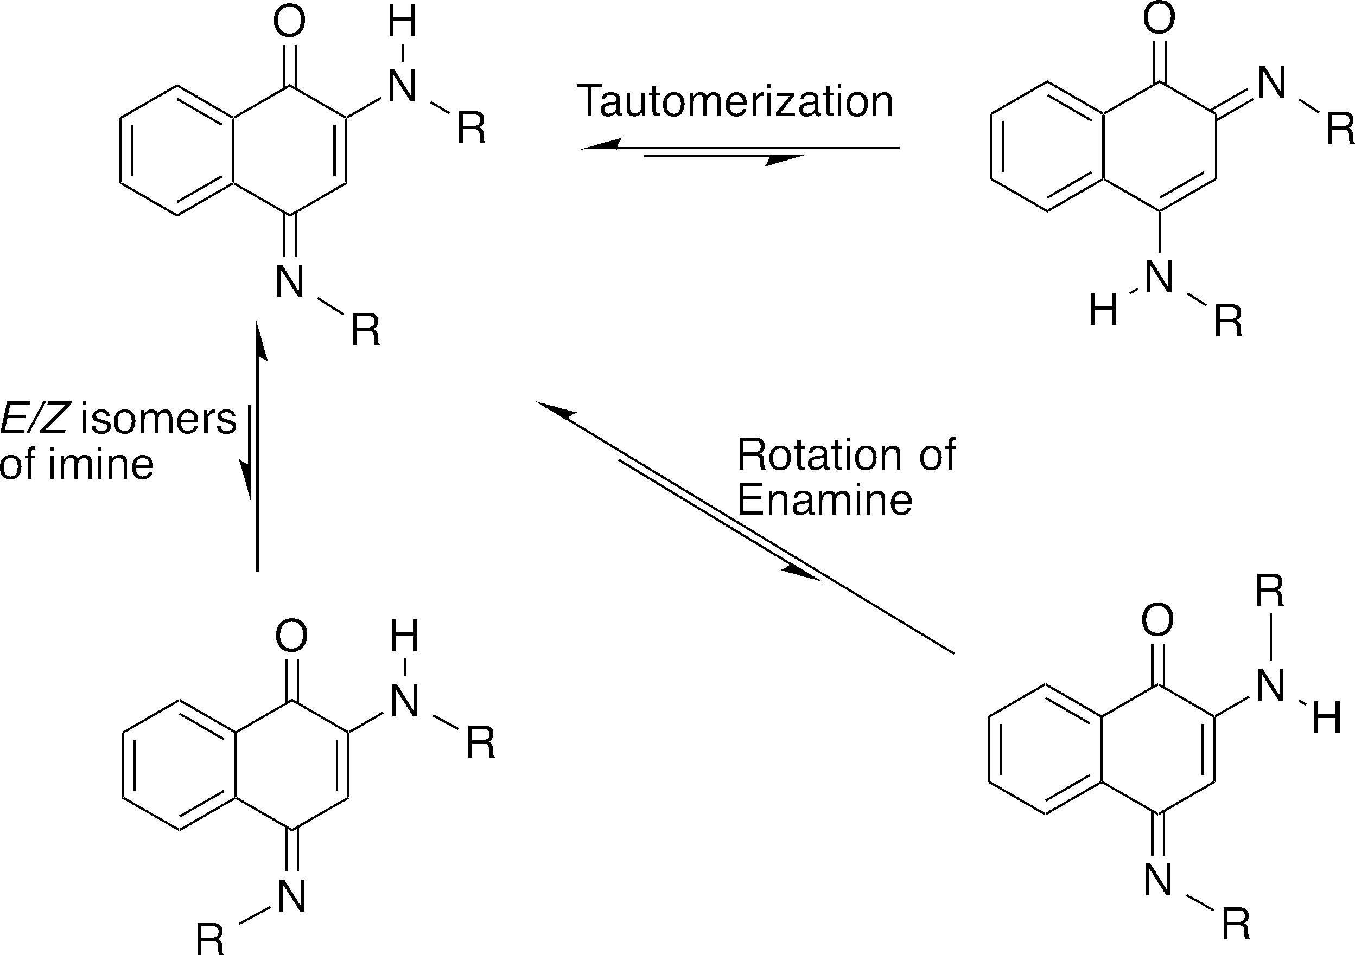
Possible equilibrium forms of the aminoimino structure.
We predicted that this type of compound would not form with bulky R groups. (E)-2-(tert-butylamino)-4-(tert-butylimino)naphthalen-1(4H)-one (I) (Fig. 3) is the first compound of this type with a tertiary alkyl group.

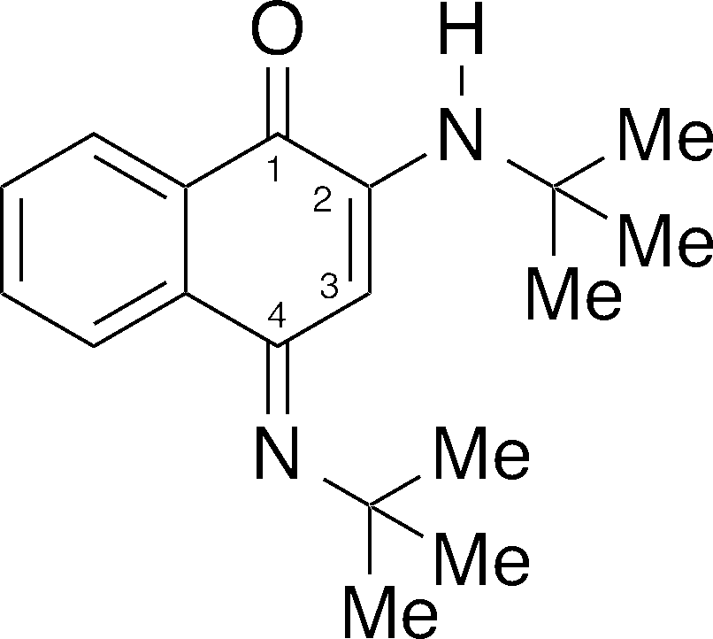
2D Structure of (E)-2-(tert-butylamino)-4-(tert-butylimino)naphthalen-1(4H)-one (I)
As part of our work on the synthesis and properties of naphthoquinones, we isolated compound (I) as a secondary product. To confirm the identity and form of this compound, we report the crystal structure of (E)-2-(tert-butylamino)-4-(tert-butylimino)naphthalen-1(4H)-one (Fig. 4).

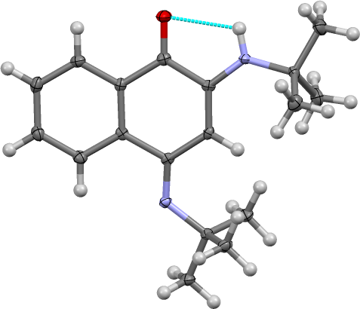
The molecular structure of compound (I), showing the displacement ellipsoids drawn at the 50% probability level. The intramolecular hydrogen bond is shown by the dashed bond.

Structural commentary
Compound (I) possesses an intramolecular hydrogen bond between the N-H on C2 and the carbonyl at C1 (Table 1). This H-bond can more easily be seen in the space-filling model of Compound (I) (Fig. 5). The intramolecular interaction forms a 5-membered ring with an angle between the donor N-H and the C=O of 109 (2)°. The C2-N-H bond angle [115 (2)°] is biased toward the carbonyl. The distance between the donor H and the acceptor carbonyl oxygen is 2.20 (2) Å, shorter than expected due to the bulkiness of the tert-butyl group (vide infra).
Hydrogen-bond geometry (Å, ° ).
D–H•••A | d D–H | d H•••A | d D•••A | ∠ D–H•••A
N2–HN2•••O1 | 0.88 (2) | 2.2 (2) | 2.63 (1) | 109 (2)
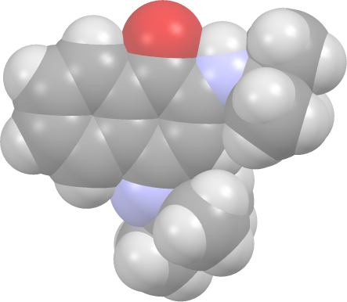
Space-filling structure of (E)-2-(tert-butylamino)-4-(tert-butylimino)naphthalen-1(4H)-one (I)
These tert-butyl groups also shield the nitrogens and provide a hydrophobic environment on one side of the quinone. As shown in Figure 6, the carbons of the tert-butyl groups are between 4.228 (4) and 4.825 (4) Å, which brings them within distance of London attraction.

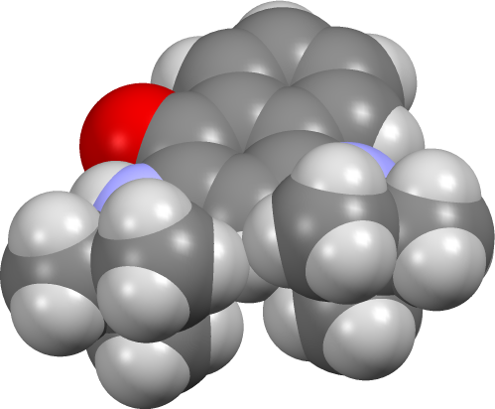
Side view of space-filling structure of compound (I)
The imine C=N bond length at C4 is 1.291 (3) Å , which is shorter than the enamine C—N bond length at C2 [1.353 (3) Å ] reflecting the greater double bond character at C4. The distance between the enamine N/t-butyl C [1.475 (4) Å] is shorter than the imino N/t-butyl C [1.485 (3) Å] due to steric compression at the imine. However, the bond angles around the two nitrogens [imine C4-N-C(tert-butyl) = 124.1 (2)° versus enamine C2-N-C(tert-butyl) = 129.2 (2)°] are very similar due to the delocalization of pi electrons between the two nitrogens. This system can be considered to be a type of vinylogous amidine, with both nitrogens as trigonal planar. The aromatic ring is planar, as expected, and has internal bond angles that range from 118.6 (2)° to 120.6 (2)°. However, the quinone system is slightly non-planar, with the C3-C4(imine)-C4a angle of 116.9 (2)° showing the greatest deviation from the ideal 120°.

Supramolecular features
In the crystal structure of (I) (Fig. 7), the center of the unit cell contains the tert-butyl groups. There are no intermolecular hydrogen bonds, as seen in a similar structure with n-butyl groups (vide infra); the tert-butyl groups shield the nitrogen and prevent close approach of the supramolecular donors and acceptors. There are no pi–stacking interactions present; the aromatic rings are separated by more than 6 Å.

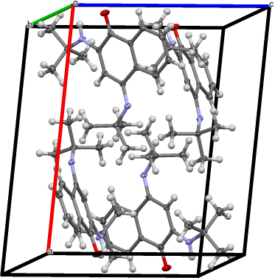
The crystal packing of compound (I), viewed along the b-axis direction.

Database survey
A search of the Cambridge Structural Database (Version 5.38, update November 2016; Groom et al., 2016) for the substructure of 2-(alkylamino)-4-(alkylimino)naphthalen-1(4H)-one yielded 3 hits (we did not restrict the bonds types to the mayor tautomer). Two of the structures, ESOFID (Schweinfurth et al., 2016) and UDAZEF (Singh et al., 2007) use aromatic amines [aniline or substituted aniline] as the amine moiety. Only one structure, UDAZIJ (Singh et al., 2007), uses an aliphatic primary amine (n-butylamine) in the positions 2 and 4. UDAZIJ is noteworthy because the intramolecular N-H•••O bond is 2.34 (2) Å, much longer than compound (I), and that in the crystal lattice of UDAZIJ a dimeric assembly forms held together by intermolecular hydrogen bonding interactions between the N-H and carbonyl of adjoining molecules.

Synthesis and crystallization
The synthesis of (E)-2-(tert-butylamino)-4-(tert-butylimino)naphthalen-1(4H)-one is based on a new procedure (complete publication in progress). A total of 192 mg (1.00 mmol) of 4-chloronaphthalene-1,2-dione and 211 µL (2.00 mmol, 2 equiv.) of tert-butylamine were dissolved in tert-amyl alcohol (3.0 mL). This solution was stirred at 110 °C under a nitrogen atmosphere for 2 hours. After being allowed to cool to room temperature, the green-brownish solution (originally yellow) was diluted with saline water (30 mL) and extracted with ethyl acetate (3 X 20 mL). The combined organic layers were dried over Na₂SO₄, filtered, and then concentrated under reduced pressure. The crude material (249 mg, a brown dark solid) was separated by silica gel column chromatography using ethyl acetate to obtain the reaction product and the secondary product (compound (I); 119 mg, a dark brown oily solid). Compound (I) was further purified by another silica gel column chromatography using a gradient [100% dichloromethane (CH₂Cl₂) and then 100% methyl tert-butyl ether (C₅H₁₂O)], the fractions were dried under vacuum pressure to yield 14 mg of the pure product (5% yield) as a yellow oily solid. Part of the purified product was re-dissolved in methanol with a few drops of water and placed at room temperature for slow evaporation. After several days, yellow needle-like crystals were obtained. Mp (104-105) °C using a Fisher-Johns with calibrated thermometer; ¹H-NMR (600 MHz, CDCl₃) δ 8.46-8.48 (dd, J = 7.8, 1.3 Hz, 1 H), 8.09-8.12 (dd, J = 7.8, 1.3 Hz, 1 H), 7.61-7.64 (td, J = 7.8, 1.3 Hz, 1 H), 7.48-7.52 (td, J = 7.8, 1.2 Hz, 1 H), 6.36 (s, 1 H), 5.53 (br. s, 1 H), 1.56 (s, 9 H), 1.47 (s, 9 H).

Refinement details
Crystal data, data collection and structure refinement details are summarized in Table X. All hydrogen atoms are placed in calculated positions [C—H = 0.98–0.99 Å; U iso(H) = 1.2 or 1.5U eq(C)].
Acknowledgements
The Centro de Investigaciones en Productos Naturales (CIPRONA), the Centro de Electroquímica y Energía Química (CELEQ) and the Escuela de Química, Universidad de Costa Rica (UCR) provided support.
References

