Title
Rahul Motan

Assignment - 3
1 a) To prove the problem can be solved using Dynamic Programming, We need to first prove the problem has a optimal substructure. Let’s assume we are given $n=5$ points such that $p_{i}=\left(x_{i},y_{i}\right) ∀ 1≤i≤5$
There is no intuitive way to suggest an optimal solution but to check for all given points & find the best set of fitting lines. To do this we can assume we have an optimal solution $O$, and in this lies the $n^{th}$ point $p_{n}$. Now, there must be a line segment beginning at some point ‘$i$’ that connects the $n^{th}$ point and is the best fit among all possible lines drawn from $i, i+1, i+2. . . . n$

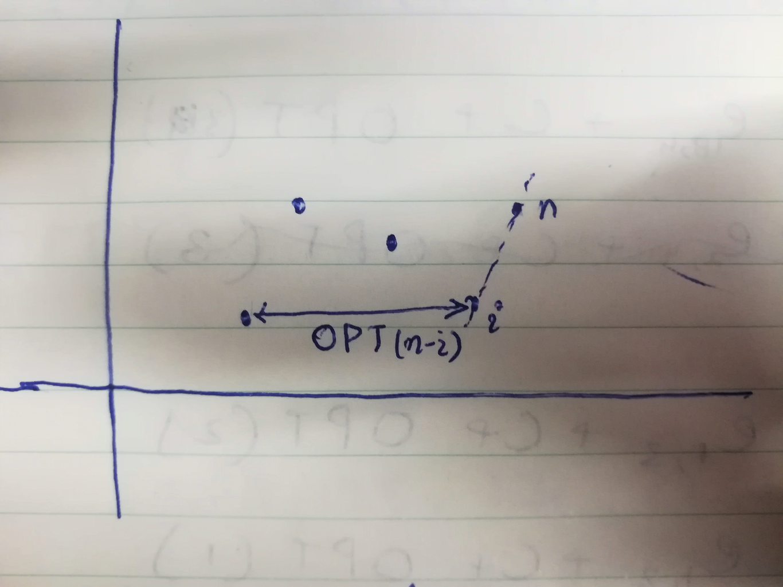
For n = 5
Thus, further evaluation of the above sub-structure gives the following recurrence for $n∈O$,
here we can say, $OPT\left(0\right)=0$ as for no point there will be no penalty.
$OPT\left(n\right)=E\left(i,n\right)+C+OPT\left(n−i\right)$
$Points remaining≡$ $n−i=i−1, \left(1,2,3....i....n\right)$
$OPT\left(n\right) = E\left(i,n\right)+C+OPT\left(i−1\right)$
b) So for the above given recursion we can draw a recursion tree to visualize if our optimal substructure stands correct.

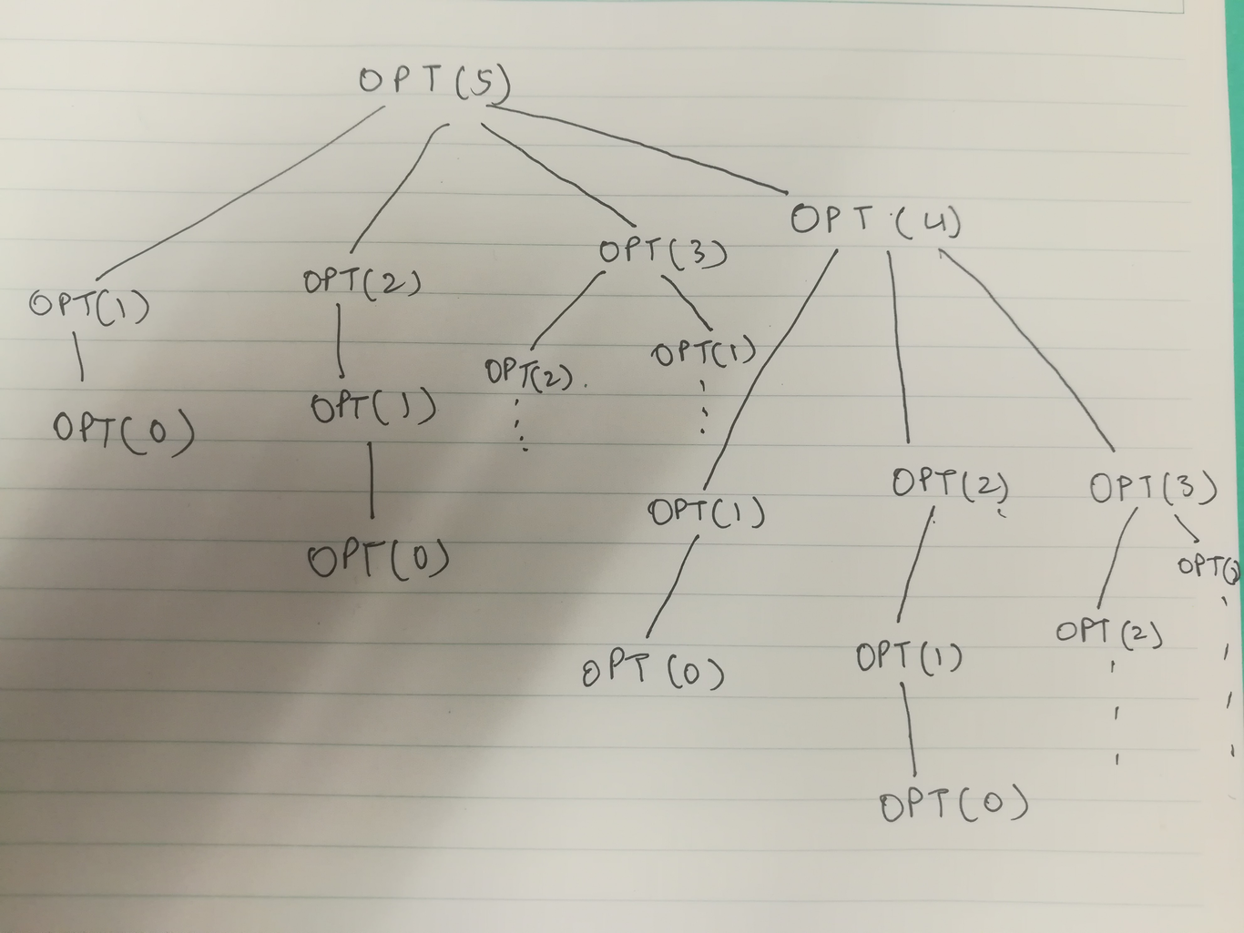
Recursion tree for n = 5
As we can see this type of recursion depicts optimal substructure as our sub-problems lead to the solution of the problem if we go bottom-up.
Since we have to find the best fitting line, we’ll have to minimize the penalty for all the points.
So the recurrence for the remaining $i to j points$ can be given as:-
$OPT\left(j\right) = min\left(E\left(i,j\right)+C+OPT\left(i−1\right)\right) ∀ 1≤i≤j$
c) Error computation involves computing error for $i.j ≃ n^{2}$ pairs and using the formula that is given it will take $O\left(n\right)$ time for calculating all the co-efficients for every pair so this takes the time complexity to $O\left(n^{3}\right)$
Next we iterate over all the pairs to calculate the penalty for each pair of points starting from 1 to n. So that takes time in the order of $O\left(n^{2}\right)$. So the total time complexity remains to be $O\left(n^{3}\right)$.
Space Complexity: For memoization we’ll need an array of size $O\left(n\right)$ and to save all the error (for all i,j pairs) we’ll need $O\left(n^{2}\right)$ space

d) BEST-FIT($P\left\{\left(x_{1}, y_{1}\right),\left(x_{2},y_{2}\right),\left(x_{3},y_{3}\right),\left(x_{4},y_{4}\right) . . . . \left(x_{n,}y_{n}\right)\right\}$){
$foreach i←1 to n$ {
$foreach j←i+1 to n$ {
$compute E\left(i,j\right)$
}
}
Create memo table M of size n
$M\left[0\right]=0$ // OPT(0) = 0
$A\left[0...n\right]$
$foreach i←1 to n$ {
$M\left[i\right]=∞$
$foreach j←1 to i$ {
$if M\left[j−1\right]+C+E\left(j,i\right)<M\left[i\right]$
$M\left[i\right]=E\left(j,i\right)+C+M\left[j−1\right]$
$A\left[i\right]=j$
}
}
traverse backwards through A beginning from A[n] till 0 as the value at A[n] will be the $i^{th} point$ where the last optimal partition was created save the values in array say parts[]
return parts
}

2) a) In this problem we are given a sequence of ‘n’ weights for each participant i.e total ‘m’ participants. Let’s suppose we have an optimal solution for this problem, say $O$.
Now, consider the $n^{th}$ weight of a participant, that weight can either belong to the longest weight loss sequence or not, if it does we just add this to already found subsequence & we get an even longer subsequence otherwise we just look at the remaining n-1 weights and find a subsequence from it. Given problem is quite similar to the problem of finding longest common subsequence in two strings.

b) Given a sequence of numbers, say $A =\left\{a_{1},a_{2},...., a_{n}\right\}$ we can find the longest decreasing subsequence which will be a subset of $A$. It need not consist of consecutive members from the original array. Let that sequence be $Z=\left\{z_{1},z_{2},....., z_{k}\right\}$ where $\left|Z\right|≤\left|A\right|$ and $z_{1}>z_{2}>z_{3}......>z_{k}$. We need to find all the possible subsets of the form given above and then check which is the longest of them all. To compute that we compare every$i member with the j member such that 0≤i≤j \&amp; 1≤j<n$ and increase the length of the subset if the conditions match. Individually every member of the array ’A’is in itself a decreasing subsequence.
c) LongestLoss(int[] ar){
// initialize memo table with value 1 as all of the elements are decreasing subsequence in itself
M[0…m][0…n] = 1
SSeq[0…m][0….n]
$for k←0 to m$ {
$for i← 1 to n$ {
$for j←0 to n$ {
$if\left(ar\left[k\right]\left[j\right]>ar\left[k\right]\left[i\right] AND M\left[k\right]\left[i\right]<M\left[k\right]\left[j\right]\right)${
$M\left[k\right]\left[i\right] = 1+M\left[k\right]\left[j\right]$
$SSeq\left[k\right]\left[i\right] = j$
}
}
}
}
max, (i,j)$←$Now find the maximum in M and save the value and index [i][j] of the location
weeks[]$←$from this SSeq[i][j] traverse backwards as all the week numbers are stored as linked to the index
return max, weeks

