A de nuovo glance on the gene Resuscitation-promoting factor (rpfb) of Mycobacterium Tuberculosis (MTb) using a Sequence Analysis approach.
Ioannis Valasakis
The purpose of this coursework is to provide computational research information on rpfb, a gene in the Mycobacterium Tuberculosis (MTb). It is also known by its ID: RV1009. The approach is going to be methodological, as discussed in Sequence Analysis lectures. Computational Software, Online Databases and Web Services like Protein BLAST, HHBlits and InterPro are utilised to retrieve the required information in order to generate further insights.

Introduction
RpfB is a gene responsible for the creation of the protein Resuscitation-promoting factor (RpfB) in the Mycobacterium Tuberculosis (MTb). Resuscitation of MTb is crucial to the aetiology of Tuberculosis, not only because latent tuberculosis is estimated to affect one-third of the world population(Ruggiero et al. 2009). Kapoor et all showed that the resuscitation-promoting factor RpfB is mainly responsible for MTb resuscitation from dormancy (Kapoor et al. 2013). Given the impact of latent Tuberculosis, RpfB represents an interesting target for tuberculosis drug discovery. Currently, no molecular models of substrate binding and catalysis are hitherto available for this enzyme.
In the Central Dogma of Molecular Biology (CRICK 1970), Sir Francis Crick describes the one-way process where each gene in the DNA molecule carries the information needed to construct one protein, which, acting as an enzyme, controls one chemical reaction in the cell. This coursework is structured based on the above mentioned idea.

KEYWORDS
rpfb; tuberculosis; sequence analysis; cell wall

Results

General Genome Features
RpfB gene is located in the forward strand of the MTb chromosome in the location 1,128,091-1,129,179, with a length of 1089 bp. It consists of 362 amino acids and it has the transcript ID CCP43759 (also known as Rv1009), the protein ID 362aa and a UniProt ID of P9WG29. The current review of

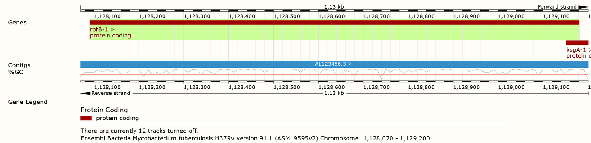
EnsemblBacteria view of the gene RpfB.

Transcriptional Regulation
Test

Protein
To discover the conserved protein domains of the protein, I used NCBI’s Conserved Domain Database (CDD). The protein is characterised as a resuscitation-promoting factor, which is a cell-wall glycosidase that cleaves cell-wall peptidoglycan; it stimulates resuscitation of dormant cells. Three domains are conserved: YabE, Transglycosylase and G5. Similar results can be shown by using the InterPro protein database.

Discussion

License
© 2018 Ioannis Valasakis. This manuscript version is made available under the CC-BY-NC-ND 4.0 license http://creativecommons.org/licenses/by-nc-nd/4.0

References
Ruggiero, Alessia, Barbara Tizzano, Emilia Pedone, Carlo Pedone, Matthias Wilmanns, and Rita Berisio. 2009. “Crystal Structure of the Resuscitation-Promoting Factor (DeltaDUF) RpfB from M. Tuberculosis”. Journal of Molecular Biology 385 (1). Elsevier BV: 153–62. doi:10.1016/j.jmb.2008.10.042.
Kapoor, Nidhi, Santosh Pawar, Tatiana D. Sirakova, Chirajyoti Deb, William L. Warren, and Pappachan E. Kolattukudy. 2013. “Human Granuloma In Vitro Model for TB Dormancy and Resuscitation”. Edited by Pere-Joan Cardona. PLoS ONE 8 (1). Public Library of Science (PLoS): e53657. doi:10.1371/journal.pone.0053657.
CRICK, FRANCIS. 1970. “Central Dogma of Molecular Biology”. Nature 227 (5258). Springer Nature: 561–63. doi:10.1038/227561a0.

