Ultrasound-guided muscle biopsy: a practical alternative for investigation of myopathy
Anish Raithatha
Dimitri Amiras
christopher.lord
stuart.viegas
Mohammad Reza Ashraghi
Introduction
Muscle biopsy is an essential diagnostic procedure in the investigation of the diagnosis of myopathy (Dastmalchi & Alexandersson, 2010).
The cohort of patients undergoing this procedure often have multiple co-morbidities, posing a significant anaesthetic risk and requiring that the muscle biopsy procedure is performed under general anaesthesia which infers additional clinical risk. Furthermore muscle biopsies for the diagnosis of neuromuscular pathology require careful preservation of cellular architecture, which is less important for biopsies used for the diagnosis of other pathologies such as malignancy . Exploration of alternative methodologies to obtain adequate muscle biopsy samples is therefore of benefit to patients and patient care.

Local protocol utilises a combination of clinical evaluation and MRI routinely to identify suitable targets for muscle biopsy by open surgical biopsy procedure. MRI is used to identify muscles that do not demonstrate significant fat content with preference to those demonstrating features of active disease with intrinsic muscle and peri-fascial oedema (Figure 1).

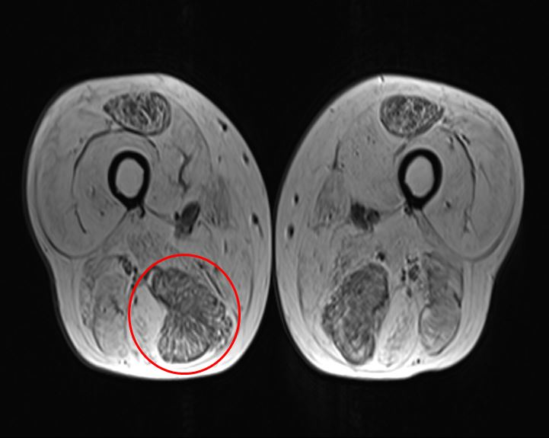
Axial T1 MRI image of the thighs, demonstrating fatty atrophy of the majority of the muscle groups and relatively sparing of the rectus femoris and semimembranosus muscles bilaterally. The right semimembranosus was selected for biopsy (circled), based on its reduced fat content.

Despite this pre-procedural planning muscle biopsies can be non-diagnostic, due to a combination of the limited accuracy of intra-operative identification of viable muscle and the constraint of access to target muscles (Joyce, Oskarsson, & Jin, 2012). A retrospective review of 106 patients undergoing muscle biopsy demonstrated a diagnostic pathologic yield of 47% (Tenny & Follett, 2018).
To complement the surgical technique, we have initiated an ultrasound-guided muscle biopsy service utilising a modified Bergström needle and vacuum technique. This allows the targeting of muscles previously not suitable for a surgical biopsy.
Aims and objectives
To retrospectively review the diagnostic accuracy and patient feedback outcomes of our ultrasound-guided muscle biopsy service that is utilised for the investigation of myopathy.

Methods and materials
At our muscle multidisciplinary team meeting (MDT), selected difficult cases of patients with undiagnosed myopathy where an open surgical biopsy was non-diagnostic or deemed too technically challenging, were discussed. If it was felt to be feasible by the musculoskeletal radiologist, a target muscle was identified on magnetic resonance imaging (MRI) and an ultrasound guided muscle biopsy was scheduled. A modified Bergström needle (Figure 2) and vacuum technique was performed under ultrasound guidance to better target a previously identified muscle (Figure 3).
After identifying the target muscle using ultrasound, local anaesthetic was infiltrated into the subcutaneous tissue and fascial plane. Facial perforation was then performed using a scalpel under direct sonographic guidance, to avoid any significant vascular structures and facilitate passage of the blunt tipped bergstrum needle into the muscle compartment.
The modified Bergström needle was then advanced to the target muscle under continuous sonographic guidance under high flow suction (Figure 4).
Once the needle was passed into the muscle, the stylet was retracted and 1-2 passes were performed. Each sample was placed in an universal container and sent for immediate histopathological analysis.
After the procedure each patient was observed whilst asked to lie on the site of biopsy for 2 hours. Once stable the patient was discharged.

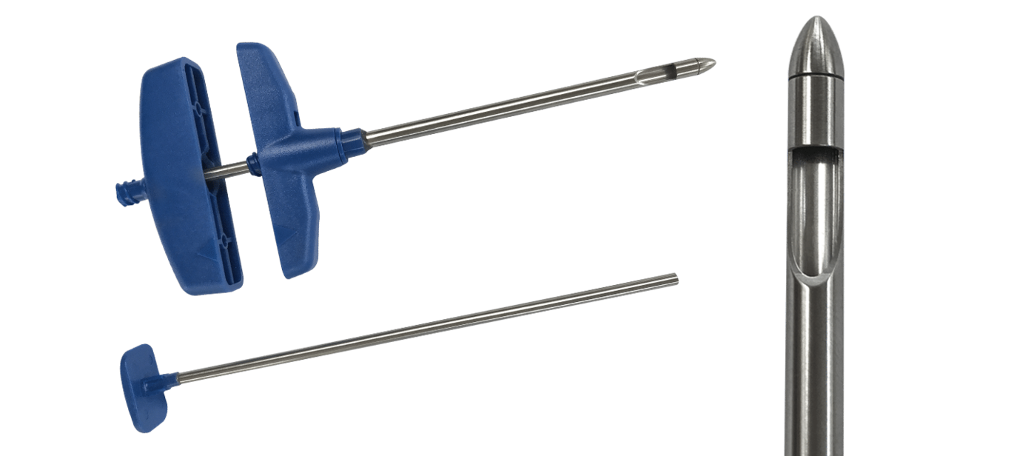
Modified Bergström needle (“Muscle Biopsy Needle”, n.d.)
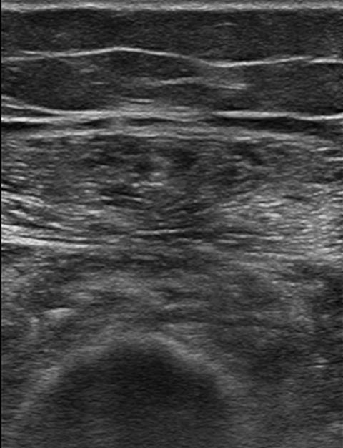
Ultrasound of the leg demonstrates an expanded, hyperechoic semimembranosus muscle.

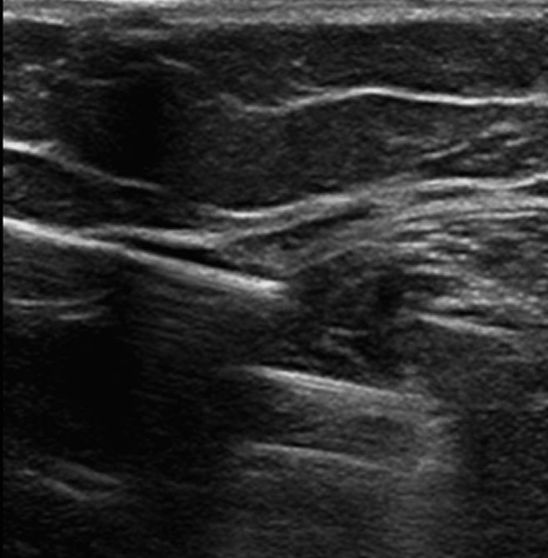
The muscle was targeted under real-time ultrasound guidance, and biopsy samples retrieved utilising a modified Bergström needle and suction technique. The above image shows the gap for the biopsy and identifies the muscle fibers being sampled
Post-biopsy, patients were reviewed on an outpatient basis, determined by clinical need.
Histology reports for the ultrasound-guided procedures were reviewed to confirm if this technique had allowed adequate diagnosis. Samples for genetic analysis

In addition, each patient undergoing the procedure was retrospectively surveyed and asked to comment on any scar, complication and if they would favour the procedure in the future.
Results
Over a two year period, a cohort of 10 patients met criteria to undergo the ultrasound-guided muscle biopsy using a modified Bergström needle and suction technique. These patient’s underwent a total of 11 biopsies during this time. Table 1. summarises the outcome of these.
A retrospective review demonstrated that ten of the eleven samples were of satisfactory diagnostic quality and permitted histological analysis. The one that was non-diagnostic was inappropriately transported in formaldehyde following the biopsy. The biopsy for this patient was successfully repeated. One patient had vastus lateralis and a paraspinal muscle biopsied. For this patient, the vastus lateralis was diagnostic, but the paraspinal was not. Furthermore, all ten of the successful ultrasound-guided biopsies aided a diagnosis, either by confirming non-specific muscle pathology, directly supporting a specific diagnosis or by excluding a specific diagnosis.

Patient feedback from the procedure was encouraging and no significant complications were reported. Four patients had undergone a surgical biopsy previously. Two of these preferred the ultrasound-guided biopsy to the surgical approach, while the remaining two did not specify. No complications were reported from the eleven biopsies. When asked to rate their experience between 0-5, with 0 being extremely poor and 5 being excellent, six patients rated 4 or 5, one rated 3. The others did not fill this part of the questionnaire.
Furthermore, of the four patient’s who had had a previous surgical biopsy that had been unsuccessful in establishing a diagnosis, an ultrasound guided biopsy was successful in aiding a diagnosis in all. This is particularly well demonstrated in a case of a 55 year old patient with a history of myopathic weakness since his teenage years affecting all limbs and extra-ocular muscles. The MRI of his muscles had shown marked atrophy and fatty infiltration (Figure 1) , making a viable muscle biopsy target difficult to select. This was discussed with the neurosurgical team who did not feel they could reliably biopsy muscle. He had already undergone two surgical muscle biopsies over the preceding decade which had been non-diagnostic. Therefore, after discussion in muscle MDT, he underwent a successful ultrasound guided muscle biopsy using the aforementioned technique. This high quality biopsy has aided us in diagnosing an autophagic vacuolar myopathy that is suspected to be a new case of X-linked myopathy with excessive autophagy (XMEA).

Summary of ultrasound guided muscle biopsy outcome and feedback. * Biopsy transported in formaldehyde. ** 2 samples taken from quadricep and paraspinal muscles. Quadricep sample was appropriate, paraspinal was not. *** 0 (extremely poor) - 5 (Excellent).
Patient # | Previous Surgical Biopsy | Complications | Appropriate Sample | Diagnostically helpful | Diagnosis | Feedback Available | Patient Experience* | Preferred to surgical biopsy (if applicable)
1 | Yes | No | Yes | Yes | Systemic Vasculitis | Yes | 5 | Yes
2 | No | No | Yes | Yes | Jo-1/Ro 52 associated inflammatory myopathy | Yes | 3 | N/A
3 | Yes | No | Yes | Yes | Autophagic Vacuolar Myopathy | Yes | 4 | No response.
4 | No | No | Unknown* | No | Unspecified Myopathy | Yes | 4 | N/A
5 | No | No | Yes | Yes | Possible LGMD | No | N/A | N/A
6 | No | No | Yes | Yes | No definite muscle pathology | No | N/A | N/A
7 | No | No | Yes** | Yes | Non-specific pathology – Possible axial myopathy | No | N/A | N/A
8 | Yes | No | Yes | Yes | Sporadic late-onset nemaline rod myopathy | Yes | 5 | Yes
9 | Yes | No | Yes | Yes | Anti-SRP +ve necrotising myopathy | Yes | 5 | Yes
10 | No | No | Yes | Yes | Likely IBM | Yes | 5 | N/A
11 | No | No | Yes | Yes | Axial Myopathy | No | N/A | N/A
Discussion
Image-guided muscle biopsy is performed at multiple institutions globally, utilising either MRI or sonographic guidance (Lindequist, Larsen, & Schrøder, 1990) (Lassche, Janssen, Voermans, Futterer, & van Engelen, 2014). However, current evidence demonsrates that sonographic-guidance is associated with fewer bleeding complications and is more cost-effective than utilisation of MRI due to the longer procedure time and use of disposable materials (Lassche, Janssen, Voermans, Futterer, & van Engelen, 2014). Current studies have not utilised a modified Bergström needle technique in combination with ultrasound guidance, and therefore our data set is the first to evaluate the use of this approach with ultrasound.
Ultrasound-guided per cutaneous muscle biopsy has been demonstrated to provide diagnostic rates comparable to open biopsy in the assessment of acute muscle disease but less successful for chronic disease (O’Sullivan, Gorman, Hardiman, Farrell, & Logan, 2006) . Furthermore, this technique conveys further practical benefits : the modified Bergström needle and suction technique is best utilised for difficult to access muscle groups that cannot be targeted using an open approach , requires a smaller incision and reduces use of surgical theatre time. The procedure is also rapid and can be performed in an outpatient setting under local anaesthesia. Visualisation of key structures minimises the risk of post procedural bleeding. Additionally, the procedure is better tolerated by patients in comparison to surgical methods.
Furthermore, from a operational perspective, it is more feasible to allocate these procedures on an ultrasound list without impacting modality demand, in comparison to utilising MRI, when most departmental MRI scanners are used to near maximal capacity, and therefore this could create additional patient back-logs.
Our current data demonstrates a 100% success rate for utilisation of an ultrasound-guided approach in cases where open surgical biopsy has been inconclusive, and thereby establishes the use of sonographically-guided biopsy as a viable practice to facilitate accurate histological diagnosis in this patient sub-cohort. The potential benefit of this approach is particularly demonstrated in the case of XMEA described above. Furthermore, excluding a single processing error, 100% of our patients had a diagnostically helpful biopsy using ultrasound guidance.
The procedure was well tolerated by patients with minimal bleeding. No complications were reported by patients. At least half of those who have previously had a surgical biopsy expressed a preference for the ultrasound guided approach and none expressed a preference for surgical biopsies.
Conclusion
In the context of establishing a neuromuscular diagnosis, we demonstrated benefit in utilising an ultrasound-guided modified Bergström needle technique to obtain viable histological samples in patients that have had an unsuccessful open biopsy procedure.
Previous studies have utilised this technique with MR-guidance, but our data shows that an ultrasound guided procedure infer additional advantages, providing comparable success rates to other techniques, and have practical, clinical, operational and patient-centred benefits compared to alternative techniques.
Furthermore, the procedure was not associated with significant complication and was well tolerated by patients with positive feedback.

References
. https://www.merit.com/peripheral-intervention/biopsy/bone-biopsy/muscle-biopsy-needle/. Retrieved from https://www.merit.com/peripheral-intervention/biopsy/bone-biopsy/muscle-biopsy-needle/
Dastmalchi, M., & Alexandersson, H. (2010). Targeted Treatment of the Idiopathic Inflammatory Myopathies. In Targeted Treatment of the Rheumatic Diseases (pp. Chapter 14). Elsevier. https://doi.org/10.1016/b978-1-4160-9993-2.00014-x
Joyce, N. C., Oskarsson, B., & Jin, L. W. (2012). Muscle biopsy evaluation in neuromuscular disorders.. Phys Med Rehabil Clin N Am, 23, 609–631.
Lassche, S., Janssen, B. H., Voermans, N. C., Futterer, J. J., & van Engelen, B. G. M. (2014). G.P.16. Neuromuscular Disorders, 24(9-10), 799. https://doi.org/10.1016/j.nmd.2014.06.030
Lindequist, S., Larsen, C., & Schrøder, H. D. (1990). Ultrasound guided needle biopsy of skeletal muscle in neuromuscular disease. Acta Radiologica, 31(4), 411–413. https://doi.org/10.3109/02841859009172017
O’Sullivan, P. J., Gorman, G. M., Hardiman, O. M., Farrell, M. J., & Logan, P. M. (2006). Sonographically Guided Percutaneous Muscle Biopsy in Diagnosis of Neuromuscular Disease. Journal of Ultrasound in Medicine, 25(1), 1–6. https://doi.org/10.7863/jum.2006.25.1.1
Tenny, M., Schmidt, & Follett. (2018). An assessment of preoperative evaluation modalities in predicting muscle biopsy diagnostic yield and therapeutic impact. Rheumatology and Orthopedic Medicine, 3(1). https://doi.org/10.15761/rom.1000142

