Chp 1: Introduction
Torey
(Ho, Baryshnikova, and Brown 2018)
(Zhao and Fang 2005)
(Straight, Field, and Mitchison 2005)
(Zihni et al. 2016)
(Arnold, Stephenson, and Miller 2017)
(Chen et al. 2014)
(Zaidel-Bar, Zhenhuan, and Luxenburg 2015)
(Alt, Ganguly, and Salbreux 2017)
what is conveyed or represented by a particular arrangement or sequence of things.
All life on this planet stemmed from a single cell. While the complexity of a single cell is immense imagine 37 trillion cells, stuck together, performing specialized tasks, organized into tissues, organs, and the complexity of a human being become apparent (Bianconi et al. 2013). How can such complexity originate from a single cell? There are so many steps involved, the cell has to divide, cells have to adhere to one another, cells need to differentiate to perform specialized tasks, cells need to produce mechanical force to bend and fold tissues to make the organs, and the organs systems have to coordinate to maintain the life of the organism. If every animal starts as a single cell then the first cell must contains of the information needed to build an organism. How can something so tiny contain so much information? The simple and yet complex, unique and yet consistently six pointed geometry of a snowflake provides a hint.
The intricate structure of a snowflake emerges from the hexagonal geometry of frozen water molecules (Fig. 1.1 A). As a solid, water molecules form a crystal lattice as a result of the physically bent molecular geometry of water and the chemical properties where oxygen is is more negative and hydrogen is more positive (Fig. 1.1 A). From simple geometry and chemical properties a beautiful, complex, and unique snowflake is born. A tiny water molecule, just a mere 2.5 Angstroms, contains all of the information necessary to build a snowflake. Knowing this, it should not be difficult to understand how a cell which is made up of trillions of molecules can provide the framework for something as simultaneously simple, complex, and unique as a human being.
In our cells the sequence of nucleotide contained in the double helix of DNA is the master regulator of information storage (Fig 1.1 B). The genes in our DNA code for different types of proteins (Fig 1.1 B). Some of these proteins make other structures, such as lipids and chains of sugars (Fig 1.1 B). It isn’t often thought of this way but the physical and chemical properties of proteins, lipids, and sugars store information for the cell as well, similar to how the structure of a water molecule stores information for the snowflake. The main difference between a living cell and a snowflake is that the cell built of more complex and less rigid material. This allows the cells to take on many different shapes generated and maintained by proteins that produce mechanical force all while remaining plastic enough to respond to stimuli, change, and adapt itself overtime. Cells achieve this dynamic plasticity not only the expression of certain genes that determine the type and shape of a cell but also the specific local accumulation and activation of the proteins that dictate the immense variety an adaptability of cellular architectures seen (Fig 1.1 B). If cellular changes always required the expression of new genes, this would be too slow, other responses are stored in the structure of the proteins themselves. One fascinating examples of this is how proteins can respond to mechanical cues. This allows cells to sense a forces and produce an almost instantaneous response. The focus of my thesis work is on this, how cells respond to mechanical inputs and can adjust their mechanical properties to make up an effective tissue.
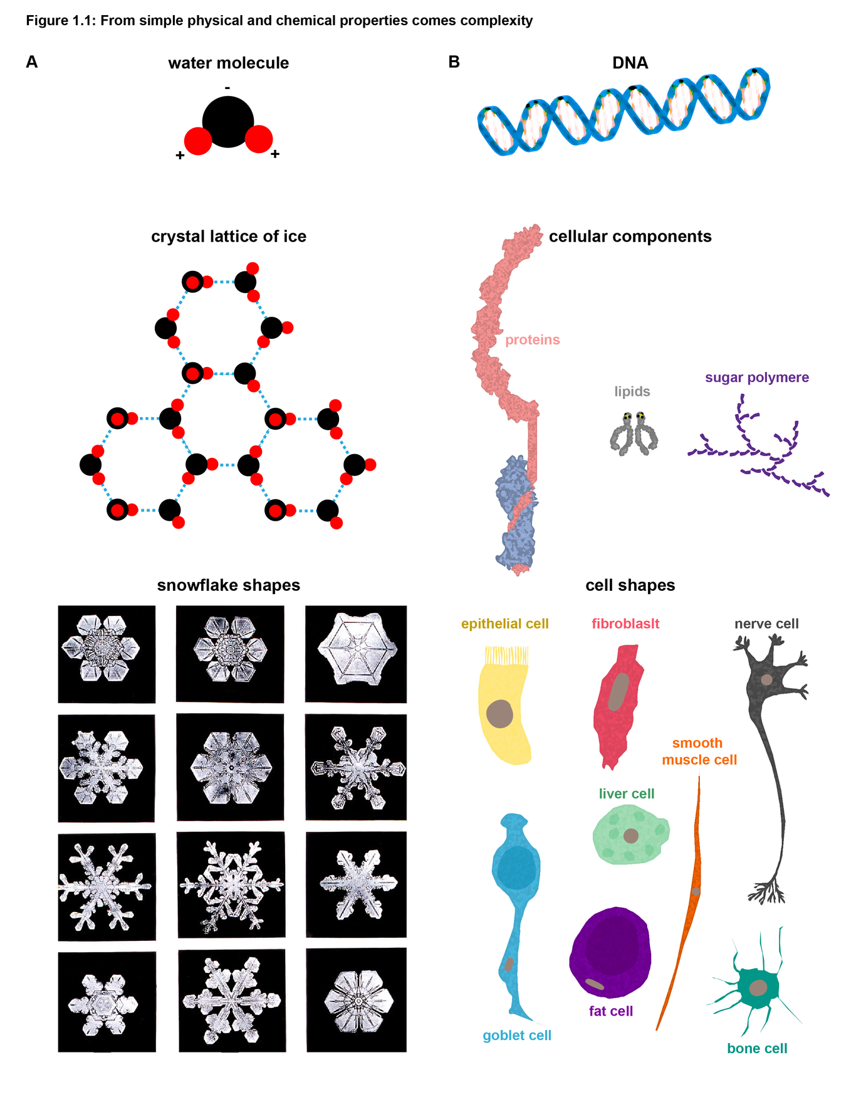
This is a caption
The mechanical consequences of cytokinesis
For a mulitcellular organism the only time they under go a mechanical change that spans their entire being is during their first cell division. Cytokineses, the process of splitting a cell in two is driven by tiny pico newton forces generated by motor proteins that slide cytoskeletal filaments. (Fig. 1.2) This mechanical process has fascinated scientists for over a century and we have unraveled many secrets of cytokinesis (Pollard 2010). The classic model for how eukaryotic cells generate the force required to pinch themselves in two is through sliding filaments of actin with the motor protein Myosin II. Many eukaryotes from amoebas, yeast, and humans, use this method to pinch themselves in two, however, many organism have found other methods such as plants which rely on membrane vesicle fusion and the addition of extracellular cell wall material (Assaad 2001), or the slime mold which in addition to filament sliding can also use traction forces to drive cytokinesis (Reichl et al. 2008; Neujahr, Heizer, and Gerisch 1997). Yeast can also divide with several disabled myosin motors (Lord and Pollard 2004). Surprisingly, successful cytokinesis can occur in vertebrates with Myosin II mutants that produce tension within the ring but cannot translocate actin filaments (Ma et al. 2012). In addition to actin and Myosin II there are many additional genes involved in cytokinesis. The most robustly characterized eukaryotic cytokinesis is the tiny fission yeast where over 150 genes are involved (Pollard and Wu 2010). Through studies in yeast and many other organism we have found that in order for a cell to successfully divide it must overcome several obstacles. First the cell must properly position the contractile ring. Second the cell must assemble the ring and connect it to the membrane. Third, contraction of the ring must be established, tuned, and maintained while ring disassembly occurs as the ring grows smaller and smaller. Finally, the membrane must be fused to separate the daughter cells. Most of the research in this field has focused on this first division of multicellular creatures or division in single cell organisms (Pollard 2010; Rappaport 1996; Green, Paluch, and Oegema 2012). While this research has been extremely useful there is a finite amount we can learn about cytokinesis in isolated cells. For a multicellular being the moments after the first division provide a new challenge, a neighboring cell! Most of the human cells that divide in our body have many neighboring cells, not just one, this posses all sorts of obstacles for a dividing cell. How does the dividing cell overcome the resistive forces of neighboring cells? Do neighboring cells assist with cell division? How does the tissue maintain its barrier functions as cells within it divide? Chapter two of my dissertation aims to answer several of these questions.

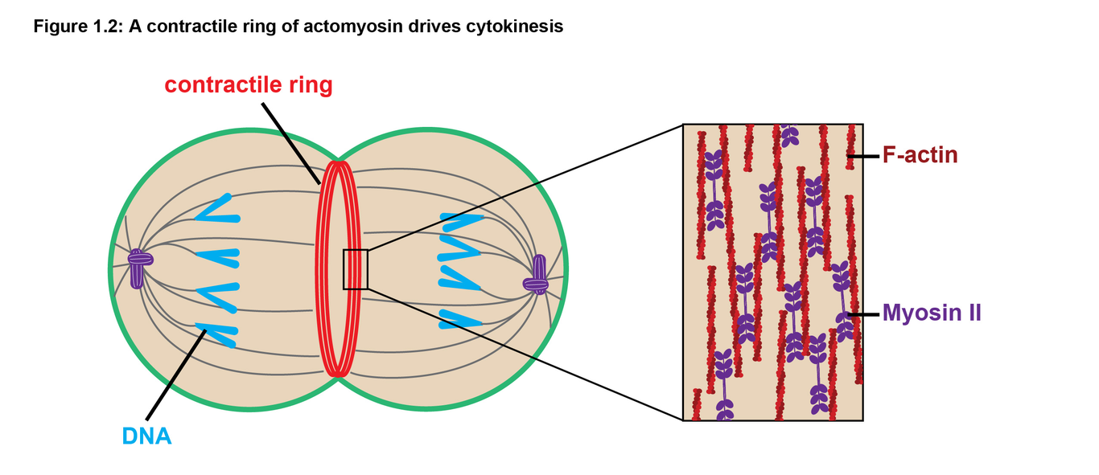
This is a caption
Signaling to build a contractile ring
To establish the contractile ring the small GTPase RhoA, the master regulator of contractility, must be localized and activated at the site of division. RhoA cycles between and active form facilitated by guanine nucleotide exchange factors (GEFs) and an inactive form facilitated by GTPase activating proteins (GAPs). When in the active GTP-bound conformation, RhoA associates with the membrane and activate specific effector proteins, resulting in localized effects on the cytoskeleton. For example, active RhoA promotes formation of actomyosin contractile arrays via its key effector proteins: formin, which nucleates unbranched actin filaments, and Rho-associated coiled-coil kinase (ROCK), which phosphorylates the regulatory light chain of Myosin II to increase contractility (fig. qq). RhoA activity is properly positioned through the delivery of GEFs and GAPs along microtubules to the division site. In brief, MLKP1, a motor protein, transports MgcRacGAP which can bind the Rho GEF Ect2. The co-accumulation and MgcRacGAP and Ect2 results in an activation and inactivation flux of RhoA at the division site maintaining properly localized RhoA activity (Miller and Bement 2008).

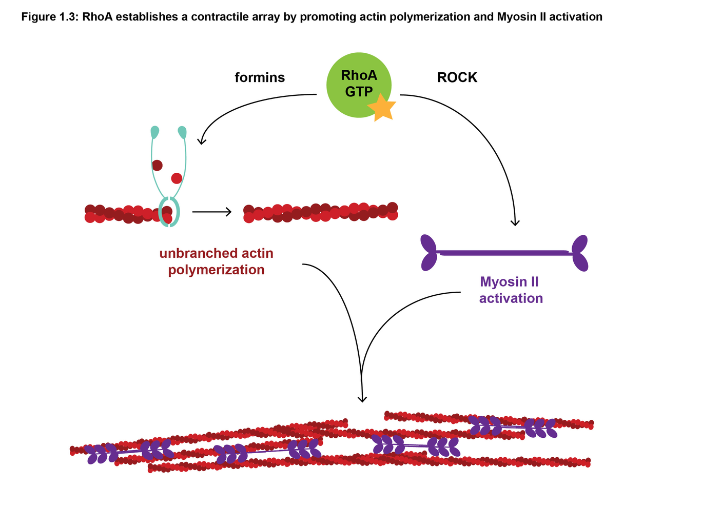
This is a caption
Scaffolding a contractile ring
Anillin is a well-characterized scaffolding protein in cytokinesis and is a major focus of my third chapter where I demonstrate a new role for Anillin in regulating epithelial mechanics. During cell division, Anillin ensures successful cytokinesis by bundling filamentous-actin (F-actin), linking F-actin and Myosin II to the membrane, and regulating RhoA activity at the contractile ring (Piekny and Maddox 2010). The N-terminal domains of Anillin participate in actomyosin binding/assembly, while the C-terminal domains include PH and C2 domains, which anchor it to the membrane, a RhoA binding domain, which allows it to interact with active RhoA, and binding sites for interacting with the GEF Ect2 and the GAPs MgcRacGAP and p190RhoGAP-A (Piekny and Maddox 2010; Frenette et al. 2012; Manukyan et al. 2014; Sun et al. 2015). Through direct binding to active RhoA, Anillin helps reset the clock on RhoA activation, acting as a buffer to extend the lifespan of active RhoA before passing it off downstream RhoA effectors (Budnar et al. 2018). Early in cytokinesis, Anillin participates in a positive feedback loop in which its accumulation at the contractile ring is both dependent on and enhances Rho activation (Piekny and Glotzer 2008). Later in cytokinesis, it interacts with p190RhoGAP-A in a tension-sensitive manner, inactivating RhoA in response to excessive force (Manukyan et al. 2014). Finally, Anillin’s bundling of F-actin also affects contractility in the ring where moderate levels of Anillin promotes efficient contraction of actomyosin (Descovich et al. 2017). Thus, Anillin helps to promotes efficient contraction by fine-tuning RhoA signaling, bundling F-actin, and linking the contractile ring to the membrane.

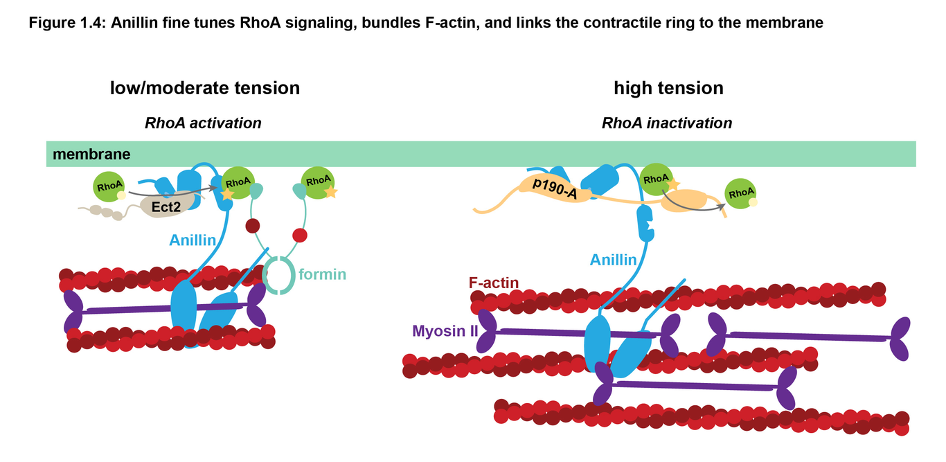
This is a caption
Dividing in a tissue
Much of the work on cytokinesis has been done in either replicating singled celled organisms or the first embryonic development of multicellular organisms. From this we have learned a great deal about the mechanisms of ring constriction but cells in our body and other mulicellular organisms don’t divide in isolation. Cells in tissues are connected to one another via cell-cell junctions, cell-cell junctions will be covered in the next section, but still divide rapidly. For example, the cells lining your small intestine are dividing so rapidly that the epithelial lining is turning over every 2-4 days! Cells in a tissue have all of the same cell autonomous obstacles to overcome when it comes to cytokinesis but they have many more additional problems and questions to be to solved with the added complexity of being in a tissue. Do dividing cells in a tissue communicate with their neighbors? Do neighboring cells actively participate in cell division? How does the dividing cell overcome the resistive force of neighboring cells? Do cells in a tissue need to produce more force to successfully divide or do neighboring cells become more compliant? Is and or how is the barrier of an epithelium maintained during cell division? Early studies using electron microscopy and immunostaining showed that epithelial cells remain in contact with one another during cell division (Jinguji and Ishikawa 1992; Baker and Garrod 1993). This means that both the dividing cell and the neighboring cell are undergoing large shape changes during cell division. How are both cells responding to these mechanical inputs? Three very exciting papers showed that dividing cells in Drosophila tissue actually break their cell-cell junctions to invaginate the membrane (Guillot and Lecuit 2013; Founounou, Loyer, and Le 2013; Herszterg et al. 2013). One of the papers even found that there was a loss of adhesion between the dividing cell and the neighboring cell (Guillot and Lecuit 2013). This raises several interesting questions, are the forces from cytokinesis disrupting cell adhesion or is cell adhesion being regulated by non force dependent mechanism? Additionally, why is junction disengagement only happening in certain tissues (Guillot and Lecuit 2013), but not others (Jinguji and Ishikawa 1992; Baker and Garrod 1993; Founounou, Loyer, and Le 2013; Herszterg et al. 2013)? Is the barrier function of epithelial tissues being disrupted by forces from cytokinesis and what impacts does this have on the organism? Chapter two of my thesis address whether or not the epithelial barrier is maintained during cytokinesis and how cell-cell junctions respond to the mechanical cues from cytokinesis.

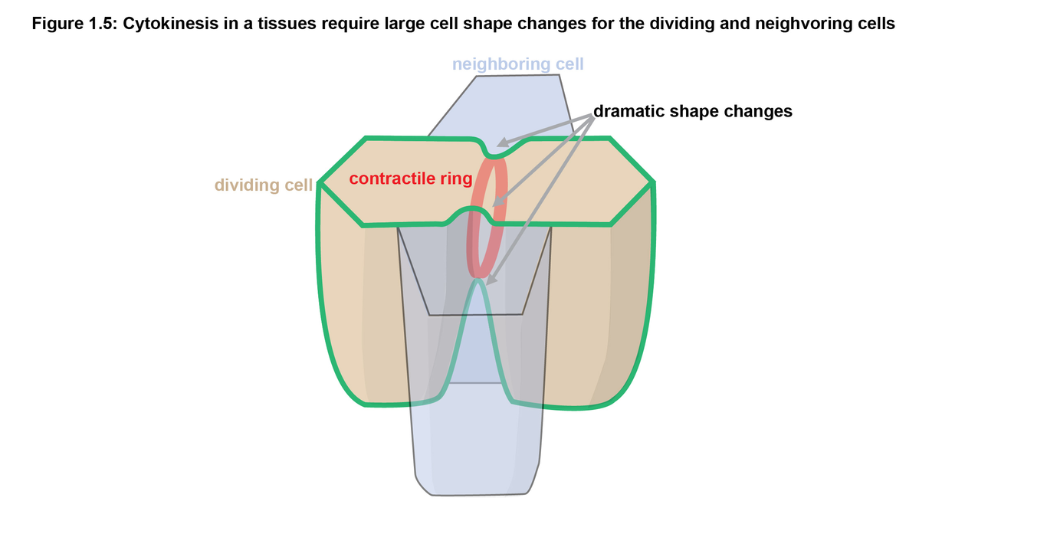
This is a caption
Cell-cell junctions
Without the ability for cells to adhere to one another all life on this planet would be destined to be unicellular. To achieve multicellularity life had to evolve a solution to mechanically connect the two daughter cells that form after cytokinesis. Interestingly many of the proteins that assemble to form the contractile ring during cell divisions are also found at cell-cell junctions, the structures that adhere cells together, even though the functions of these cellular structures are very different. The contractile ring functions to cut a cell in two while cell-cell junctions functions to mechanically link cells together and allow tissues to form barriers; without them multicellularity on the level of a human being could not exist. Some organism such as Choanoflagellates can live as a unicellular or multicellular organism. They achieve multicellularity not with specialized cell-cell junctions but by skipping the last step of cytokinesis, remaining connected via and intracellular bridge and sharing cytoplasm (Dayel et al. 2011). Again highlighting the intimate link between cell division and adhesion. To achieve mulicellularity on a larger scale cells had to evolve specialized adhesion solutions so that tissues could be both rigorous enough to maintain tissue and barrier integrity and dynamic enough to maintain tissue homeostasis through the flux of cell renewal and cell death. Cell-cell junctions emerged 600 million years ago but the ultrastructure of cell-cell junctions was first identified only a few decades ago in a seminal electron microscopy study by Farquhar and Palade (Farquhar and Palade 1963). The authors described the apical junctional complex in vertabrates being composed of tight junctions (or zonula occludens), where the space between epithelial cells is almost completely obliterated, adherens junctions (or zonula adherens), located just basal to the tight junction where the cell membranes are brought in close proximity (~20 nm apart), as well as “conspicuous bands of dense material located in the subjacent cytoplasmic matrix”, which we now know to be junctional actomyosin (Farquhar and Palade 1963). The apical junctional complex in vertebrates plays the critical role of sealing the paracellular space and adhering epithelial cells to one another (Hartsock and Nelson 2008; Van Itallie and Anderson 2014).

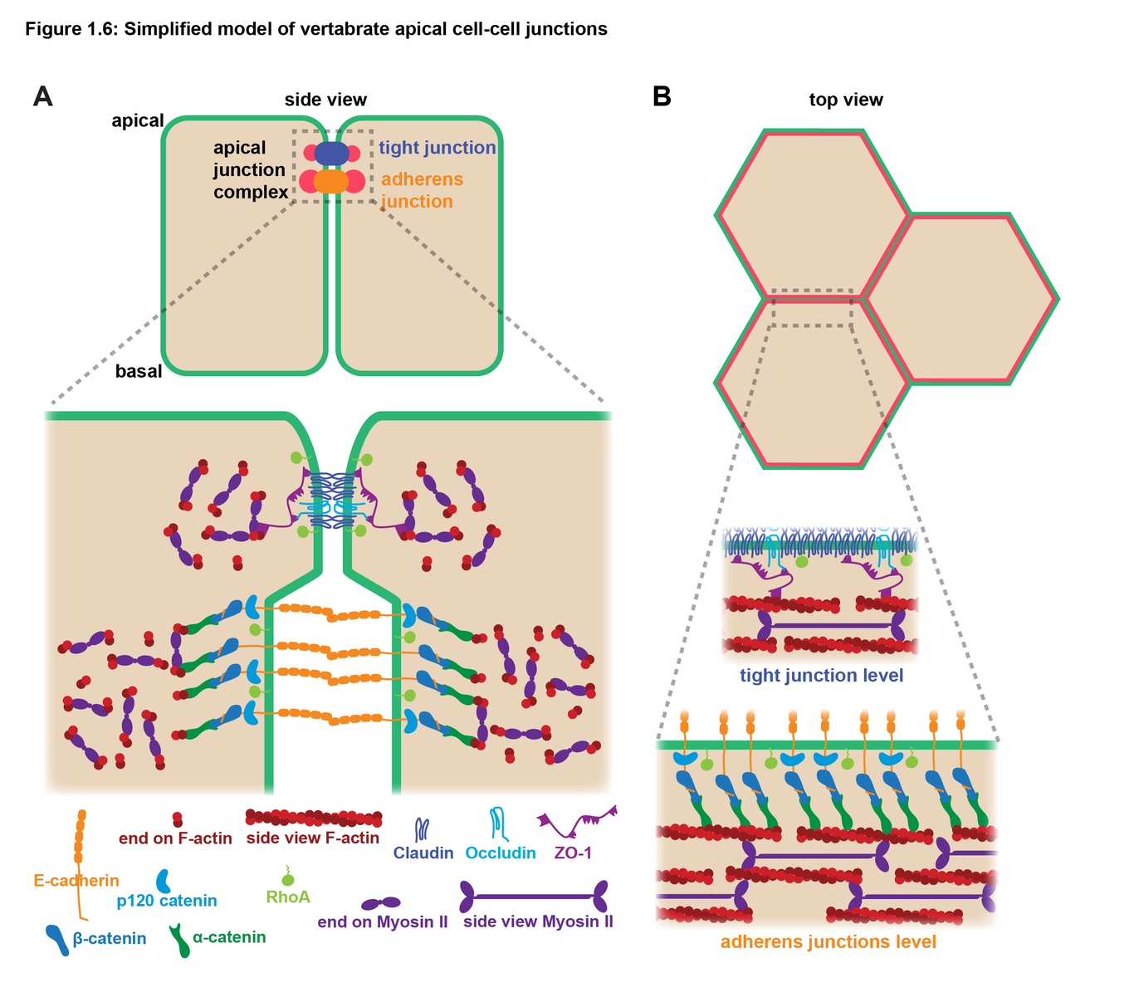
This is a caption
Tight junction mechanics
Tight junctions are are well known to be important determinant of epithelial barrier function, however, recent studies have also revealed that they can sense and regulate apical forces. Classically tight junctions seal the intercellular spaces between adjacent epithelial cells and form regulated, selective (size- and ion-specific) barriers. Barrier function can be acutely regulated in epithelial tissues by signaling mechanisms – notably by changes in actomyosin contractility (Shen et al. 2011). To achieve these functions, the tight junction transmembrane proteins (Claudins, Occludin, immunoglobulin-like JAMs) form tight junction strands, which are linked to the underlying actomyosin cytoskeleton via cytoplasmic plaque proteins (Zonula Occludens (ZO) proteins, Cingulin, Afadin, etc.) (Van Itallie and Anderson 2014) (Fig qq). The ZO proteins (ZO-1, ZO-2, and ZO-3) bind to the cytoplasmic tail of Claudins and Occludin with their N-termini (Itoh et al. 1999; Li et al. 2005). ZO-1 interacts with F-actin through its C-terminus; ZO-2 and ZO-3 also interact with F-actin, although the binding sites have not been determined (Fanning et al. 1998; Wittchen, Haskins, and Stevenson 1999). ZO proteins are proposed to initiate the polymerization of Claudins into TJ strands (Umeda et al. 2006), and ZO-1 has the ability to stabilize Claudin strands (Van Itallie, Tietgens, and Anderson 2017). In addition to their role in regulating the barrier of epithelial sheets it is also becoming clear that tight junctions are also important regulators of epithelial mechanics. For example, when ZO-1 and -2 are depleted F-actin and Myosin II dramatically increase at adherens junctions and generate high tension in line with the junction (Fanning, Van, and Anderson 2012; Choi et al. 2016) meaning tight junction negatively regulate tension on adherens junctions (Hatte, Prigent, and Tassan 2018). Additional work has shown that ZO-1 itself is mechanosensitive. Tensile force along ZO-1 reveals a binding site for the transcription factor DbpA, thus sequestering it to inhibit cell proliferation, with additional possible effects on barrier function and epithelial morphogenesis (Spadaro et al. 2017). These initial studies position tight junctions as important mechanical signaling centers in addition to the classic role in regulating tissue barrier function.

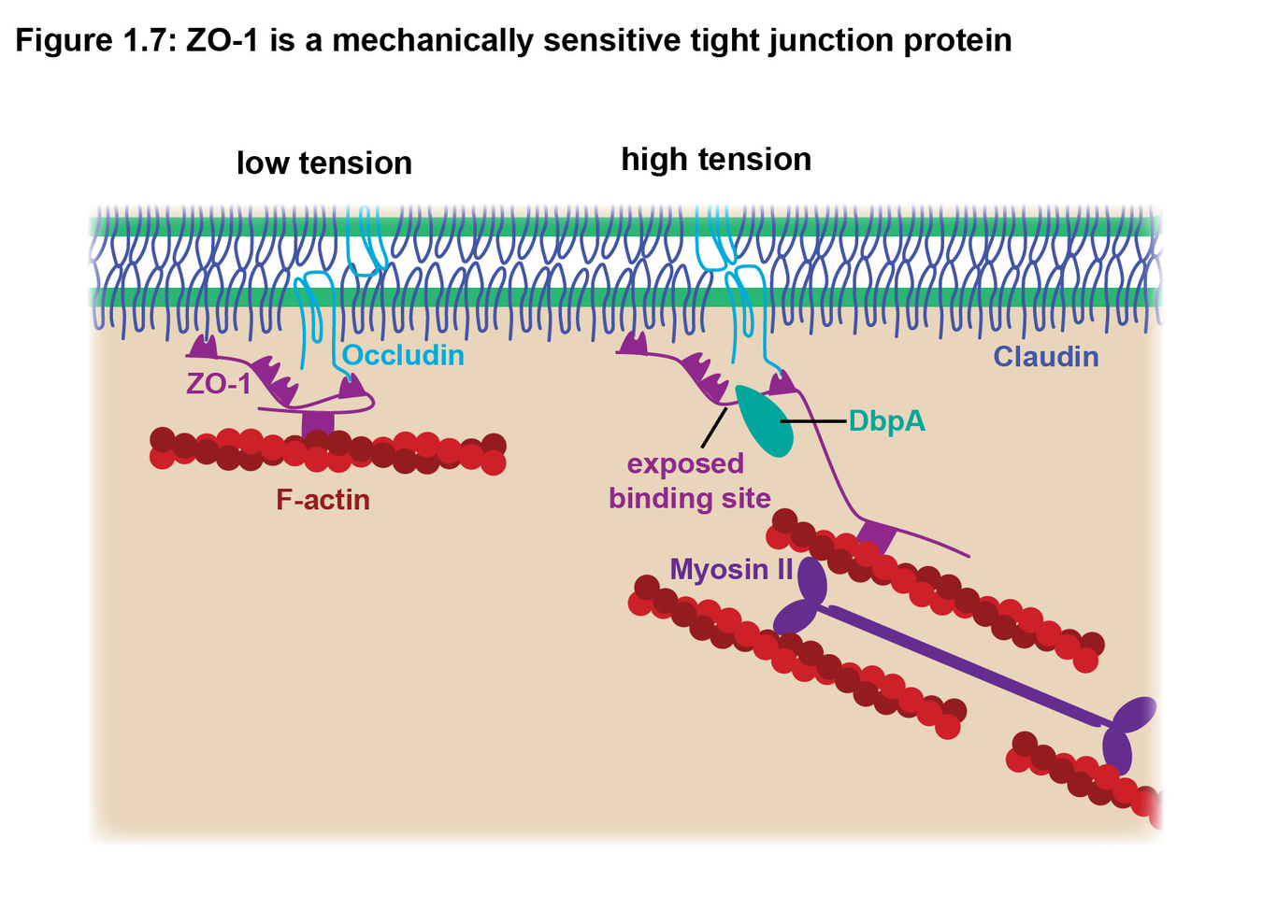
This is a caption
Adherens junction mechanics
Adherens junctions, located just basal to the tight junction, mediate cell-cell adhesion and are well known for transmitting mechanically forces across epithelial cells into tissues. Adherens junctions are functionally important for epithelial homeostasis and morphogenesis. In addition to resisting mechanical forces from neighboring cells, the contractile actomyosin network associated with adherens junctions can also transmit tension across cell-cell junctions to neighboring cells, actively shaping tissues during development. For example, contraction of actomyosin coupled to adherens junctions promotes apical constriction of individual cells, which collectively leads to tissue folding (Coravos and Martin 2016; Takeichi 2014), and promotes intercalation, during which cells remodel their cell-cell contacts through neighbor exchange (Lecuit and Yap 2015), more on this in the following sections. Each of these functional roles of adherens junctions is dependent on regulated linkage of the core molecular components of adherens junctions to the actomyosin cytoskeleton.
The core AJ components include the transmembrane proteins (E-cadherin and Nectins) and cytoplasmic plaque proteins (β-catenin, α-catenin, p120-catenin, Vinculin, Afadin, etc.) (Quiros and Nusrat 2014; Ratheesh and Yap 2012) (Fig qq). E-cadherin forms both small spot-like clusters along the lateral membrane as well as an apical belt-like structure, the zonula adherens, which is located just basal to the tight junction. F-actin plays an important role in corralling the small E-cadherin clusters (Wu, Kanchanawong, and Zaidel-Bar 2015), and actomyosin drives their coalescence and stabilization at the apical zonula adherens (Ratheesh and Yap 2012). The linkage of E-cadherin to F-actin is achieved via catenin proteins. β-catenin binds to the cytoplasmic tail of E-cadherin, and α-catenin binds to β-catenin. Although α-catenin can bind F-actin, there were controversies about whether α-catenin can simultaneously bind to both the cadherin/catenin complex and F-actin (Yamada et al. 2005). Recent work demonstrated that α-catenin can indeed bind both, but only under actomyosin-generated force (Buckley et al. 2014; Nelson and Weis 2016). This work showed that under tension, the cadherin/catenin complex forms a stable bond with F-actin (Buckley et al. 2014). Furthermore, actomyosin-mediated tension promotes a conformational change in α-catenin, which reveals a binding site for Vinculin (Yonemura et al. 2010). Vinculin is is then only recruited to cell-cell junctions under mechanical tension to function in reinforcing cell adhesion and the linkage to F-actin in the face of mechanical force (le Duc et al. 2010; Yonemura et al. 2010).

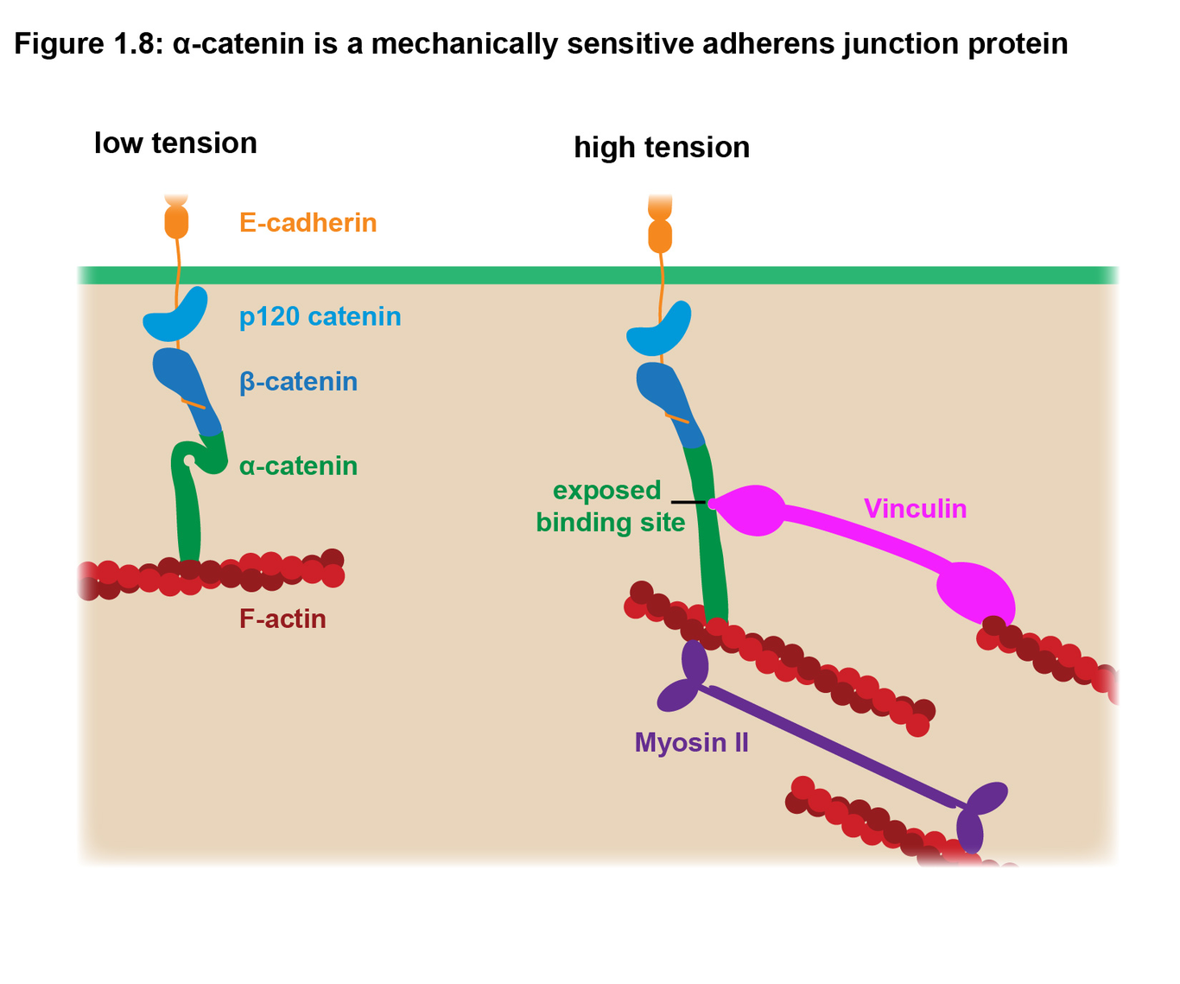
This is a caption
Force generation on the epithelial surface
Without the ability to orient mechanical forces and adjust the mechanical properties a an attempts to achieve multicellularity is destined to remain a one dimensional chain, a two dimensional sheet, or three dimensional sphere of cells, depending on the orientation of cell division. The production of forces from individual cells allows a tissue to sculpt itself through tissue bending and elongation events. These mechanical events in conjunction with controlled cell death are what allow organisms to take the variety of shapes we see in multicellular organism on earth. Changes in the mechanical properties of a tissue also directly effect the prognosis of certain diseases, such as cancer. With the adherent functions of cell-cell junctions and their connection to thick bundles of actin filaments it is no wonder these structures were first studied as possible regulators of force generation at the apical surface of epithelial tissues. To fully understand the amazing process of development and to understand, treat, and prevent disease such as cancer, we need a comprehensive understanding of how epithelial sheets regulate their mechanics.
Circumferential actomyosin
A key mechanical change in epithelial cells during development is the constriction of the apical surface of cells. This constriction shrinks the apical surface which causes the tissue to bend in on itself which is a key step for gastrulation to form primary tissue layers of the organism and neurulation to form the spinal cord. Using electron microscopy early studies in frog, newt, and chick, showed evidence that circumferential actin filaments directly associated with adherens junctions were likely driving apical constriction during neurulation (Baker and Schroeder 1967; Burnside 1971; Karfunkel 1972). Later immunostaining work in brush border cells induced to apically constrict highlighted that myosin associated strongly with cell edges before and after apical constriction (Hirokawa et al. 1983). Using quick freeze deep etch electron microscopy Hirokawa and colleges most convincingly that in brushed border cells also apically constrict by squeezing in the adherens junctions first, leaving their apical surfaces bulging out (Hirokawa et al. 1983). The contractile nature of the circumferential actomyosin network was demonstrated by islolating the actomyosin apparatus from chicken epithelial cells. Upon addition of ATP to the purified actomyosin apparatuses the rings of actomyosin constricted (Owaribe and Masuda 1982). Additional work on embryoing tissue wounds demonstrated the importance of supracellular junctional cables that from to close the wound via a purse string constriction method (Martin and Lewis 1992) (Nodder and Martin 1997). With all of this evidence it should not be surprising that the circumferential actomyosin was thought to be the only contributor epithellial mechanics for over 50 years.

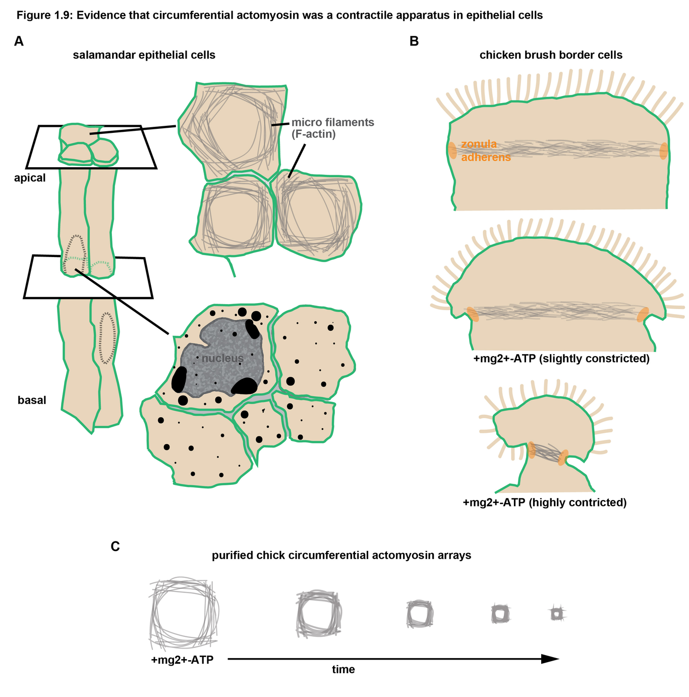
This is a caption
Medial-apical actomyosin
In addition to the band of circumferential actomyosin associated with junctions there another actomyosin network that produces mechanical forces in epithelial tissues. Probably because it is less conspicuous than junction actomyosin it took much longer for researchers to appreciate importance of medial-apical actomyosin network (Fig. 1.10), in fact even when it was directly observed it the more prominent purse string model was still favored. The protein Shroom 3 was first characterized near the turn of the millennia to induce apical constriction for neural tube closure in both mice and frog (Haigo et al. 2003; Hildebrand and Soriano 1999; Nishimura and Takeichi 2008). Interestingly, the proposed mechanism for Shoorm 3 induced apical constriction was the accumulations of actomyosin around the circumference of cells even though both junctional and medial apical actomyosin increased (Haigo et al. 2003; Nishimura and Takeichi 2008). Medial-apical actomyosin was first appreciated for its role in apical constriction when live imaging was performed on gastrulating Drosophila (Martin, Kaschube, and Wieschaus 2009). Where the researches found that temporal burst of Myosin II accumulated medial-apically to induce apical constriction in a pulsed contraction. Outside of morphogenic events such as apical constriction medial-apical actomyosin has been shown to be a load bearing structure in stable epithelia (Ma et al. 2009). Laser hole drilling of both junctional and medial-apical F-actin revealed that epithelia acts more as continuous mechanical sheet rather than an array of contractile vertices (Ma et al. 2009). Even with with these findings epithelial tissues are still often thought of as an array of contractile vertices and conclusions are made assuming the mechanical strain is stored only in circumferential actomyosin. Medial-apical and junctional are distinct, but also very similar. There are still many unanswered question about the function of medial-apical actomyosin and it’s interplay with circumferential actomyosin. How are they controlled and regulated and differentiated, does one feed into the other, etc. My third chapter shows that the scaffolding protein Anillin dramatically increased medial-apical actomyosin and this leads to dramatic changes in the mechanics of epithelial cells.

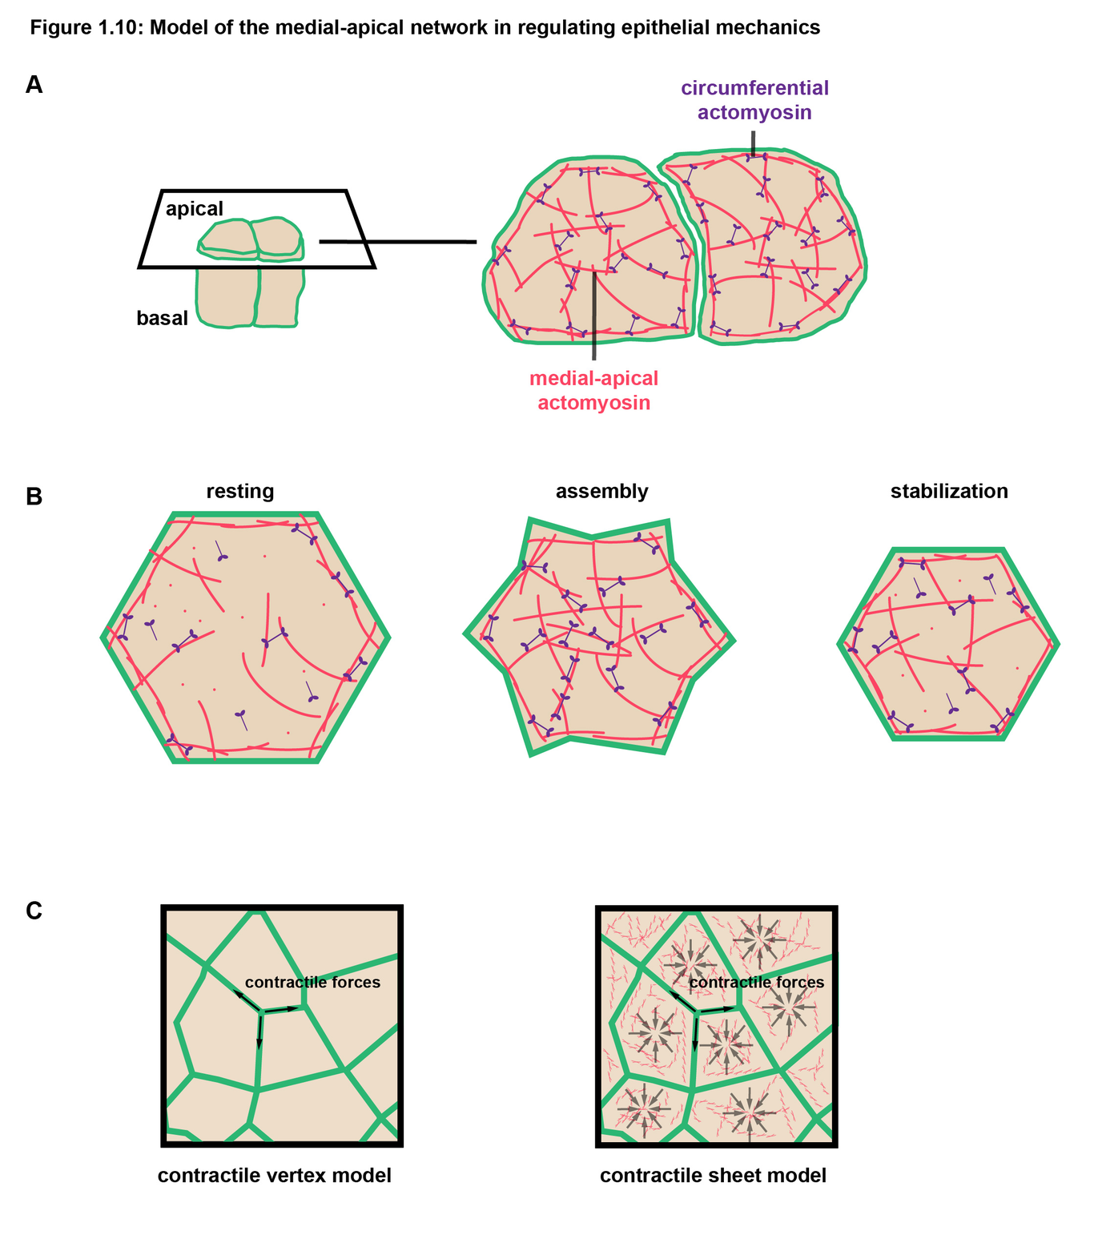
This is a caption
Dissertation goals
In this dissertation, I investigate how epithelial cells respond to mechanical cues and regulate their cellular mechanics. In Chapter 2, I describe how vertebrate epithelial cells maintain the barrier function of the tissue during cytokinesis by reinforcing their cell-cell junctions in response to forces generated by the contractile ring. In Chapter 3, I explore how the scaffolding protein Anillin contributes to epithelial cell and tissue mechanics. Preliminary experiments hinted that Anillin functions in generating tension in line with cell-cell junctions via the circumferential actomyosin belt, however, upon deeper investigation I found a new role for Anillin in dramatically organizing medial-apical actomyosin which has mechanical affects at the cellular, tissue, and whole embryo level. In Chapter 4 I discuss the implications of my findings in the context of the field and propose future experiments that I would be interested in pursuing.

References
Ho, B, A Baryshnikova, and GW Brown. 2018. “Unification of Protein Abundance Datasets Yields a Quantitative Saccharomyces Cerevisiae Proteome.”. Cell Syst 6: 192–205.e3.
Zhao, WM, and G Fang. 2005. “MgcRacGAP Controls the Assembly of the Contractile Ring and the Initiation of Cytokinesis.”. Proc Natl Acad Sci U S A 102: 13158–63.
Straight, AF, CM Field, and TJ Mitchison. 2005. “Anillin Binds Nonmuscle Myosin II and Regulates the Contractile Ring.”. Mol Biol Cell 16: 193–201.
Zihni, C, C Mills, K Matter, and MS Balda. 2016. “Tight Junctions: from Simple Barriers to Multifunctional Molecular Gates.”. Nat Rev Mol Cell Biol 17: 564–80.
Arnold, TR, RE Stephenson, and AL Miller. 2017. “Rho GTPases and Actomyosin: Partners in Regulating Epithelial Cell-Cell Junction Structure and Function.”. Exp Cell Res 358: 20–30.
Chen, L, S Xiao, K Pang, C Zhou, and X Yuan. 2014. “Cell Differentiation and Germ-Soma Separation in Ediacaran Animal Embryo-like Fossils.”. Nature 516: 238–41.
Zaidel-Bar, R., G. Zhenhuan, and C. Luxenburg. 2015. “The Contractome - a Systems View of Actomyosin Contractility in Non-Muscle Cells”. Journal of Cell Science 128 (12). The Company of Biologists: 2209–17. doi:10.1242/jcs.170068.
Alt, Silvanus, Poulami Ganguly, and Guillaume Salbreux. 2017. “Vertex Models: from Cell Mechanics to Tissue Morphogenesis”. Philosophical Transactions of the Royal Society B: Biological Sciences 372 (1720). The Royal Society: 20150520. doi:10.1098/rstb.2015.0520.
Bianconi, E, A Piovesan, F Facchin, A Beraudi, R Casadei, F Frabetti, L Vitale, et al. 2013. “An Estimation of the Number of Cells in the Human Body.”. Ann Hum Biol 40: 463–71.
Pollard, Thomas D. 2010. “Mechanics of Cytokinesis in Eukaryotes”. Current Opinion in Cell Biology 22 (1). Elsevier BV: 50–56. doi:10.1016/j.ceb.2009.11.010.
Assaad, F. F. 2001. “Plant Cytokinesis. Exploring the Links”. PLANT PHYSIOLOGY 126 (2). American Society of Plant Biologists (ASPB): 509–16. doi:10.1104/pp.126.2.509.
Reichl, EM, Y Ren, MK Morphew, M Delannoy, JC Effler, KD Girard, S Divi, PA Iglesias, SC Kuo, and DN Robinson. 2008. “Interactions between Myosin and Actin Crosslinkers Control Cytokinesis Contractility Dynamics and Mechanics.”. Curr Biol 18: 471–80.
Neujahr, R, C Heizer, and G Gerisch. 1997. “Myosin II-Independent Processes in Mitotic Cells of Dictyostelium Discoideum: Redistribution of the Nuclei, Re-Arrangement of the Actin System and Formation of the Cleavage Furrow.”. J Cell Sci 110 ( Pt 2): 123–37.
Lord, M, and TD Pollard. 2004. “UCS Protein Rng3p Activates Actin Filament Gliding by Fission Yeast Myosin-II.”. J Cell Biol 167: 315–25.
Ma, X., M. Kovacs, M. A. Conti, A. Wang, Y. Zhang, J. R. Sellers, and R. S. Adelstein. 2012. “Nonmuscle Myosin II Exerts Tension but Does Not Translocate Actin in Vertebrate Cytokinesis”. Proceedings of the National Academy of Sciences 109 (12). Proceedings of the National Academy of Sciences: 4509–14. doi:10.1073/pnas.1116268109.
Pollard, Thomas D., and Jian-Qiu Wu. 2010. “Understanding Cytokinesis: Lessons from Fission Yeast”. Nature Reviews Molecular Cell Biology 11 (2). Springer Nature: 149–55. doi:10.1038/nrm2834.
Rappaport, R. 1996. Cytokinesis in Animal Cells. Cambridge University Press. doi:10.1017/cbo9780511529764.
Green, Rebecca A., Ewa Paluch, and Karen Oegema. 2012. “Cytokinesis in Animal Cells”. Annual Review of Cell and Developmental Biology 28 (1). Annual Reviews: 29–58. doi:10.1146/annurev-cellbio-101011-155718.
Miller, Ann L., and William M. Bement. 2008. “Regulation of Cytokinesis by Rho GTPase Flux”. Nature Cell Biology 11 (1). Springer Nature: 71–77. doi:10.1038/ncb1814.
Piekny, Alisa J., and Amy Shaub Maddox. 2010. “The Myriad Roles of Anillin during Cytokinesis”. Seminars in Cell & Developmental Biology 21 (9). Elsevier BV: 881–91. doi:10.1016/j.semcdb.2010.08.002.
Frenette, Paul, Eric Haines, Michael Loloyan, Mena Kinal, Paknoosh Pakarian, and Alisa Piekny. 2012. “An Anillin-Ect2 Complex Stabilizes Central Spindle Microtubules at the Cortex during Cytokinesis”. Edited by Claude Prigent. PLoS ONE 7 (4). Public Library of Science (PLoS): e34888. doi:10.1371/journal.pone.0034888.
Manukyan, A., K. Ludwig, S. Sanchez-Manchinelly, S. J. Parsons, and P. T. Stukenberg. 2014. “A Complex of p190RhoGAP-A and Anillin Modulates RhoA-GTP and the Cytokinetic Furrow in Human Cells”. Journal of Cell Science 128 (1). The Company of Biologists: 50–60. doi:10.1242/jcs.151647.
Sun, Lingfei, Ruifang Guan, I-Ju Lee, Yajun Liu, Mengran Chen, Jiawei Wang, Jian-Qiu Wu, and Zhucheng Chen. 2015. “Mechanistic Insights into the Anchorage of the Contractile Ring by Anillin and Mid1”. Developmental Cell 33 (4). Elsevier BV: 413–26. doi:10.1016/j.devcel.2015.03.003.
Budnar, Srikanth, Kabir B. Husain, Guillermo A. Gomez, Maedeh Naghibosidat, Suzie Verma, Nicholas A. Hamilton, Richard G. Morris, and Alpha S. Yap. 2018. “Scaffolding of RhoA Contractile Signaling by Anillin: a Regulatory Analogue of Kinetic Proofreading”, March. Cold Spring Harbor Laboratory. doi:10.1101/282756.
Piekny, Alisa J., and Michael Glotzer. 2008. “Anillin Is a Scaffold Protein That Links RhoA Actin and Myosin during Cytokinesis”. Current Biology 18 (1). Elsevier BV: 30–36. doi:10.1016/j.cub.2007.11.068.
Manukyan, A., K. Ludwig, S. Sanchez-Manchinelly, S. J. Parsons, and P. T. Stukenberg. 2014. “A Complex of p190RhoGAP-A and Anillin Modulates RhoA-GTP and the Cytokinetic Furrow in Human Cells”. Journal of Cell Science 128 (1). The Company of Biologists: 50–60. doi:10.1242/jcs.151647.
Descovich, Carlos Patino, Daniel B Cortes, Sean Ryan, Jazmine Nash, Li Zhang, Paul S Maddox, Francois Nedelec, and Amy Shaub Maddox. 2017. “Crosslinkers Both Drive and Brake Cytoskeletal Remodeling and Furrowing in Cytokinesis”, June. Cold Spring Harbor Laboratory. doi:10.1101/150813.
Jinguji, Yoichi, and Harunori Ishikawa. 1992. “Electron Microscopic Observations on the Maintenance of the Tight Junction during Cell Division in the Epithelium of the Mouse Small Intestine.”. Cell Structure and Function 17 (1). Japan Society for Cell Biology: 27–37. doi:10.1247/csf.17.27.
Baker, J, and D Garrod. 1993. “Epithelial Cells Retain Junctions during Mitosis.”. J Cell Sci 104 ( Pt 2): 415–25.
Guillot, C, and T Lecuit. 2013. “Adhesion Disengagement Uncouples Intrinsic and Extrinsic Forces to Drive Cytokinesis in Epithelial Tissues.”. Dev Cell 24: 227–41.
Founounou, N, N Loyer, and Borgne R Le. 2013. “Septins Regulate the Contractility of the Actomyosin Ring to Enable Adherens Junction Remodeling during Cytokinesis of Epithelial Cells.”. Dev Cell 24: 242–55.
Herszterg, S, A Leibfried, F Bosveld, C Martin, and Y Bellaiche. 2013. “Interplay between the Dividing Cell and Its Neighbors Regulates Adherens Junction Formation during Cytokinesis in Epithelial Tissue.”. Dev Cell 24: 256–70.
Jinguji, Yoichi, and Harunori Ishikawa. 1992. “Electron Microscopic Observations on the Maintenance of the Tight Junction during Cell Division in the Epithelium of the Mouse Small Intestine.”. Cell Structure and Function 17 (1). Japan Society for Cell Biology: 27–37. doi:10.1247/csf.17.27.
Dayel, MJ, RA Alegado, SR Fairclough, TC Levin, SA Nichols, K McDonald, and N King. 2011. “Cell Differentiation and Morphogenesis in the Colony-Forming Choanoflagellate Salpingoeca Rosetta.”. Dev Biol 357: 73–82.
Farquhar, MG, and GE Palade. 1963. “Junctional Complexes in Various Epithelia.”. J Cell Biol 17: 375–412.
Hartsock, Andrea, and W. James Nelson. 2008. “Adherens and Tight Junctions: Structure Function and Connections to the Actin Cytoskeleton”. Biochimica Et Biophysica Acta (BBA) - Biomembranes 1778 (3). Elsevier BV: 660–69. doi:10.1016/j.bbamem.2007.07.012.
Van Itallie, CM, and JM Anderson. 2014. “Architecture of Tight Junctions and Principles of Molecular Composition.”. Semin Cell Dev Biol 36: 157–65.
Shen, L, CR Weber, DR Raleigh, D Yu, and JR Turner. 2011. “Tight Junction Pore and Leak Pathways: a Dynamic Duo.”. Annu Rev Physiol 73: 283–309.
Itoh, M, M Furuse, K Morita, K Kubota, M Saitou, and S Tsukita. 1999. “Direct Binding of Three Tight Junction-Associated MAGUKs, ZO-1, ZO-2, and ZO-3, with the COOH Termini of Claudins.”. J Cell Biol 147: 1351–63.
Li, Y, AS Fanning, JM Anderson, and A Lavie. 2005. “Structure of the Conserved Cytoplasmic C-Terminal Domain of Occludin: Identification of the ZO-1 Binding Surface.”. J Mol Biol 352: 151–64.
Fanning, AS, BJ Jameson, LA Jesaitis, and JM Anderson. 1998. “The Tight Junction Protein ZO-1 Establishes a Link between the Transmembrane Protein Occludin and the Actin Cytoskeleton.”. J Biol Chem 273: 29745–53.
Wittchen, ES, J Haskins, and BR Stevenson. 1999. “Protein Interactions at the Tight Junction. Actin Has Multiple Binding Partners, and ZO-1 Forms Independent Complexes with ZO-2 and ZO-3.”. J Biol Chem 274: 35179–85.
Umeda, K, J Ikenouchi, S Katahira-Tayama, K Furuse, H Sasaki, M Nakayama, T Matsui, S Tsukita, M Furuse, and S Tsukita. 2006. “ZO-1 and ZO-2 Independently Determine Where Claudins Are Polymerized in Tight-Junction Strand Formation.”. Cell 126: 741–54.
Van Itallie, CM, AJ Tietgens, and JM Anderson. 2017. “Visualizing the Dynamic Coupling of Claudin Strands to the Actin Cytoskeleton through ZO-1.”. Mol Biol Cell 28: 524–34.
Fanning, AS, Itallie CM Van, and JM Anderson. 2012. “Zonula Occludens-1 and -2 Regulate Apical Cell Structure and the Zonula Adherens Cytoskeleton in Polarized Epithelia.”. Mol Biol Cell 23: 577–90.
Choi, W, BR Acharya, G Peyret, MA Fardin, RM Mège, B Ladoux, AS Yap, AS Fanning, and M Peifer. 2016. “Remodeling the Zonula Adherens in Response to Tension and the Role of Afadin in This Response.”. J Cell Biol 213: 243–60.
Hatte, G, C Prigent, and JP Tassan. 2018. “Tight Junctions Negatively Regulate Mechanical Forces Applied to Adherens Junctions in Vertebrate Epithelial Tissue.”. J Cell Sci 131.
Spadaro, D, S Le, T Laroche, I Mean, L Jond, J Yan, and S Citi. 2017. “Tension-Dependent Stretching Activates ZO-1 to Control the Junctional Localization of Its Interactors.”. Curr Biol 27: 3783–95.e8.
Coravos, JS, and AC Martin. 2016. “Apical Sarcomere-like Actomyosin Contracts Nonmuscle Drosophila Epithelial Cells.”. Dev Cell 39: 346–58.
Takeichi, M. 2014. “Dynamic Contacts: Rearranging Adherens Junctions to Drive Epithelial Remodelling.”. Nat Rev Mol Cell Biol 15: 397–410.
Lecuit, T, and AS Yap. 2015. “E-Cadherin Junctions as Active Mechanical Integrators in Tissue Dynamics.”. Nat Cell Biol 17: 533–39.
Quiros, Miguel, and Asma Nusrat. 2014. “RhoGTPases Actomyosin Signaling and Regulation of the Epithelial Apical Junctional Complex”. Seminars in Cell & Developmental Biology 36 (December). Elsevier BV: 194–203. doi:10.1016/j.semcdb.2014.09.003.
Ratheesh, A, and AS Yap. 2012. “A Bigger Picture: Classical Cadherins and the Dynamic Actin Cytoskeleton.”. Nat Rev Mol Cell Biol 13: 673–79.
Wu, Y, P Kanchanawong, and R Zaidel-Bar. 2015. “Actin-Delimited Adhesion-Independent Clustering of E-Cadherin Forms the Nanoscale Building Blocks of Adherens Junctions.”. Dev Cell 32: 139–54.
Yamada, S, S Pokutta, F Drees, WI Weis, and WJ Nelson. 2005. “Deconstructing the Cadherin-Catenin-Actin Complex.”. Cell 123: 889–901.
Buckley, CD, J Tan, KL Anderson, D Hanein, N Volkmann, WI Weis, WJ Nelson, and AR Dunn. 2014. “Cell Adhesion. The Minimal Cadherin-Catenin Complex Binds to Actin Filaments under Force.”. Science 346: 1254211.
Nelson, WJ, and WI Weis. 2016. “25 Years of Tension over Actin Binding to the Cadherin Cell Adhesion Complex: The Devil Is in the Details.”. Trends Cell Biol 26: 471–73.
Yonemura, S, Y Wada, T Watanabe, A Nagafuchi, and M Shibata. 2010. “Alpha-Catenin as a Tension Transducer That Induces Adherens Junction Development.”. Nat Cell Biol 12: 533–42.
le Duc, Q, Q Shi, I Blonk, A Sonnenberg, N Wang, D Leckband, and Rooij J de. 2010. “Vinculin Potentiates E-Cadherin Mechanosensing and Is Recruited to Actin-Anchored Sites within Adherens Junctions in a Myosin II-Dependent Manner.”. J Cell Biol 189: 1107–15.
Baker, Patricia C., and Thomas E. Schroeder. 1967. “Cytoplasmic Filaments and Morphogenetic Movement in the Amphibian Neural Tube”. Developmental Biology 15 (5). Elsevier BV: 432–50. doi:10.1016/0012-1606(67)90036-x.
Burnside, B. 1971. “Microtubules and Microfilaments in Newt Neuralation.”. Dev Biol 26: 416–41.
Karfunkel, P. 1972. “The Activity of Microtubules and Microfilaments in Neurulation in the Chick.”. J Exp Zool 181: 289–301.
Hirokawa, N, TC 3rd Keller, R Chasan, and MS Mooseker. 1983. “Mechanism of Brush Border Contractility Studied by the Quick-Freeze, Deep-Etch Method.”. J Cell Biol 96: 1325–36.
Owaribe, K, and H Masuda. 1982. “Isolation and Characterization of Circumferential Microfilament Bundles from Retinal Pigmented Epithelial Cells.”. J Cell Biol 95: 310–15.
Martin, P, and J Lewis. 1992. “Actin Cables and Epidermal Movement in Embryonic Wound Healing.”. Nature 360: 179–83.
Nodder, S, and P Martin. 1997. “Wound Healing in Embryos: a Review.”. Anat Embryol (Berl) 195: 215–28.
Haigo, SL, JD Hildebrand, RM Harland, and JB Wallingford. 2003. “Shroom Induces Apical Constriction and Is Required for Hingepoint Formation during Neural Tube Closure.”. Curr Biol 13: 2125–37.
Hildebrand, JD, and P Soriano. 1999. “Shroom, a PDZ Domain-Containing Actin-Binding Protein, Is Required for Neural Tube Morphogenesis in Mice.”. Cell 99: 485–97.
Nishimura, T, and M Takeichi. 2008. “Shroom3-Mediated Recruitment of Rho Kinases to the Apical Cell Junctions Regulates Epithelial and Neuroepithelial Planar Remodeling.”. Development 135: 1493–1502.
Martin, AC, M Kaschube, and EF Wieschaus. 2009. “Pulsed Contractions of an Actin-Myosin Network Drive Apical Constriction.”. Nature 457: 495–99.
Ma, Xiaoyan, Holley E Lynch, Peter C Scully, and M Shane Hutson. 2009. “Probing Embryonic Tissue Mechanics with Laser Hole Drilling”. Physical Biology 6 (3). IOP Publishing: 036004. doi:10.1088/1478-3975/6/3/036004.

