Improving adhesion by polyurethane adhesives by incorporating thermally expandable particles (TEPs) in them: a review
Pragyadeep Roy

Introduction
Adhesive bonding, today, is employed in a variety of materials. Synthetic adhesives have been an integral part in furniture production, since mid 1900. Mostly, the adhesives are composed of polyurethanes (PUR). PURs are considered to belong to a range of chemicals sharing similar chemistry. These are polymers, composed of units of organic chains joined by urethane or carbamate links. Most PURs are thermosetting polymers and are resistant to high temperatures, hence do not melt. Polyurethane polymers are formed by the reaction of isocyanate and a polyol. Both the isocyanates and polyols used contain two or more functional groups per molecule, generally.
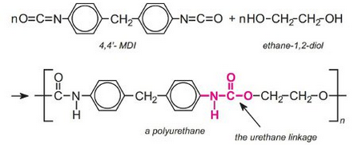
Reaction representing PUR production
In today’s world, enhancement in properties like, lifetime, strength and safety provided, is highly demanded from polymers. Also, nowadays recycling polymers, employing environmental friendly techniques is considered to be a matter of paramount concern. Hence, it is necessary to break the bonds, in the components so that different materials can be reused properly and qualitatively on a high level.
In order to achieve these properties and goals, thermally expandable particles (TEPs) have significantly played roles and has been included in the bigger picture. TEPs comprise of thermoplastic shell filled with liquid hydrocarbon. Heating them causes softening of shell material and also, gasification of the hydrocarbon liquid inside it. And in turn, the shell expands as the gas inside it pressurizes the softened shell from inside out, causing it to swell, 50 to 100 times of the initial volume. The shell stiffens and the particle remains in its expanded form, when heat is removed. Expansion temperatures vary from 70 to 285 degree centigrades depending on particle and grade.
This unique property of TEPs has been employed in structural adhesives for recycling purposes by Nishiyama et al. The simple heating of the joint over 100 degree centigrades easens separation of the bonded materials. But, the performance of the material in high temperature was poor as the particles began to expand at aroung 60 degree centigrades, which was lower than the glass transition temperature (Tg) of the adhesive.
Further modifications to get rid of these pitfalls were made by Kim et al., as they found that the joint can be dismantled with microwave treatment for 4 min. Furthermore, McCurdy et al. used TEPs with three structural adhesives for automotive industry in order to obtain joint dismantling and found that matching a high performance TEPs with a high performance adhesive, is not sufficient to obtain an efficient joint dismantling as there are important implications for joint performance (i.e. joint durability).
This study focuses on the question whether TEPs with polyurethane adhesives are can be potentially used as adhesives joints, by investigating their mechanical and thermal behaviour.

Materials

1. Adhesive
A two-component structural polyurethane adhesive SikaForce s 7888 L10 was chosen for this study. It is known to cure at room temperature. This adhesive, also a polyurethane, combines high strength with large ductility. Benefits, that this adhesive can offer, are: high peel strength, impact resistance, improved fatigue behaviour, more stable crack propagation, etc.

2. TEPs
Expancel 031 DU 40 particles supplied by Expancel Nobel Industries (Sweden) were chosen for this study. The diameter of these particles ranges mainly from 10 mm to 16 mm. Following diagrams show the dimensions of particles before and after expansion.

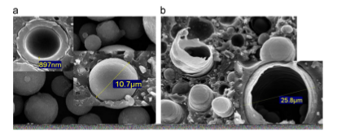
SEM (Scanning Electron Microscopy) images before and after expansion (from left to right)

3. Substrates
Hard tool steel DIN 40CrMnMo7 substrates were employed for the specimens, so as to assure an elastic behaviour of the adherends. Mechanical properties of the tool steel are as follows.

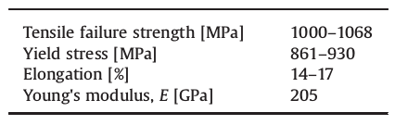
Mechanical Properties of steel substrates

Specimens manufacture and Methods
The TEPs-modified adhesive was spun with a Speed Mixer (DAC 150.1 FVZ Speedmixer, Hauschild, Germany) at 2500 rev/min for 1 min. This caused the formation of an efficient and homogeneous dispersion, which was bubble-free.
Analyses and tests that were performed on the mixture were - SEM(Scanning Electron Microscopy) analysis, Tensile Tests, DCB (Double Cantilever Beam) Tests and Thermal Tests.
SEM analysis was used to check the TEPs-modified adhesive cured matrix structure and it turned out to be a uniform dispersion of particles. Bulk “dogbone-shaped” and DCB specimens with TEPs percentage weights - 0 wt%, 5 wt%, 10 wt% and 15 wt% TEPs, were produced. Whereas for the thermal analysis, specimens with six TEPs percentage weights - 0 wt%, 5 wt%, 10 wt%, 15 wt%, 25 wt% and 50 wt%, were manufactured.
For tensile tests, the “dogbone” specimens were subjected to tension and the displacement caused due to it was recorded. For DCB tests, the specimens were kept at RT at a constant displacement rate of 1 mm/min.In each case four joints were tested to failure. Loads and displacements to failure were recorded.

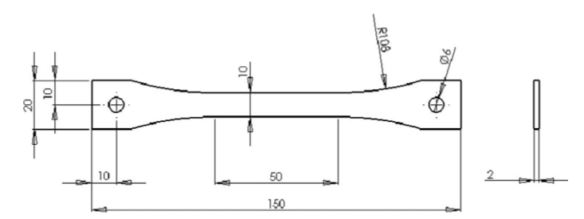
Tensile test specimen geometry bulk specimens (diameters in mm)
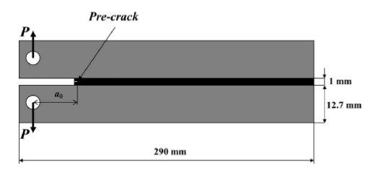
DCB specimen geometry
The particles while encapsulated in adhesives. Hence, for analyzing their thermal behaviour, change in volume of each specimen with increase in temperature was recorded. The temperature varied from RT to 150 degree centigrades at a very slow and controlled rate of 2 K/min, to allow a homogeneous temperature all over the sample. Three samples were tested for each specimen.
SEM analyses were performed on the fracture surfaces of the “dogbone” specimens and thermal analysis specimens using a high resolution Scanning Electron Microscope with X-Ray Microanalysis. Samples were coated with a gold (Au)/palladium (Pd) thin film (for 120 s. and with a 15 mA current), by sputtering, using the SPI Module Sputter Coater equipment prior to examination. Secondary electron images were collected at different magnifications (200 X, 500 X, 1000 X, 2000 X and 5000 X).

Results and Discussion

1. Tensile tests

a. Effect of wt% TEPs on the tensile properties of the adhesive
For each specimen, a tensile stress–strain curve was plotted based on load, displacement values and specimen dimensions.

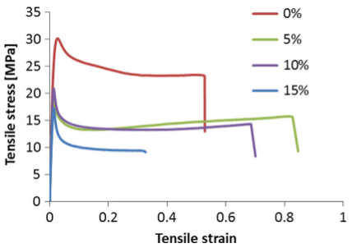
Stress vs Strain curve for specimens
The stress–strain curve provided parameters for calculating the elastic modulus, tensile strength at yield and maximum tensile strain. Variation of Young’s modulus and tensile strength at yield as a function of wt% TEPs is as follows:

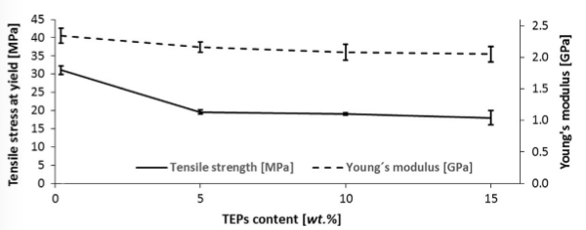
Average tensile strength at yiels and Young’s modulus as a function of wt% of TEPs

b. SEM analysis
As expected, for the TEPs-modified specimens the surface was seen to be more irregular indicating a higher deformation, i.e. the material is more ductile (as the yield strength is lowered, the fracture is more ductile in nature). The particles dispersion and sizes were also examined. Also, it was evident that the TEPs-modified adhesive samples showed a uniform dispersion of particles.

2. DCB tests

a. DCB failure mode
After the tests, the failure modes of the specimens were evaluated visually.
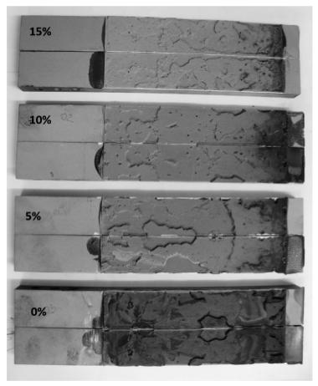
DCB failure modes
Evident from Fig. 6, the failure in the DCB specimens was cohesive in all cases. After the fracture surface morphology of the DCB specimens were examined, it a multi-scale fracture mechanism is observed and also, topographic marks were found to have developed on the failure surfaces.

b. Effect of wt% TEPs on the fracture toughness
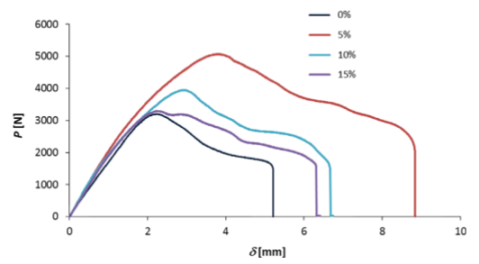
Representative experimental P-δ curves for different wt% TEPs
Evident from the above graph, the elastic stiffness was almost the same for all TEPs percentage weight and also, the maximum load increased by addition of TEPs. An increase in displacement can also be observed for all the wt% TEPs concentrations.
The critical fracture energy in mode I, G_{Ic} , was evaluated using the Compliance-Based Beam Method (CBBM)which has the following mathematical expression:
$G_{Ic} = \frac{6P^{2}}{b^{2}h}\left(\frac{2a_{eq}^{2}}{h^{2}E_{f}}+\frac{1}{5G}\right)$
where a_{eq} is an equivalent crack length obtained from the experimental compliance and accounting for the fracture process zone (FPZ) at the crack tip, h is the specimen height, b is the specimen width, E_{f} is a corrected flexural modulus to account for all phenomena affecting the P– δ curve, such as stress concentrations at the crack tip and stiffness variability between specimens, and G is the shear modulus of the adherends.

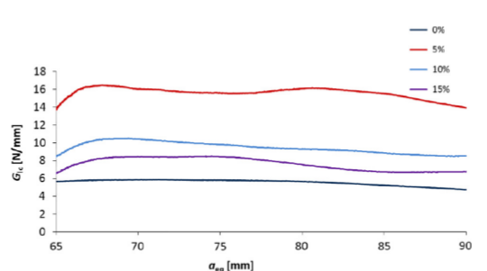
Representative R-curves for different wt% TEPs
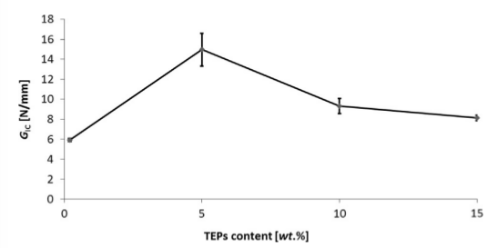
G_{Ic} plotted as a function of wt% of TEPs
It can be seen that the fracture toughness significantly increases for the TEPs-modified DCB specimens. From data point the Graph in Fig. 9, for 5 wt% TEPs-modified specimens, G_{Ic} , increased by approximately 152%. For 10 wt%, G_{Ic} , increased by approximately 57%, while for 15 wt%, G_{Ic} increased by approximately 37%.

3. Thermal analysis tests results
A thermal analysis was performed in order to investigate the behaviour of the particles while encapsulated in this particular adhesive system.

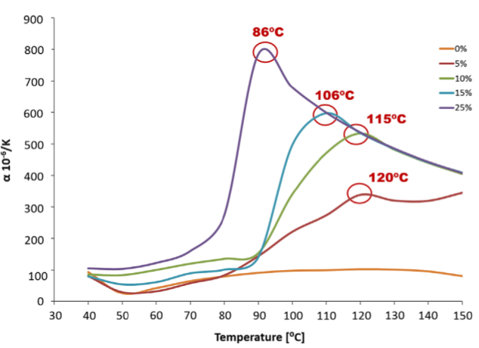
Linear coefficient of thermal expansion plotted as function of temperarture for different wt% of TEPs
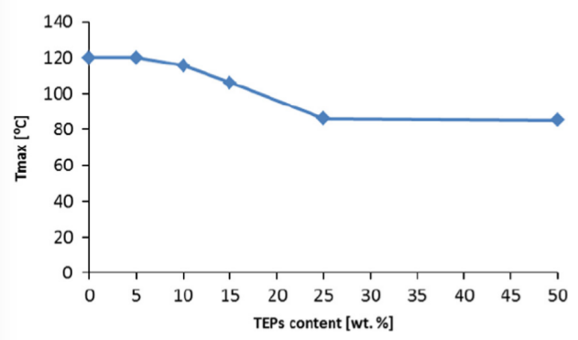
Maximum Temperature expansion (T_{max}) plotted as a function of wt% of TEPs
As observed from the graph in Fig. 10, the temperature, where the specimens show the maximum expansion, varies inversely with TEPs % weight. It was also observed that the expansion takes place in a range of temperatures, between 80 degree centigrades and 120 degree centigrades. Hence, from 80 to 90 degree centigrades onwards, a volumetric increase is also observed, due to expansion of particles.

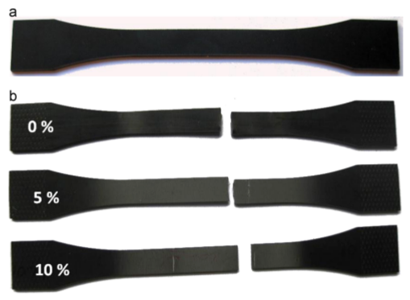
Bulk specimens before (a) and after tests (b).
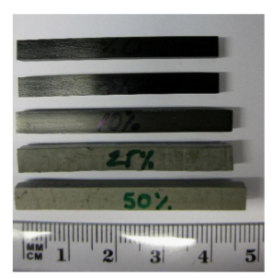
Specimens after thermal analysis

Conclusion
The results associated with the topic have put forth well-defined inferences. The study was concerned with the usage of TEPs in polyurethane adhesive joints and the potential benefits that could be obtained from this association. Here are a few inferences which the results have proven.
– the toughness of the adhesive gets enhanced with addition of TEPs.
– the toughness improvement is obtained without any loss of stiffness (E) or ductility.
– a significant decrease in adhesive strength at yield with increasing wt% TEPs was found. This might be explained by the drastic change in the adhesive structure, by the volume occupied by the particles and by the fact that TEPs act as stress concentrators.
– the temperature where the particles show the maximum expansion varies inversely with TEPs wt%.
– TEPs-modified polyurethane adhesive should be used in products with controlled temperature between 90 and 120 degree centigrades, depending on the TEPs concentration to obtain the highest expansion ratio. Below this range of temperature, not all the particles will expand, and above it, the TEPs-modified adhesive will deteriorate.

References
1. Banea M. D., da Silva L.F.M., Carbas R.J.C., Campilho R.D.S.G.;Mechanical and thermal characterization of a structural polyurethaneadhesive modified with thermally expandable particles. International Journal of Adhesion & Adhesives; 2014.
2. Jayaraman, Krishnamoorthy;Studies on polyurethane adhesives and surfacemodification of hydrophobic substrates. University of Massachusetts Amherst; 2007
3. https://en.wikipedia.org/wiki/Scanning_electron_microscope
4. https://en.wikipedia.org/wiki/Fracture_mechanics
5. http://polyurethanes.org/en/where-is-it

