U3_AOS1_Topic05_Power functions - TUTES
Kenneth

Question Group information
Name: Power functions
Summary:
Methods comes packed with many different functions. In this topic we’ll look at just a few more crucial functions that come in power form. Don’t freak out, though! Power form is just a fancy name given to functions in this form:
$$y=x^{n}$$
In fact, all we look at is how the graph changes if we adjust what $n$ is. We already know what type of functions we get if $n=1,2,3,4,...$ ; they’re just polynomials! But what if we make $n$ any of these values?
$$n=−2,−1,\frac{1}{3},\frac{1}{2}$$
Let’s see what they look like!
Videos:
Video1 url:
Video 1 title:
Video 1 thumb url:
Start at:
End at:

Tutorial number: 1
Prompt: What are implied and maximal domains?
Title: Implied and maximal domains
Sometimes when we’re given a function the domain isn’t specified. This happens because the question assumes we know the domain of this function. The assumed domain is called the implied domain, or the maximal domain.
So, how do we go about finding implied domains? We simply ask ourselves the following question:
“What value(s) can $x$ not take?"
In other words, what can’t $x$ be? Therefore, the implied/maximal domain will be everything excluding these values.
To answer this question, we need to look for some characteristics that restrict the values of $x$. Two of the common types of restrictions are caused by square roots and fractions.

Square roots
Whenever we see a square root in a function, we instantly know that whatever’s inside the square root can’t be negative. This is because it’s not possible to find the square root of a negative number; see for yourself by trying to find the square root of $−1$.
$$\begin{matrix}\sqrt{−1}= ?\end{matrix}$$
Therefore, we can say that if we have:
$$\begin{aligned}
&\sqrt{x}
\newline
&\Rightarrow x\geq 0\end{aligned}$$
Even though the domain isn’t given to us, we know that the implied domain is: $x≥0$.
Let’s see another example: $y=\sqrt{3x+6}$.
By knowing that everything inside the square root has to be greater than or equal to zero, we can solve for its implied domain:
$$\begin{aligned}
3x+6 &\geq 0
\newline
3x &\geq -6
\newline
x &\geq -2\end{aligned}$$
Hence, we know the domain is $x∈[−2,∞)$. From this example you can see that it’s necessary to take everything inside the square root and make it greater than or equal to zero.

Fractions
With any fraction, we know that the denominator can’t be zero since we get an undefined number — if the bottom is zero, then everything falls apart! For fractions like $\frac{1}{2}$ or $\frac{x+4}{3}$, this isn’t a problem since their denominators are fixed at $2$ and $3$ respectively.
On the other hand, if we see $x$ in the denominator of a fraction it’s possible that we could divide by zero for some value(s) of $x$.
To work out what value(s) of $x$ make the denominator zero, we simply take what’s in the bottom and make it not equal to zero.
$$\begin{aligned}
&\frac{1}{x}
\newline
\Rightarrow x&\neq 0\end{aligned}$$
So, even though we’re not given a domain, it is already implicit that $x≠0$, since the denominator can’t be zero.
Let’s look at another example: $y=\frac{1}{5x−7}$
Since the denominator can’t be zero:
$$\begin{aligned}
5x-7 &\neq 0
\newline
5x &\neq 7
\newline
x &\neq \frac{7}{5}\end{aligned}$$
Hence the maximal domain is $x∈R\backslash \{\frac{7}{5}\}$. Note again that we make the entire expression in the bottom of the fraction not equal to zero.
When we go further into the world of Maths Methods, we’ll find some more functions that put restrictions on what $x$ can be. For now, it’ll be more than enough to just remember these two.
Tutorial number: 2
Prompt: How do we sketch square root functions?
Title: Square root functions
The simpliest square root function is given by this equation:
$$f(x)=\sqrt{x}$$
From this equation, there are a few conclusions we can draw:
- The domain of this function is $[0,∞)$.
- The range of this function is $[0,∞)$.
- The endpoint is at $(0,0)$.
Putting this together, the graph of this function looks like this:
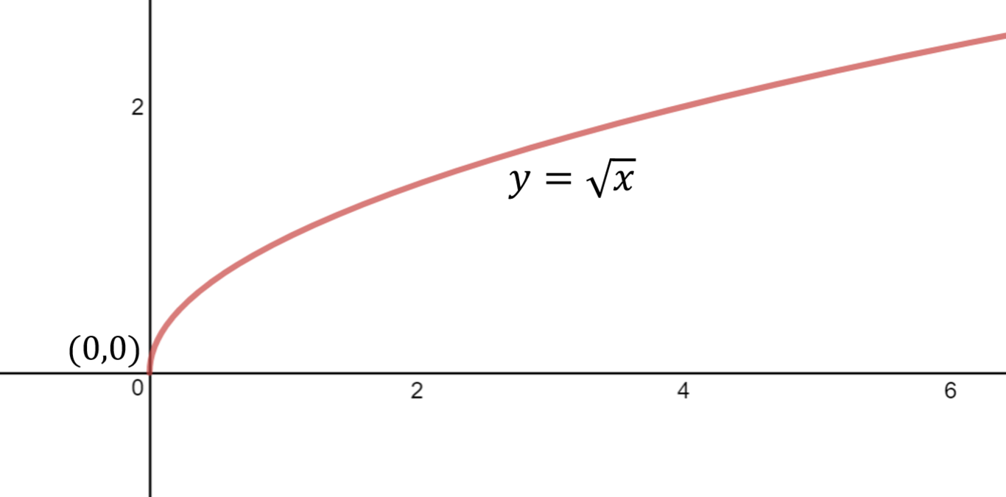
{{s3_url}}/tutorial-02/power_sqrt_1.png
Note that square root functions starts moving almost vertically from its endpoint before shooting off.
With transformations, square root functions are in this form:
$$f(x)=a\sqrt{x−h}+k$$
The meaning of each letter is very similar to other functions we have seen.
|p3cm||p3cm|p3cm p3cm|p3cm p3cm|
Letters & Types of transformation &
Magnitude of $a$ & Dilation & $|a|>1$ & Narrower & $|a|<1$ & Wider
Sign of $a$ & Reflection & $a>0$ & Upright & $a<0$ & Upside down
$h$ & Horizontal translation & $h>0$ & Moved to the right & $h<0$ & Moved to the left
$k$ & Vertical translation & $k>0$ & Moved up & $k<0$ & Moved down
Hence, the translations tell us that the endpoint is located at $(h,k)$.

Reflections
Reflections are things we need to be aware of when sketching square root functions. Since the graph is not symmetrical about the $y$-axis anymore, we have two types of reflections depending on where the negative sign is.
$$y=−\sqrt{x}$$
Since the negative sign is outside the square root, this reflection affects the whole equation; i.e. the $y$-values. Hence, this is a reflection in the $x$-axis since the $x$-axis is the line of symmetry about which the graph is being flipped. The result is a graph that is flipped upside-down.
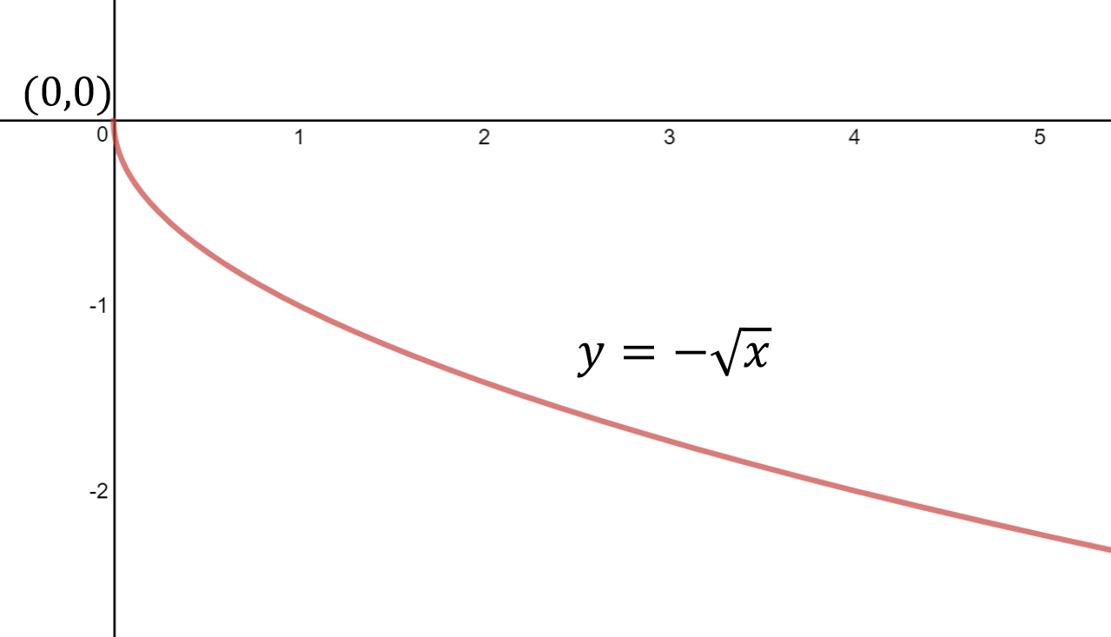
{{s3_url}}/tutorial-02/power_sqrt_2.png
Now let’s consider this reflection:
$$y=\sqrt{−x}$$
Here, the negative is directly in front of the $x$, meaning it is the $x$ values that are affected this time. Therefore, the $y$-axis now acts as the line of symmetry, making this a reflection in the $y$-axis. The result is a graph that still starts at $(0,0)$, but now veers off to the left.
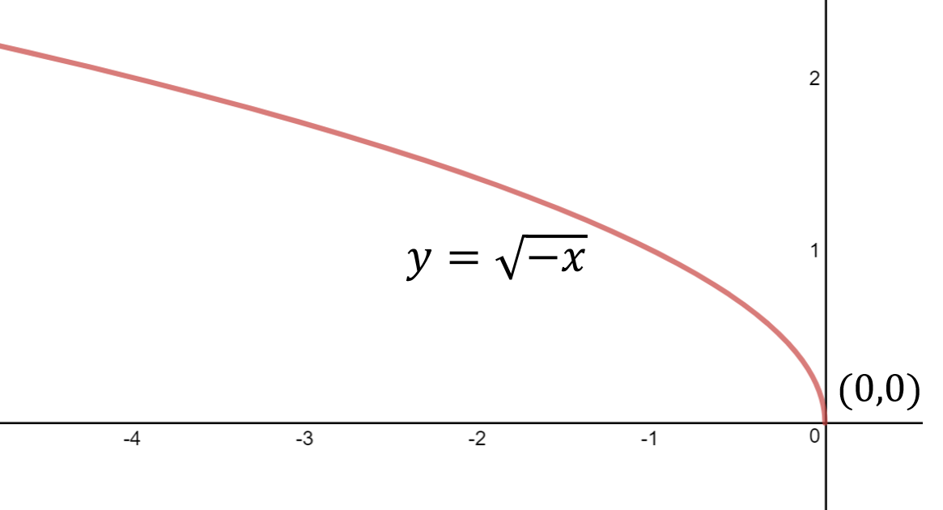
{{s3_url}}/tutorial-02/power_sqrt_3.png
In summary, a square root function graph can point in four different directions. All we need to do is to ask ourselves: where are the negative signs in my function?
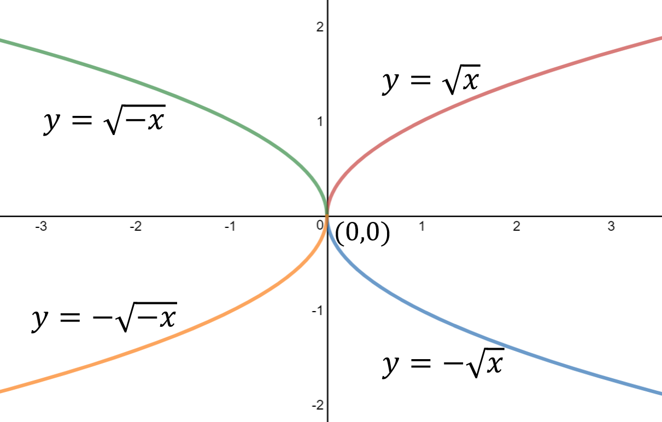
{{s3_url}}/tutorial-02/power_sqrt_4.png
Suppose we have this example: $y=\sqrt{−x+1}+5$
Let’s find the the endpoint first. It might be tempting to say that the endpoint is located at $(−1,5)$, especially since we have to reverse the sign in front of $h$ to see the translation. This wouldn’t be right though. We can only see translations correctly if they are directly next to $x$. This means we have to rewrite our equation by factorising the $−1$ out of the expression under the square root.
$$y=\sqrt{−(x−1)}+5$$
Now we can see that the graph has shifted one unit to the right, meaning the endpoint is in fact located at $(1,5)$.
Let’s try to identify any reflections too. We can see that there is a negative inside the square root, implying that there is a reflection in the $y$-axis. Therefore, our graph should head towards the top-left of the Cartesian plane.
Let’s try to find the $y$-intercept.
$$\begin{aligned}
y & \text{-intercept when} \; x = 0
\newline
\Rightarrow y &= \sqrt{-(0)+1}+5
\newline
y &= \sqrt{1}+5
\newline
y &= 6
\newline
&\therefore (0, 6)\end{aligned}$$
How about the $x$-intercept?
$$\begin{aligned}
x & \text{-intercept when} \; y = 0 \newline
\Rightarrow 0 &= \sqrt{-x+1} + 5 \newline
-5 &= \sqrt{-x+1}\end{aligned}$$
But wait! How can a positive square root equal a negative number? Clearly this equation has no solutions, which means there is no $x$-intercept.
With this information, we can now sketch the graph.
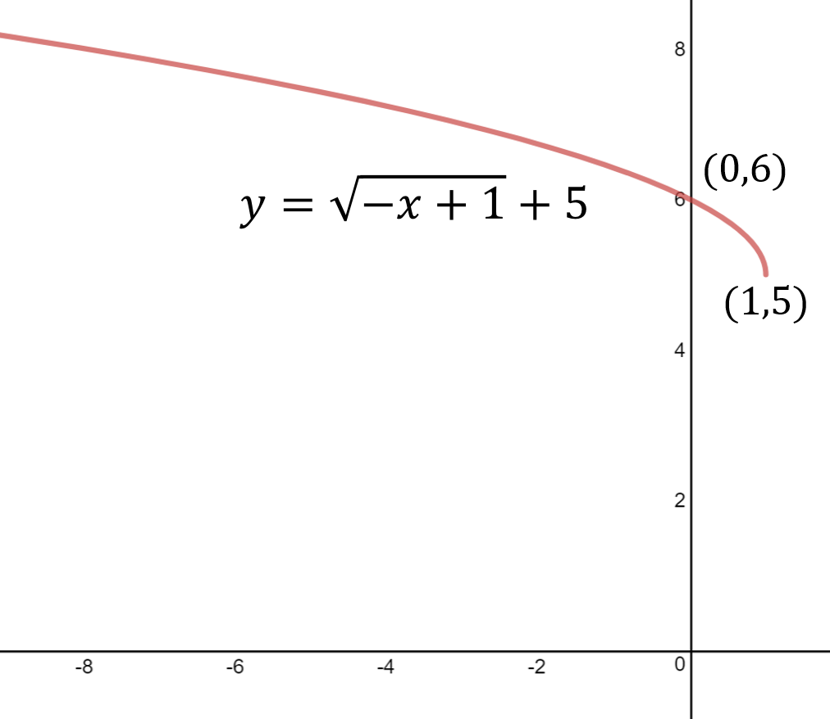
{{s3_url}}/tutorial-02/power_sqrt_5.png
Tutorial number: 3
Prompt: How do we sketch cube root functions?
Title: Cube root functions
The shape of cube root functions a
For example:
$$\begin{aligned}
\sqrt[3]{8} &= 2 \newline
\text{ } \newline
\sqrt[3]{-8} &= -2\end{aligned}$$
Let’s take a look at the basic cube root function:
$$f(x)=\sqrt[3]{x}$$
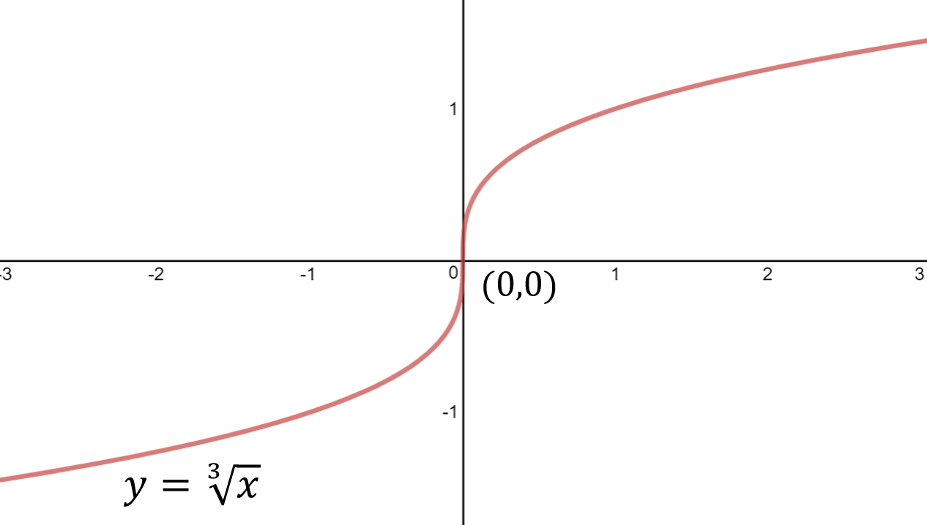
{{s3_url}}/tutorial-03/power_cbrt_1.png
- The domain of this function is $(−∞,∞)$, or $R$.
- The range of this function is $(−∞,∞)$, or $R$.
- The graph is vertical at the point $(0,0)$.
Note that cube root graphs have a continuous vertical point instead of a square roots’ vertical endpoint.
With transformations, the equation now looks like this:
$$f(x)=a\sqrt[3]{x−h}+k$$
Again, these transformations are very similar to square root functions.
|p3cm||p3cm|p3cm p3cm|p3cm p3cm|
Letters & Types of transformation &
Magnitude of $a$ & Dilation & $|a|>1$ & Narrower & $|a|<1$ & Wider
Sign of $a$ & Reflection & $a>0$ & Upright & $a<0$ & Upside down
$h$ & Horizontal translation & $h>0$ & Moved to the right & $h<0$ & Moved to the left
$k$ & Vertical translation & $k>0$ & Moved up & $k<0$ & Moved down
Hence, the vertical point of the graph is located at $(h,k)$.

Reflections
Both types of reflections actually have the same effect on a cube root graph. A reflection in the $x$-axis looks the same as a reflection in the $y$-axis for cube root graphs, since:
$$\begin{aligned}
&\sqrt[3]{-x}
\newline
&=\sqrt[3]{-1} \times \sqrt[3]{x}
\newline
&=-1 \times \sqrt[3]{x}
\newline
&=-\sqrt[3]{x}
\newline
\Rightarrow \sqrt[3]{-x} &=-\sqrt[3]{x}\end{aligned}$$
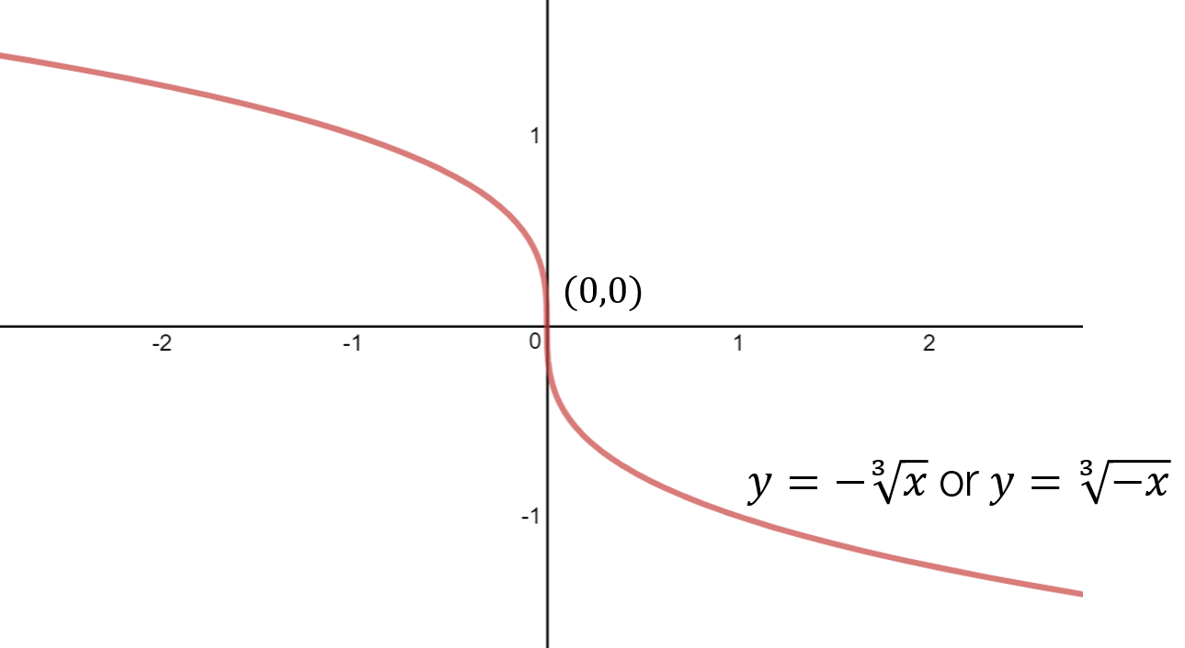
{{s3_url}}/tutorial-03/power_cbrt_2.png
Let’s look at an example: $y=2\sqrt[3]{x+6}−2$.
This is a positive graph without any reflections, so it should angle upwards and end in the top-right corner. The graph is also vertical through the point $(−6,−2)$.
To find the $x$-intercept, make $y=0$ and solve for $x$:
$$\begin{aligned}
2 \sqrt[3]{x+6}-2&=0
\newline
\sqrt[3]{x+6}&=1
\newline
x+6&=1
\newline
x&=-5\end{aligned}$$
Hence, the $x$-intercept is at $(−5,0)$.
Now, let’s get the $y$-intercept by making $x=0$.
$$\begin{aligned}
y&=2 \sqrt[3]{0+6}-2
\newline
y&=2 \sqrt[3]{6}-2\end{aligned}$$
Thus, the $y$-intercept is at $(0,2\sqrt[3]{6}−2)$.
With all this, we can sketch the graph!
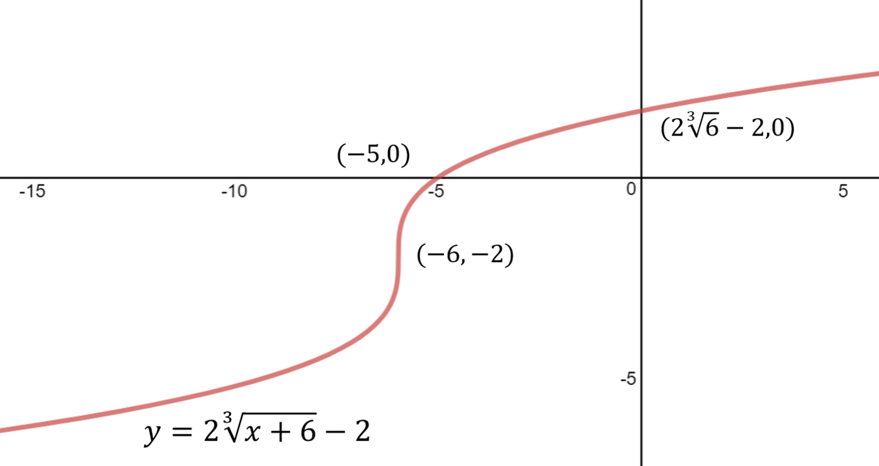
{{s3_url}}/tutorial-03/power_cbrt_3.png

Useful tips!
Let’s stick with the last cube root example just above. How do we know whether the number $2\sqrt[3]{6}−2$ is positive or negative? Why is this important? Because it affects whether the $y$-intercept is above or below the $x$-axis. If we don’t have a calculator, how can we estimate whether the number is positive or negative?
There are many ways of working this out, some intuitively and others mathematically. One way that we’ll discuss here is to approximate how big $\sqrt[3]{6}$ is by hand.
First of all, we know the following two perfect cubes:
$$\begin{aligned}
\sqrt[3]{1} &= 1 \newline
\sqrt[3]{8} &= 2\end{aligned}$$
This means that the answer to $\sqrt[3]{6}$ must lie somewhere between $1$ and $2$. Why? Because $\sqrt[3]{6}$ is itself in between $\sqrt[3]{1}$ and $\sqrt[3]{8}$.
$$\begin{aligned}
\sqrt[3]{1} &= 1 \newline
\sqrt[3]{6} &\approx 1.5 \newline
\sqrt[3]{8} &= 2\end{aligned}$$
We don’t know that it’s exactly 1.5, but we can safely say that it’s approximately ($≈$) $1.5$. Using this, we can also approximate the entire value of $2\sqrt[3]{6}−2$.
$$\begin{aligned}
\sqrt[3]{6} &\approx 1.5 \newline
2\sqrt[3]{6} &\approx 3 \newline
2\sqrt[3]{6} - 2 &\approx 1\end{aligned}$$
Since $2\sqrt[3]{6}−2>0$, we know that $2\sqrt[3]{6}−2$ is positive and belongs above the $x$-axis! We can apply this technique to square roots, as well as other roots if we simply take it step by step.
Tutorial number: 4
Prompt: How do we sketch hyperbolas?
Title: Hyperbola functions
The equation of a simple hyperbola is given as:
$$y=\frac{1}{x}$$
A hyperbola is a function that has a very special shape since it has two branches.
{{s3_url}}/tutorial-04/power_hyp_1
{{s3_url}}/tutorial-04/power_hyp_1
This hyperbola has the following characteristics:
- The implied domain is $x∈R\backslash \{0\}$.
- The range is $y∈R\backslash \{0\}$.
- One vertical asymptote at $x=0$.
- One horizontal asymptote at $y=0$. (Always remember to label the equations of the asymptotes!)
- The graph approaches the horizontal asymptotes when $x$ approaches positive infinity and negative infinity. In other words: $y→0$ when $x→±∞$.
- The graph approaches the vertical asymptotes when $x$ approaches zero from the left and right. In other words: $y→±∞$ when $x→0^{±}$.

Asymptotes
Asymptotes are special characteristics of certain functions. They can be described as follows:
An asymptote is a line (in Maths Methods) that the graph will keep approaching but never reach. So, when drawing graphs involving asymptotes, it’s important that the graphs:
- Never touch the asymptote.
- Never cross over the asymptote.
- Never turn away from the asymptote.

Transformations
With transformations, the equation of a hyperbola looks like:
$$y=\frac{a}{x−h}+k$$
|p3cm||p3cm|p3cm p3cm|p3cm p3cm|
Letters & Types of transformation &
Magnitude of $a$ & Dilation & $|a|>1$ & Narrower & $|a|<1$ & Wider
Sign of $a$ & Reflection & $a>0$ & Upright & $a<0$ & Upside down
$h$ & Horizontal translation & $h>0$ & Moved to the right & $h<0$ & Moved to the left
$k$ & Vertical translation & $k>0$ & Moved up & $k<0$ & Moved down

Effects of translations on asymptotes

Horizontal translation
When the graph is shifted to the left or right the vertical asymptote, which started at $x=0$, is also shifted to the left or right. Hence, the vertical asymptote has the equation:
$$x=h$$
For example, the graph of $y=\frac{1}{x−2}$ has a vertical asymptote at $x=2$. This is because $h=2$, meaning the graph and the vertical asymptote are shifted two units to the right.

Vertical translation
Similarly, when the graph is shifted up or down the horizontal asymptote, which started at $y=0$, is also shifted up or down. Hence, the horizontal asymptote has the equation:
$$y=k$$
For example, the graph of $y=\frac{1}{x}+4$ has a horizontal asymptote at $y=4$. This is because $k=4$, meaning the graph and the horizontal asymptote are shifted 4 units up.

Reflections
Reflections in the $x$-axis look pretty much the same as reflections in the $y$-axis. Why? Let’s have a look.
Let’s start off with a reflection in the $y$-axis, meaning that there is a negative directly in front of $x$.
$$\begin{aligned}
y&=\frac{1}{-x}
\newline
y&=\frac{1}{-(x)}
\newline
y&=-\frac{1}{x}\end{aligned}$$
Hence, we can see that putting a negative in front of $x$ is the same as putting a negative in front of the whole function. A negative in front of the entire fraction indicates a reflection in the $x$-axis.
Let’s look at an example: $y=−\frac{2}{x+1}−3$.
When sketching graphs with asymptotes, it’s good practice to find and sketch the asymptotes first. In this case, we can find the asymptotes easily by finding the values of $h$ and $k$. The asymptotes are at:
$$\begin{aligned}
y &= -3 \newline
x &= -1\end{aligned}$$
Once we have the asymptotes, we can find the $x$- and $y$-intercepts.
To find $x$-intercept, make $y=0$ and solve for $x$.
$$\begin{aligned}
-\frac{2}{x+1}-3&=0
\newline
\frac{2}{x+1}&=-3
\newline
2&=-3(x+1)
\newline
-\frac{2}{3}&=x+1
\newline
x&=-\frac{2}{3}-1
\newline
x&=-\frac{5}{3}\end{aligned}$$
So the $x$-intercept is at $(−\frac{5}{3},0)$.
To find the $y$-intercept, make $x=0$ and solve for $y$.
$$\begin{aligned}
y&=-\frac{2}{0+1}-3
\newline
y&=-2-3
\newline
y&=-5\end{aligned}$$
So the $y$-intercept is at $(0,−5)$.
Now we can sketch the graph!
{{s3_url}}/tutorial-04/power_hyp_2
{{s3_url}}/tutorial-04/power_hyp_2
Notice the way in which the graph approaches both asymptotes. It gets closer and closer to it, though the graph never touches, crosses or turns away from the asymptotes. This is called asymptotic behaviour.
Tutorial number: 5
Prompt: How do we sketch the graph of a truncus?
Title: Truncus functions
A truncus without any transformation has this equation:
$$y=\frac{1}{x^{2}}$$
The graph of a truncus function is very similar to a hyperbola, except both branches are on the same side of the $x$-axis.
{{s3_url}}/tutorial-05/power_truncus_1
{{s3_url}}/tutorial-05/power_truncus_1
A hyperbola has the following characteristics:
- The implied domain is $x∈R\backslash \{0\}$.
- The range is $y∈R^{+}$, or $y∈(0,∞)$.
- One vertical asymptote at $x=0$.
- One horizontal asymptote at $y=0$. (Always remember to label the equations of the asymptotes!)
- The graph approaches the horizontal asymptotes when $x$ approaches $±∞$.
- The graph approaches the vertical asymptotes when $x$ approaches $0$ from the left and right.
With transformations, the equation of a truncus looks like:
$$y=\frac{a}{(x−h)^{2}}+k$$
|p3cm||p3cm|p3cm p3cm|p3cm p3cm|
Letters & Types of transformation &
Magnitude of $a$ & Dilation & $|a|>1$ & Narrower & $|a|<1$ & Wider
Sign of $a$ & Reflection & $a>0$ & Upright & $a<0$ & Upside down
$h$ & Horizontal translation & $h>0$ & Moved to the right & $h<0$ & Moved to the left
$k$ & Vertical translation & $k>0$ & Moved up & $k<0$ & Moved down

Effects of translations on asymptotes

Horizontal translation
When the graph is shifted to the left or right the vertical asymptote, which started at $x=0$, is also shifted left or right. Hence, the vertical asymptote has the equation:
$$x=h$$
For example, the graph of $y=\frac{1}{(x−2)^{2}}$ has a vertical asymptote at $x=2$. This is because $h=2$, meaning the graph and the vertical asymptote are shifted two units to the right.

Vertical translation
Similarly, when the graph is shifted to up or down the horizontal asymptote, which started at $y=0$, is also shifted up or down. Hence, the horizontal asymptote has the equation:
$$y=k$$
For example, the graph of $y=\frac{1}{x^{2}}+4$ has a horizontal asymptote at $y=4$. This is because $k=4$, meaning the graph and the horizontal asymptote are shifted 4 units up.

Reflections
While we can reflect the graph in both the $x$- and $y$-axes, only reflections in the $x$-axis cause a noticeable change in the direction of the graph. Since it’s symmetrical about the $y$-axis, reflections in the $y$-axis don’t affect the direction of the graph:
$$\begin{aligned}
y&=\frac{1}{(-x)^2} \newline
y&=\frac{1}{x^2}\end{aligned}$$
Let’s sketch the graph: $y=\frac{8}{(x+4)^{2}}+2$.
Firstly, it’s a good idea to look for the equations of the asymptotes. In this example, $h=−4$ and $k=2$ (don’t forget to reverse the sign in front of $h$ to get the correct number!). Hence, the asymptotes are at $x=−4$ and $y=2$.
To find $x$-intercepts, we make $y=0$ and solve for $x$.
$$\begin{aligned}
\frac{8}{(x+4)^2}+2&=0 \newline
\frac{8}{(x+4)^2}&=-2 \newline
8 &= -2(x+4)^2 \newline
(x+4)^2&=-\frac{8}{2} \newline
(x+4)^2&=-4\newline
x+4&=\sqrt{-4}\newline\end{aligned}$$
Wait! We don’t know what the square root of $−4$ is. Since we cannot square root a negative number, there is no solution to this equation, and hence there are no $x$-intercepts. We can see why once we sketch the graph.
To obtain $y$-intercepts, we make $x=0$ and solve for $y$.
$$\begin{aligned}
y=\frac{8}{(0+4)^2}+2 \newline
y=\frac{8}{(4)^2}+2 \newline
y=\frac{8}{16}+2 \newline
y=\frac{1}{2}+2 \newline
y=\frac{5}{2} \newline\end{aligned}$$
Hence, the $y$-intercept is located at $(0,\frac{5}{2})$.
Sketching this graph would give us the following:
{{s3_url}}/tutorial-05/power_truncus_2
{{s3_url}}/tutorial-05/power_truncus_2
Tutorial number: 6
Prompt: How do we sketch rational power functions?
Title: Fractional power functions
Fractional power functions are given in this form:
$$x^{\frac{m}{n}}$$
where $m$ and $n$ are natural numbers (positive whole numbers).
Sketching fractional power functions (e.g. $y=x^{\frac{2}{3}}$ or $y=x^{\frac{3}{2}}$) can be challenging, mainly because there are a few factors that can affect the shape and the domain of the graph.

1. Shape domination — what does the general shape look like?
First thing we need look at is which one is bigger: the numerator or denominator of the power. The bigger number will determine the shape of the function. For example, since the $3$ is bigger than the $2$ in $y=x^{\frac{3}{2}}$, the graph of $y=x^{\frac{3}{2}}$ will have a cubic shape.
{{s3_url}}/tutorial-06/power_frac_1.png
{{s3_url}}/tutorial-06/power_frac_1.png
The graph of $y=x^{\frac{3}{2}}$ angles upwards at a steeper and steeper rate, just like a cubic graph would, since the dominant number is the $3$ in the numerator.
On the other hand, the graph of $y=x^{\frac{2}{3}}$ has a cube root shape because the $3$ in the denominator dominates.
{{s3_url}}/tutorial-06/power_frac_2.png
{{s3_url}}/tutorial-06/power_frac_2.png
If we just examine the right-most half of the graph, we can see that the graph of $y=x^{\frac{2}{3}}$ seems to flatten out, just like a cube root graph would.

2. Denominator parity — is the denominator even or odd?
First thing’s first, what does parity mean? Parity is the general name for something that’s even or odd. This is pretty much the same concept when we refer to the sign of a number — whether its positive or negative.
Next, we need to check whether the denominator is even or odd. This will tell us whether a negative tail will exist.
When the denominator is even, the function acts like a square root: we can’t square root negative numbers. Hence, the negative half, or the negative tail, of the function doesn’t exist.
For example, the function $y=x^{\frac{3}{2}}$ has an even denominator. A denominator of $2$ implies that it has a square root:
$$\begin{aligned}
y&=x^{\frac{3}{2}} \newline
y&=(x^3)^{\frac{1}{2}} \newline
y&=\sqrt{x^3}\end{aligned}$$
By using our power laws we can uncover that the function does in fact have a square root. Since we know that we can’t square root negative numbers, $x$ itself can’t be negative. So, the graph will start at $(0,0)$ and extend to the right as shown below.
{{s3_url}}/tutorial-06/power_frac_1.png
{{s3_url}}/tutorial-06/power_frac_1.png
From this, we can say that whenever the denominator of the fraction is even (e.g. $y=x^{\frac{7}{4}}$ or $y=x^{\frac{5}{6}}$), the graph won’t have a negative tail.
When the denominator is odd, a negative tail will exist. In other words, the domain is $x∈R$.
Why is this? Odd denominators imply things like cube roots. Let’s take $y=x^{\frac{5}{3}}$ as an example.
$$\begin{aligned}
y &= x^\frac{5}{3} \newline
y &= (x^5)^\frac{1}{3} \newline
y &= \sqrt[3]{x^5}\end{aligned}$$
Remember that we can cube root negative numbers, meaning all positive and negative numbers, and zero, can be subbed in. Hence, the left-half of the graph, or the negative tail will exist.
{{s3_url}}/tutorial-06/power_frac_4.png
{{s3_url}}/tutorial-06/power_frac_4.png

3. Numerator parity — is the numerator even or odd?
Finally, we need to check whether the numerator is even or odd. We do this to see whether the negative tail is flipped above the $x$-axis. Of course, if no negative tail exists in the first place (because the denominator is even) then this step is redundant. Hence, only do this step if the denominator is odd.
When the numerator is even, the function turns all negative values into positive values, just like the quadratic $x^{2}$.
The function $y=x^{\frac{2}{3}}$ contains a square since the numerator is $2$.
$$\begin{aligned}
y&=x^{\frac{2}{3}} \newline
y&=(x^{\frac{1}{3}})^2\end{aligned}$$
Any number, positive or negative, will become positive after squaring. So the graph $y=x^{\frac{2}{3}}$ will not go to the negative region of the $y$-value. Instead, the entire negative tail will be reflected in the $x$-axis.
{{s3_url}}/tutorial-06/power_frac_2.png
{{s3_url}}/tutorial-06/power_frac_2.png
The graph above shows us that this equation has a shape of the cubic graph, but since it is squared, the negative tail is reflection in the $x$-axis.
Therefore, whenever we have an even numerator (e.g. $y=x^{\frac{4}{3}}$ or $y=x^{\frac{8}{5}}$), the negative tail will always be reflected in the $x$-axis.
If the numerator is odd, then the graph won’t be reflected. These graphs will retain their smooth shape, just like the graph of $y=x^{\frac{5}{3}}$ from above. The range of the function will be $y∈R$.

Example
Let’s try to sketch the following function:
$$y=−(x−2)^{\frac{3}{4}}+1$$
So there are a few things we need to consider before sketch the graph.
- Shape domination:
  - The denominator is bigger than the numerator, since $4>3$. This means that the graph will have a fourth root shape, which is just like a square root.
- Denominator — even or odd?
  - Since the denominator is even, there is no negative tail.
- Numerator - even or odd?
  - We don’t have to check the numerator since the denominator is even and there’s no negative tail.
Now that we know what the shape of the graph will look like, let’s see how it’s been transformed:
- Reflection in the $x$-axis. The graph will extend to bottom right.
- Translation $2$ units to the right.
- Translation $1$ unit up.
The end point is at $(0,0)$ before any transformation. After the translations, the endpoint is at $(2,1)$ since we move $2$ units to the right, then $1$ unit up.
There is no $y$-intercept because the end point is at the right of the graph and goes to the right. So it will never crosses the $y$-axis. We can check this by trying to solve for the $y$-intercept anyway:
$$\begin{aligned}
\text{Sub} \; x = 0 \newline
y &= -(0-2)^\frac{3}{4} + 1 \newline
y &= -(-2)^\frac{3}{4} + 1\end{aligned}$$
Notice that we have an even denominator, meaning we have to take the fourth root of $−2$. We can’t take the square root of negative numbers, nor can we take the fourth root of negative numbers. This means there’s no valid solution to this equation, and hence no $y$-intercept.
To find the $x$-intercept, we need to make $y=0$ and solve for $x$:
$$\begin{aligned}
-(x-2)^{\frac{3}{4}}+1&=0 \newline
(x-2)^{\frac{3}{4}}&=1 \newline
x-2&=1^\frac{4}{3} \newline
x-2&=1 \newline
x&=3 \newline\end{aligned}$$
So, the $x$-intercept is located at $(3,0)$.
With all this information, we can sketch the graph:
{{s3_url}}/tutorial-06/power_frac_3.png
{{s3_url}}/tutorial-06/power_frac_3.png

