GR07_HW02 - Vernacular and Climate sensitive Architecture (Honolulu and Clermont - Ferrand)
Alexandra Mangina
Chrysoula Evangelou
Dimitrios Pinakiotis

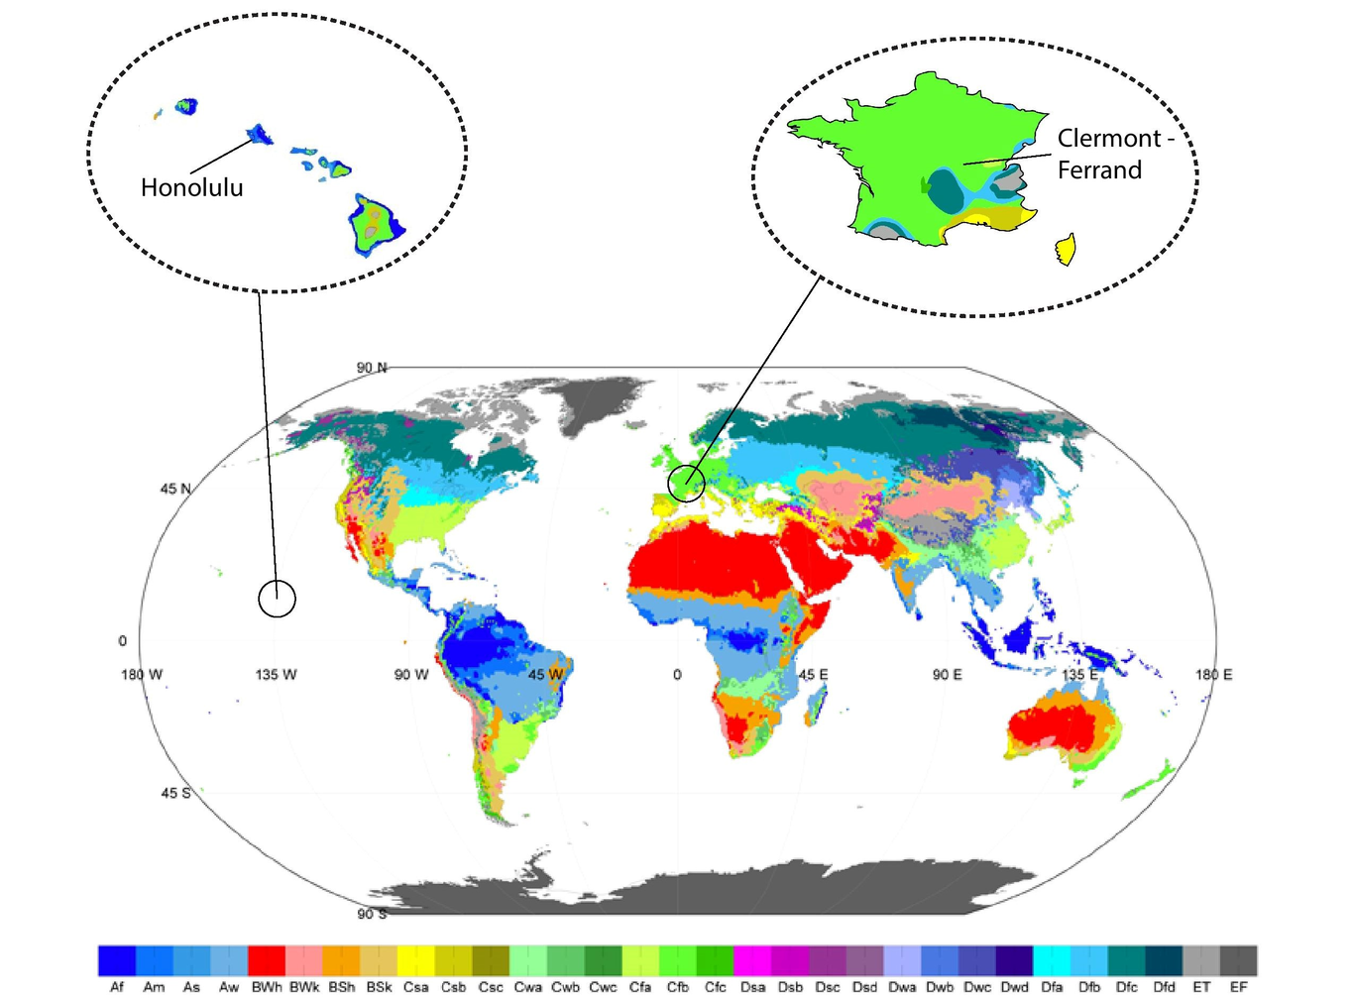
Köppen Climate Classification Map - Given Climates

Introduction - Climate Analysis

Honolulu

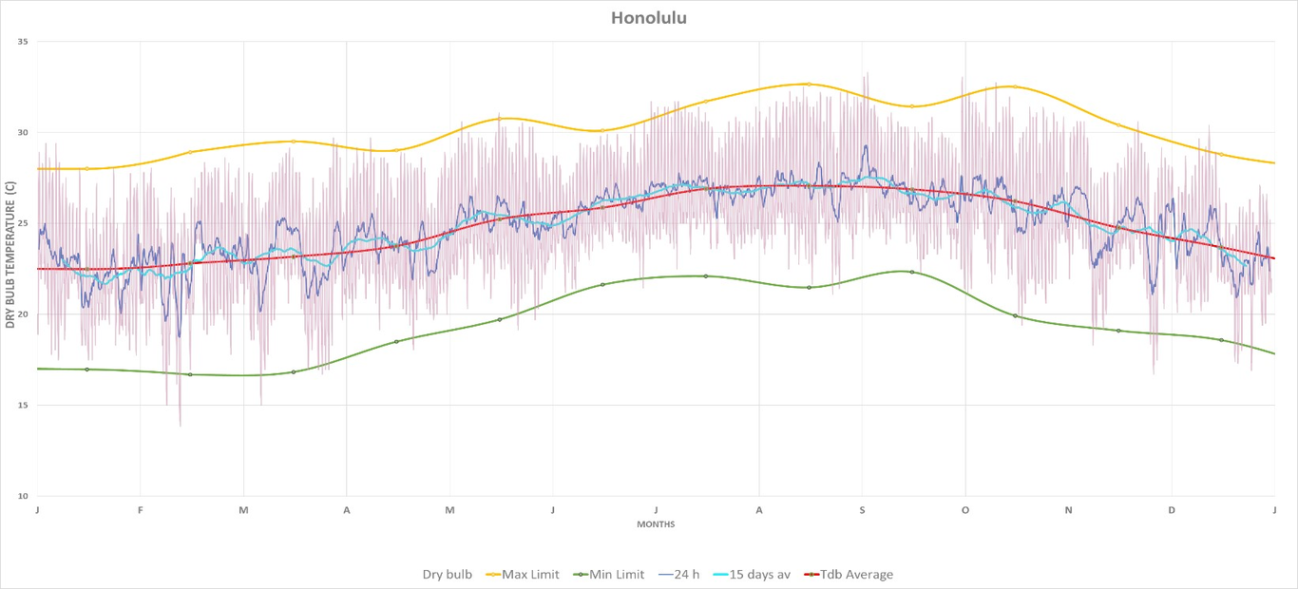
Moving Average
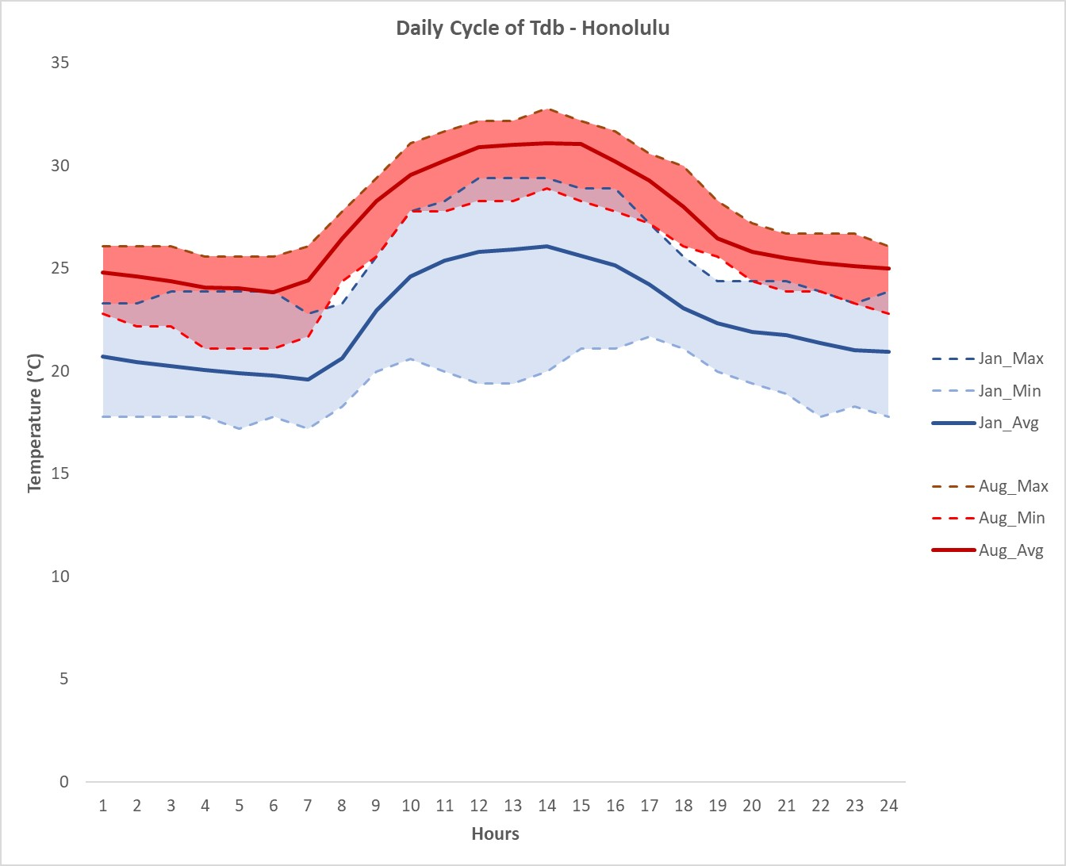
Tdb - Daily Cycle

Clermont - Ferrand

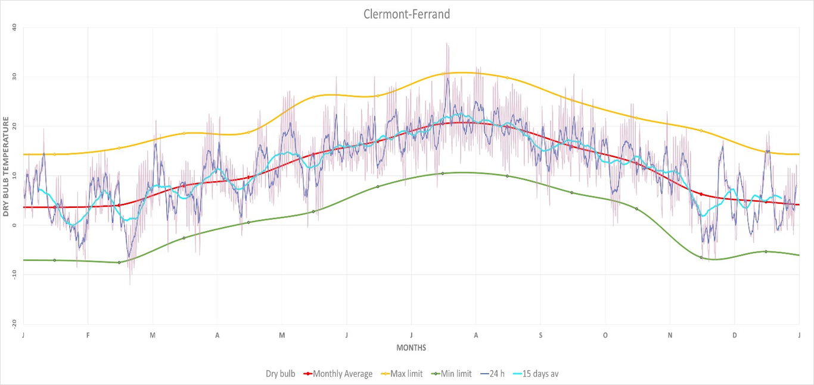
Moving Average
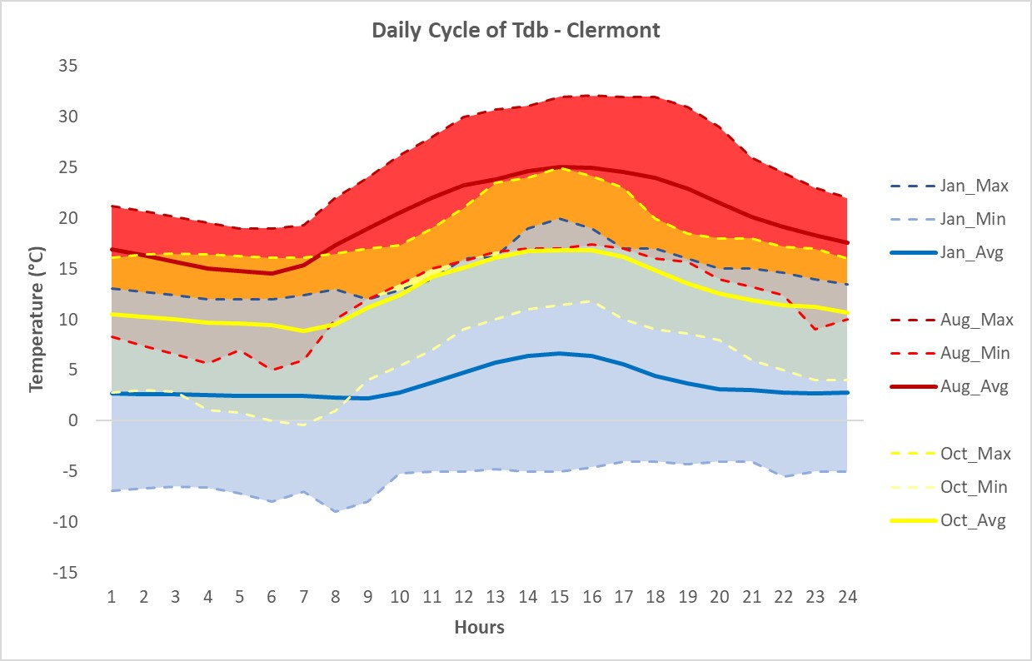
Tdb - Daily Cycle

Abstract
Vernacular architecture is an architectural style that is designed based on local needs, availability of construction materials and reflecting local traditions. At least originally, vernacular architecture did not use formally-schooled architects, but relied on the design skills and tradition of local builders. However, since the late 19th century many professional architects have worked in this style.
Vernacular architecture can be contrasted against polite architecture which is characterized by stylistic elements of design intentionally incorporated for aesthetic purposes which go beyond a building’s functional requirements. This article also covers the term traditional architecture, which exists somewhere between the two extremes yet still is based upon authentic themes.
One of the most significant influences on vernacular architecture is the macro climate of the area in which the building is constructed. Buildings in cold climates invariably have high thermal mass or significant amounts of insulation. They are usually sealed to prevent heat loss, and openings such as windows tend to be small or non-existent. Buildings in warm climates, by contrast, tend to be constructed of lighter materials and to allow significant cross-ventilation through openings in the fabric of the building.
Buildings for a continental climate must be able to cope with significant variations in temperature, and may even be altered by their occupants according to the seasons.
Buildings take different forms depending on precipitation levels in the region – leading to dwellings on stilts in many regions with frequent flooding or rainy monsoon seasons. Flat roofs are rare in areas with high levels of precipitation. Similarly, areas with high winds will lead to specialized buildings able to cope with them, and buildings will be oriented to present minimal area to the direction of prevailing winds.
Climatic influences on vernacular architecture are substantial and can be extremely complex.

Chapter 1 - Examples of Vernacular Architecture

Honolulu
The Hawaiian Islands are an archipelago of eight major islands, several atolls, numerous smaller islets, and seamounts in the North Pacific Ocean, extending some 2,400 kilometers from the island of Hawaii in the south to northernmost Kure Atoll. It is the northernmost island group in Polynesia, occupying most of an archipelago in the central Pacific Ocean.
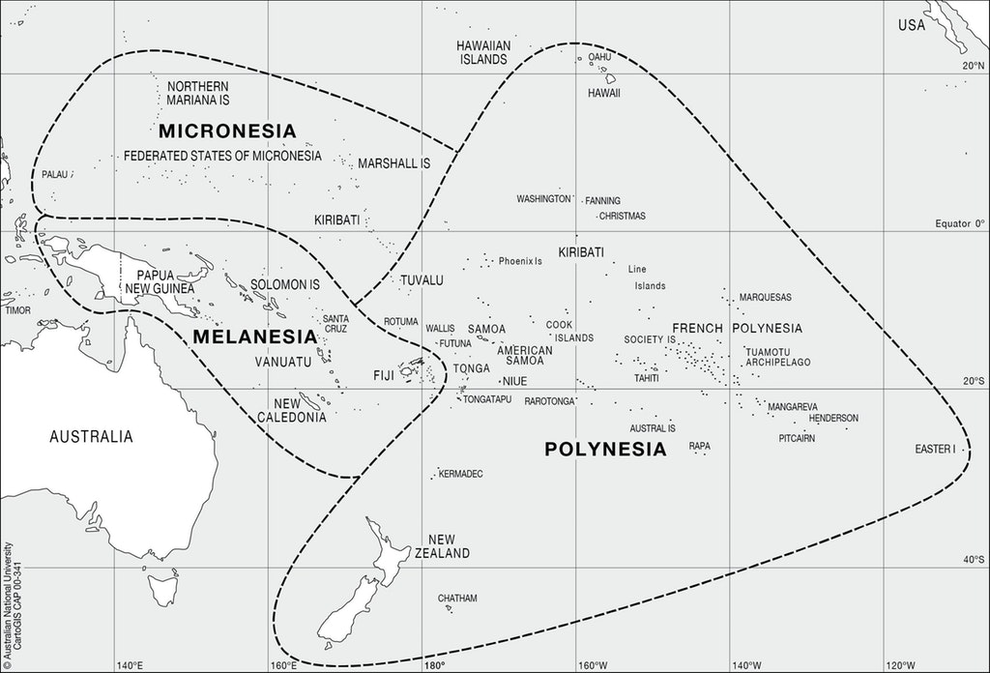
Districts of the South Pacific Islands
Hawaii’s climate, according to Köppen climate classification, can be characterized tropical (megathermal climate). This type of climate has every month of the year with an average temperature of 18°C or higher, with significant precipitation. Further classification of tropical climates is based on the seasonal precipitation type. As it can be seen from the graph below, Hawaii’s rainfall pattern is spectacularly diverse. Annual means range from 204 mm near the summit of Mauna Kea to 10.271 mm near Big Bog on the windward slope of Haleakalā, Maui. Therefore, the climate can be classified as tropical rainforest but even tropical savanna.
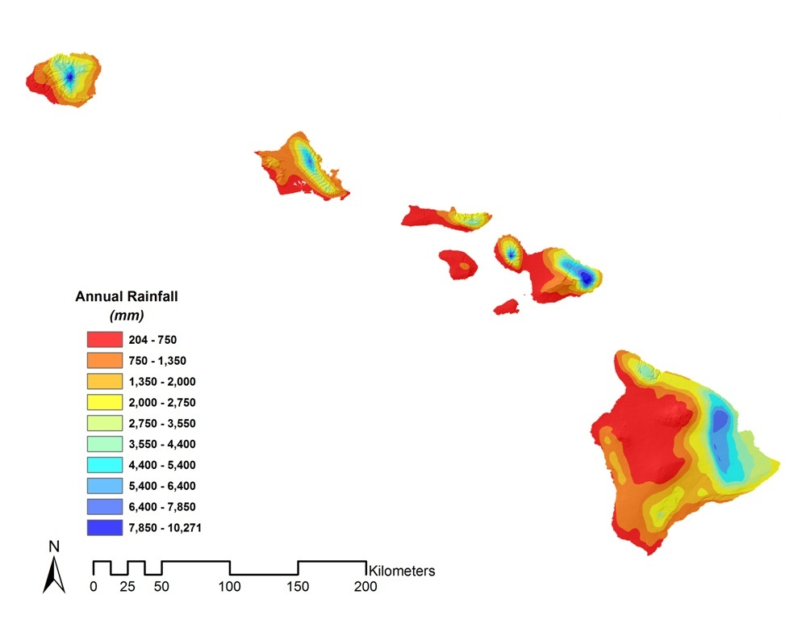
Mean Annual Rainfall - State of Hawaii
Tropical rainforests have a type of tropical in which there is no dry season—all months have an average precipitation value of at least 60 mm. On the other hand, tropical savannas have a pronounced dry season with the driest month having precipitation less than 60 mm.
All the Pacific islands can be classified in the same categories based on their climate and, even though the Pacific architecture is highly diverse, there are regular patterns of architecture not only concerning the space organization but also concerning their thermal comfort. The reason for this is that main consideration when addressing the architecture of the tropics is the climate and the prevailing conditions that define the habitation in the region. The climate has dictated the types of materials available and the building techniques which have been developed and refined over hundreds of years. Regarding the materials, due to the lush vegetation of the region, the common are the organic ones. As for the building response to thermal comfort, while it has adapted to contemporary techniques, during its primitive era it was succeeded through natural conditioning and it was significantly successful in terms of energy conservation and thermal regulation.
In the picture below, it can be observed that, despite the differences of the various types of traditional buildings in the Pacific islands, there are indisputable similarities among them. The need of a shelter for the inhabitants of the Pacific islands, led to a more unified type of construction with a lot of common characteristics. Thick walls, wide roof overhangs, high ceilings, limited fenestration and open fireplace are some of the characteristics that stand out mostly for all the six aforementioned shelters that prevail due to the similar climate of the regions. Furthermore, the technique for the construction of the traditional hales as well as the most preferable materials used for their implementation, where common for all the island simplex. In the next chapter, the case of the Hawaiian traditional architecture is going to be analyzed thoroughly but it should be acknowledged that the same principals apply to the Pacific architecture.
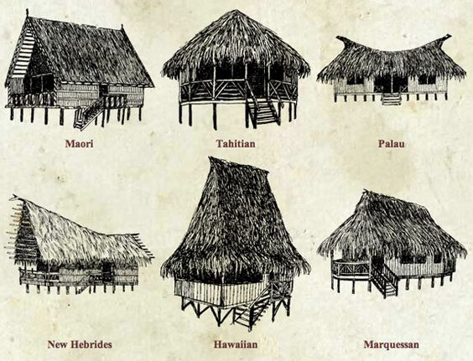
Traditional buildings in several Pacific Islands
Ancient Hawaiians lived sustainably and recognized that human civilization is an integral part of the natural world. Pursuing everyday activities in the midst of warm sunshine and gentle breezes ancient Hawaiians lived their lives mostly outdoors. The mild climate did not require a shelter of thick walls and insulation for protection against rough weather.
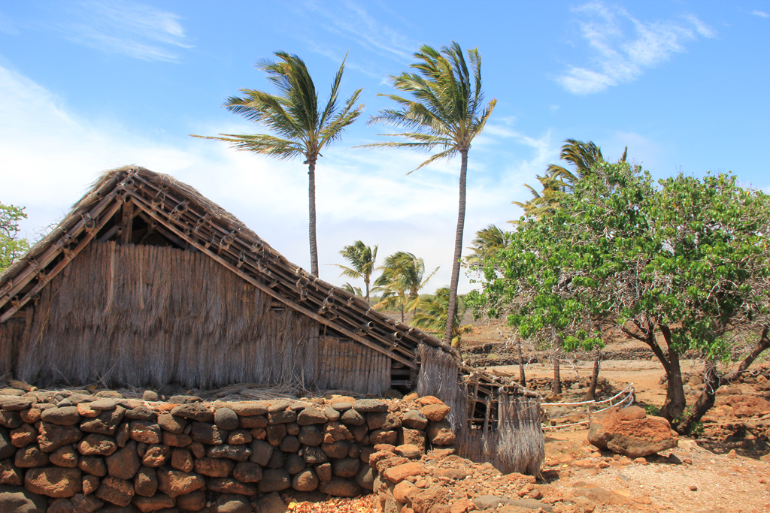
Example of Vernacular Architecture - Honolulu
The houses were built of palm thatch with relatively steep hipped roofs, well interwoven (using significant amounts of flat braided cordage) with no windows and few doors. Traditional hale were constructed of native woods lashed together with cordage. Materials for thatching were provided by the renewable resource of plant leaves and grasses.
The grass cabins are of a grayish color, are shaped much like our cottages, only with higher and steeper roofs usually, and are made of some kind of weed strongly bound together in bundles. The roofs are very thick, and so are the walls; the latter have square holes in them for windows. At a distance these cabins have a furry appearance, as if they might be made of bearskins. They are very cool and pleasant inside.
Thatch shelters were not all family homes. They served many purposes. A hale like this could have been used at a fish camp for a few days visit. A Hawaiian village consisted of many different types of hale. Different hale provided places for different kinds of work and rest.
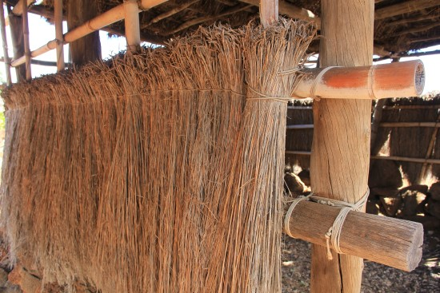
Thatch of a hale
Pili grass was one of the most common materials used for thatching. Grass bundles were made by fastening with twisted fiber or vines and then tied to horizontal purlins. Large piles of Pili grass has to be collected to thatch an entire house. Huge piles to prepare and tie into bundles. Fortunately the task could be shared by the young, the females and the elderly of a family unit or village.
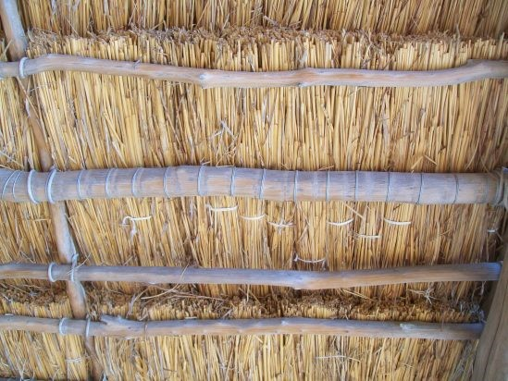
Overlapping of hatch sheds
Overlapping of each course or row of thatch sheds any rainfall in the same manner as any shingle, tile or clay roof. Pili grass with its pleasant odor was a preferred material for thatch. Palm, Pandanus, sugar cane and Ti leaf bundles were other common covering materials. Consider this, it takes about 40 Ti leaves to cover a square foot. Palm branches with the lower leaves removed have an added advantage when used in construction. The stiff stalks add rigidity to the framework and with the large mass of the palm the surface can be covered quickly and with depth. Grass thatch will last for many years but being an organic material it will eventually decompose and have to be replaced. Grass and leaves are naturally regenerative and a hale like this is a sustainable design. Pili grass also has a sweet aromatic scent that makes for a pleasant home environment. Grass is a natural sustainable resource and with a little help from the gathered family a new roof or walls can easily be replaced.
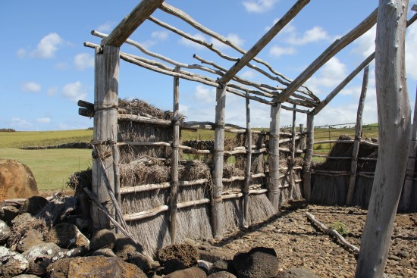
Woodframe of the hales
Palm, Pandanus, sugar cane and Ti leaf bundles were other common covering materials. Consider this, it takes about 40 Ti leaves to cover a square foot. Palm branches with the lower leaves removed have an added advantage when used in construction. The stiff stalks add rigidity to the framework and with the large mass of the palm the surface can be covered quickly and with depth. Grass thatch will last for many years but being an organic material it will eventually decompose and have to be replaced. Grass and leaves are naturally regenerative and a hale like this is a sustainable design.
There are two basic house designs used in old Hawaii a steep roof ‘A’ frame or an ‘A’ frame raised on short walls. Hawaiians had no nails or metal of any kind. Wooden poles were notched and fastened together with appropriate thicknesses of twisted string, twine or rope. Starting at the bottom, overlapping rows of thatch are tied to horizontal purlins, up the walls and over the roof.
Clermont - Ferrand
Clermont - Ferrand is a city and commune of France, in the Auvergne-Rhône-Alpes region. It sits on the plain of Limagne in the Massif Central the chain of volcanoes Chaîne des Puys surround it. According to Köppen climate classification, the climate is characterized as Cfb (Marine West Coast Climate).
Cfb (subtropical highland variety) climates usually occur in the higher middle latitudes on the western sides of continents between the latitudes of 40° and 60°. The subtropical highland variety of the oceanic climate (Cfb) exists in elevated portions of the world that are within either the tropics or subtropics, though it is typically found in mountainous locations in some tropical countries. Despite the latitude, the higher altitudes of these regions mean that the climate tends to share characteristics with oceanic climates, though it also tends to experience noticeably drier weather during the lower-sun “winter” season. In locations outside the tropics, other than the drying trend in the winter, subtropical highland climates tend to be essentially identical to an oceanic climate, with mild summers and noticeably cooler winters, plus, in some instances, some snowfall. In the tropics, a subtropical highland climate tends to feature spring-like weather year-round, where temperatures remain relatively constant and snowfall is seldom seen.

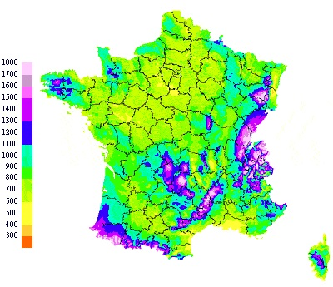
Precipitation Map - France
Specifically, for the case of Clermont-Ferrand, the climate is mild and generally warm and temperate. The average temperature of the year is 10°C. The warmest month, on average, is July with an average temperature of 18.9°C. The coolest month on average is January, with an average temperature of 0.6°C. Clermont-Ferrand has a significant amount of rainfall during year (as much as 150 days per year) however the precipitation is often of low intensity.
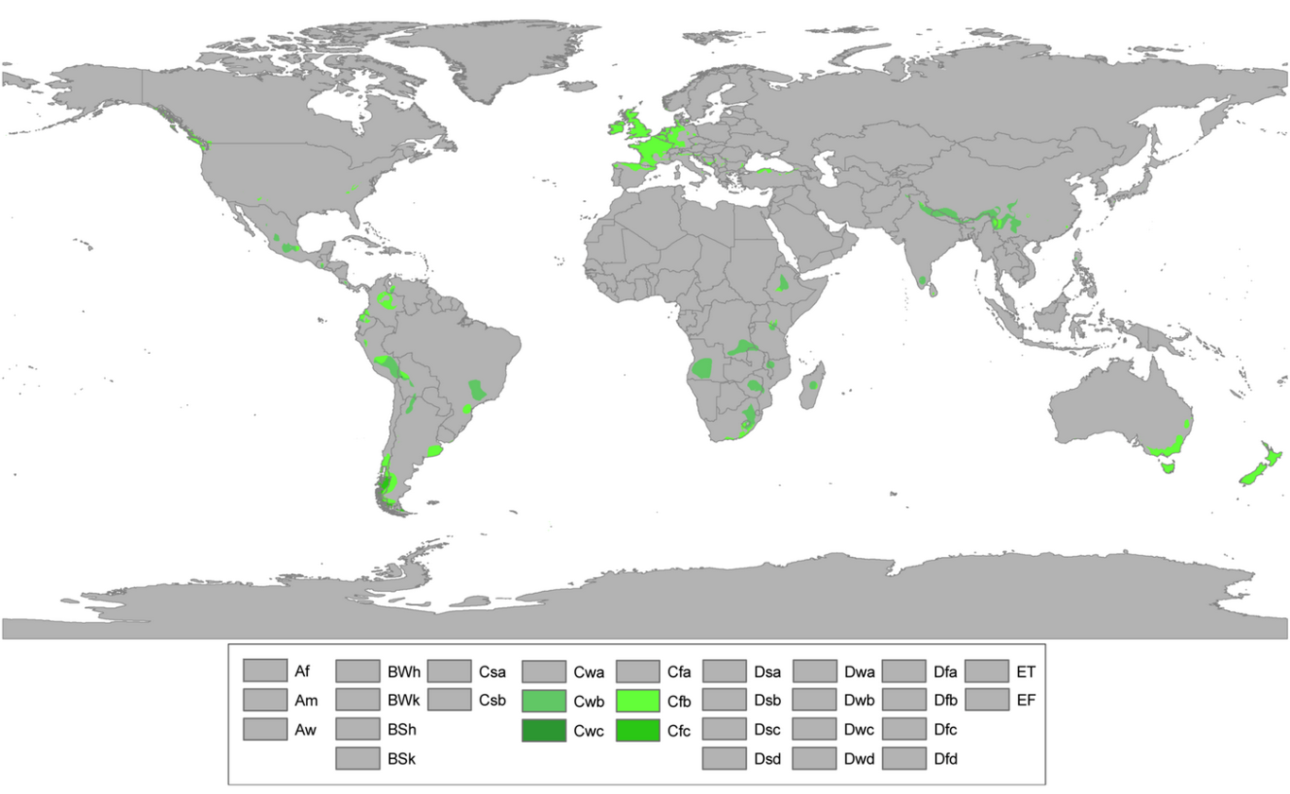
Regions of oceanic climate around the world
This type of climate can be found not only in central Europe but in different places around the world. More specifically, as it can be seen from the map below, there are regions in all continents with climate classified in the same category (and even the same subcategory). Thus, buildings constructed in Europe, South America and Australia share the same principles necessarily being influenced from one another.
In the next paragraphs, the traditional architecture and climate responsive building techniques of buildings in Clermont-Ferrand are going to be analyzed in depth. However, it important to mention that the characteristics of the climate have dictated many of the properties of the envelope and the strategies used and as a result, buildings with many similarities can be found in all the aforementioned areas of the world.
The high precipitation and the humidity of this climate generated a necessity for buildings with roofs with high inclination and earthen walls made of masonry or lime wash. The wooden constructions are also similar due to the abundance of the regions in trees. As in all the cases of traditional architectures, the local materials were preferred therefore even thatched roofs can be found. Since the protection from the sun and storms was not of significant importance, buildings in these areas have openings.
At this point, it must be stated that apart from the climatic adaptation the buildings are highly influenced by culture and as a result there is a vast diversity in terms of aesthetics. The principles, however, remain the same in all the cases. On the pictures below, typical buildings from Northern Spain, Chile, Australia and Ireland are demonstrated and the pattern of building techniques and materials is shared among all of them.
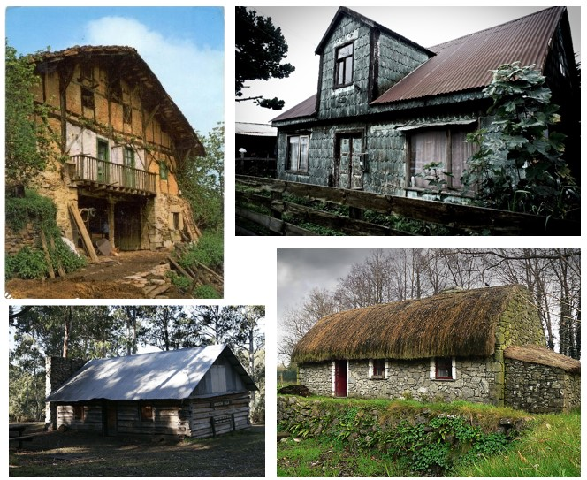
Canvas of Vernacular Architecture in oceanic climates in Northern Spain - Chile - Australia - Ireland
Old Town of Clermont-Ferrand sits on the site of a volcano. Because of that is evidenced the extensive use of lava as a building material, which does tend to give some of the otherwise magnificent buildings a rather gloomy appearance.
- Auvergne Half-Timbered Houses
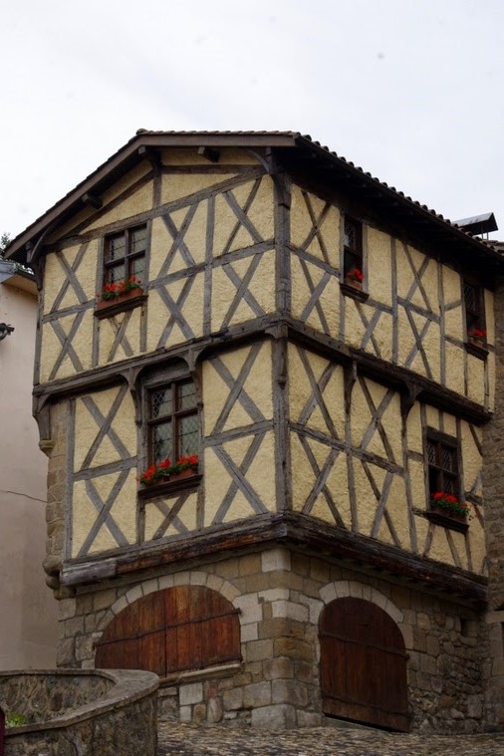
Half-Timbered House - Auvergne,France
Timber framing in French is known colloquially as pan de bois and half-timbering as colombage. The timber-framing technique has historically been popular in climate zones which favor deciduous hardwood trees, such as oak. Techniques used in timber framing date back to Neolithic times, and have been used in many parts of the world during various periods such as ancient Japan, continental Europe, and Neolithic France. The Normandy tradition features two techniques: frameworks were built of four evenly spaced regularly hewn timbers set into the ground or into a continuous wooden sill and mortised at the top into the plate.
The juxtaposition of exposed timbered beams and infilled spaces created the distinctive “half-timbered”. The most ancient known half-timbered building is called the House of opus craticum. It was buried by the eruption of Mount Vesuvius in Herculaneum, Italy. Opus craticum was mentioned by Vitruvius in his books on architecture as a timber frame with wattle work infill. However, the same term is used to describe timber frames with an infill of stone rubble laid in mortar the Romans called opus incertum.
Half-timbered construction in the Northern European vernacular building style is characteristic of medieval and early modern Denmark, England, Germany, and parts of France and Switzerland, where timber was in good supply yet stone and associated skills to dress the stonework were in short supply. The earliest surviving (French) half-timbered buildings date from the 12th century. In half-timbered construction, timbers that were split in half provided the complete skeletal framing of the building.
The walls are filled using cob -sometimes of a cob and stone mix-, only then floor and the roof structure are been built. The wooden framework is naturally strong and rigid once erected, the strength of the structure can be supplemented using wood plugs. Cob is an English term attested for an ancient building material that has been used for building since prehistoric times. The etymology of cob is unclear, but in several senses, means to beat or strike, which is how cob material is applied to a wall. Cob is a natural building material made from subsoil, water, fibrous organic material (typically straw), and sometimes lime.
The dominant construction material used in the Auvergne region of France is stones. Τhe half-timbered structure in Auvergne is built over a stone structure, protecting the first floor from potential fires and the humidity. Half-timbered properties are partially made of local stones, the half-timbering structure covering a part of the house only. This half-timbered style is a legacy of the middle-ages. The use of wood forms the key element of these Auvergne properties. Wood is used both inside and outside the house, for both decoration or protection. Some Auvergne half-timbered houses also have a corbelling structure, giving more space to the upper floors’ rooms. A corbel is a piece of wood jutting out of a wall to carry the bearing weight of the floor above. This is a technique used since Neolithic times – late Stone Age (around 3,500 BC): this is actually a traditional construction method in the region.
- Auvergne Farmhouses
i. Auvergne Houses: Basalt stones are used. In the North of the French region, roofs are covered with Lauze or flat tiles

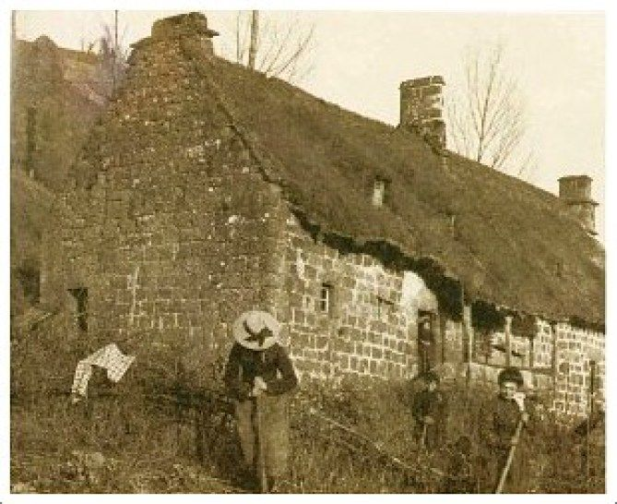
Farmhouse - Auvergne,France
These French houses are originally based on the model of the farmhouse, strictly speaking, being the house of the farmer.
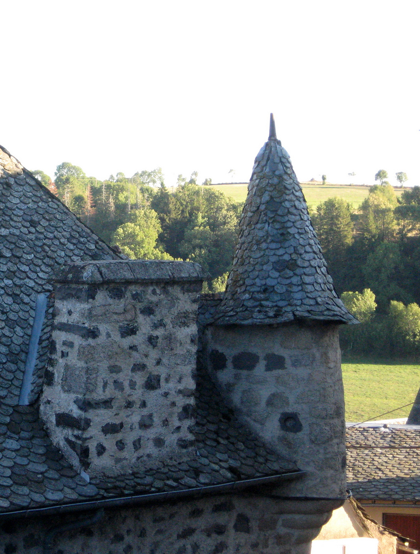
Lauze Tile Roofing - Auvergne,France
Auvergne farmhouses are built with local materials. Foundations are made up of local stones. The very particularity of Auvergne is the Lauze or lava tiles found on roofs, as well as some tiled roofs. Those stone materials were used to cover roofs, either with schist, volcanic tuff, limestone or sandstone – all local materials prepared on building sites after being carted there from working sites, quarries, outcrops and various rocky massifs. Because sloping roofs in schistose Lauze slates are very heavy and need sturdy frames, alternative solutions in the form of limestone arches and domes are frequent in vernacular buildings in Mediterranean Europe.
These Auvergne properties are often organized around a square front farmyard. They are of rectangular shape. The farmyard is originally closed, a wide wooden gate allowing access for large vehicles. Nowadays most courtyards have vanished and a garden replaces them. Farming and breeding animals was the main activity of the original inhabitants and thus the architecture was adapted to their needs.
The living area is often located on the first floor of these French traditional houses, that can be accessed via outside stone stairs. The front façade of the farmhouse is made of stone and Pisé (rammed earth). Windows are of medium dimensions with small window-panes.
The roof structure is made of wood, it is upheld by the front façade walls.
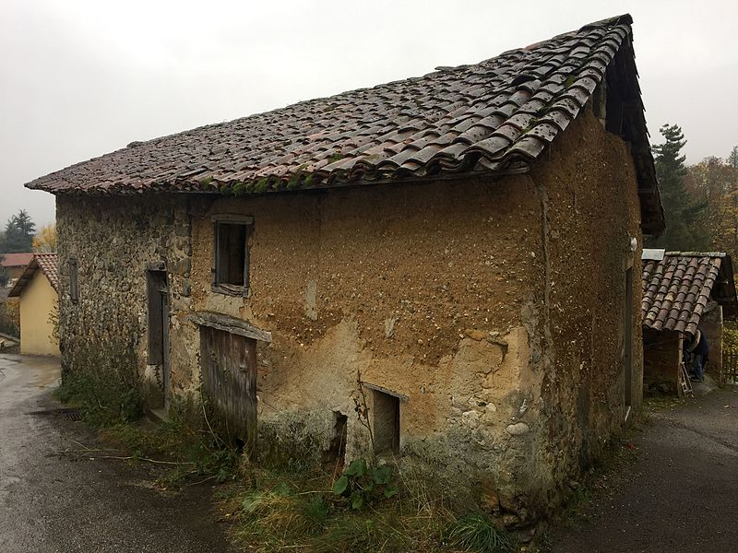
Rammed Earth (Pisé) Building - France
The environment around these houses is made of many trees, and many ponds can be found, that were created since earth was taken to create Pisé (rammed earth) walls. Edifices of rammed earth are thought to be more sustainable and environmentally friendly than popular techniques of construction. Because rammed-earth edifices use locally available materials, they usually have low embodied energy and generate very little waste. The soils used are typically low in clay, between 5% and 15%, which conserve the topsoil for agriculture. When the soil excavated in preparation for a foundation can be used, the cost and energy consumption of transportation are minimal.
Rammed earth is probably the least environmentally detrimental construction material and technique that is readily and commercially available today to construct solid masonry edifices.
ii. Cantal Houses
Made of Schist, Granite with roofs covered by Lauze stone tiles, volcanic slate or grey Lava. The steepness of the roofs is explained by the fact that in this way the snow slides off, hence lightening the load on the chestnut or oak roof beams.
The walls of the houses in the northern part of the area are made of volcanic stone and sometimes those situated in the south are made of granite stone. The thickness of the walls and the small openings ensure that the houses are perfectly suited to even the coldest of winters and hottest of summers.
Houses often boast a tower attached often a pigeonnier. The tower can be of round or square shape.

Chapter 2 - Design Strategies

Since housing for traditional cultures around the globe typically had a fairly low environmental impact, in today’s terms, was “green”. This “greenness” of houses was born out of necessity rather than choice. Local materials were used, because of what was available at that time. Placement and construction of houses were tailored to local environmental conditions that worked with the wind, sun, and topography of the area. Thus, the thermally responsive traditional methods can be implemented into modern building techniques.
Βioclimatic design is based on analysis of the climate, including ambient energy of sun, wind, temperature and humidity. Furthermore, it utilizes passive and ambient energy sources to achieve human comfort through building design and construction, including heating, cooling and daylighting techniques. Derived from regional and local conditions and opportunities, bioclimatic analysis and design provide both a knowledge base and an inspiration for architecture and sustainable design.
The following table is the well known as “Watson and Labs matrix” (1973) and it became current in the literature of architectural design, since is a result of the bioclimatic design research.
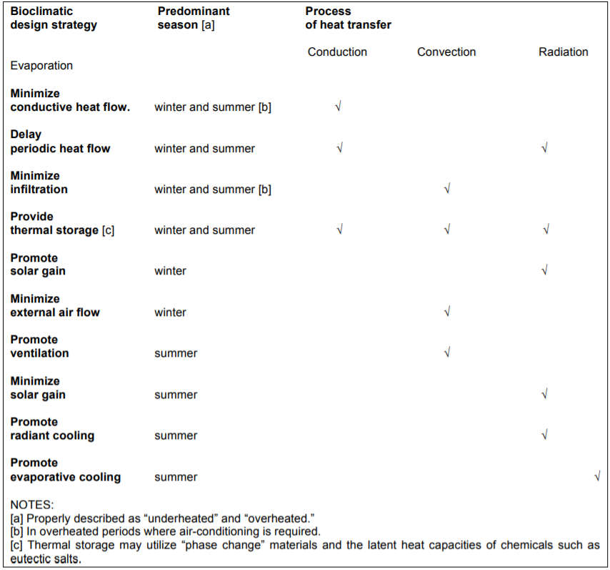
Strategies of Bioclimatic Design
In winter (or under heated periods), the objectives of bioclimatic design are to resist loss of heat from the building envelope and to promote gain of solar heat. In summer (or overheated periods), these objectives are the reverse, to resist solar gain and to promote loss of heat from the building interior. The strategies can be set forth as:
• Minimize conductive heat flow. This strategy is achieved by using insulation. It is effective when the outdoor temperature is significantly different, either lower or higher, than the interior comfort range. In summer, this strategy should be considered whenever ambient temperatures are within or above the comfort range and where natural cooling strategies cannot be relied upon to achieve comfort.
• Delay periodic heat flow. While the insulation value of building materials is well understood, it is not as widely appreciated that building envelope materials also can delay heat flows that can be used to improve comfort and to lower energy costs. Time lag through masonry walls, for example, can delay the day’s thermal impact until evening and is a particularly valuable technique in hot arid climates with wide day-night temperature variations. Techniques of earth sheltering and beaming also exploit the long-lag effect of subsurface construction.
• Minimize infiltration. “Infiltration” refers to uncontrolled air leakage around doors and windows and through joints, cracks, and faulty seals in the building envelope. Infiltration (and the resulting “exfiltration” of heated or cooled air) is considered the largest and potentially the most intractable source of energy loss in a building, once other practical insulation measures have been taken.
• Provide thermal storage. Thermal mass inside of the insulated envelope is critical to dampening the swings in air temperature and in storing heat in winter and as a heat sink in summer.
• Promote solar gain. The sun can provide a substantial portion of winter heating energy through elements such as equatorial-facing windows and greenhouses, and other passive solar techniques which use spaces to collect, store, and transfer solar heat.
• Minimize external air flow. Winter winds increase the rate of heat loss from a building by “washing away” heat and thus accelerating the cooling of the exterior envelope surfaces by conduction, and also by increasing infiltration (or more properly, exfiltration) losses. Siting and shaping a building to minimize wind exposure or providing windbreaks can reduce the impact of such winds.
• Promote ventilation. Cooling by air flow through an interior may be propelled by two natural processes, cross-ventilation (wind driven) and stack-effect ventilation (driven by the buoyancy of heated air even in the absence of external wind pressure). A fan (using photovoltaic for fan power) can be an efficient way to augment natural ventilation cooling in the absence of sufficient wind or stack-pressure differential.
• Minimize solar gain. The best means for ensuring comfort from the heat of summer is to minimize the effects of the direct sun by shading windows from the sun, or otherwise minimizing the building surfaces exposed to summer sun, by use of radiant barriers, and by insulation.
• Promote radiant cooling. A building can lose heat effectively if the mean radiant temperature of the materials at its outer surface is greater than that of its surroundings, principally the night sky. The mean radiant temperature of the building surface is determined by the intensity of solar irradiation, the material surface (film coefficient) and by the emissivity of its exterior surface (its ability to “emit” or re-radiate heat). This contributes only marginally, if the building envelope is well insulated.
• Promote evaporative cooling. Sensible cooling of a building interior can be achieved by evaporating moisture into the incoming air stream (or, if an existing roof has little insulation, by evaporative cooling the exterior envelope such as by a roof spray.) These simple and traditional techniques are most useful in hot-dry climates if water is available for controlled usage. Mechanically assisted evaporative cooling is achieved with an economizer-cycle evaporative cooling system, instead of, or in conjunction with, refrigerant air conditioning.

Honolulu
Hawaii’s climate presented unique challenges for the planning and designing of constructions that would be healthy and pleasing for their occupants. The mostly constant high temperature in combination with the high humidity, has forced people to locate and design their first settlements in ways in order to provide them shade, ventilation and sufficient light. Possibly the most important priority of settlements was their resilience and the traditional buildings had a number of wind and thermal resistance characteristics. The houses were built of palm thatch with relatively steep hipped roofs, well interwoven (using significant amounts of flat braided cordage) with no windows and few doors. The porosity of the building materials prevented excessive heat build-up within the interior spaces. However, traditional methods and materials had disadvantages such as low durability, poor technology and fire risk in terms of their thatched roofs and wooden structures, but were particularly successful in the terms of energy conservation and thermal regulation. While traditional methods and materials are much better suited to the tropical climate than contemporary methods and materials their durability needs to be enhanced.
More specifically, according to Köppen climate classification, for the tropical charactirization of Honolulu’s climate, the decisions for a more energetically efficient shettle were taken by avoiding the overheating of the interior space. In other words, through all the year, the majority of the external Temperatures overpass the comfort conditions. For this reason, the inhabitants of the Hawaiian islands, with the reasonable choice of the materials, the orientation and the shape of the constructions aimed to reduce the heat gains and increase the heat losses along the year.

Heat transfer
Intelligent site selection and building orientation achieved to eliminate the extremes of heat, cold, humidity, air movement and exposure. However, one of the most significant characteristics of the Hawaiian hale is the thick wall and roof, which usually are not clearly separated because of the great inclination of the latter. Both parts are usually constructed from layered grass, as already mentioned, and this vegetative cover ameliorates climatic problems in many ways. One of the main reasons is temperature variability, since due to their high conductivity a significant reduction in the heat transfer is achieved. Additionally, the porosity of the structure retains the cooling moisture of precipitation, as well as cools and refreshes the heated air by evaporation. In other words, the evaporation of moisture from paved, surfaces spray heads, mulches and foliage provide welcome relief from heat. Last but not least, during the cooler hours of the days, the thick cover with limited fenestration is able to protect the soils and environs from the freezing winds.

Ventilation and Air changes
Single wall plantation houses used few materials and therefore the natural ventilation was obtained. This contributed not only to the air quality inside the building but also to the temperature, since the air moving across the moist surface of the foliage of the walls made the air cooler. Additionally to the small number of openings, the raised post-and-pier construction kept the interior area cool and fresh during the hot months.

Solar gains and radial losses
Structural protection was important not only for the heat and the strong winds, but also to avoid the discomfort of solar radiation. The precise design of the Hawaiian hales response to the angles and arches of the sun. Wide roof overhangs and limited fenestration can be distinguished in the settlements of Pacific islands. The vegetative cover is of major importance not only for the insulation of the building, but also for the shading that is necessary to be provided. The high inclination of the roof shades the ground surface and provides sunscreen, shade and shadow to the occupants. Additionally, the good estimation of the openings, allowed also a favored amount and type of light to be received at the favored time. Furthermore, the wide overhangs, especially those over the fenestration, shade the windows from the sun during the overheating summer period, while allows the sun rays to reach the window surfaces and spaces in winter. This can be justified, because mid-day solar altitude angles are much higher in summer months than in winter. In this way, by providing summer sun shading is not necessary to conflict with winter solar heat gain. Lastly, the wide overhangs of the roof minimize also the reflectivity of ground and building surfaces outside windows facing the summer sun.
To sum up, the primitive architecture revealed a commendable level of performance when judged in the light of modern building technologies. All these evidents from the past, addressed nowadays, based on the combination of climate and needs of comfort of the inhabitants,the first roots for a bioclimatic design of the new structures. According to Köppen climate classification, for the tropical charactirization of Honolulu’s climate and for a sustainable and energetically efficient design, the “Watson and Labs matrix” listed below can be followed.

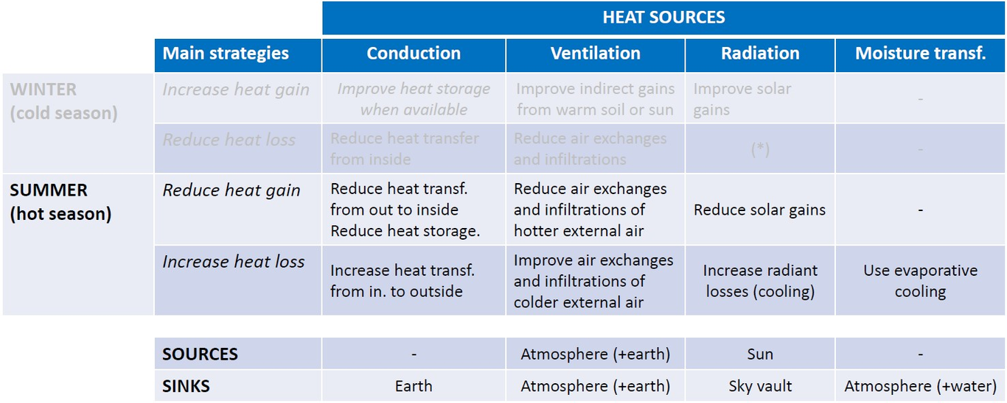
Design strategies for the Hawaiian climate
It is important the Hawaiian primary architecture to be used in defining the developing and future architecture of these islands. Improving the energy efficiency of Hawaii’s buildings, both old and new, offers tremendous potential to save energy especially for the cooling needs. Therefor it is of major importance to follow the roles for the energetic design that the “Watson and Labs matrix” provides.
The combination of tropical sun and western architecture influences can dramatically affect new constructions regarding the heating load and can result in the requirement of an air conditioning system. However, thanks to the bioclimatic design, the reasonable analysis of all the parameters can influence the final energetic balance and lead to a more sufficient result.
Firstly, the orientation and configuration of a building are critically important due to their strong influence on the design of effective solar control and daylight systems, as well as their impact on the performance of naturally ventilated buildings. Building orientation determines the amount of solar radiation falling on the wall and roof of the building and the ventilative effectiveness of the building’s openings. Building shape also determines the depth to which daylight can penetrate and the effectiveness of cross ventilation.

Reduce Solar gains
In the case of Hawaii, it is desirable to minimize the wall area and especially glass area facing east and west. These orientations receive long periods of exposure to the hot summer sun and are difficult to shade effectively. However, the key effective shading is to intercept the heat outside the building. Overhangs and eaves are effective against the midday sun, particularly on the south side. For the lower morning and afternoon sun, vertical fins are desirable on the east and west façade.

Ventilation and air changes
The optimum orientation for ventilation depends on the window location as well as the direction of the prevailing winds. When windows are in opposite walls, rotating the building 45 degrees with respect of the prevailing wind direction provides the highest average velocities and the best overall distribution of the air movement within the space. Inlets for natural ventilation can often be designed for less optimal wind orientations, because the reduction of solar gains is more important. Lat but not least, it is desirable to have a compact plan to minimize the surface area exposed to the sun and exterior openings should be well sealed to minimize the loss of cooled air.

Heat transfer
In our tropical climate, the major source of heat gains is radiant heat through windows, roofs and walls. Therefore the selection of the building systems and the materials will dramatically affect the building’s energy performance. To reduce the amount of heat that penetrates a building’s exterior envelope, the materials selected should be capable of reducing both conductive and radiant heat flow. For example, from an energetic performance standpoint, glazing materials should have a high daylight transmission and a low shading coefficient. As far as the walls and roof is concerned, when they are heavily exposed to solar radiation an effective and appropriate level of insulation should be determined. Stopping the flow of heat into a building through radiation may be more important in Hawaii, particularly in roofs, since they are the most exposed to the sun areas. Most forms of thermal insulation restrict conductive and convective heat flow by trapping layers of still air.
To sum up, a number of common features have been found in the different tropical regions. These features are independent of location, social organisation or religious affiliation. Though each tropical region is unique, they are all inextricably linked through shared patterns of climatic adaptations and by surprisingly specific but similar cultural forms and colonial influences that have evolved and diffused to meet their shared requirements. Building construction is determined by the distribution of naturally available building materials, one exemplar being palm thatch which is available and readily used in most tropical regions. The table listed below provides a summary of building evolution in four different tropical regions, highlighting the common features of traditional building and their modern adaptions. These modern adaptations provide the recommended design methods and materials for tropical regions.
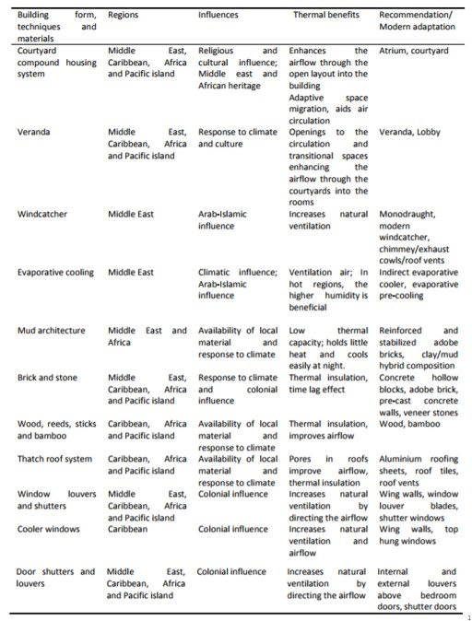
Recommendations for modern building techniques based on traditional architecture

Clermont - Ferrand

Key Design Objectives
Oceanic climates present cost-effective opportunities to achieve carbon zero or positive outcomes because they require relatively simple design adjustments to achieve low or zero heating and cooling energy use.
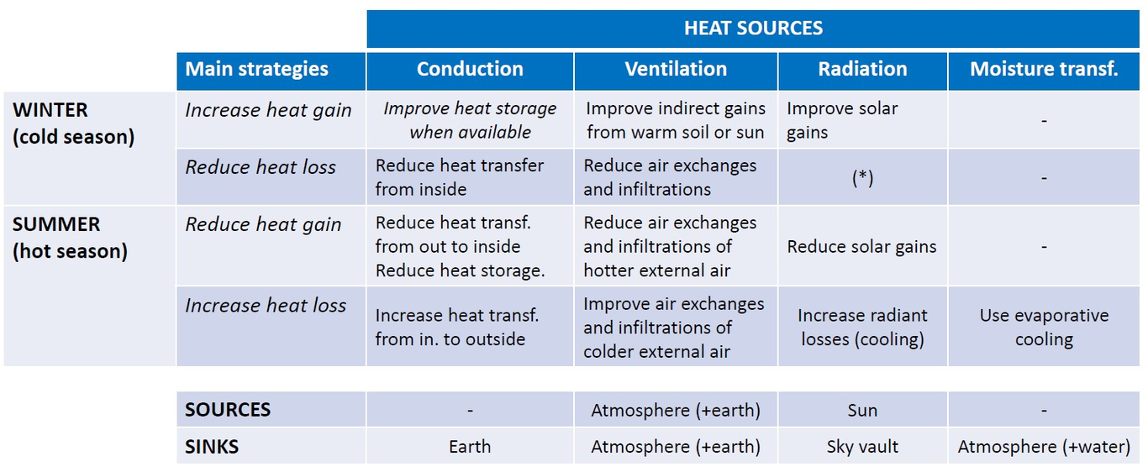
Design strategies of Clermont-Ferrand
Since Clermont – Ferrand is a place which is related with local constructional materials, the following design strategies can be presented as an effective way to maximize comfort and minimize energy needs through the design procedure:

Design Considerations
- Individual site analysis and location within the region will determine whether heating or cooling is the predominant need
- Use convective ventilation and heat circulation
- Lower thermal mass requirements allow for low embodied energy solutions
- Sites with solar access require north-facing living areas with majority of glazing
- Where solar access is unavailable, lightweight solutions that respond quickly and efficiently to minimal, carbon-efficient auxiliary heating are a viable alternative

Windows and Shading
- Avoid overuse of glazing
- Carefully size and orientate windows, as this will often yield ideal results with less expensive glazing options
- Reduce expenditure on glazing and divert the savings to efficient appliances and on-site renewable energy generation, generating effective carbon reductions
- When glazing is used, use high SHGC and low U-value glazing
- Use passive solar shading on northerly windows
- Minimize and shade all east and west-facing glass in summer
- Consider adjustable shading to allow variable solar access in spring and autumn

Insulation
- Use bulk and reflective insulation in ceilings, and bulk or reflective insulation in walls
- Insulate all thermal mass externally
- Refer to Insulation for recommended optimal insulation levels
- Insulate under concrete slabs if using in-slab heating
- Insulate elevated floors by the use of lightweight concrete
- Seal thoroughly against droughts and use entry airlocks

Heating and Cooling
- Reducing heat gain though appropriate use of windows and glazing (size, location and type) is a critical design consideration
- Cooling comfort is simply achieved with adequate cross-ventilation and minimizing solar and ambient heat gains with shading and insulation
- Passive solar heating is essential and simply achieved where solar access is available
- Earth coupled slabs maintain comfortable summer temperatures that can easily be raised by passive solar heating in winter

Construction Systems
- Earth coupled slabs are highly beneficial
- High thermal mass walls can be used if within glass to mass ratios (Glass to mass ratios compare the area of solar exposed, passively shaded, south/north facing glazing to the area of exposed, insulated internal mass -walls and floor- to avoid overheating passive solar houses). These ratios should be varied according to solar availability, diurnal temperature ranges, type and orientation of glazing and shading (ambient and diffuse gains).
- Low embodied energy walls, roofing and finishes

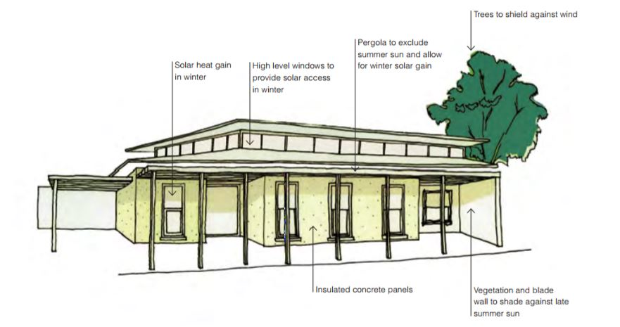
General Design for Mild Temperate Climates
Regarding winter requirements in oceanic climates, since the underheated period is not as severe, surface/volume and insulation standards are not as a rigorous as in cool temperate climates for example. Solar heat input in winter is desirable, so orientation and other considerations are the same as for cool temperate.
As overheating in summer is possible, structural sun control is necessary. Cut-offs between winter heating and summer sun exclusion depend on average monthly temperatures. Consider the use of deciduous vegetation for automatic shading discrimination between winter and summer.
As night temperatures are often below appropriate, even in summer, thermal mass is desirable. The thermal mass is, of course, also beneficial for passive solar design for winter. Summers are generally milder, with lower maximum and less frequent extreme days. Ventilation can cope with most summer overheating by removing the surplus heat. But if shading is adequate, such overheating should rarely occur. However, on a few extreme days, severe overheating may combine with elevated humidities to produce conditions worse than those in the tropics. On such days, additional care needs to be taken with reducing solar gain and air exchange rates, to limit the extent of internal temperature and humidity rises.

Location, siting and landscape
South facing slopes will significantly reduce available solar radiation, and ground surface temperatures may be reduced enough to maintain frost cover long into winter days. Slopes facing up to 40° west of north would be beneficial in winter, but severely aggravate summer sun exposure. Overall, north facing slopes, up to 20° east, are considered optimal. Planting should assure sun access in winter, to north elevations of buildings. Ideally, trees close to buildings would be deciduous, admitting winter sun and providing summer shade and evaporate cooling.

Building shape and orientation
Reduced surface/volume ratio of the building to minimize potential heat losses should be balanced against optimum planning for passive solar design. A rectangular compact plan of approximately 2:1 ratio is desirable, with the long axis oriented east-west. Two-storey designs improve the isolation of interior spaces from the external environment.

External envelope
To reduce winter losses and summer heat gains, the building envelope should be insulated to high standards. Windows should be moderate in size, and double glazing will usually be justified on other than the northern orientation. Construction should be air-tight, compatible with the requirements for minimum ventilation. External doors and windows should be weather striped. Consideration should be given to simple heat exchangers to retrieve heat from exhaust air, to preheat incoming air.

Building mass
Though the building may not be continuously occupied, environmental conditions are expected to be maintained on a continuous, rather than intermittent basis. Therefore, there is an advantage in having an appropriate amount of internal thermal mass, to reduce the internal temperature swing to a minimum. A winter temperature swing of less than 4°C without supplementary heating should be considered an appropriate standard for the construction.
Thermal mass is a necessary component of passive solar design. It absorbs excess heat during the sunlit period, and returns it to the space at night. For maximum effectiveness, thermally massive elements should have a large surface area, and a thickness based on their optimum diurnal heat capacity. Thermal mass is also beneficial during the summer. During the day, it takes up heat from the interior, moderating any temperature rise. During the night, it can give up its stored heat to controlled ventilation.

Passive solar design
Where good winter sun is available, glazing should face the equator, with insulated shutters for control of conducted heat losses at night. However, except for areas separate from display and storage, conventional ‘direct gain’ solar collection is unacceptable.

Chapter 3 - Climate Responsive Modern Architecture
Climate responsive architecture takes into consideration seasonality, the direction of the sun (sun path and solar position), natural shade provided by the surrounding topography, environmental factors (such as wind, rain fall, humidity) and climate data (temperature, historical weather patterns, etc.) to design comfortable and energy efficient homes

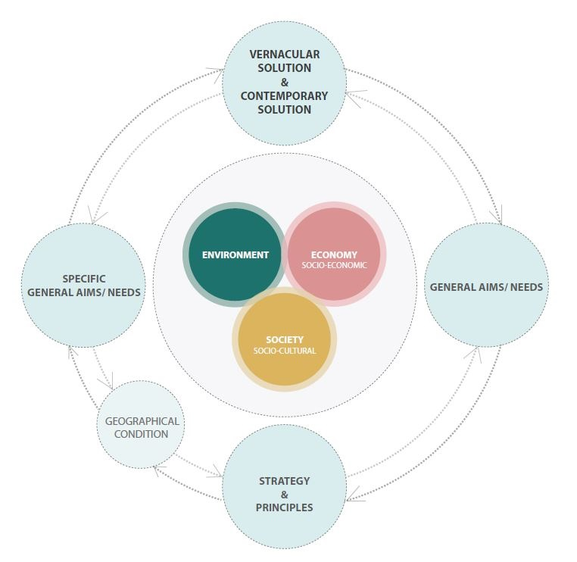
(Correia et al. 2014)

Tropical Climate
Case Study: House on a Hill / Horana, Sri Lanka
House on a Hill

Building Design
All walls are protected from the direct sun. Through ventilation is used extensively and the owners complain that the inside of the building is cold during the night. Disintegrated rock excavated from the site used for all walling material. Exposed on outside and parts plastered on inside. Some walls are in brick left exposed.

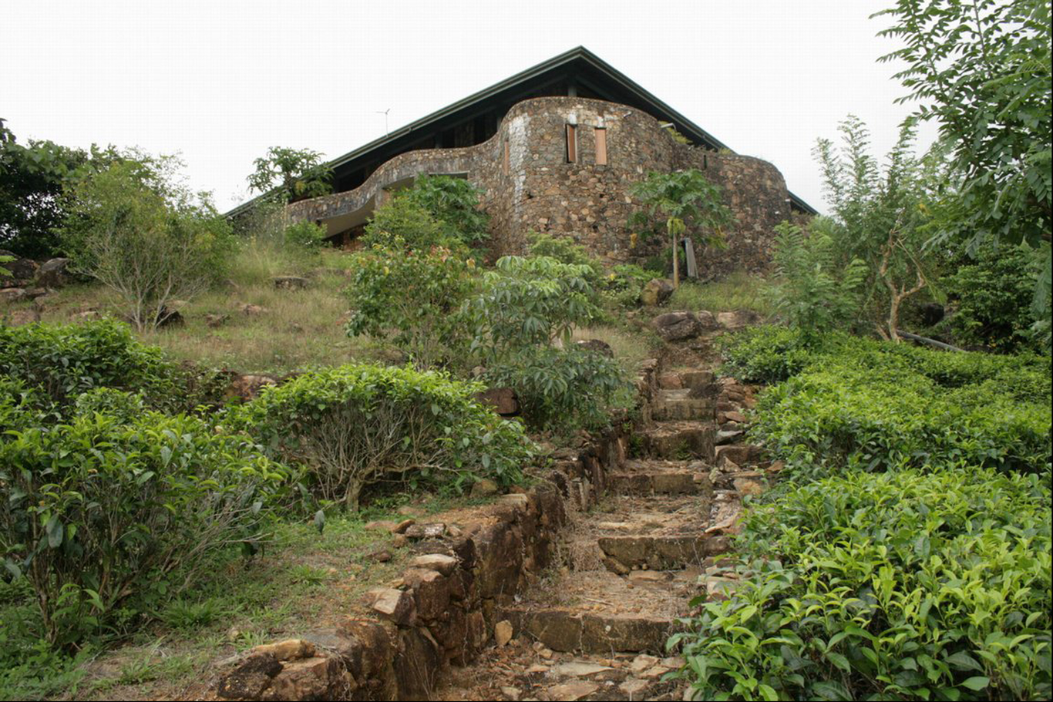
House on a Hill-1
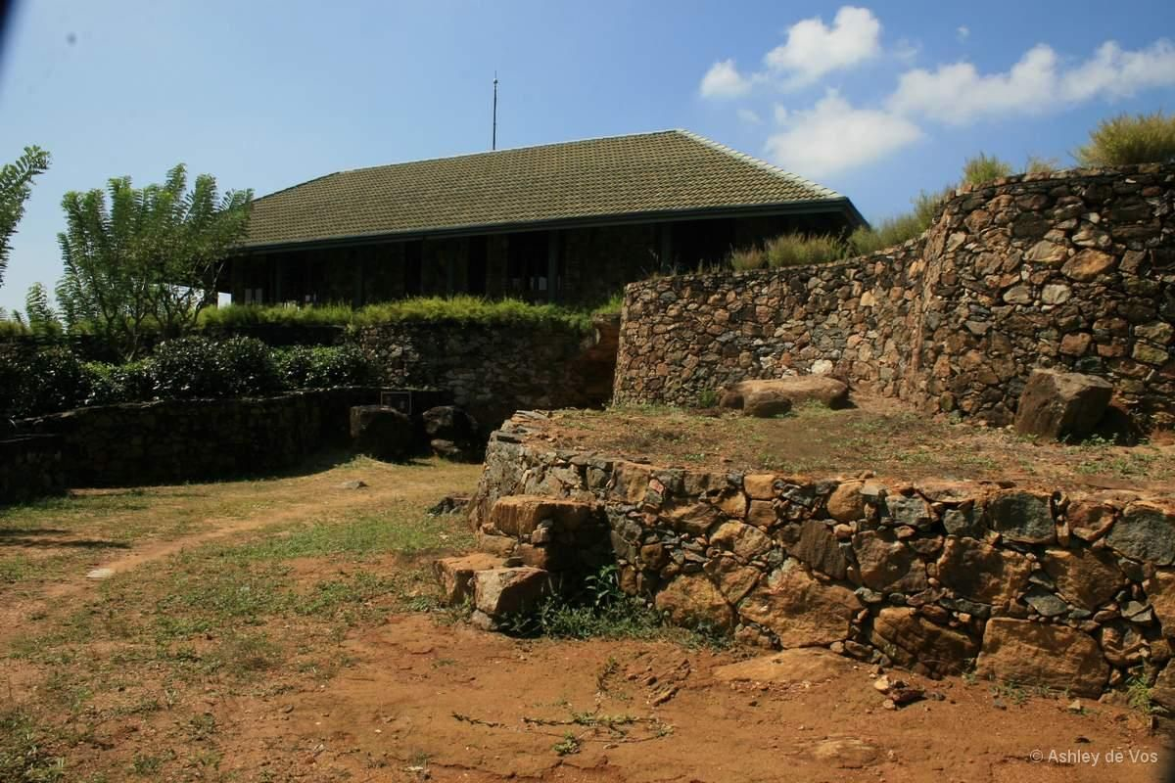
House on a Hill-2
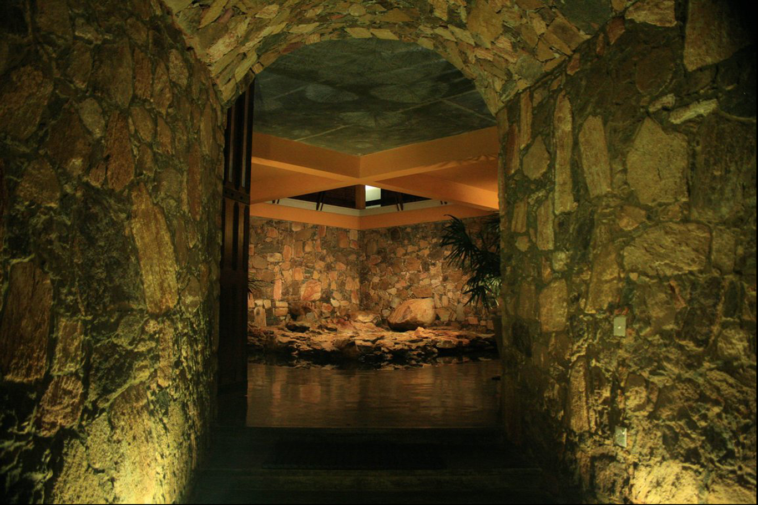
House on a Hill-3
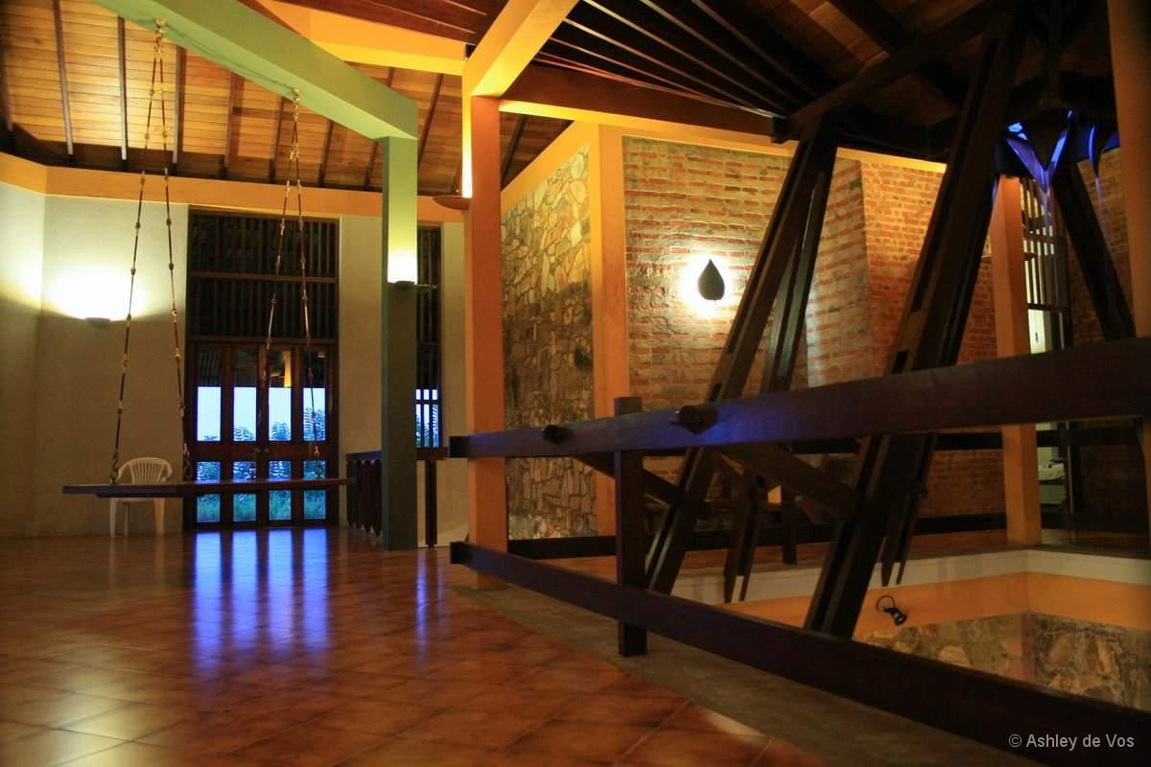
House on a Hill-4

Natural Lighting
Designed for natural light, the deep eaves of the roof provide shading for fenestration and walls

Water Efficiency
Rain water collected / diverted for irrigation purposes

Passive Heating/Cooling
The whole building works on a carefully thought out cross ventilation system. All spaces naturally ventilated. The wind from the land as well as the sea is carefully channeled in to the inner space

Cost effective features
Disintegrated rock excavated from the site used for all walling material

Eco-friendly features
The project sits inside the hill and is totally protected. Colors are meant to blend not stand out. The forest of endemic trees planted at the entrance are now grown. Shields the building from the North and it also provides privacy for the swimming pool

Oceanic Climate
Case Study: Chancellery, University of Sunshine Coast / Queensland, Australia
Chancellery
A variety of guidelines for sensitive climatic building design were developed including the use of shaded space and sun control, passive cooling through cross ventilation and the use of lightweight exterior construction of low thermal capacity to avoid the accumulation and re-radiation of heat. A key objective of the Master Plan document was that all new buildings comply with the north east/south west orientation and be designed to produce comfortable interior environments with minimal interference from artificial climate controls.
The site planning principles that form the basis of the Master Plan and Chancellery designs are to orientate the buildings to minimize solar gain, reduce density and modify the building massing to increase airflow though the site. Relatively high wind speeds are needed to achieve cross ventilation with rates of 1 m per second to achieve indoor comfort conditions. High humidity is a key climatic constraint of this site due to its coastal location and topography.
The master planning principles for the University have set up what appears to be a standardized visual and organisational hierarchy. However the climate determinants across the site present very different conditions creating unusual opportunities for environmental design.

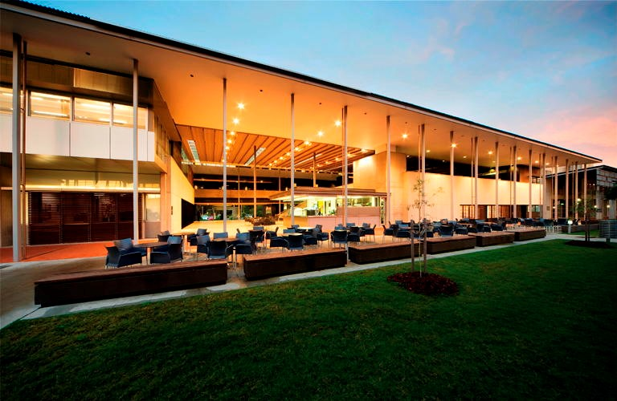
Chancellery-1

Building Planning
Breezeways and stairs are treated as external naturally ventilated spaces. They are oriented east-west and north-south and act as ‘ducts’ through which the breeze can be channeled. This provides comfortable thermal conditions deep inside the plan and reduces the effective depth of each of the four buildings to achieve more effective cross ventilation and daylighting.
A central outdoor space serves as a shaded meeting place and also acts as a semi-enclosed courtyard that introduces light and ventilation into the building. The space is oriented towards the south west avoiding direct sunlight penetration for most of the year and is cooled by breezeway openings that channel air through the space. A concrete floor is shaded and provides thermal cooling to the space during the day, whilst the double height volume separates warmed air from the occupants.

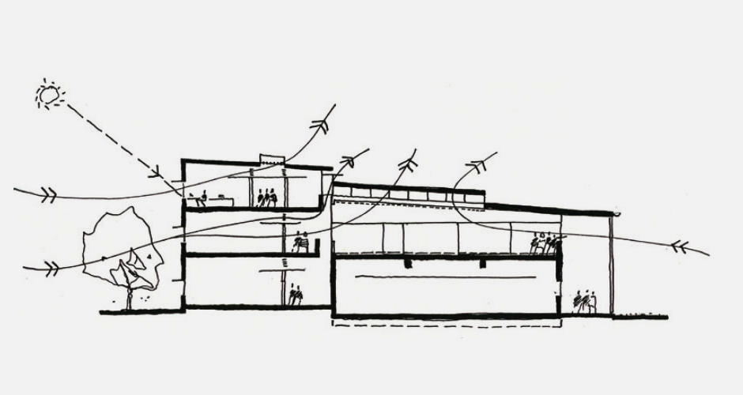
Cross-Section Looking East

Natural ventilation and mixed mode climate control
Design investigations of thermal comfort were completed during the design development phase of the Chancellery to determine which passive design and natural ventilation strategies achieved the least number of hours of discomfort each year and thus reduced annual hours where air conditioning would be needed. It was determined that the use of 24 hour ventilation through night purging, combined with the use of exposed thermal mass, cross ventilation for teaching rooms and ventilating skylights and clerestories in public areas, would achieve the best thermal comfort conditions.
A combination of simple horizontal and vertical solar shading, internal blinds, thermal mass and night time purging maximise the period of the year during which natural ventilation can provide adequate cooling and thereby minimise the use of air conditioning.
Offices and tutorial rooms are designed to operate with a mixed-mode changeover capability. Each room is provided with natural cross ventilation by means of operable sliding windows to the outer wall and an exhaust damper located at high level to the wall adjacent to the breezeway. Sun hoods are designed to provide weather protection so that windows can remain open during summer rain.
If desired by the occupants doors can be left open when rooms are in natural ventilation mode. Individual fan coil units provide heating and cooling from locations above doorways. Fresh air intake is provided from the naturally ventilated breezeways immediately adjacent to the fan coil units by means of high-level anodised aluminium grilles.
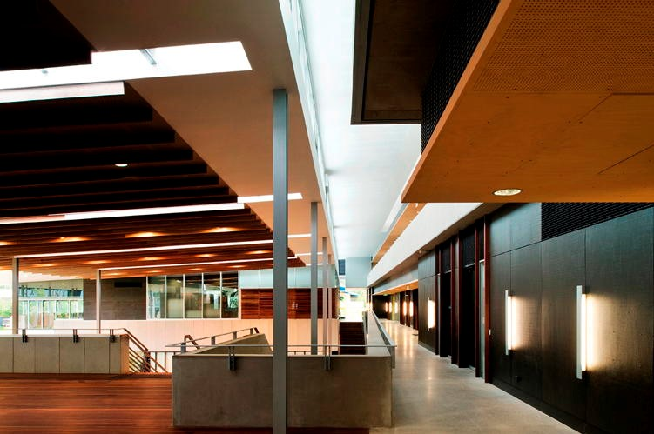
Breezeway and Outdoor Mezzanine

Natural daylighting
The Chancellery maximizes the use of natural lighting through a variety of strategies and only supplements this with artificial lighting where necessary. The key planning strategy is the separation of the overall building footprint into four separate buildings covered by a large overhanging roof. The buildings are arranged to suit areas of more and less daylight availability. The teaching and office spaces which represent the greatest amount of floor area are oriented towards the north east and thereby provided with the most access to daylight whilst being separated from the car-parking by a green zone to mitigate reflected light and glare. The Chancellery and Student Services are located to the south west corner and the lecture theater is positioned to the south east corner requiring the least daylighting. Skylights and clerestory windows provide consistent daylighting to the building interior above the circulation breezeways and the social spaces between the buildings.
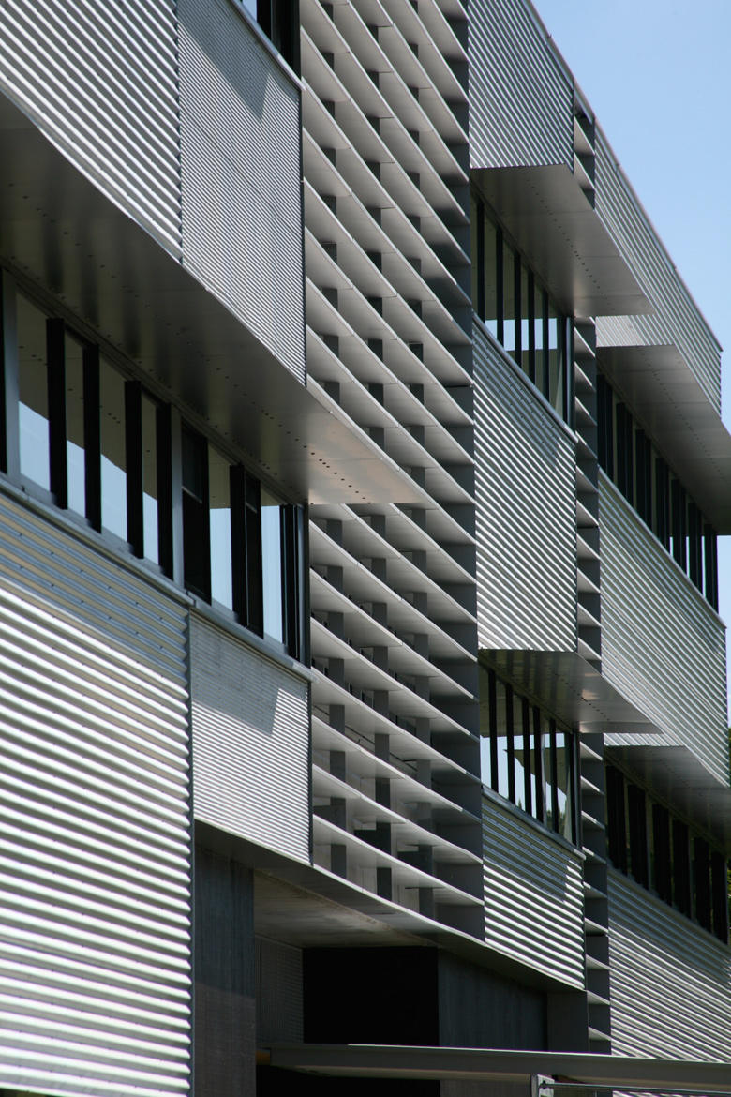
North facing Facade introducing Daylight
The façade design maximizes the use of natural lighting to provide optimum visual comfort for occupants whilst minimizing the need for artificial lighting. The strategy adopted was to maximize window widths to the full width of the rooms and specify 6mm clear float glass that offers a high visual light transmittance and control. The entry of direct natural light is controlled by maximizing solar shading thereby ensuring occupant visual and thermal comfort.

Thermal mass
Thermal design studies completed during the building design phase proposed the use of heavy masonry or concrete walls to the external fabric. Further design development lead to high levels of internal thermal mass, protected from solar gain and high external temperatures by a lightweight façade cladding and insulation. The exposed concrete floor slabs and columns and the partly exposed soffits assist in stabilizing internal temperatures by absorbing internal heat generated during the day. Breezeways serve as cool islands providing cool air and air movement to the occupants and supplying the fan coil units to the adjacent rooms.

References
Evolution of buildings in four tropical regions with regards to thermal comfort
Tropical Architecture
Hawaiian Design: Strategies for Energy Efficient Architecture
Charles Van Ravenswaay: 2006. The arts and architecture of German settlements in Missouri: a survey of a vanishing culture University of Missouri Press: 2006. ISBN 978-0-8262-1700-4
M Correia, G Carlos, H Guillaud, S Mecca, M Achenza, F López-Manzanares, C Mileto. VerSus project: Lessons from vernacular heritage for sustainable architecture. 211–215 InVernacular Architecture: Towards a Sustainable Future. CRC Press, 2014. Link
J. H. Williams, 1971.Roman Building-Materials in South-East England in Britannia, Vol. 2, (1971), pp. 166–195. Society for the Promotion of Roman Studies
Nikolas Davies, Erkki Jokiniemi: 2008. Dictionary of architecture and building construction. Architectural Press. ISBN 978-0-7506-8502-3: pp 181
Soils for Rammed Earth, Caliche Block, and Soil Material Construction". Austin, TX, USA: Sustainable Sources
Watson D. (1989) Bioclimatic Design Research. In: Böer K.W. (eds) Advances in Solar Energy. Advances in Solar Energy (An Annual Review of Research and Development), vol 5. Springer, Boston, MA

References
Correia, M, G Carlos, H Guillaud, S Mecca, M Achenza, F López-Manzanares, and C Mileto. 2014. “VerSus Project: Lessons from Vernacular Heritage for Sustainable Architecture”. In Vernacular Architecture: Towards a Sustainable Future, 211–15. CRC Press. doi:10.1201/b17393-39.

