Greenness influence on sound noise perception
Andrea Quilici${}^{1}$ , Andreetti Alice${}^{2}$, Constance Brouillet${}^{3}$
1 EPFL
1 EPFL
2 EPFL
Andreetti, A. Brouillet, C. and Quilici, A.

Introduction
The effect of noise in urban areas due mainly to road traffic is nowadays an health issue forgt our societies. Researches exploring the benefits of green neighborhoods on human health are increasing. Experiments focused on the presence of outdoor vegetation from dwelling’s window on self-reported noise annoyance (Van Renterghem and Botteldooren 2015) had been published. Moreover, greenbelts seem to be potentially effective tools for minimizing the noise due to traffic using various trees species (Karbalaei et al. 2015). The following study, on its hand, is establishing the relationship between green urban areas and the level of noise, focusing on the influence of noise due to road traffic on the health of urban residents. The hypothesis developped for the municipality of Vernier (Switzerland) is an inverse relation between the degree of greenness of a city and the noise due to road traffic at night.

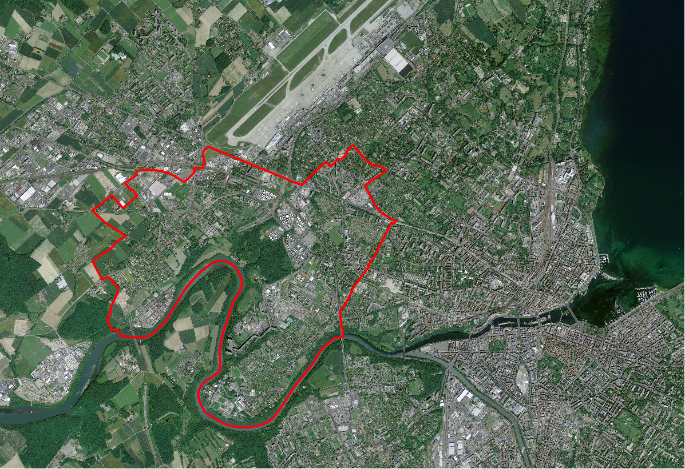
Border of the municipality of Vernier (Switzerland)

Initial data
A set of data including two sonBases files, four RVB images of the Vernier’s region and a a vector file highlighting the limits of the municipality of Vernier is used to carry out the study.
- The four RVB images or orthophotos were downloaded from the Swisstopo website managed by the Federal Office of Topography (direct link to the website: https://www.swisstopo.admin.ch/fr/home.html). Note that orthophotos were taken in 2014 with a ground resolution of 0.5 m.
- The vector file with the limits of the municipality of Vernier have no specified sources.
- The total population in 2015
- As said previously, two sonBases files in form of raster were investigated. One including the daily noise in Vernier and its periphery, and the second one the noise generated at night. An important series of data was combined in order to produce the noise data set more commonly named, SonBase. Noise calculations were achieved by integrated data from different Federal Offices (e.g. Federal Offices of Roads FEDRO, Transport FOT, Civil Aviation FOCA and so on). Geographic features required for the noise calculation were issued once more from the Federal Office of Topography (i.e. vectorised map of Switzerland 1: 25 000; and the digital elevation model DEM, DHM25) .
All the data were projected over the CH1903+LV03 coordinate reference system.

Methods
In order to evaluate the correlation between the greenness and the noise, initial data were loaded on QGIS first and secondly on the GeoDa software. All data mentioned previously were imported from the disk folder and georeferenced using the same coordinate systems SCR EPSG21781. It is important to note that this coordinate system was applied to all the layers created for the study.
Subsequently, a regular grid surrounding the Vernier municipality, was created manually with a chosen grid resolution of 50*50 m. In the next step, a grenness index was build by removing the Blue and the Red from the 4 RVB images merged in once thanks to the Virtual Raster Catalogue tool. However, a word of caution is needed: in order to simplify the procedure, it has been assumed that the green color is a good indicator of the vegetation. Accuracy can be increased by calculating the NDVI (James et al. 2015).
As next step, statistique de zone allowing to calculate essential variables had been used in order to underlight later on the relation between the greenness and the noise during the day and the night. Among these variables, mean, median, standard deviation can be cited. Results from these calculations were shown in the Attributes table tool of the regular grid.
Finally, a layer of the Vernier municipality containing the information previously calculated was exported on GeoDa where all the principal statistic analysis, as well as thematic maps, were computed.
For further information on the tools and functions used in QGIS (bold characters) , please refer to the QGIS guide book (http://www.qgis.org/en/docs/index.html ). For the Geoda function, you can refer to the litterature.

Results
The following images, obtained with the program GeoDa, allow to analyse the different correlation between greenness and night traffic noise attenuation. The totality of the territory occupied by the municipality of Vernier has been investigated. The mean correlation between the greenness and the night traffic noise can be seen in Fig.3 and in Fig.5 as a blue line which is used as reference value.
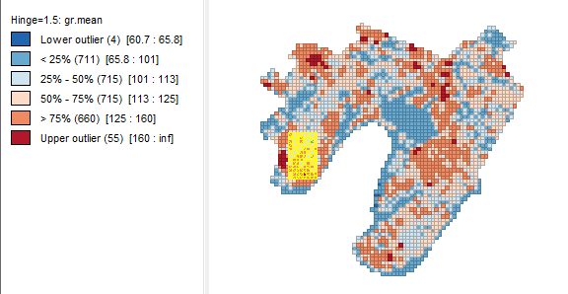
High dense dwelling area
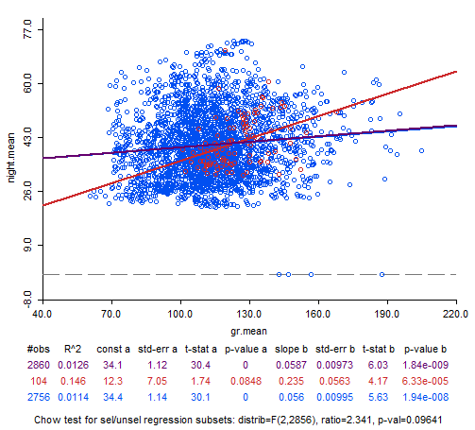
Greenness and night noise correlation in high dense dwelling area
In order to analyze this phenomenon in more details, the study has been done over two specific and different locations. The first area is a high density dwelling zone, where it is expected to see a minor effect of attenuation of traffic noise. The second one is a forest zone where we suppose to have a negative correlation.
Fig.2 highlights a restricted area in the South-West part of Vernier, mostly occupied by buildings and constructions. The positive correlation shown in Fig.3 point out that the sound noise mainly due to road traffic is not mitigated by the buildings.
In contrary, Fig.4 highlights a concentrated belt of vegetation, situated in the central part of the municipality. Looking at Fig.5 is it possible to see now an inverse correlation between the mean of greenness values and the night traffic noise ones. This result confirm the supposition that a green spot inside a village can really have an impact on the decreasing of the noise perceived and propagated.
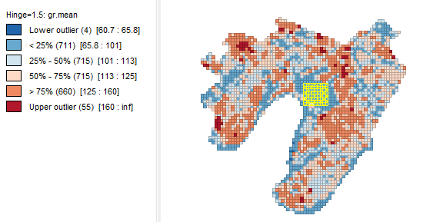
Forest area
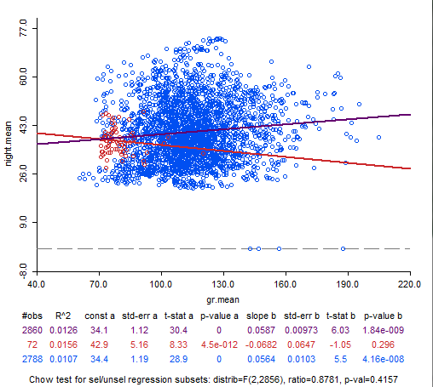
Greenness and night noise correlation in forest area

Discussion
First of all, a positive correlation between the mean of the greenness in high density dwelling zone and the mean of the noise attenuation is shown in Fig. 3. This results is a direct consequence of the absence of the vegetation. Indeed where the density of buildings increases, the perception of the noise due to road traffic increases as well. This quite strong positive correlation let suppose that the sound propagates better and further thanks to the rebounding against the walls.
On the other hand, it is possible to observe that the presence of the forest induce an attenuation of the noise. This phenomena is related to the fact that a relative negative correlation between the greenness mean and the night mean noise is shown in Fig. 5. Therfore, it is possible to say that the presence of a green area in a urban zone leads to a gain in quality of life, relates to the sound noise.

Conclusion
In order to investigate the inverse relationship between the degree of greenness in urban areas and the level of noise that characterize them, the example of the municipality of Vernier has been used. Two different locations were investigated and the results demonstrate that there is an inverse relationship between the presence of vegetation and the level of noise. On the other hand, it has been shown that in the most urbanized area, with a lack of greenness, a positive correlation is found. The same output should show up for the day noise data. It is then possible to confirm vegetation as a good contributor to heathier quality of citizens’ life.

Contributions of the authors
All the authors performed the analyze of the data set using QGIS and GeoDa, looked for the references and processed the discussion. AA wrote the introductions and conclusion. B drafted the initial data and the methods. AQ wrote the results.

References
Van Renterghem, Timothy, and Dick Botteldooren. 2015. “The Effect of Outdoor Vegetation as Seen from the Dwelling’s Window on Self-Reported Noise Annoyance”. In 10th European Congress and Exposition on Noise Control Engineering (Euronoise 2015), 2395–98.
Karbalaei, Samaneh Sadat, Elham Karimi, Hamid Reza Naji, Seyed Mahmood Ghasempoori, Seyed Mohsen Hosseini, and Mina Abdollahi. 2015. “Investigation of the Traffic Noise Attenuation Provided by Roadside Green Belts”. Fluctuation and Noise Letters 14 (04): 1550036.
James, Peter, Rachel F Banay, Jaime E Hart, and Francine Laden. 2015. “A Review of the Health Benefits of Greenness”. Current Epidemiology Reports 2 (2): 131–42.

