Machine Learning HW2 Programming assignment
Gur Asees Singh Chandok

2.

a. Linear Regression:
This Problem was solved using matlab and the code for the solution is present in file hw2part2a.m.
Below derivation was used for getting to the formula for calculating the least squares

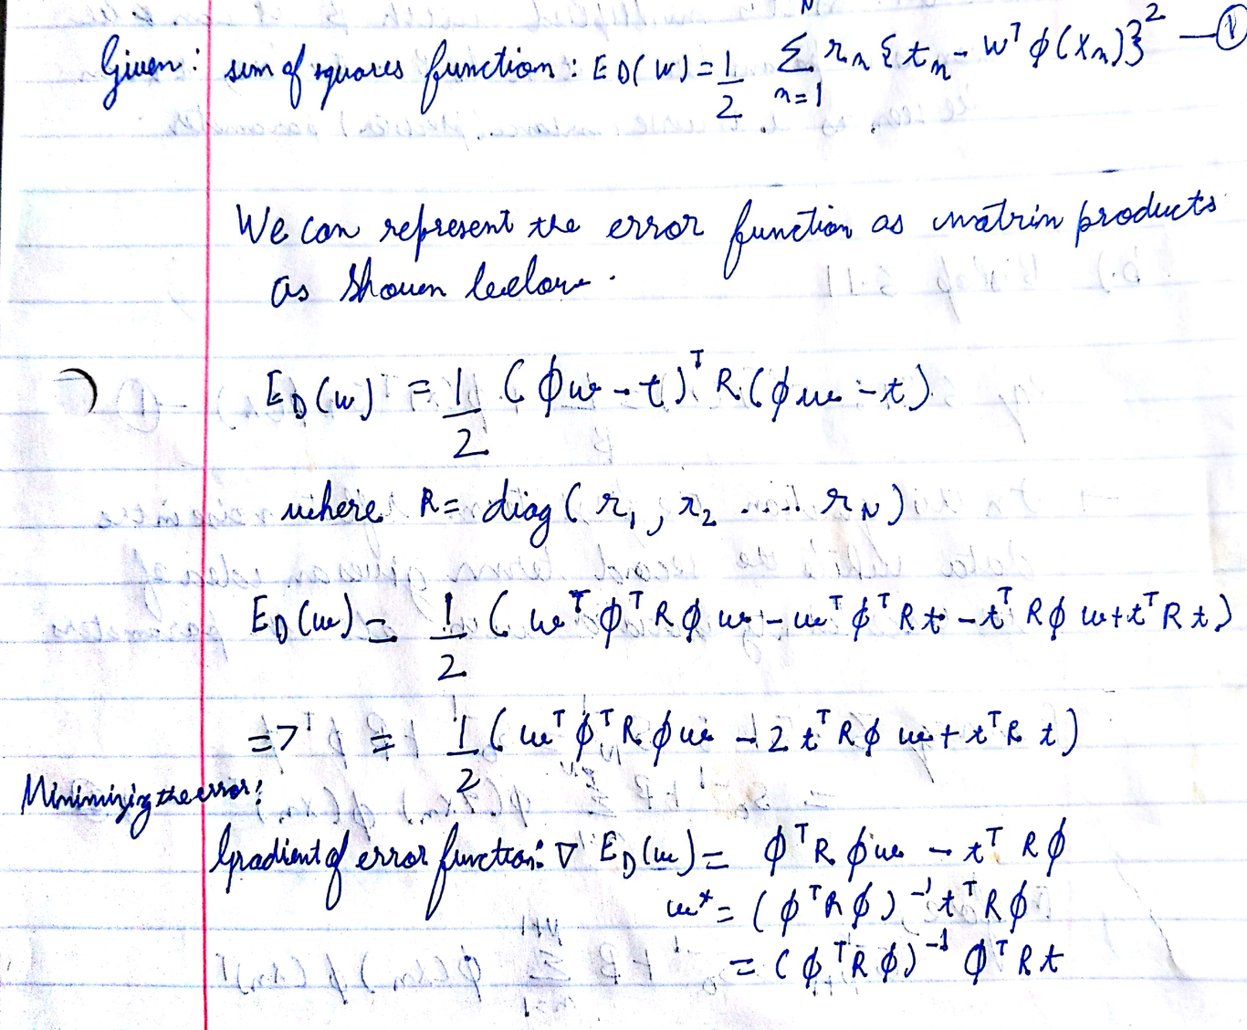
Derivation for computing sum of squares function using Matrix method
In the code $R=I, ϕ→X ,t→y and w^{*} →weights$. Also,comments are present before each line of code to make it easy to understand.The output of the code is the best choice for 3rd variable.The program would can be used with different data provided the column names are same.However, even if the column names are different the program should give the right index for the best new variable but the label would be incorrect.
Each variable was tested as a prospective 3rd variable and In addition to finding least squares, R2 score was used to choose the variable.
R2
Using this method the variable ‘LIC’ i.e. 4th column was chosen as it had the best R2 score( coefficient of determination) and least squares.
This can be also be seen in the plot below, the plot shows the R2 score after choosing each variable as 3rd variable on y axis against variable name on the x axis.

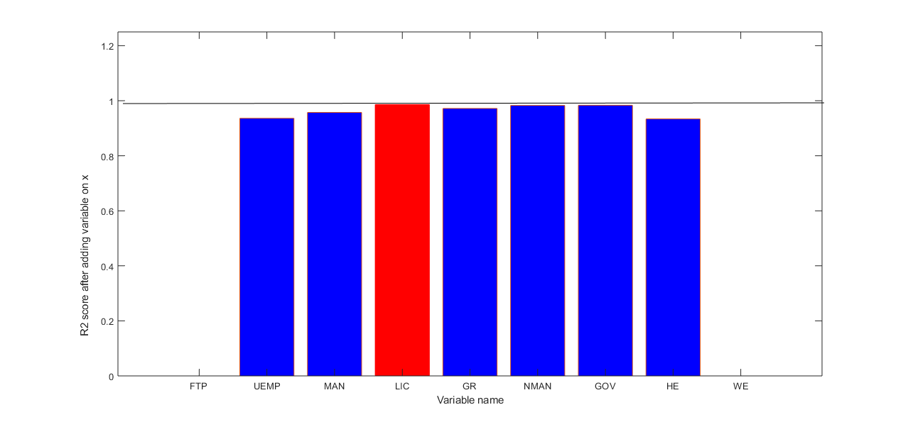
Improvement in R2 score after choosing each variable as variable 3

Clearly, LIC has the best R2 score after selection as the 3rd variable and therefore it was chosen as the 3rd variable

