Systematic review and meta-analysis of the effect of ABO blood group on the risk of COVID-19 infection
George Balaouras
Paolo Eusebi
Polychronis Kostoulas
We have been experiencing a global pandemic with baleful consequences for mankind, since the Severe Acute Respiratory Syndrome Coronavirus 2 (SARS-CoV-2) was first identified in Wuhan of China, in December 2019. So far, several potential risk factors for SARS-CoV-2 infection have been identified. Among them, the role of ABO blood group polymorphisms has been studied with results that are still unclear. The aim of this study was to collect and meta-analyze available studies on the relationship between SARS-CoV-2 infection and different blood groups, as well as Rhesus state. We performed a systematic search on PubMed/MEDLINE and Scopus databases for published articles and preprints. Twenty-two studies, after the removal of duplicates, met the inclusion criteria for meta-analysis with ten of them also including information on Rhesus factor. The odds ratios (OR) and 95% confidence intervals (CI) were calculated for the extracted data. Random-effects models were used to obtain the overall pooled ORs. Publication bias and sensitivity analysis were also performed. Our results indicate that blood groups A, B and AB have a higher risk for COVID-19 infection compared to blood group O, which appears to have a protective effect. An association between Rhesus state and COVID-19 infection could not be estabished.

Introduction
Coronaviruses (COVs) are enveloped viruses with a single positive-stranded RNA genome. They belong to the subfamily Orthocoronavirinae under the family Coronaviridae and are classified into four genera: Alphacoronaviruses (α), Betacoronaviruses (β), Gammacoronaviruses (γ) and Deltacoronaviruses (δ). The viral genome normally encodes four structural proteins, spike (S), envelope (E), membrane (M), and nucleocapsid (N) (Ren et al. 2020) . The term coronavirus refers to the appearance of CoV visions, when observed under electron microscopy, in which spike projections from the virus membrane, give the semblance of a crown, or corona in Latin (Su et al. 2016) . To date, seven human CoVs (HCoVs) are known. Among them, HCoV-229E and HCoV-NL63 are alpha-CoVs. The other five beta-CoVs include HCoV-OC43, HCoV-HKU1, Severe Acute Respiratory Syndrome Coronavirus (SARS-CoV), Middle East Respiratory Syndrome Coronavirus (MERS-CoV) and Severe Acute Respiratory Syndrome Coronavirus 2 (SARS-CoV-2) (Ye et al. 2020) . In December 2019, a human outbreak of pneumonia, later named coronavirus disease (COVID-19), began spreading across the planet, infecting millions. The causative agent of COVID-19 was quickly identified as a novel coronavirus, the Severe Acute Respiratory Syndrome Coronavirus 2 (SARS-CoV-2). Although close evolutionary relationships to bat CoVs suggest a bat origin for SARS-CoV-2, our understanding is notably limited by the scarcity of available sequenced CoV genome (Banerjee et al. 2021). As a novel beta coronavirus, SARS-CoV-2 shares 79% genome sequence identity with SARS-CoV and 50% with MERS-CoV. Its genome organization is shared with other beta coronaviruses (Hu et al. 2021).
The spike protein S appears to be critical for cellular entry because it guides the virus to attach to the host cell. The receptor-binding domain (RBD) of the spike protein S binds to Angiotensin-Converting Enzyme 2 (ACE2) to initiate cellular entry (Pillay 2020). The SARS-CoV-2 virus typically causes respiratory and gastrointestinal sickness. It can be transmitted through aerosols and direct or indirect contact, as well as during medical cases and laboratory sample handling. The disease is characterized by symptoms such as high fever, chills, cough, breathing difficulty, diarrhea, myalgia, fatigue and may occasionally lead to complications like pneumonia, severe acute respiratory syndrome (SARS) and eventually death (Pal et al. 2020).
After the ABO blood group system was found by Karl Landsteiner in 1901, the search for the relationship between blood groups and various diseases has continued uninterrupted (Wu et al. 2020). Recently, several studies have reported an association between blood group and SARS-CoV-2 infection. However, results are conflicting, perhaps due to the potential effect of multiple confounding effects, and controversy remains with respect to the role of blood type on COVID-19 infection (Liu et al. 2020). We performed a meta-analysis to assess the association between ABO blood groups, Rhesus state and COVID-19 infection.

Materials and Methods

Search strategy
A systematic online search for published literature was carried out in PubMed/MEDLINE and Scopus databases, including unpublished articles, with the MESH (medical subject heading) terms ‘’ABO blood groups’‘ and ’‘COVID-19’‘. In order to expand our search scale, we also conducted a full-text search with the relevant terms (’‘SARS-CoV-2 infection’‘, ’‘2019-nCoV infection’‘, ’‘novel coronavirus infection’‘ and ’‘ABO polymorphisms’’). The searching time period was restricted between February 1st 2021 to March 7th 2021 and we limited the search language to English, with no restrictions on country or publication state.
Study selection
We included the studies that fulfilled the following inclusion criteria: i) studies that reported an association between COVID-19 infection and ABO blood groups and/or Rhesus state; ii) case-control and cohort studies; iii) provision of original data. Excluded studies included: (i) reviews, clinical guidelines, and expert consensus; (ii) animal or in vitro cell studies; (iii) studies for which the full text was not available; (iv) studies with insufficient data.
Data extraction
Data extraction included: first author’s name, publication year, title and the link of the study, case definition, the distribution numbers of participants for each blood group (along with Rhesus state, when there was a record) and for both, SARS-CoV-2 infected and uninfected subjects. For each study, a numerical ID was used. Infection was confirmed by Polymerase Chain Reaction (PCR) and/or clinical diagnosis, although for several studies the confirmation method for SARS-CoV-2 infection was not specified. Some studies included more than one group of controls, along with the corresponding population of cases, while other studies reported more than one group of controls and cases. We included in the analysis all the comparisons regarding different subgroups of controls and cases, in order to avoid any overlapping.

Statistical analysis
For each study, we extracted the cross-classified frequencies between infection state and blood group. We used logistic regression for deriving Odds Ratios (ORs) and their asymptotic standard errors, after adjusting for multiplicity using the Benjamin-Hochberg procedure (Benjamini and Hochberg 1995). We assessed heterogeneity using the I-squared statistic. Publication bias was assessed by visual inspection of the funnel plots and further validated by Egger’s test (Egger et al. 1997). Pooled ORs estimates and 95% confidence intervals (CIs) were obtained by performing meta-analysis using the inverse variance method. Due to the amount of heterogeneity a random-effects model has been used for the ABO gene, by applying the Hartung-Knapp-Sidik-Jonkman method (IntHout et al. 2014) for $τ^{2}$. The 95% prediction intervals (PIs) were also computed. The PIs present the heterogeneity in the same metric as the original effect size measure, illustrating which range of true effects can be expected in future settings (IntHout et al. 2016). We explored the robustness of our meta-analysis results using the leave-one-out method.

Software
All models were run in R v4.0 using the meta package (Schwarzer and others 2007)

Results
Literature search
The literature search of the PubMed/MEDLINE and Scopus databases resulted in 589 potentially relevant studies (PubMed records=389 and Scopus records=200). The 351 of them were removed because they were duplicates. According to the inclusion criteria, we excluded the 216 irrelevant studies by screening abstract and title. Eventually, a total of 22 articles (GÖKER et al. 2020; Hoiland et al. 2020; Ad’hiah et al. 2020; Solmaz and Araç 2021; Taha et al. 2020; Dzik et al. 2020; Zalba et al. 2020; Chegni et al. 2020; Franchini et al. 2021; Gamal et al. 2021; Wu et al. 2020; Khalil et al. 2020; El-Shitany et al. 2021; Valenti et al. 2020; Muñiz-Diaz et al. 2021; Kibler et al. 2020; Barnkob et al. 2020; Bhandari et al. 2020; Rahim et al. 2021; Abdollahi et al. 2020; Fan et al. 2020; Boudin et al. 2020) were included in this systematic review and meta-analysis (Figure 1).
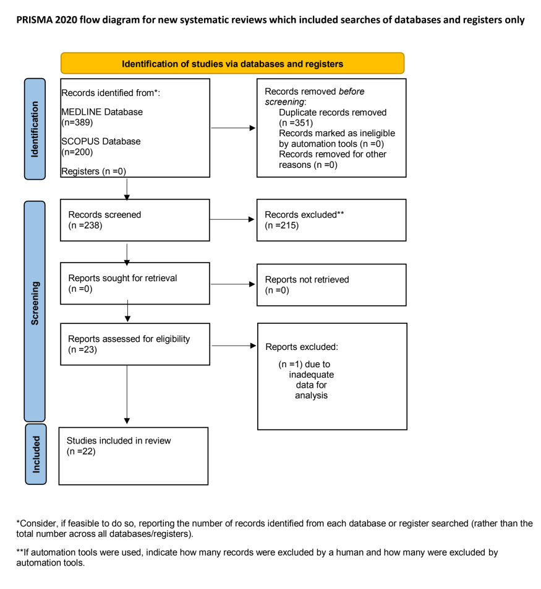
The PRISMA flow-chart
Study characteristics
Twenty-two studies were identified, meeting our inclusion criteria for meta-analysis, with the majority of them being case-control studies. All studies were published in 2020, except for five studies that were published in 2021. Half of the studies were carried out in Europe and North America while the other half in Asia and Africa. A total of 84,659,546 subjects were included in this meta-analysis, with 21,462 COVID-19 infected subjects and 84,638,084 uninfected subjects. Among them, 147,302 subjects were positive for Rhesus state and 20,313 negative. Most of the participants were adult males, forty to seventy years old. In most of the studies, COVID-19 diagnosis was confirmed by a PCR test, using nasal or pharyngeal swab specimens. The main characteristics of the studies are listed in Table 1.
Characteristics of the included studies
Study Year | Country | Study Design | Sample Size (case/control) | Rhesus Status (positive/negative) | Age. years | Male% (Case/Control) | Patients | Controls
Boudin et al, 2020 | France | Retrospective Cohort | 1263/406 | 1439/230 | Median Age (IQR): 28(23-36)/27(23-33) | 87/87 | Patients with COVID-19 confirmed by RT-PCR or clinical symptoms suggestive to covid-19 | Tested negative for COVID-19 or no clinical symptoms
Fan et al. 2020 | China | Retrospective Case-Control | 105/103 | ND | Mean Age±SD: (56.8±18.3)/(54.0±15.0) | 52.4/54.4 | Patients with COVID-19 confirmed by RT-PCR or clinically diagnostic cases | Tested negative for COVID-19 or no clinical symptoms
Abdollahi et al. 2020 | Iran | Cross-Sectional | 397/500 | 802/95 | Mean Age (SD): 58.81 (15.4)/48.53 (17.9) | 63.5/46.2 | Patients with COVID-19 confirmed by RT-PCR | Healthy population
Rahim et al. 2021 | Pakistan | Cross-Sectional | 1935/1935 | ND | Mean Age ±SD: (39.73±15.26)/(32.36±8.65) | 68.6/67.7 | Patients with COVID-19 confirmed by RT-PCR | Healthy blood donors
Bhandari et al. 2020 | USA | Retrospective Case-Control | 825/396 | 1160/61 | Mean Age ±SD: (57.64±18.17)/(54.21±20.99) | 61/44 | Patients with COVID-19 confirmed by RT-PCR | Patients who were hospitalized without COVID-19
Barnkob et al. 2020 | Denmark | Retrospective Cohort | 7422/466232 7422/2204742 | ND | Median Age (IQR): 52 (40-67)/50 (36-64) | 32.9/32 | Patients with COVID-19 confirmed by RT-PCR | Tested negative for COVID-19/ Healthy population
Kibler et al. 2020 | France | Retrospective Cohort | 22/680 | 352/350 | Mean Age ±SD: (82±8.4)/(82±6.9) | 31.8/45 | Patients with COVID-19 confirmed by RT-PCR/ patients with typical symptoms and characteristic imaging findings on chest computed tomography (CT) | Patients who were hospitalized without COVID-19
Muniz-Diaz et al. 2021 | Spain | Retrospective Cohort | 854/75870 965/52584 | ND | Median Age (IQR): 45.0 (36.0-53.0)/45.0 (32.0-53.0) | 39.5/51.5 59.07/49.85 | COVID-19 blood donors confirmed by RT-PCR /transfused patients with COVID-19 | Healthy blood donors/Patients transfused without COVID-19
Valenti et al. 2020 | Italy | Case-Control | 505/890 505/18097 | ND | Median Age (IQR): 69.0 (59.0-77.0)/72.1 (58.2-82.5) | ND | COVID-19 patients. confirmation method was not specified | Healthy blood donors/transfused patients
El-Shitany et al. 2021 | Saudi Arabia and Egypt | Retrospective Cross-Sectional | 726/707 | 1185/248 | ND | 15.2/16.5 | COVID-19 recovered patients. confirmed by RT-PCR or biochemical and clinical symptoms | Healthy population
Khalil et al. 2020 | Lebanon | Retrospective Case-Control | 146/6479 | ND | Mean Age ±SD. (IQR): (41.9±18.52). (28-57) CO | 66.4 CO | Patients with COVID-19 confirmed by RT-PCR | Patients who were hospitalized without COVID-19
Wu et al. 2020 | China | Retrospective Case-Control | 187/1991 | ND | ≥40: 63.1% CO | 51.9 CO | Clinically diagnosed COVID-19 patients | Patients who were hospitalized without COVID-19
Gamal et al. 2020 | Italy | Retrospective Case-Control | 1600/27715 | 25206/4104 | ND | ND | Patients with COVID-19 confirmed by RT-PCR | Healthy blood donors
Franchini et al. 2021 | Italy | Case-Control | 447/16911 | ND | Mean Age ±SD: (477±121)/(471±143) | 86.1/61.0 | Blood donors clinically recovered from COVID-19 | Healthy blood donors
Chegni et al. 2020 | Iran | Case-Control | 76/80982137 | ND | >59: 53.2% CO | 77.7 CO | COVID-19 patients. confirmation method was not specified | Healthy population
Zalba-Marcos et al. 2020 | Spain | Retrospective Cohort | 225/182384 | ND | Mean Age (SD) of 44% 70.1(15.1) CO | 64 CO | Patients with COVID-19 confirmed by RT-PCR | Healthy population
Dzik et al. 2020 | USA | Case-Control | 957/5840 | ND | ND | ND | Patients with COVID-19 confirmed by RT-PCR | Patients who were hospitalized without COVID-19
Taha et al. 2020 | Sudan | Case-Control | 557/1000 | 1422/135 | (26-35): 41.8% CO | 42 CO | Patients with COVID-19 confirmed by RT-PCR | Healthy population
Solmaz et al. 2021 | Turkey | Cross-Sectional | 1667/127091 | 113868/14980 | ND | ND | Patients with COVID-19 confirmed by RT-PCR | Healthy population
Ad’hiah et al. 2020 | Iraq | Case-Control | 300/595 | ND | Mean Age ±SD: (49.7±12.3/29.3±6.9) | 59.7/49.7 | Patients with COVID-19 confirmed by RT-PCR | Healthy blood donors
Hoiland et al. 2020 | Canada | Retrospective Cohort | 95/398671 95/62246 | ND | Median Age (IQR) of 60%: 66 (58-73) CO | 64.2 CO | Patients with COVID-19 confirmed by RT-PCR | Healthy blood donors
Goker et al. 2020 | Turkey | Retrospective Case-Control | 186/1882 | 1868/200 | Median Age (IQR): 42 (19-92) CO | 53.8 CO | Patients with COVID-19 confirmed by RT-PCR | Healthy blood donors

Association between blood groups and COVID-19 infection
Meta-analysis for the ABO group (Table 2 and Figures 2-7), revealed increased odds of COVID-19 infection in the (i) A group vs O (OR = 1.29, 95% Confidence Interval: 1.15 to 1.44), (ii) B vs O (OR = 1.15, 95% CI 1.06 to 1.25), and (iii) AB vs. O (OR = 1.32, 95% CI 1.10 to 1.57). Prediction intervals include the reference value of 1 for the OR in all pairwise comparisons. The visual inspection of the funnel plots (Fig. 8) and the results of Egger’s test showed some evidence of publication bias for the comparison between of A vs. O (p=0.013) and A vs. B (p=0.047). Sensitivity analysis by the leave-one-out method provided similar estimates (Supplementary Files).
Meta-analysis results
Blood groups / Rhesus status | Comparison | OR | 95% CI | 95% PI | I2 | 95% CI
ABO | A - AB | 0.98 | (082 to 117) | (048 to 198) | 0.25 | (0 % to 56 %)
 | A - B | 1.1 | (098 to 123) | (067 to 179) | 0.26 | (0 % to 56 %)
 | A - O | 1.29 | (115 to 144) | (079 to 21) | 0.54 | (25 % to 71 %)
 | AB - B | 1.11 | (096 to 127) | (066 to 186) | 0.03 | (0 % to 48 %)
 | AB - O | 1.32 | (110 to 157) | (067 to 259) | 0.41 | (2 % to 65 %)
 | B - O | 1.15 | (106 to 125) | (087 to 153) | 0 | (0 % to 38 %)
Rhesus | Rh+ vs. Rh- | 0.97 | (083 to 113) | (061 to 154) | 0.38 | (0 % to 70 %)
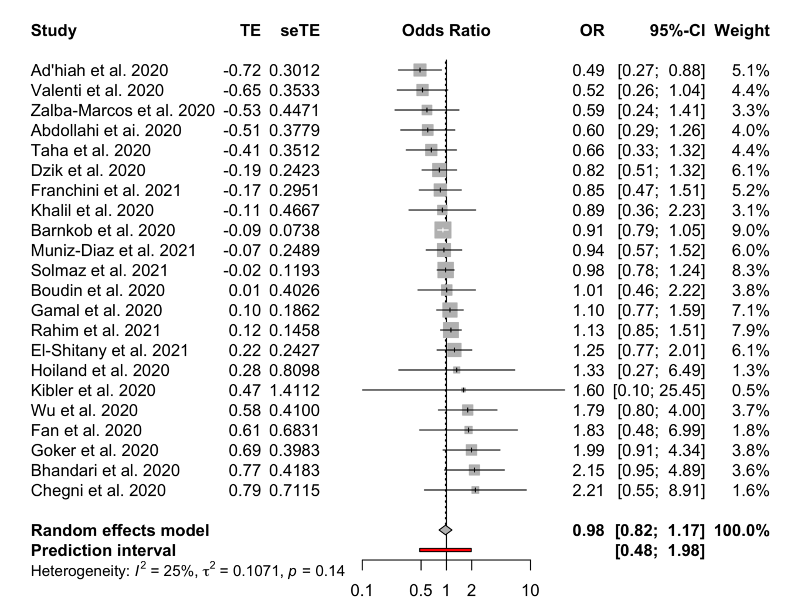
Forest plots for the ABO gene comparison of A vs. AB group
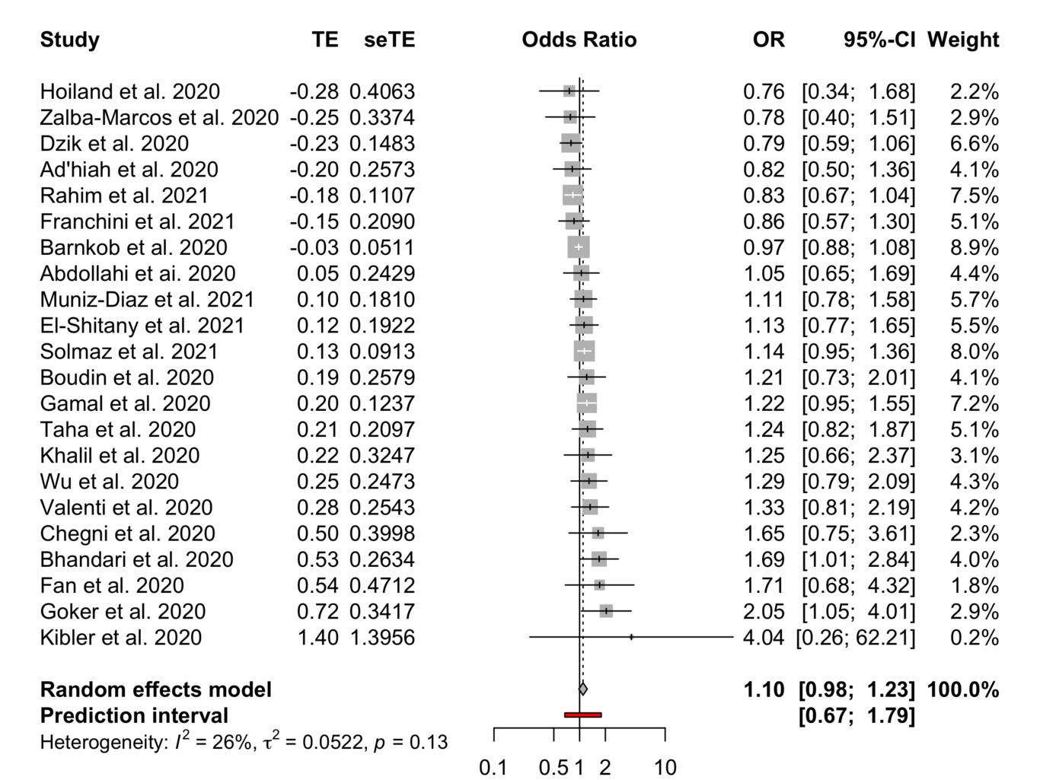
Forest plots for the ABO gene comparison of A vs. B group
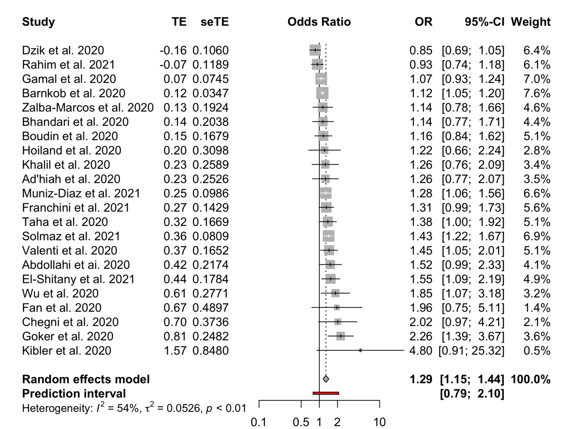
Forest plots for the ABO gene comparison of A vs. O group
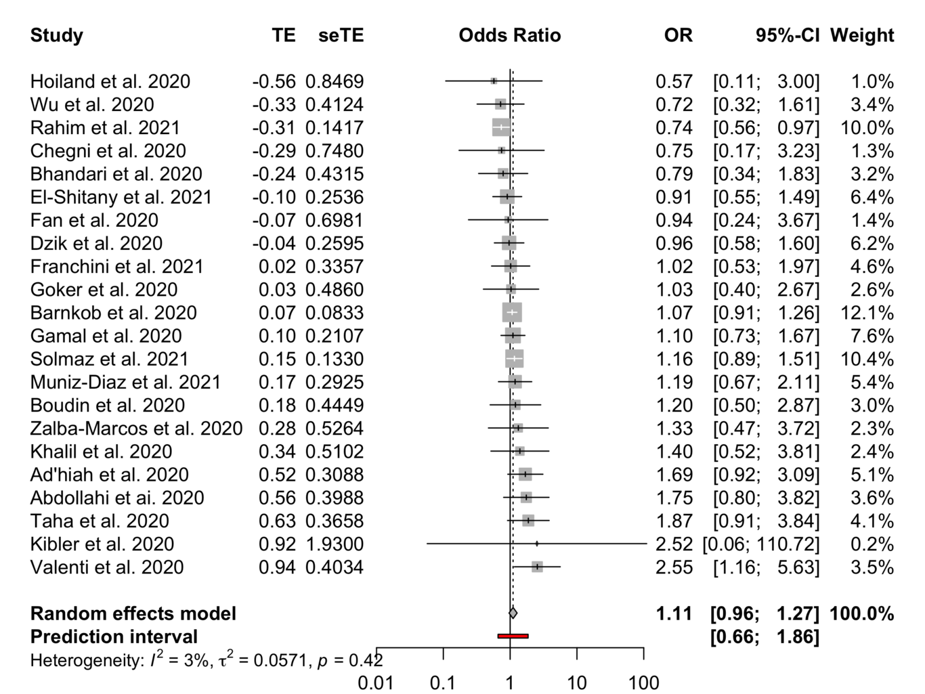
Forest plots for the ABO gene comparison of B vs. AB group
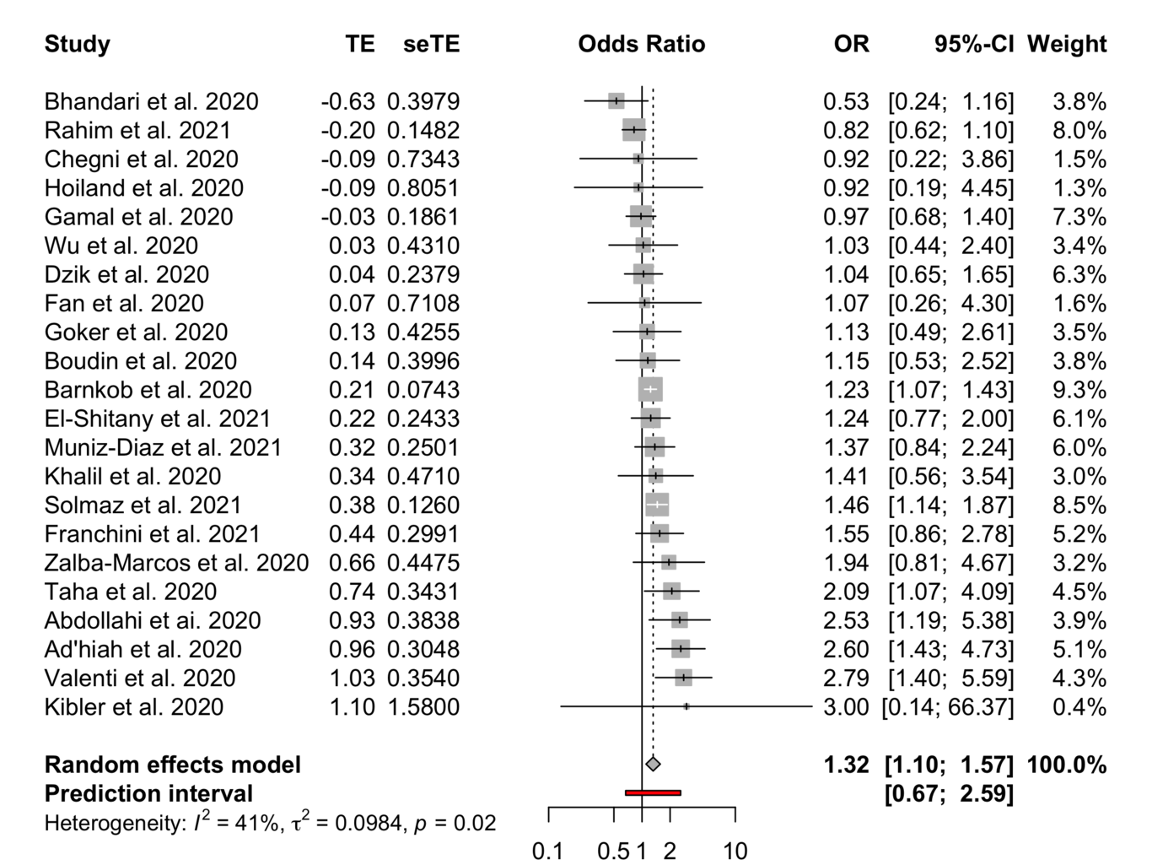
Forest plots for the ABO gene comparison of O vs. AB group
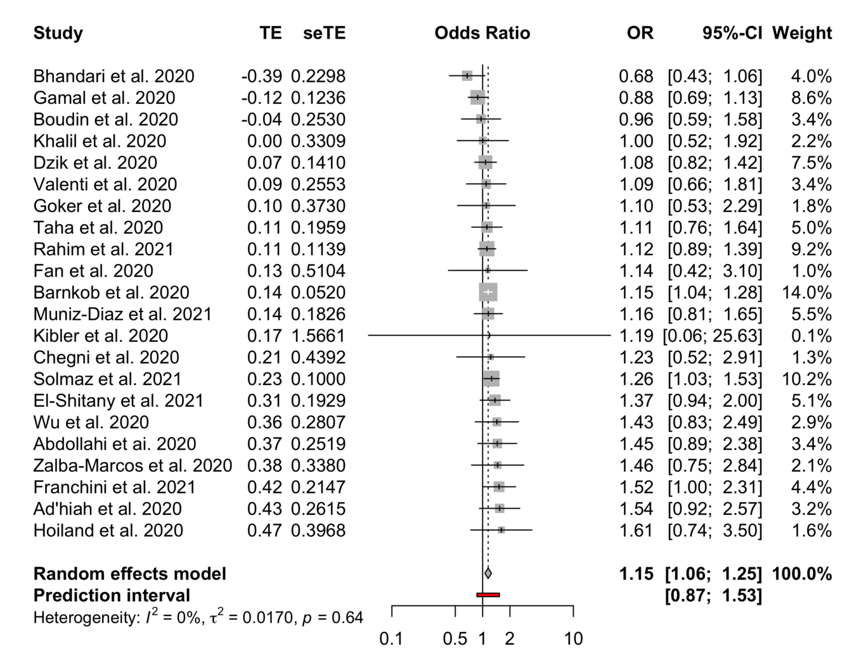
Forest plots for the ABO gene comparison of B vs. O group
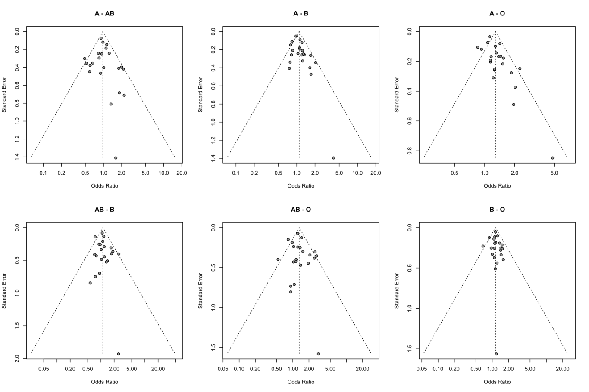
Funnel plots for the ABO gene

Association between Rhesus status and COVID-19 infection
Meta-analysis of the association between Rhesus state and COVID-19 infection (Figures 9 and 10) in the 10 studies that included information on Rhesus, did not provide evidence of association with the COVID-19 infection (Rh+ vs Rh- OR = 0.97, 95% CI 0.83 to 1.13). The 95% PI includes the reference value of 1 for the OR in all pairwise comparisons. The leave-one-out sensitivity analysis provided similar estimates (Supplementary Files). Visual inspection of the funnel plot (Figure 5) and the results of Egger’s test (p=0.618) showed no evidence of publication bias.
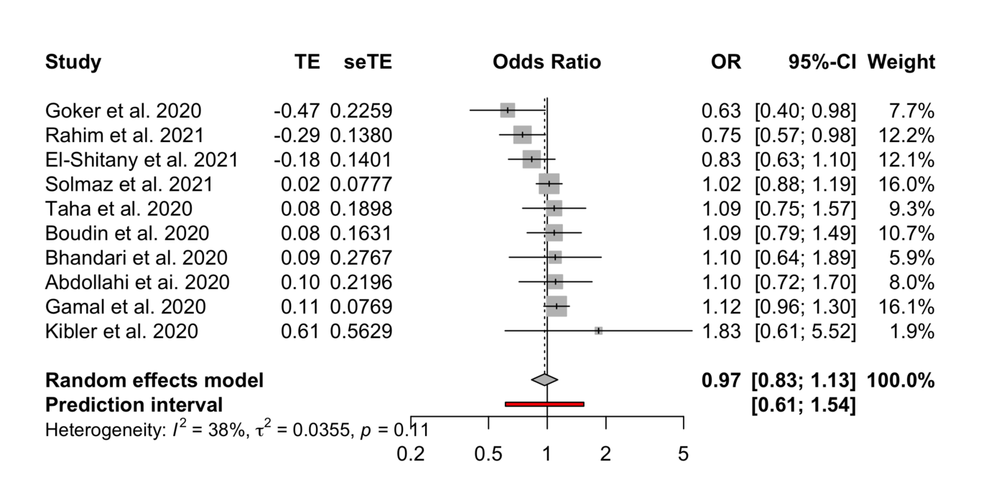
Forest plot for the Rhesus status
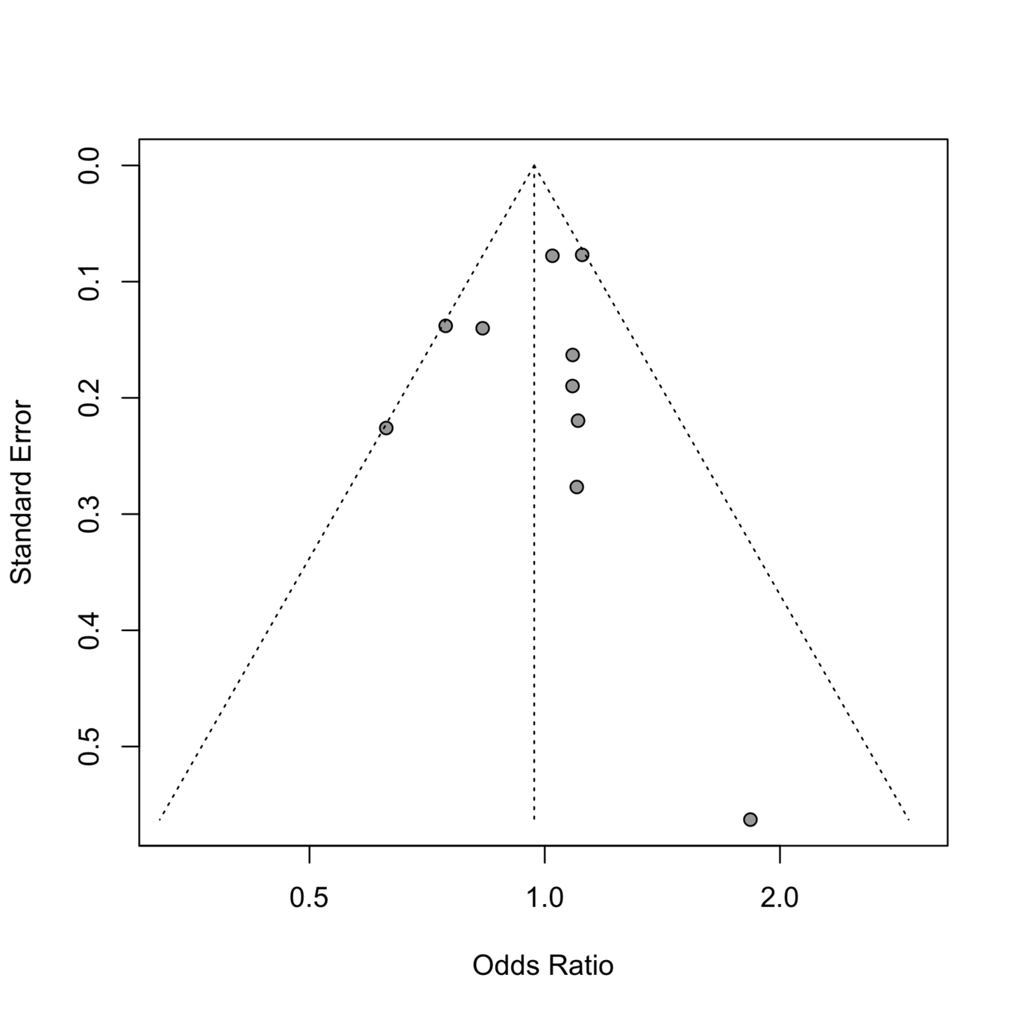
Funnel plot for the Rhesus status

Discussion
The aim of the study was to assess the relationship between COVID-19 infection and different blood groups, as well as Rhesus state, using a meta-analysis method. Twenty-two studies were selected for blood type and ten for the Rhesus factor. Our results revealed that the blood groups A, B and AB are associated with an increase in the risk of COVID-19 infection in comparison with the O blood group, which seems to be protective. A mild publication bias was observed for the A and O blood group pair, through the visual inspection of the funnel plots and the results of Egger’s test. Further, moderate to substantial heterogeneity, has been observed for the blood groups A and AB in comparison with the O blood group. Blood group B was characterized by the absence of heterogeneity.
Although the mechanisms that can explain the observed data have not yet been clarified, some assumptions can be made. The main one assumes that the anti-A and anti-B natural antibodies being produced in individuals with blood group O could potentially block viral adhesion to cells, which could explain a lower risk of infection. Potential lack of such antibodies in blood groups A and B may explain the higher risk of COVID-19 infection but further studies are needed to elucidate this hupothesis (Pourali et al. 2020). Concerning the Rhesus status, there was not evidence of an association with COVID-19 infection. The visual inspection of the Rhesus factor funnel plot and the results of Egger’s test showed moderate heterogeneity but no evidence of publication bias.
The interpretation of the overall estimates should be done with caution because of the observed heterogeneity between studies. There was variability in the design and sample size, while a considerable part of the pooled control population comes mainly from a single study (Golinelli et al. 2020). Further, the COVID-19 confirmation method was either genetic, clinical, or even unreported while potential confounding factors such as age, gender, race, region, and underlying diseases that may influence the predisposition to COVID-19 infection could not be accounted for due to absence of relevant information. Finally, the observed publication bias may be due to the study language chosen, which may have led to the exclusion of other relevant studies, in other languages (Liu et al. 2020). Nevertheless, despite the unexplained heterogeneity, subgroup and sensitivity analysis still confirmed our results.
In conclusion, this meta-analysis provides evidence for an increased risk of COVID-19 infection for blood groups A, B and AB compared to blood group O, while an association between Rhesus state and COVID-19 infection could not be established.

Supplementary files
1. Leave-one-out method results for ABO blood group
Hosted file
supplementary data_ABO_leave_one_out.xlsx available at https://authorea.com/users/155758/articles/518298-systematic-review-and-meta-analysis-of-the-effect-of-abo-blood-group-on-the-risk-of-covid-19-infection
2. Leave-one-out method results for Rhesus
Hosted file
supplementary data_Rh_leave_one_out.xlsx available at https://authorea.com/users/155758/articles/518298-systematic-review-and-meta-analysis-of-the-effect-of-abo-blood-group-on-the-risk-of-covid-19-infection

References
Abdollahi A, Mahmoudi-Aliabadi M, Mehrtash V, Jafarzadeh B, Salehi M. The Novel Coronavirus SARS-CoV-2 Vulnerability Association with ABO/Rh Blood Types.. Iran J Pathol. 2020;15:156–60.
Ad’hiah AH, Allami RH, Mohsin RH, Abdullah MH, AL-Sa’ady AJR, Alsudani MY. Evaluating of the association between ABO blood groups and coronavirus disease 2019 (COVID-19) in Iraqi patients. Egyptian Journal of Medical Human Genetics [Internet]. September 2020;21(1). Available at: https://doi.org/10.1186%2Fs43042-020-00097-x
Banerjee A, Doxey AC, Mossman K, Irving AT. Unraveling the Zoonotic Origin and Transmission of SARS-CoV-2. Trends in Ecology & Evolution [Internet]. March 2021;36(3):180–4. Available at: https://doi.org/10.1016%2Fj.tree.2020.12.002
Barnkob MB, Pottegård A, Støvring H, Haunstrup TM, Homburg K, Larsen R, et al. Reduced prevalence of SARS-CoV-2 infection in ABO blood group O.. Blood Adv. 2020;4:4990–3.
Benjamini Y, Hochberg Y. Controlling the False Discovery Rate: A Practical and Powerful Approach to Multiple Testing. Journal of the Royal Statistical Society: Series B (Methodological) [Internet]. January 1995;57(1):289–300. Available at: https://doi.org/10.1111%2Fj.2517-6161.1995.tb02031.x
Bhandari P, Durrance RJ, Bhuti P, Salama C. Analysis of ABO and Rh Blood Type Association With Acute COVID-19 Infection in Hospitalized Patients: A Superficial Association Among a Multitude of Established Confounders.. J Clin Med Res. 2020;12:809–15.
Boudin L, Janvier F, Bylicki O, Dutasta F. ABO blood groups are not associated with risk of acquiring the SARS-CoV-2 infection in young adults.. Haematologica. 2020;105:2841–3.
Chegni H, Pakravan N, Saadati M, Ghaffari AD, Shirzad H, Hassan ZM. Is There a Link between COVID-19 Mortality with Genus, Age, ABO Blood Group Type, and ACE2 Gene Polymorphism?. Iran J Public Health. 2020;49:1582–4.
Dzik S, Eliason K, Morris EB, Kaufman RM, North CM. COVID-19 and ABO blood groups.. Transfusion. 2020;60:1883–4.
Egger M, Smith GD, Schneider M, Minder C. Bias in meta-analysis detected by a simple graphical test. BMJ [Internet]. September 1997;315(7109):629–34. Available at: https://doi.org/10.1136%2Fbmj.315.7109.629
El-Shitany NA, El-Hamamsy M, Alahmadi AA, Eid BG, Neamatallah T, Almukadi HS, et al. The Impact of ABO Blood Grouping on COVID-19 Vulnerability and Seriousness: A Retrospective Cross-Sectional Controlled Study among the Arab Community.. Int J Environ Res Public Health. 2021;18.
Fan Q, Zhang W, Li B, Li DJ, Zhang J, Zhao F. Association Between ABO Blood Group System and COVID-19 Susceptibility in Wuhan.. Front Cell Infect Microbiol. 2020;10:404.
Franchini M, Glingani C, Fante CD, Capuzzo M, Stasi VD, Rastrelli G, et al. The protective effect of O blood type against SARS-CoV-2 infection. Vox Sanguinis [Internet]. September 2021;116(2):249–50. Available at: https://doi.org/10.1111%2Fvox.13003
Gamal N, Villa E, Rolli M, Pecorari M, Mirabella G, Bertellini E, et al. Subjects with blood group O are not at lower risk to acquire SARS-CoV-2 infection.. Vox Sang. 2021;116:471–2.
Golinelli D, Boetto E, Maietti E, Fantini MP. The association between ABO blood group and SARS-CoV-2 infection: A meta-analysis.. PLoS One. 2020;15:e0239508.
GÖKER H, ALADAĞ-KARAKULAK E, DEMİROĞLU H, AYAZ CM, BÜYÜKAŞIK Y, İNKAYA AC, et al. The effects of blood group types on the risk of COVID-19 infection and its clinical outcome. TURKISH JOURNAL OF MEDICAL SCIENCES [Internet]. June 2020;50(4):679–83. Available at: https://doi.org/10.3906%2Fsag-2005-395
Hoiland RL, Fergusson NA, Mitra AR, Griesdale DEG, Devine DV, Stukas S, et al. The association of ABO blood group with indices of disease severity and multiorgan dysfunction in COVID-19. Blood Advances [Internet]. October 2020;4(20):4981–9. Available at: https://doi.org/10.1182%2Fbloodadvances.2020002623
Hu B, Guo H, Zhou P, Shi ZL. Characteristics of SARS-CoV-2 and COVID-19.. Nat Rev Microbiol. 2021;19:141–54.
IntHout J, Ioannidis JP, Borm GF. The Hartung-Knapp-Sidik-Jonkman method for random effects meta-analysis is straightforward and considerably outperforms the standard DerSimonian-Laird method.. BMC Med Res Methodol. 2014;14:25.
IntHout J, Ioannidis JPA, Rovers MM, Goeman JJ. Plea for routinely presenting prediction intervals in meta-analysis. BMJ Open [Internet]. July 2016;6(7):e010247. Available at: https://doi.org/10.1136%2Fbmjopen-2015-010247
Khalil A, Feghali R, Hassoun M. The Lebanese COVID-19 Cohort; A Challenge for the ABO Blood Group System.. Front Med (Lausanne). 2020;7:585341.
Kibler M, Dietrich L, Kanso M, Carmona A, Marchandot B, Matsushita K, et al. Risk and Severity of COVID-19 and ABO Blood Group in Transcatheter Aortic Valve Patients.. J Clin Med. 2020;9.
Liu N, Zhang T, Ma L, Zhang H, Wang H, Wei W, et al. The impact of ABO blood group on COVID-19 infection risk and mortality: A systematic review and meta-analysis.. Blood Rev. 2020;:100785.
Muñiz-Diaz E, Llopis J, Parra R, Roig I, Ferrer G, Grifols J, et al. Relationship between the ABO blood group and COVID-19 susceptibility, severity and mortality in two cohorts of patients.. Blood Transfus. 2021;19:54–63.
Pal M, Berhanu G, Desalegn C, Kandi V. Severe Acute Respiratory Syndrome Coronavirus-2 (SARS-CoV-2): An Update.. Cureus. 2020;12:e7423.
Pillay TS. Gene of the month: the 2019-nCoV/SARS-CoV-2 novel coronavirus spike protein.. J Clin Pathol. 2020;73:366–9.
Pourali F, Afshari M, Alizadeh-Navaei R, Javidnia J, Moosazadeh M, Hessami A. Relationship between blood group and risk of infection and death in COVID-19: a live meta-analysis.. New Microbes New Infect. 2020;37:100743.
Rahim F, Amin S, Bahadur S, Noor M, Mahmood A, Gul H. ABO / Rh-D Blood types and susceptibility to Corona Virus Disease-19 in Peshawar Pakistan. Pakistan Journal of Medical Sciences [Internet]. December 2021;37(1). Available at: https://doi.org/10.12669%2Fpjms.37.1.3655
Ren LL, Wang YM, Wu ZQ, Xiang ZC, Guo L, Xu T, et al. Identification of a novel coronavirus causing severe pneumonia in human: a descriptive study.. Chin Med J (Engl). 2020;133:1015–24.
Schwarzer G, others. meta: An R package for meta-analysis. R news. 2007;7(3):40–5.
Solmaz İ, Araç S. ABO blood groups in COVID-19 patients; Cross-sectional study.. Int J Clin Pract. 2021;75:e13927.
Su S, Wong G, Shi W, Liu J, Lai ACK, Zhou J, et al. Epidemiology Genetic Recombination, and Pathogenesis of Coronaviruses. Trends in Microbiology [Internet]. June 2016;24(6):490–502. Available at: https://doi.org/10.1016%2Fj.tim.2016.03.003
Taha SAH, Osman MEM, Abdoelkarim EAA, Holie MAI, Elbasheir MM, Abuzeid NMK, et al. Individuals with a Rh-positive but not Rh-negative blood group are more vulnerable to SARS-CoV-2 infection: demographics and trend study on COVID-19 cases in Sudan. New Microbes and New Infections [Internet]. November 2020;38:100763. Available at: https://doi.org/10.1016%2Fj.nmni.2020.100763
Valenti L, Villa S, Baselli G, Temporiti R, Bandera A, Scudeller L, et al. Association of ABO blood group and secretor phenotype with severe COVID-19. October 2020;60(12):3067–70. Available at: https://doi.org/10.1111%2Ftrf.16130
Wu BB, Gu DZ, Yu JN, Yang J, Shen WQ. Association between ABO blood groups and COVID-19 infection, severity and demise: A systematic review and meta-analysis.. Infect Genet Evol. 2020;84:104485.
Wu Y, Feng Z, Li P, Yu Q. Relationship between ABO blood group distribution and clinical characteristics in patients with COVID-19.. Clin Chim Acta. 2020;509:220–3.
Ye ZW, Yuan S, Yuen KS, Fung SY, Chan CP, Jin DY. Zoonotic origins of human coronaviruses.. Int J Biol Sci. 2020;16:1686–97.
Zalba MS, Antelo ML, Galbete A, Etayo M, Ongay E, García-Erce JA. Infection and thrombosis associated with COVID-19: Possible role of the ABO blood group.. Med Clin (Engl Ed). 2020;155:340–3.

