Arctic Ocean-Sea ice reanalysis for the period 2007-2016 using the adjoint method
guokun Lyu
We present an Arctic ocean-sea ice reanalysis covering the period 2007-2016 based on the adjoint approach of the ECCO consortium. The spatiotemporal variation of Arctic sea surface temperature (SST), sea ice concentration (SIC), and sea ice thickness (SIT) are substantially improved after the assimilation of the ocean and sea ice observations. By assimilating additional WOA18 hydrographic data, the freshwater content of the Canadian Basin becomes closer to the observations and translates into changes of the ocean circulation and of transports through the Fram and Davis straits. The new reanalysis compares well with previous filter-based (TOPAZ4) and nudging-based (PIOMAS) reanalyses regarding SIC and SST. However, the mean state and variability of the freshwater content and the transport properties of our reanalysis are different from the TOPAZ4 reanalysis, likely due to a lack of hydrographic observations.
Keywords —Arctic ocean-sea ice reanalysis, data assimilation, adjoint method

Introduction
The Arctic Ocean is a hotspot in the changing Earth System and is experiencing rapid warming of surface air temperature (AMAP 2019), changes in the freshwater content of the Canadian Basin (Proshutinsky et al. 2019), in the mass exchange with the Atlantic Ocean (Dmitrenko et al. 2008) and the Pacific Ocean (Woodgate, Weingartner, and Lindsay 2012) and a dramatic decline in sea ice cover (Kwok 2018). The sea ice coverage at the ocean-atmosphere interface modulates the heat, freshwater, and momentum fluxes and is potentially changing the heat and freshwater budgets of the Arctic system. Improving our understanding of the Arctic Ocean circulation and its changes, its interactions with sea ice and the atmosphere, as well as its exchanges with the Pacific and Atlantic Oceans, is crucial for making predictions and projections of Arctic changes.
Due to the harsh environmental conditions and diplomatic constraints, the Arctic Ocean remains one of the most under-sampled regions of the global Oceans. Although sea ice concentration (SIC) is frequently observed by satellites, the sea ice cover limits hydrographic observations and degrades the accuracy of altimetry-based sea level observations (Armitage et al. 2016; Rose et al. 2019). The sparseness of observations limits their interpretation in terms of mechanisms and feedbacks in the Arctic Ocean. Numerical model simulations, which provide spatiotemporal-varying ocean states, are therefore used to complement in-situ and satellite observations, and to understand the Arctic Ocean variability and its causes. However, model simulations also suffer from model deficiencies, such as biases in transports (Aksenov et al. 2016; Fieg et al. 2010) and misrepresentations of the ice edge.
To further improve state-of-the-art numerical simulations of the Arctic Ocean circulation and, at the same time, to improve our interpretation of the sparse observations, models are being constrained by ocean observations through data assimilation techniques. Resulting ocean-sea ice reanalyses (e.g., (Fenty and Heimbach 2013; Fenty, Menemenlis, and Zhang 2015; Koldunov et al. 2017)) provide an invaluable basis for assessing variability and trends of the Arctic sea ice cover (Chevallier et al. 2016), or oceanic transports and their variability (Uotila et al. 2018). However, analyzing the dynamics of the sea ice changes and the full freshwater budget of the Arctic remains difficult from reanalyses.
A crucial factor in this context is that most of the coupled ocean-sea ice reanalyses are produced with sequential methods (so-called filters), which introduce unphysical mass and energy increments during each analysis step (see (Stammer et al. 2016) for a review on methods). For instance, the TOPAZ4 reanalysis (Xie et al. 2017) uses an ensemble Kalman Filter to assimilate near-real-time observations, resulting in potential discontinuities in the reanalysis during each analysis step. In contrast, the PIOMAS reanalysis (Lindsay and Zhang 2006) uses a nudging scheme to assimilate SIC observations and sea surface temperature (SST), thereby continuously adding source terms to the governing equations. Discontinuities introduced by the data assimilation are thereby alleviated. From both reanalyses, we cannot expect to obtain detailed dynamical insights into mechanism leading to observed ocean-sea ice changes.
In contrast, the adjoint assimilation technique preserves model dynamics by bringing the model simulation close to observations through changing control parameters, and the resulting reanalysis is dynamically consistent over a long assimilation window (years to decades) (Stammer et al. 2016). Applications of the adjoint method excluding the assimilation of sea ice data have been a mature field (Forget et al. 2015; Köhl 2014) but remain challenging when sea ice data is to be incorporated.
Great efforts have been made to implement the adjoint method to coupled ocean-sea ice model (e.g., (Fenty and Heimbach 2013; Heimbach et al. 2010)) with encouraging results. However, the adjoint model may still suffer from strong unphysical sensitivities, which degrades the usefulness of the adjoint sensitivity, limits the number of iterations performed, and stalls the optimization process. For instance, (Koldunov et al. 2017) reported that only five iterations could be performed in their Arctic ocean-sea ice assimilation system within a 1-year assimilation window because locally large unphysical sensitivities arose, rendering the adjoint sensitivity useless for the optimization algorithms. Causes for the problem still have to be understood in detail, but may likely arise from linearizing nonlinear processes in the sea ice model.
Here, we use the adjoint method to constrain a coupled ocean-sea ice model by ocean observations. Building on the work of (Koldunov et al. 2017) , we aim to improve the previous setup of the Arctic reanalysis by modifying the adjoint model to enable more iterations over longer assimilation windows covering the period 2007-2016. In this work, we will examine the changes imposed in the model through the assimilation procedure and compare the resulting reanalysis against the TOPAZ4 (Xie et al. 2017) and PIOMAS (Lindsay and Zhang 2006) reanalyses.
The structure of the remaining paper is as follows. The data assimilation system, observations, and the TOPAZ4 and PIOMAS reanalyses are described in Section 2. In Section 3, we assess the details of the model-data misfit reduction. Improvements in SIC and sea ice thickness (SIT) are evaluated and compared against TOPAZ4 and PIOMAS reanalyses in Section 4. Section 5 focuses on ocean state changes concerning SST, freshwater content (FWC), and transports through Fram Strait, Davis Strait, and the Barents Sea Opening. A comparison with the TOPAZ4 reanalysis is also shown in that section. Adjustments of the control variables are examined in Section 6. Section 7 provides concluding remarks.

The data assimilation system and observations
This study builds on the coupled ocean-sea ice data assimilation system presented in the study of (Koldunov et al. 2017) . The system uses a pan-Arctic configuration of the MITgcm (Marshall et al. 1997) coupled with a dynamic-thermodynamic sea ice model (Losch et al. 2010). The adjoint model is generated by the Transformation of Algorithms in Fortran (Giering and Kaminski 1998) () and is then modified to stabilize the adjoint when calculated over a 4-year assimilation window following the approach in (Stammer et al. 2018).

The coupled ocean-sea ice model
The model domain covers the entire Arctic Ocean north of the Bering Strait and the Atlantic Ocean north of 44°N (see Figure 1). The open boundaries are nested laterally into a 16-km Atlantic-Arctic configuration (SERRA et al. 2010). The system has 50 vertical z-levels ranging from 10 m at the surface and 456 m in the deep ocean. In the horizontal, a curvilinear grid with a resolution ~16 km is used.
Atmospheric states from the 6-hourly NCEP/NCAR-RA1 reanalysis (“The NCEP/NCAR 40-Year Reanalysis Project | Bulletin of the American Meteorological Society | American Meteorological Society” 1996), including 2-m air temperature, 10-m wind vectors, precipitation rate, 2-m specific humidity, downward longwave radiation, and net shortwave radiation, and bulk formulae are used to compute the surface momentum, heat, and freshwater fluxes. The river runoff is applied near the river mouth with seasonal-varying river discharge. A virtual salt flux parameterization is used to simulate the effects of freshwater input on salinity changes. The K-profiles scheme of (Large, McWilliams, and Doney 1994) is used to parameterize unresolved vertical mixing effects.
The thermodynamic sea ice model is based on the zero-layer formulation of Semtner (1976) and ). And the dynamic sea ice model is based on ) and is implemented following ). The thermodynamic-dynamic sea ice model is then modified for the application of adjoint data assimilation (; ).

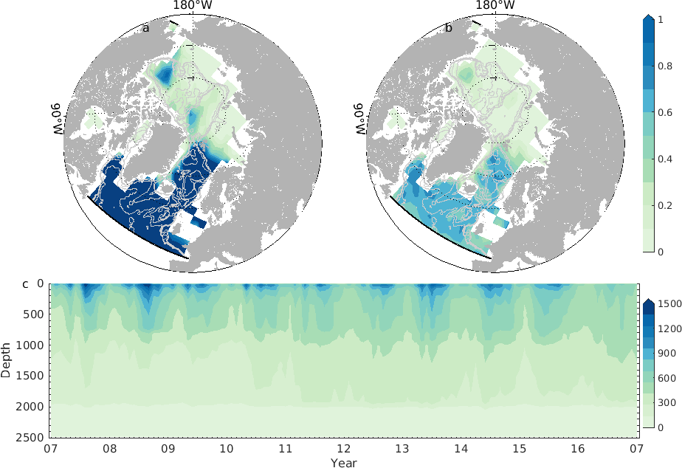
Model domain and profiles observing frequency (number/month) on a 3˚´3˚ grid from April-October (a) and November-March (b). At most one profile is counted each day on each grid. Panel (c) is the number of observations assimilated depending on time (per month) and depth caption.

The adjoint method
The adjoint of the forward model is used to bring the model simulation into consistency with available observations. The method minimizes a quadratic model-data misfit, (also called cost function; Eq. 1), weighted by the prior data uncertainties, by adjusting control variables iteratively.
$$J(C_{ini},C_{atm}(t))=\sum_{t=1}^{T1}{[}y(t)−E(t)x(t)]^{T}[R(t)]^{−1}[y(t)−E(t)x(t)]+C_{ini}^{T}P(0)^{−1}C_{ini}+{\overline{C_{atm}}}^{T}Q_{m}^{−1}\overline{C_{atm}}+\sum_{t=0}^{T1}{C_{atm}^{′}}{\left(t\right)}^{T}Q_{a}^{−1}C_{atm}^{′}(t) \left(1\right)$$

Over the whole reanalysis period (2007-2016), we adjust the initial temperature, salinity, and SIC of the year 2007 (C_{ini}) and daily atmospheric states on the model grid (C_{atm}(t)), which include 2-m air temperature, 2-m specific humidity, precipitation rate, 10-m wind vectors, downward longwave radiation, and net shortwave radiation. Due to the computational limit and potential instability of the adjoint model, we separate the whole 10-year period (2007-2016) into three chunks (2007-2010, 2010-2013, 2013-2016) with a one-year overlap. A total number of ~10⁹ elements are adjusted in each chunk to reduce the cost function. The initial state of the latter chunk is taken from the last iteration of the former chunk to avoid discontinuities when moving to the next period.
On the right-hand side of equation (1), the first term computes the uncertainty-weighted model-data misfits, where y(t) and x(t) represent observations and model state at time t, and E(t) maps model states to the corresponding observations. T denotes the transpose of the matrix. The remaining three terms penalize the adjustments of the initial state C_{ini}, time-mean atmospheric forcing , and time-varying atmospheric forcing and are weighted by their prior uncertainties P(0), Q_{m}, and Q_{a}, respectively. Prior uncertainties of the initial state P(0) and of the time-varying atmospheric forcing Q_{a} are computed as the standard deviation of the nonseasonal variability of the corresponding variables using the WOA18 ocean atlas and the NCEP-RA1 reanalysis. Uncertainties of the mean component of 2-m air temperature, 2-m specific humidity, precipitation rate, 10-m wind vectors, downward longwave radiation, and net shortwave radiation are set to 1°C, 0.001 kg kg⁻¹, 1.5*10⁻⁸ mm s⁻¹, 2 m s⁻¹, 20 W m⁻², and 20 W m⁻².
To stabilize the adjoint model for a four-year assimilation window, we made the following modifications to the adjoint of MITgcm:
1) disable the K-profiles mixing parameterization scheme,
2) use a free-drift sea ice dynamic model,
3) increase the Laplacian diffusivity of heat and salinity to 500 m² s⁻¹, and lateral eddy viscosity to 10000 m² s⁻¹,
4) apply a filter () to the thermodynamic sea ice sub-model to remove spurious strong sensitivities. The filter compares the sensitivity on one model grid with the mean value of the surrounding eight model gridpoints. We set the sensitivity to 0 if the sensitivity is ten times larger than the mean value.
These modifications stabilize the adjoint model over a long period but, at the same time, degrades the accuracy of the adjoint sensitivity.
A quasi-Newton algorithm based on ) is used to iteratively reduce the cost function by adjusting the control vectors employing the adjoint sensitivities. The optimization stops when the gradient descent algorithm cannot further reduce the cost function due to the degraded usefulness of the adjoint sensitivities. The analyses discussed below are based on the zeroth iteration (referred to as “INTAROS-ctrl”) and the last iteration (referred to as “INTAROS-opt”) of the optimization.

Observations and prior uncertainties
Both in-situ and remote sensing observations are used to constraint the model simulation. Data sets that are assimilated and their sources are listed in Table 1.
SST is based on optimal interpolated microwave and infrared data. SST data is not available over the sea ice-covered region, but we assume SST is at freezing temperature (-1.96 °C) where sea ice is observed but not simulated. Along-track sea level anomaly observations from satellite altimetry are available over ice-free regions. With specific algorithms, sea level could be retrieved over the sea ice-covered areas with significantly larger errors (; ). Additionally, the model is constrained to the WOA18 climatology and the mean dynamic height from ). Hydrographic profiles from EN4 data () and UDASH data () are used, while duplicated data are removed. On average, the Atlantic sector of the pan-Arctic Ocean is observed more than once per month on a 3°´3° box during April-October (Figure 1a) while once per two months during November-March (Figure 1b). However, the Arctic Ocean is severely under-sampled (Figure 1a, b). In the vertical, the profiles cover mainly the top 800 m (Figure 1c) and more observations are available in the summer season than in the winter season.
Uncertainties of along-track SLA, temperature and salinity profiles, temperature and salinity atlas are the same as in ). Uncertainties of SST consist of errors from the data and representative errors based on the method of ). Uncertainties of SIT and mapped SLA over sea ice-covered regions are provided by the data sets. SIC uncertainties are assumed to be geographic dependent and are computed using the method of ). Mean dynamic height uncertainties were set to 1 cm. Since the data of the temperature and salinity climatology are interpolated to the finer grid, thereby inventing additional data points, we reduced the weight of the temperature and salinity climatology cost component by a factor of 10 and 50, respectively. Due to the low number of hydrographic profiles, we increased the weighting of the hydrological profiles component by a factor of 10 to increase their relative importance with limited iterations.

The TOPAZ4 and PIOMAS reanalyses
Available variables from the TOPAZ4 () and the PIOMAS () reanalyses are compared with our reanalysis. Table 2 lists the details of the two reanalyses. The three systems show significant differences. The PIOMAS reanalysis assimilates the least observations and the coarsest resolution among the three products. The data assimilation methods in the TOPAZ4 and our reanalysis are computational more expensive than the PIOMAS reanalysis and more observations are assimilated.

Evaluation of the optimization
The optimization involved running the MITgcm forward to evaluate the cost function over the time frame 2007-2016, split into three sections as described above. The adjoint model integration then provided gradients of the cost function with respect to control parameters, which were used in an iterative way to minimize the model-data misfit. In the end, a total number of 15, 21, 20 iterations were performed in the three chunks, respectively. Figure 2 shows the resulting percentage decrease in the total cost function and the individual cost components in the three chunks. Negative values indicate that the model-data misfits are increased for that type of observation. The total cost reduction is more than 30% in the three fragments. SST, SIC, and climatological temperature (WOA-T) and salinity (WOA-S) dominate the total cost function (magenta bars) and are reduced by 40%-60%. For the other constituents, MDT and SIT, errors are reduced by more than 50%, but SLA and SIC-SST are degraded. Compared to ), the present optimization achieves a larger cost function reduction for the total and individual components. Besides starting from a better first-guess solution, the increased cost function reduction, in particular, results from the larger number of iterations performed here. We note that the cost constituents of temperature and salinity profiles establish ~20% and ~10% of the total cost, respectively, and that the optimization is not capable of reducing those misfits significantly.
Because they appear as the largest improvement during the optimization, in the following section, we focus on the improvements of SIC, SIT, and SST. We compare resulting fields with those available from the TOPAZ4 () and the PIOMAS () reanalyses. We also examine the impacts of data assimilation on oceanic transports and freshwater content and compare these variables against the TOPAZ4 reanalysis.

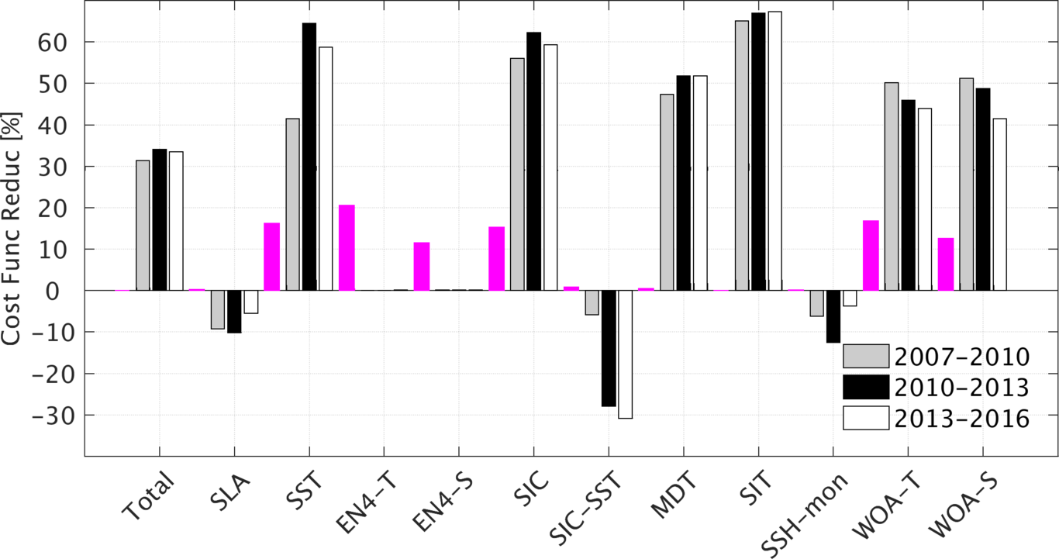
Percentage reduction of the total cost function and individual constituents in the three chunks (see legend). The magenta bars denote contributions of the individual component to the entire cost function.

Sea ice parameters improvements

Sea ice concentration
The time series of SIC shown in Figure 3a reveal a significant variation during the year with more disagreements between solutions in wintertime and fairly consistent results during the time of the summer minimum. In particular, all model simulations match the observed summer extreme minimum SIC in the years 2007, 2012, and 2016. During the winter season, INTAROS-opt follows the satellite observations well, while the TOPAZ4 reanalysis underestimates SIC during the first four years and follows INTAROS-opt after that. The PIOMAS reanalysis also matches the observations well, but it slightly overestimates SIC in the winter season. In contrast, INTAROS-ctrl simulates more SIC than is observed.
To reveal the winter inter-model discrepancies in more detail, Figure 3b shows total SIC from January to March in the year 2007. The TOPAZ4 reanalysis clearly shows a seven-day signal caused by the artificial energy and mass input at the analysis step characteristic to every filter approach. The POIMAS reanalysis shows more SIC than all the other simulations. Discontinuities are not visible in the PIOMAS reanalysis because they used a mixed nudging and optimal interpolation method to alleviate discontinuities. Yet, the nudging term still adds artificial sources and sinks to the model simulation and violates model physics. The adjoint method brings the model-simulated sea ice cover closest to the observations by adjusting the atmospheric forcing and the initial state in the year 2007.

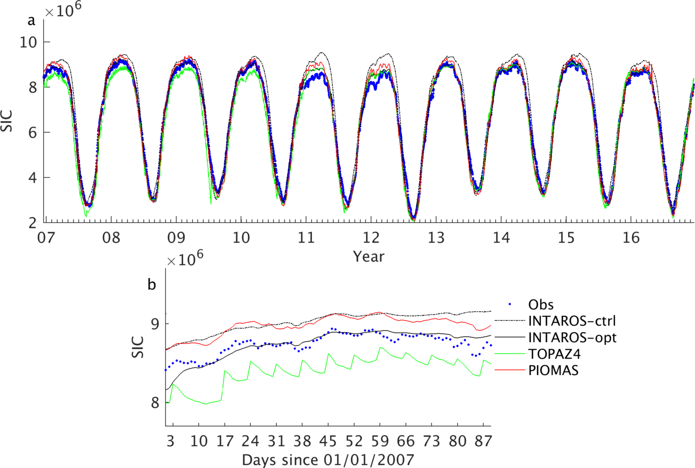
Total SIC over the model domain based on observations, the zeroth iteration of the optimization (INTAROS-ctrl), the last iteration of the optimization (INTAROS-opt), the TOPAZ4 reanalysis, and the PIOMAS reanalysis (see legend). Panel (a) is for the whole reanalysis period (2007-2016), and panel (b) is for the period January-March, 2007.
As expected, the spatial distribution of SIC is also improved upon data assimilation (Figure 4a, d). In March, the sea ice edge extends more in INTAROS-ctrl (black dashed line in Figure 4a), a feature corrected through the assimilation process (shading in Figure 4a). Improvements in the spatial distribution of SIC are even more pronounced in September (Figure 4d). In contrast to the total SIC (Figure 3a), both the TOPAZ4 and the PIOMAS reanalyses show an overall agreement with observations, considering the patterns and sea ice edge (15%). The PIOMAS reanalysis simulates more SIC in the winter season (Figure 4c) and less SIC in the summer season (Figure 4f). Overall, the three reanalyses reproduce the spatial pattern of the pan-Arctic SIC and the total SIC minimum in the years of 2007, 2012, and 2016.
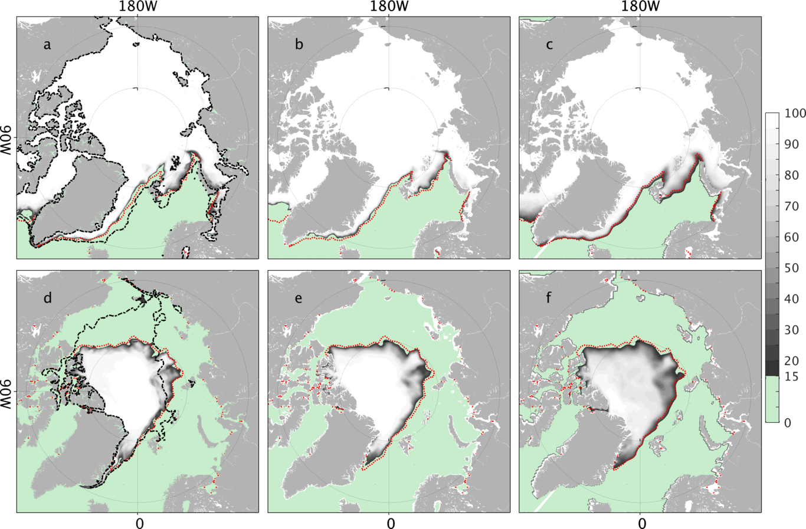
SIC in March averaged over the year 2007-2016 in INTAROS-opt (a), the TOPAZ4 reanalysis (b), and the PIOMAS reanalysis (c). Panels (d)-(f) are the corresponding SIC in September. The red dotted lines are the satellite-observed sea ice edge (15%) ,and the black dashed lines in panels (a) and (d) are the sea ice edge in INTAROS-ctrl.

Sea ice thickness and volume
SIT differences remain large among different ocean-sea ice reanalyses (), which may be caused by differences in sea ice models and how SIT is updated when ingesting observations by data assimilation. In this section, we analyze improvements to SIT due to the adjustment of the control variables and compare them with the TOPAZ4 and PIOMAS reanalyses.
The cost of SIT is reduced by ~60% in the three chunks (Figure 2), despite its very little contribution to the total cost. INTAROS-opt (Figure 5b) underestimates mean SIT in the central Arctic Ocean and in the region north of Greenland, which is covered by multiple-year sea ice, and overestimates mean SIT over seasonal sea ice extent regions. INTAROS-opt reduces mean SIT errors significantly (Figure 5c), and the root mean square error (RMSE) is reduced from 0.54 m in INTAROS-ctrl to 0.40 m in INTAROS-opt (Figure 5a).
The PIOMAS reanalysis shows a slightly larger RMSE of SIT (0.46 m) than INTAROS-opt (0.40 m) and TOPAZ4 (0.41 m, see Figure 5a). TOPAZ4 shows larger errors in October and November than both INTAROS-opt and PIOMAS, but the SIT errors are quickly reduced as the model assimilates observations sequentially, resulting in smaller RMSE than the other two products at the start of the next year. Mean SIT errors remain in the three products. Negative SIT errors up to -0.6 m exist in the central Arctic Ocean and the Eurasian Basin, extending to the northeastern Greenland coast. In the Beaufort Sea, all three reanalyses overestimate SIT by ~0.2-0.4 m with TOPAZ4 performing best. In the seasonal sea ice extent regions, including the marginal seas and around Greenland, TOPAZ4 data shows smaller mean SIT errors than the other two reanalyses.

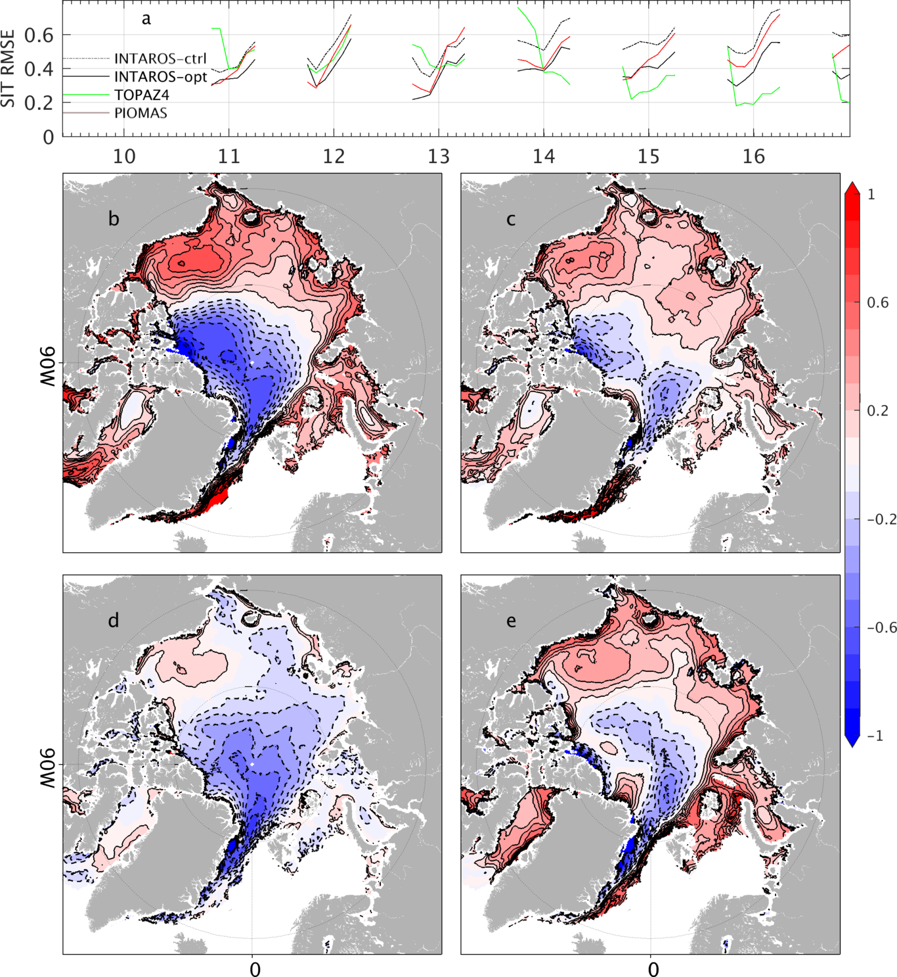
(a) RMSE between the CRYSAT2-SMOS observations and INTAROS-ctrl, INTAROS-opt, TOPAZ4, and PIOMAS. The remaining panels show the mean SIT differences between CRYSAT2-SMOS merged data and (b) INTAROS-ctrl, (c) INTAROS-opt, (d) TOPAZ4, and (e) PIOMAS. The contour interval is 0.1 m.
Despite the improvements in SIC and SIT, we note that sea ice volume shows significantly different time variability among the different reanalyses (Figure 6). For instance, our model simulations and the PIOMAS reanalysis show a more substantial seasonal variation than the TOPAZ4 data, especially before the year 2011. INTAROS-opt changes the total sea ice volume in the summer season throughout the 10 years and in the winter season after the year 2010 when additional SIT observations are available. Despite the different assimilation methods and numerical models, we see that the state-of-the-art ocean-sea ice models reproduce the spatiotemporal-varying SIC successfully. We note that SIT is also improved either through rectifying mechanisms by improvements on SIC or by assimilating additional SIT data in the winter season. Beneficial effects of assimilating satellite SIT are more clearly visible in the TOPAZ4 reanalysis after January of the year 2014.
To examine the relative importance of SIC and SIT on the residual sea ice volume, we replace each component in INTAROS-opt with observations (blue line and black dots in Figure 6). Replacing SIT with observations (black dots in Figure 6) achieves a better match with the observed sea ice volume than replacing SIC with observations (blue line in Figure 6), indicating that the sea ice volume improvement mostly results from the SIC assimilation and that SIT needs to be further improved for further reducing sea ice volume error.

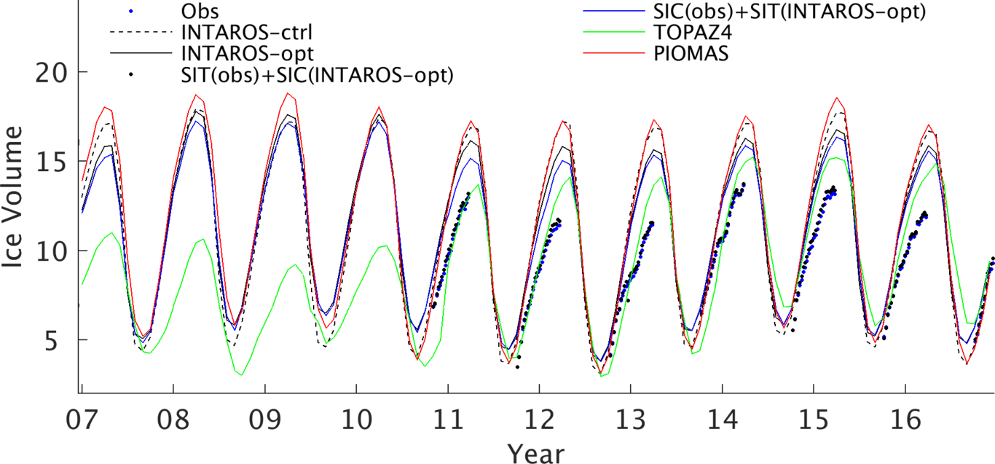
Total sea ice volume over the model domain based on CRYSAT2-SMOS merged product (Obs), INTAROS-ctrl, INTAROS-opt, TOPAZ4, and PIOMAS (see legend). Also presented are total sea ice volume using observed-SIC and SIT in INTAROS-opt (blue line), observed-SIT and SIC in INTAROS-opt (black dotted line).

Ocean changes
In the filter approaches, ocean states are changed by updating the state through assimilating observations and the propagation of the analysis increment by the forward model. The adjoint method adjusts the atmospheric forcing and the initial state to reduce the model-data misfits. These adjustments to the control variables are calculated by the information that is propagated by the adjoint model and the forward model. In this section, we concentrate on ocean changes after data assimilation and compare them with the TOPAZ4 reanalysis.

SST improvements
In INTAROS-ctrl, both the mean SST (Figure 7c) and SST anomaly (Figure 7a) show significant errors, especially in seasonal sea ice extent regions. The normalized root mean square of SST anomaly difference (Figure 7b) is significantly reduced with values ~1 in vast areas of the pan-Arctic Ocean. Near the central Arctic Ocean, normalized root mean square of SST anomaly difference can be as large as 4, indicating that the model-observations difference is still significant compared with the observation uncertainties.
SST is not observed by satellites under the sea ice, but we assume SST is -1.96 °C where sea ice is observed but not simulated in the model. INTAROS-opt reduces the mean SST errors by about 1 °C over the ice-free regions and by as much as -2 °C under the sea ice-covered area.

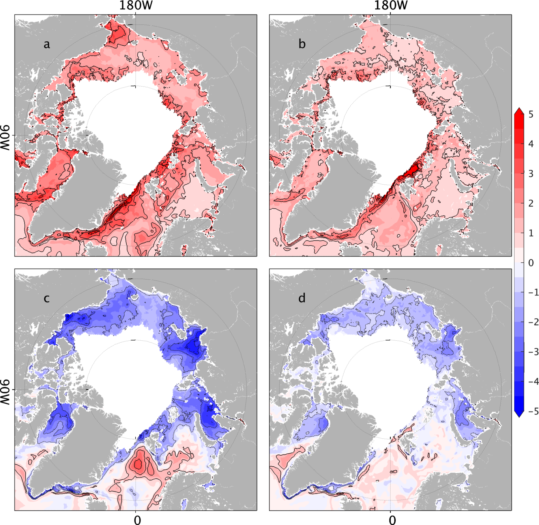
Normalized root mean square of SST anomaly difference between the observations and INTAROS-ctrl (a) and INTAROS-opt (b). Panels (c) and (d) are differences for the mean SST. The contour interval is 1 °C. The SST anomaly difference is normalized by prior uncertainties used in the data assimilation.
SST shows consistency among the Arctic ocean-sea ice reanalyses (). We compare INTAROS-opt with the TOPAZ4 reanalysis concerning the root mean square of SST anomaly difference (Figure 8a) and the mean difference (Figure 8b). The SST differences of the mean state and of the variability are located along the strong currents and the variable ice extent regions.
We took the SST time series (Figure 8c) averaged over a 50 km ´ 50 km box near Fram Strait (black box in Figure 8a) as an example to examine and explain the differences between the reanalyses and observations. During September-November 2012, SIC observations averaged over this box (blue line in Figure 8d) show sea ice appearing from 27 September to 26 October accompanied by declining SST (solid and dashed blue lines in Figure 8e). Both INTAROS-opt and the TOPAZ4 reanalysis simulate a similar process as the observations (black and green lines Figure 8d, e), starting from 11 October to 23 October and from 27 September to 23 November, respectively. Based on INTAROS-opt, we diagnose SIC changes (DA) due to advective divergence (S_{div}), atmospheric thermodynamic effects (S_{atm}), and oceanic sources (S_{oce}, Figure 8c). Figure 8c reveals that the advective convergence ( ) effect dominates the accumulation of sea ice in this region. The underlying water cools as the ice is moving in. It melts the ice from underneath, which is shown by the negative contribution from the thermodynamic effect of the ocean. The small contributions from the thermodynamics suggest that the colder water moves together with the ice into the box, while surface fluxes have a minor impact. In the TOPAZ4 reanalysis (green lines in Figure 8d, e), sea ice emerges at a date similar to that of SIC observations, but more sea ice is simulated in the middle of October. During the decay, SIC is reduced (corrected) during each step (every seven days) of the data assimilation before building up biases again between two analysis cycles. In general, no dynamics can be inferred behind the SIC changes. The decay process in the TOPAZ4 reanalysis takes more time.
We conclude that overall, the adjoint method improves the SST both in its variability and its time mean. INTAROS-opt is consistent with the TOPAZ4 reanalysis, but SST differences remain along sea ice extent regions and strong current regions, which are likely to be related to the fast ocean-sea ice interaction processes and mesoscale processes.
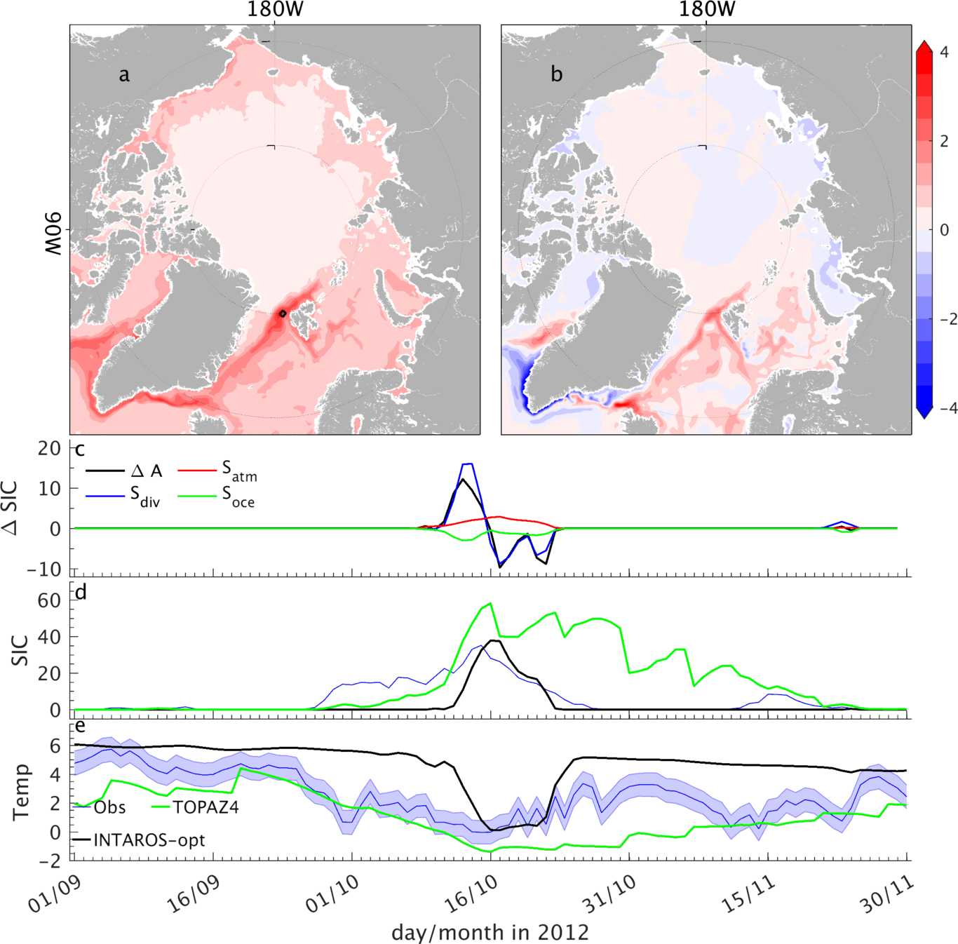
Root mean square of SST anomaly difference (a) and mean SST difference (b) between the TOPAZ4 reanalysis and INTAROS-opt. Panels (c-e) are time series for the region near the Fram Strait (black box in panel (a)) from 1 September 2012 to 30 November 2012. Panel (c) shows sea ice changes due to the advective convergence term, the thermodynamic effect of the atmosphere, and the thermodynamic effect of the ocean (see legend in c). Panel (d) shows SIC from satellite observations (blue line), TOPAZ4 reanalysis (green line), and INTAROS-opt (black line). Panel (d) shows the mean SST based on the OI product in this study (Obs), INTAROS-opt, and the TOPAZ4 reanalysis (see the legend). Observation errors are shaded.

Salinity and freshwater content changes
Salinity is an essential indicator of the freshwater budget, but direct salinity observations are extremely sparse in the Arctic Ocean. In this section, we examine the freshwater content changes (referred to 34.8 PSU as in Proshutinsky et al., 2009) and compare them with TOPAZ4 results. Freshwater content and SSS variability in the Beaufort Sea are taken as an example to analyze the differences to TOPAZ4.
After the assimilation, a freshening is noticeable in the interior of the Arctic Ocean (Figure 9a). At the same time, along the routes of outflowing Arctic water into the North Atlantic east and west of Greenland, a reduction of freshwater content can be seen. Circulation changes (vectors in Figure 9a) depict an enhanced anti-cyclonic circulation anomaly in the Canadian Basin and a weaker anti-cyclonic circulation anomaly in the Eurasian Basin. We also note an increase of Atlantic inflow west of Svalbard and St. Anna Trough and enhanced Arctic outflow through the western Fram Strait and Nares Strait. The freshwater comes mostly from the direct adjustment of the initial salinity of the year 2007 (Figure 9b). It then is redistributed towards the Canadian Basin via the mean circulation. The enhanced circulation around Greenland would, according to ), contribute to the reduction of the freshwater content. The additional freshwater content remains stored in the Canadian Basin through the enhanced anti-cyclonic circulation, as revealed by ).

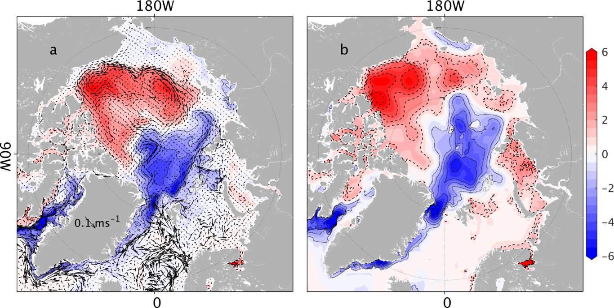
(a) Difference in mean freshwater content (in m, shading) and velocity over the top 100 m (vectors) between INTAROS-opt and INTAROS-ctrl. Panel (b) shows the freshwater content increment introduced by the initial salinity adjustment.
Compared to the TOPAZ4 reanalysis, INTAROS-opt simulates less freshwater content over the Arctic continental shelves and slightly more freshwater in the Canadian Basin (Figure 10a). One may argue that INTAROS-opt increases the freshwater content in the Canadian Basin at the expense of degrading the Arctic continental shelves. However, the mean freshwater content increment after data assimilation (Figure 9a) shows almost no changes in the Arctic marginal seas.
Based on observations (), the WOA18 atlas (), the PHC atlas version 3.0 (), INTAROS-ctrl, INTAROS-opt, and the TOPAZ4 reanalysis, we computed the freshwater content in the Beaufort Sea (Figure 10c), the Laptev and East Siberian Seas (Figure 10d). INTAROS-opt changes the mean freshwater content without altering its variability. The mean freshwater content in the Beaufort Sea is increased from 12 km³ to 16 km³ after data assimilation (Figure 10c), but changes in the marginal seas are small except for the first year (Figure 10d).
Freshwater content (Figure 10a) and SSS (Figure 10b) remain different between the TOPAZ4 system and our reanalysis, especially over the Arctic marginal shelves. SSS in the INTAROS-opt is much higher than the TOPAZ4 reanalysis in the marginal seas, resulting in less freshwater content (Figure 10a). In the TOPAZ4 system, SSS is relaxed to a combined climatology of the WOA05 and the version 3.0 of PHC (Steele, 2001) with a timescale of 30 days to complement limitations of seasonal river discharge and relatively coarse atmospheric forcing. In our reanalysis, the salinity is mainly changed by adjustment of initial salinity and atmospheric forcing. In the marginal seas, the SSS restoring term is more efficient in changing SSS, while adjusting atmospheric forcing seems not as efficient. However, it may not improve freshwater content efficiently in the marginal seas (Figure 10d) and also damps the seasonal freshwater content variability (green lines in Figure 10c, d).
The WOA18 data remains an essential source of hydrographic observations to constraint the model’s climatology in this study. However, the differences between different hydrographic atlases remain significant (Figure 10c,d) regarding mean state and variability. Although the PHC atlas data () is more popularly used in studies of the Arctic Ocean, we note that the WOA18 atlas is closer to the observations (Figure 10c) concerning the freshwater content in the Beaufort Sea. Moreover, WOA18 reveals the secondary maximum of freshwater content occurring from May to July (). Increasing the number of Arctic Ocean hydrographic observations and improving the quality of the Arctic Ocean climatology are required for further improving the model simulation through data assimilation.
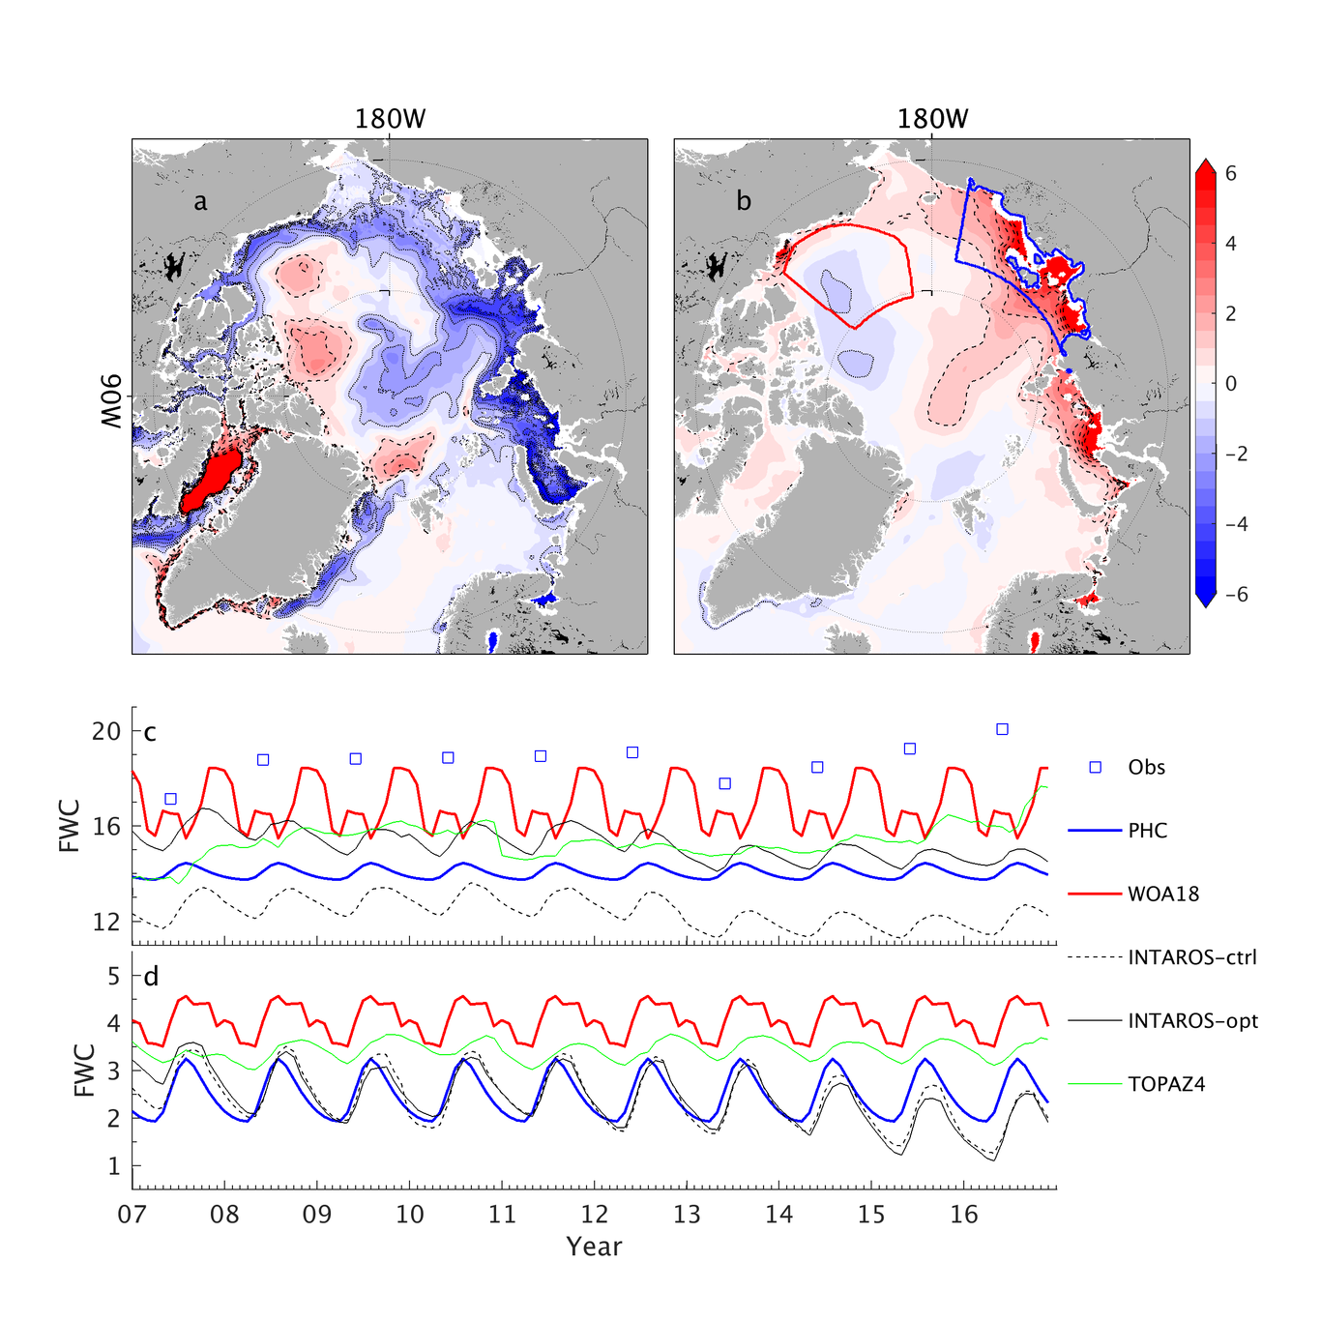
Differences in freshwater content (in meters, a) and SSS (b) between INTAROS-opt and the TOPAZ4 reanalysis. Panels (c) and (d) are the accumulated freshwater content (´10³ km³) in the Beaufort Sea (enclosed by the red line in panel (b)), and in the Laptev and the East Siberian Seas (enclosed by the blue line in panel (b)) based on the three model simulations, the PHC and WOA climatology (see the legend). Observed freshwater content in the Beaufort Gyre (https://www.whoi.edu/website/beaufortgyre/data) is also overlaid in panel (c).

Transport changes
The Arctic freshwater content and transports through the key straits remain different among different Arctic ocean models or Arctic ocean reanalyses (; ). In contrast to ), our results show that the assimilation changes the ocean circulation in the pan-Arctic Ocean (Figure 8a). We also compare examined the transport changes in detail. Table 3 summarizes mean fluxes of volume, liquid freshwater, sea ice volume, and heat through the Fram Strait, Davis Strait, and the Barents Sea Opening in INTAROS-ctrl and INTAROS-opt. As can be seen, changes in the fluxes are much more significant than those shown by ). Sea ice volume transports are reduced by ~26.4% through the Barents Sea Opening while increased by 30.9% through the Fram Strait. Net southward volume flux through the Fram Strait is reduced by 16.8% due to an enhancement of the Norwegian North Atlantic Current and a weakening of the Arctic outflow, resulting in increased heat fluxes to the Arctic Ocean and decreased freshwater flux from the Arctic Ocean. The southward net volume flux through the Davis Strait is increased, accompanied by more southward freshwater transport. Data assimilation seems not always to bring the oceanic transports closer to observations, as the reduced liquid freshwater flux through the Fram Strait shows. Unfortunately, direct observations of the transports through the key straits cover different periods, and particular methods are used to fill the spatial gaps, resulting in significant uncertainties in the observational estimates. Moreover, model studies () also show substantial decadal variability of the transports. Because of this, direct comparisons are complicated, and conclusions drawn could be ambiguous.
To further examine transport changes after data assimilation and compare with the TOPAZ4 reanalysis, we show the volume, liquid freshwater, and sea ice volume transports from INTAROS-ctrl, INTAROS-opt, and TOPAZ4 (Figure 11). Mean freshwater transports through the Fram Strait and the Davis Strait are substantially changed, but the variability changes are small. A better match between INTAROS-opt and the TOPAZ4 reanalysis can be observed for the sea ice volume transport (Figure 11c,f) than for the liquid freshwater (Figure 11b,e) and volume transports (Figure 11a,d), especially after the year 2012. Regardless of the biases, the variability of volume and liquid freshwater transport through the Davis Strait in TOPAZ4 match well with the optimization (Figure 11d,e). However, no clear correlations are observed in volume and liquid freshwater transports through the Fram Strait (Figure 11a,b).
Overall, the optimization changes the mean freshwater transports through the Fram Strait and the Davis Strait. However, the mean volume and liquid freshwater fluxes through the key straits remain different between our reanalysis and the TOPAZ4 reanalysis.
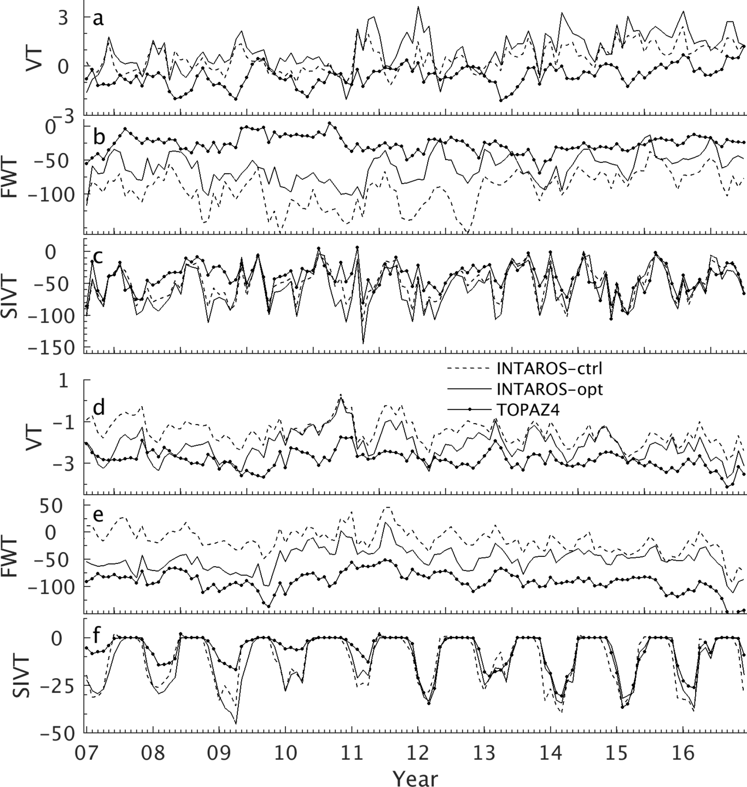
Volume (a,d), liquid freshwater (b,e), and sea ice volume (c,f) transports through the Fram Strait (a-c) and the Davis Strait (d-f). The volume and liquid freshwater flux are computed over the top 500 m.

Adjustments of the control variables
Unique to our optimization is that corrections to the control variables are the only means for adjusting the model to reduce the model-data misfit while leaving the model dynamics untouched. Figure 12a shows the resulting normalized adjustments of atmospheric states averaged over the model domain. Changes of the atmospheric state in the first 4-year period are smaller than in the remaining years, which is caused by a low number of iterations in this chunk and the additional option to adjust the initial state in the year 2007. Because more iterations have been performed, corrections to the atmospheric forcing are more pronounced than those shown in the study of ).
Among all atmospheric states, wind components are adjusted most noticeably by the optimization algorithm. The 2-m air temperature and specific humidity are also substantially changed; still, their adjustments are smaller than those of the wind. During the winter season, wind components seem to be the most efficient control variables because the Arctic Ocean is covered by sea ice blocking the heat and freshwater fluxes between the ocean and atmosphere. Although the same applies to the transfer of momentum, the free drift approximation in the adjoint enables the transfer of corrections to the wind, which is likely to be much less efficient than what the adjoint predicts. From April to October, the role of 2-m air temperature and specific humidity increase due to more open water.
We focus on corrections of the wind vectors in May (Figure 12b, c) and in November (Figure 12e, f) when the corrections are at the maximum and minimum, respectively. Normalized root mean squares of u and v wind correction anomalies depict substantial adjustments of wind vectors over seasonal sea ice extent regions in May (Figure 12b, c) and along the East Greenland Current (Figure 12e, f). Wind vectors in May are one of the most crucial factors that impact SIC in September (), indicating that wind vectors likely impact the SIC several months later thought sea ice advective convergence effects. Therefore, corrections to wind vectors in May and November may change SIC over the seasonal sea ice extent region months later.

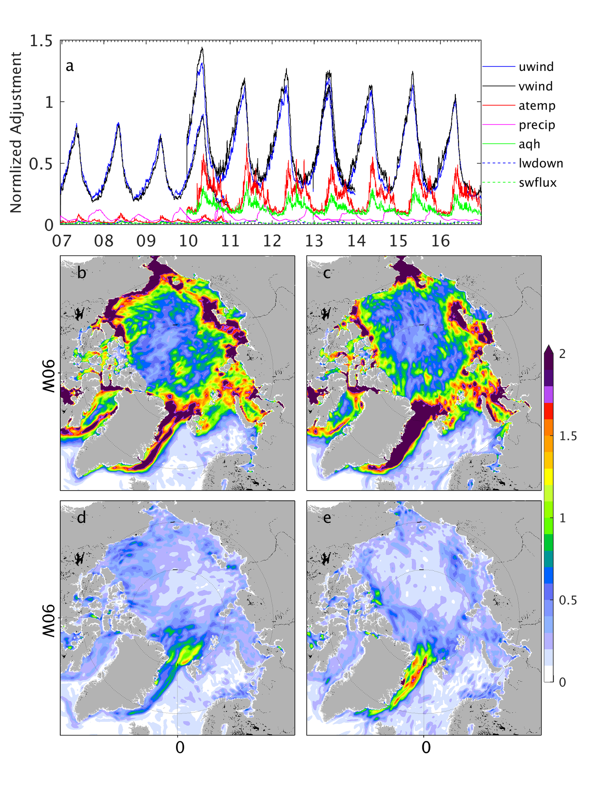
Area average of the adjustments of the control variables (see legend) normalized by their uncertainties. Adjustments of the overlapping years (2010 and 2013) are also shown. Panels (b)-(c) are normalized root mean square of corrections to wind u-component anomaly (b), wind v-component anomaly (c) in May. Panels (d)-(e) are the same as (b)-(c) but for November.

Conclusions
Building on the work of ), we provide here an Arctic ocean-sea ice reanalysis for the period 2007-2016. By applying a smoothing-algorithm to the adjoint sensitivities, thereby eliminating local random spikes in the respective fields, we were able to increase both the assimilation window to 4-year and the number of iterations performed over each window. Through the filter process, the adjoint model may underestimate the real sensitivities of the cost function to control parameters related to ocean-sea ice processes (not shown). Nevertheless, remaining adjoint sensitivities appear still effective during the optimization process in reducing the model-data misfits. Through the increased number of iterations, the optimization achieves a significantly larger cost function reduction, i.e., improvement, than reported previously by ). In particular, the data assimilation approach improves the spatial sea ice distribution, reducing the total SIC in the winter season. Together with SIC, SST is also significantly improved. However, despite the significant improvement in SIT estimates, we note that residual SIT, and thus sea ice volume errors, remain substantial.
Comparing INTAROS-opt with the TOPAZ4 and PIOMAS reanalyses, we see that all three products reproduce the SIC variations well, regarding their spatial pattern. However, SIT differences between different renanlyses remain large with the total SIC in INTAROS-opt matching the satellite observations best as compared to the PIOMAS and TOPAZ4 reanalyses. Overall, INTAROS-opt and the TOPAZ4 reanalysis have smaller RMSEs (0.40 m and 0.41 m) than the PIOMAS reanalysis (0.46 m).
Besides using additional hydrographic and sea ice thickness data, we also used the WOA18 atlas to constraint the model climatology. However, although we increased the weighting of the cost contribution of in situ profiles, the resulting model-data misfits remain large. We speculate that this is because of the sparse temporal and spatial coverage of the hydrographic observations. Because of this, the ocean climatology remains a crucial source of hydrographic data for reducing the model bias. Arctic hydrological climatology datasets need to be further improved to reduce their differences, especially over the Arctic marginal shelves. By assimilating the WOA18 atlas, we have increased the mean freshwater content in the Canadian Basin. The freshwater is mainly added through adjusting the initial salinity, which is then redistributed to the Canadian Basin by the mean circulation. Changes of circulation within the Arctic Ocean, similar to ), are consistent with a contribution to the freshening. Together with the circulation changes, mean transports through the Fram Strait and around Greenland are changed. Generally, discrepancies in the freshwater content, transport across the Fram and Davis straits remain large between INTAROS-opt and TOPAZ4, supporting the need for improving coverage of hydrographic observations in the Arctic Ocean.
Compared with the other filter-based ocean-sea ice reanalyses, our product is dynamically consistent. The data could be used for understanding the causes and consequences of the Arctic sea ice changes. The results above encourage us to use, in future applications, a single assimilation window and extend the reanalysis from the year 1991 upto date.

LaTeX and Mathematical notation
You can also include LaTeX code in your documents. Here is a simple inline equation $e^{iπ}=−1$ and here’s a longer equation, numbered:
$$\int_{0}^{+∞}{e^{−x^{2}}}dx=\frac{\sqrt{π}}{2}$$

Adding Citations and a References List
You can cite bibliographic entries easily in Authorea. For example, here are a couple of citations (Cavalleri 2016; Gregory, Meskine, and Stass 2015). By default citations are formatted according to a format accepted by the journal. Here is one more citation (Meskine 2019)

This is a table. Tables should be self-contained and complement, but not duplicate, information contained in the text. They should be not be provided as images. Legends should be concise but comprehensive – the table, legend and footnotes must be understandable without reference to the text.
Variables | JKL1 (n=30​) | Control (n=40​) | MN2 | t​ (68)
Age at testing | 38 | 58 | 504.48 | 58 ms
Age at testing | 38 | 58 | 504.48 | 58 ms
Age at testing | 38 | 58 | 504.48 | 58 ms
Age at testing | 38 | 58 | 504.48 | 58 ms
Age at testing | 38 | 58 | 504.48 | 58 ms
Age at testing | 38 | 58 | 504.48 | 58 ms

Acknowledgements
This work was supported in part through funding received from project INTAROS, funded by the European Union (Grant 727890). We thank NCEP for offering the NCEP-RA1 atmosphere reanalysis data (https://psl.noaa.gov/ ). We also thank the Met Office, C3S, BGEP, and NABOS for sharing in-situ profiles and mooring observations. The ocean-sea ice reanalysis presented here is available at https://catalog-intaros.nersc.no/dataset/ocean-sea-ice-synthesis-from-2007-2016. The model simulations were performed at the Deutsches Klimarechenzentrum (DKRZ), Hamburg, Germany. Contribution to the DFG funded Excellence Cluster CLICCS at the Center for Earth System Research and Sustainability of the University of Hamburg

Conflict of interest
You may be asked to provide a conflict of interest statement during the submission process. Please check the journal’s author guidelines for details on what to include in this section. Please ensure you liaise with all co-authors to confirm agreement with the final statement.

References
AMAP. 2019. “AMAP Climate Change Update 2019: An Update to Key Findings of Snow, Water, Ice and Permafrost in the Arctic (SWIPA) 2017”.
Proshutinsky, A., R. Krishfield, J. M. Toole, M.-L. Timmermans, W. Williams, S. Zimmermann, M. Yamamoto-Kawai, et al. 2019. “Analysis of the Beaufort Gyre Freshwater Content in 20032018”. Journal of Geophysical Research: Oceans 124 (12): 9658–89. https://doi.org/10.1029/2019jc015281.
Dmitrenko, Igor A., Igor V. Polyakov, Sergey A. Kirillov, Leonid A. Timokhov, Ivan E. Frolov, Vladimir T. Sokolov, Harper L. Simmons, Vladimir V. Ivanov, and David Walsh. 2008. “Toward a Warmer Arctic Ocean: Spreading of the Early 21st Century Atlantic Water Warm Anomaly along the Eurasian Basin Margins”. Journal of Geophysical Research 113 (C5). https://doi.org/10.1029/2007jc004158.
Woodgate, Rebecca A., Thomas J. Weingartner, and Ron Lindsay. 2012. “Observed Increases in Bering Strait Oceanic Fluxes from the Pacific to the Arctic from 2001 to 2011 and Their Impacts on the Arctic Ocean Water Column”. Geophysical Research Letters 39 (24). https://doi.org/10.1029/2012gl054092.
Kwok, R. 2018. “Arctic Sea Ice Thickness Volume, and Multiyear Ice Coverage: Losses and Coupled Variability (19582018)”. Environmental Research Letters 13 (10): 105005. https://doi.org/10.1088/1748-9326/aae3ec.
Armitage, Thomas W. K., Sheldon Bacon, Andy L. Ridout, Sam F. Thomas, Yevgeny Aksenov, and Duncan J. Wingham. 2016. “Arctic Sea Surface Height Variability and Change from Satellite Radar Altimetry and GRACE 2003-2014”. Journal of Geophysical Research: Oceans 121 (6): 4303–22. https://doi.org/10.1002/2015jc011579.
Rose, Stine Kildegaard, Ole Baltazar Andersen, Marcello Passaro, Carsten Ankjær Ludwigsen, and Christian Schwatke. 2019. “Arctic Ocean Sea Level Record from the Complete Radar Altimetry Era: 19912018”. Remote Sensing 11 (14): 1672. https://doi.org/10.3390/rs11141672.
Aksenov, Yevgeny, Michael Karcher, Andrey Proshutinsky, Rüdiger Gerdes, Beverly de Cuevas, Elena Golubeva, Frank Kauker, et al. 2016. “Arctic Pathways of P Acific W Ater: Arctic O Cean M Odel I Ntercomparison Experiments”. Journal of Geophysical Research: Oceans 121 (1): 27–59. https://doi.org/10.1002/2015jc011299.
Fieg, Kerstin, Rüdiger Gerdes, Eberhard Fahrbach, Agnieszka Beszczynska-Möller, and Ursula Schauer. 2010. “Simulation of Oceanic Volume Transports through Fram Strait 19952005”. Ocean Dynamics 60 (3): 491–502. https://doi.org/10.1007/s10236-010-0263-9.
Fenty, Ian, and Patrick Heimbach. 2013. “Coupled Sea IceOcean-State Estimation in the Labrador Sea and Baffin Bay”. Journal of Physical Oceanography 43 (5): 884–904. https://doi.org/10.1175/jpo-d-12-065.1.
Fenty, Ian, Dimitris Menemenlis, and Hong Zhang. 2015. “Global Coupled Sea Ice-Ocean State Estimation”. Climate Dynamics 49 (3): 931–56. https://doi.org/10.1007/s00382-015-2796-6.
Koldunov, Nikolay V., Armin Köhl, Nuno Serra, and Detlef Stammer. 2017. “Sea Ice Assimilation into a Coupled OceanSea Ice Model Using Its Adjoint”. The Cryosphere 11 (5): 2265–81. https://doi.org/10.5194/tc-11-2265-2017.
Chevallier, Matthieu, Gregory C. Smith, Frédéric Dupont, Jean-François Lemieux, Gael Forget, Yosuke Fujii, Fabrice Hernandez, et al. 2016. “Intercomparison of the Arctic Sea Ice Cover in Global OceanSea Ice Reanalyses from the ORA-IP Project”. Climate Dynamics 49 (3): 1107–36. https://doi.org/10.1007/s00382-016-2985-y.
Uotila, Petteri, Hugues Goosse, Keith Haines, Matthieu Chevallier, Antoine Barthélemy, Clément Bricaud, Jim Carton, et al. 2018. “An Assessment of Ten Ocean Reanalyses in the Polar Regions”. Climate Dynamics 52 (3-4): 1613–50. https://doi.org/10.1007/s00382-018-4242-z.
Stammer, D., M. Balmaseda, P. Heimbach, A. Köhl, and A. Weaver. 2016. “Ocean Data Assimilation in Support of Climate Applications: Status and Perspectives”. Annual Review of Marine Science 8 (1): 491–518. https://doi.org/10.1146/annurev-marine-122414-034113.
Xie, Jiping, Laurent Bertino, François Counillon, Knut A. Lisæter, and Pavel Sakov. 2017. “Quality Assessment of the TOPAZ4 Reanalysis in the Arctic over the Period 19912013”. Ocean Science 13 (1): 123–44. https://doi.org/10.5194/os-13-123-2017.
Lindsay, R. W., and J. Zhang. 2006. “Assimilation of Ice Concentration in an IceOcean Model”. Journal of Atmospheric and Oceanic Technology 23 (5): 742–49. https://doi.org/10.1175/jtech1871.1.
Forget, G., J.-M. Campin, P. Heimbach, C. N. Hill, R. M. Ponte, and C. Wunsch. 2015. “ECCO Version 4: an Integrated Framework for Non-Linear Inverse Modeling and Global Ocean State Estimation”. Geoscientific Model Development 8 (10): 3071–3104. https://doi.org/10.5194/gmd-8-3071-2015.
Köhl, Armin. 2014. “Evaluation of the GECCO2 Ocean Synthesis: Transports of Volume Heat and Freshwater in the Atlantic”. Quarterly Journal of the Royal Meteorological Society 141 (686): 166–81. https://doi.org/10.1002/qj.2347.
Heimbach, Patick, Dimitris Menemenlis, Martin Losch, Jean-Michel Campin, and Chris Hill. 2010. “On the Formulation of Sea-Ice Models. Part 2: Lessons from Multi-Year Adjoint Sea-Ice Export Sensitivities through the Canadian Arctic Archipelago”. Ocean Modelling 33 (1-2): 145–58. https://doi.org/10.1016/j.ocemod.2010.02.002.
Marshall, John, Alistair Adcroft, Chris Hill, Lev Perelman, and Curt Heisey. 1997. “A Finite-Volume Incompressible Navier Stokes Model for Studies of the Ocean on Parallel Computers”. Journal of Geophysical Research: Oceans 102 (C3): 5753–66. https://doi.org/10.1029/96jc02775.
Losch, Martin, Dimitris Menemenlis, Jean-Michel Campin, Patick Heimbach, and Chris Hill. 2010. “On the Formulation of Sea-Ice Models. Part 1: Effects of Different Solver Implementations and Parameterizations”. Ocean Modelling 33 (1-2): 129–44. https://doi.org/10.1016/j.ocemod.2009.12.008.
Giering, Ralf, and Thomas Kaminski. 1998. “Recipes for Adjoint Code Construction”. ACM Transactions on Mathematical Software (TOMS) 24 (4): 437–74. https://doi.org/10.1145/293686.293695.
Stammer, D., A. Köhl, A. Vlasenko, I. Matei, F. Lunkeit, and S. Schubert. 2018. “A Pilot Climate Sensitivity Study Using the CEN Coupled Adjoint Model (CESAM)”. Journal of Climate 31 (5): 2031–56. https://doi.org/10.1175/jcli-d-17-0183.1.
SERRA, NUNO, ROLF H. KÄSE, ARMIN KÖHL, DETLEF STAMMER, and DETLEF QUADFASEL. 2010. “On the Low-Frequency Phase Relation between the Denmark Strait and the Faroe-Bank Channel Overflows”. Tellus A 62 (4): 530–50. https://doi.org/10.1111/j.1600-0870.2010.00445.x.
1996. Bulletin of the American Meteorological Society 77. https://journals.ametsoc.org/bams/article/77/3/437/55258/The-NCEP-NCAR-40-Year-Reanalysis-Project.
Large, W. G., J. C. McWilliams, and S. C. Doney. 1994. “Oceanic Vertical Mixing: A Review and a Model with a Nonlocal Boundary Layer Parameterization”. Reviews of Geophysics 32 (4): 363. https://doi.org/10.1029/94rg01872.
Cavalleri, Matteo. 2016. “Recognizing Reviewers”. International Journal of Quantum Chemistry 117 (1): 6–6. https://doi.org/10.1002/qua.25323.
Gregory, Peter, Hakim Meskine, and Ingeborg Stass. 2015. “Happy Birthday -Advanced Materials Interfaces Turns One”. Advanced Materials Interfaces 2 (1): 1400522. https://doi.org/10.1002/admi.201400522.
Meskine, Hakim. 2019. “Ceci nEst Pas Une Pipe - Five Years of Excellence in Electronic Materials”. Advanced Electronic Materials 5 (1): 1800883. https://doi.org/10.1002/aelm.201800883.
Lees-Miller, John, John Hammersley, and R Wilson. 2010. “Theoretical Maximum Capacity as Benchmark for Empty Vehicle Redistribution in Personal Rapid Transit”. Transportation Research Record: Journal of the Transportation Research Board, no. 2146: 76–83.

