Carpatian Basin 30ka BP Environmental Niche Modelling
Christian Willmes
Scope: Documentation of R based Species Distribution Modelling (SDM) applied to human sites for 30ky BP.

Data
The modelling of course depends on the quality and quantity of the input data. The more environmental information, as well as archaeological finds for the probed time period is available to be incorporated into the model, the better are the results.

Sites

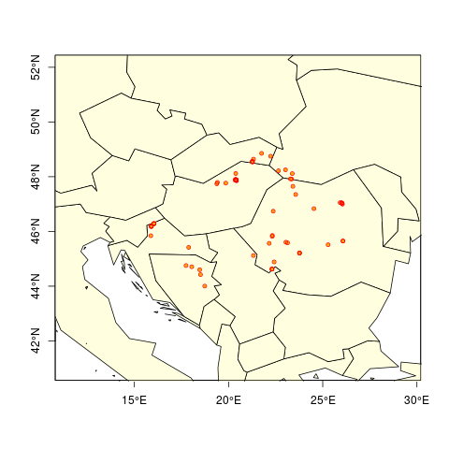
67 Sites for human settlements of around 30ky BP.

Topography
The topography data used in this study is based on the SRTM DEM (Jarvis et al. 2008).
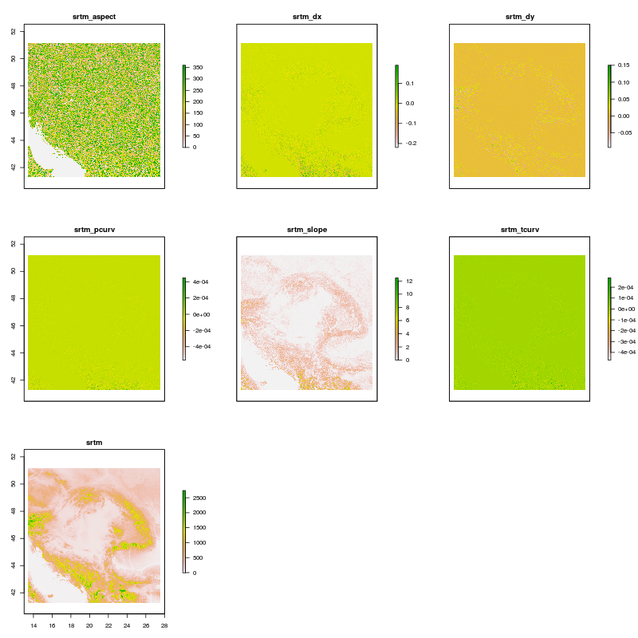
Topography predictor variables derived from SRTM DEM.
A set of 6 additional predictor varibales (slope, aspect, curvatures and partial derivatives) see fig. ???, were computed from the SRTM DEM data using the GRASS GIS r.slope.aspect tool (Shapiro and Waupotitsch 2015).

Geology and Soil
ToDo: get Geology and (Paleo-)Soil information for the Region.

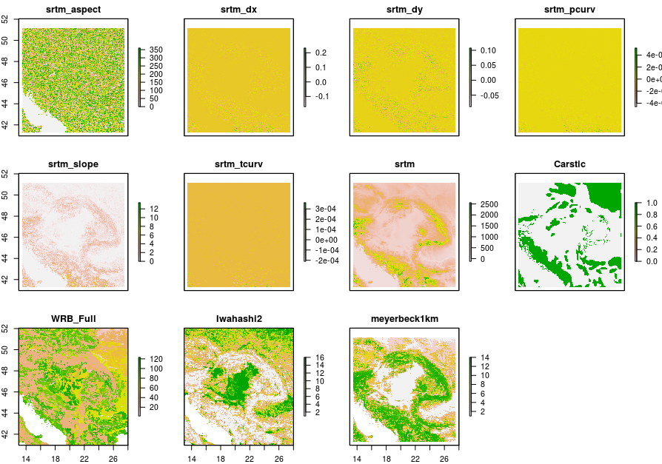
This is a caption

Landuse
ToDo: Include recent Landuse classifications, because most finds are found on open farm land.

Landform classifications
Describe Iwahshi and Meyerbeck data

Visiblity range score
ToDo: create a dataset, that computes a score for best viewshed and visibility ranges. Something similar to cellphone tower placement GIS applications.

Hydrology
ToDo: Create a paleo DEM for the Carpatian Basin (huge Task), and compute the Hydrology (River network) of the CB.

Climate

Climate proxy data
To have a reliable climate model, it is requested to have paleoenvironmental information from climate proxies, like sedimentological (e.g. from loess), palynological or other analysis, available for validating the climate model. Without a regular validation of the data, we can’t use it for producing valid estimates or assertions based on that model.

Climate Model
The climate data applied for this study is based on a new approach for spatio-temporal climate data interpolation (Willmes et al. 2017). For the application with SDM models, the 19 bio climatic variables are computed using the R dismo package (Hijmans and Elith 2016), see Fig. ???.
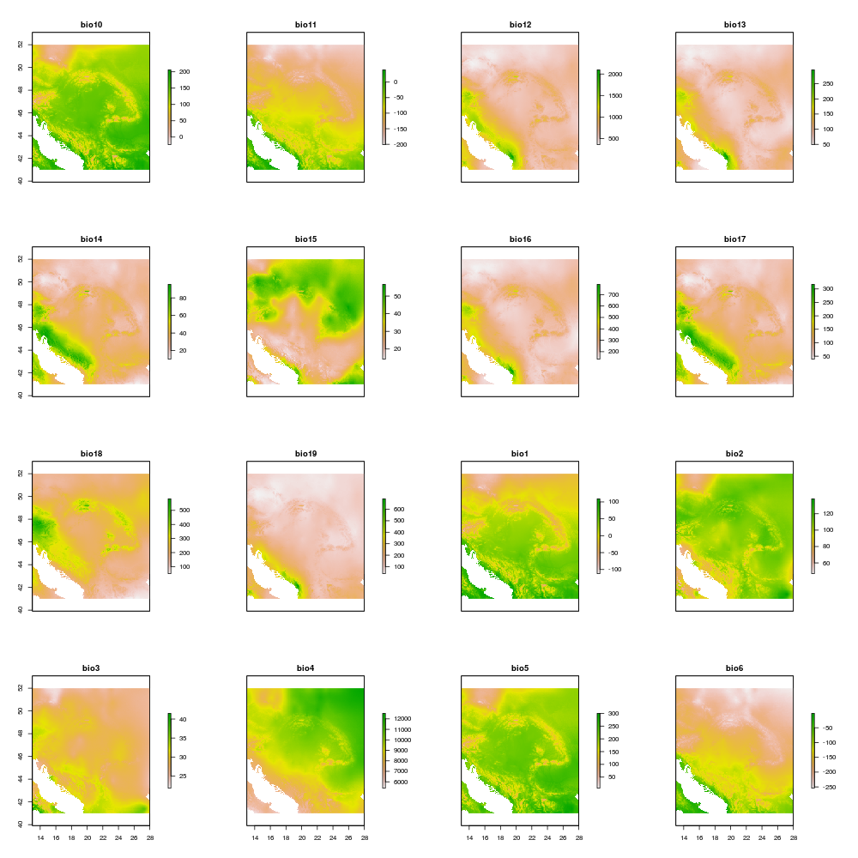
Bioclimatic variables for 30ky BP.
The bioclimatic variables computed using the dismo R package, are defined as follows:
BIO1 = Annual Mean Temperature
BIO2 = Mean Diurnal Range (Mean of monthly (max temp - min temp))
BIO3 = Isothermality (BIO2/BIO7) (* 100)
BIO4 = Temperature Seasonality (standard deviation *100)
BIO5 = Max Temperature of Warmest Month
BIO6 = Min Temperature of Coldest Month
BIO7 = Temperature Annual Range (BIO5-BIO6)
BIO8 = Mean Temperature of Wettest Quarter
BIO9 = Mean Temperature of Driest Quarter
BIO10 = Mean Temperature of Warmest Quarter
BIO11 = Mean Temperature of Coldest Quarter
BIO12 = Annual Precipitation
BIO13 = Precipitation of Wettest Month
BIO14 = Precipitation of Driest Month
BIO15 = Precipitation Seasonality (Coefficient of Variation)
BIO16 = Precipitation of Wettest Quarter
BIO17 = Precipitation of Driest Quarter
BIO18 = Precipitation of Warmest Quarter
BIO19 = Precipitation of Coldest Quarter

GIS data set
The GIS data set is published in the CRC806-Database (Willmes 2017).

Modelling Results
Application of several SDM approaches to the data presented above.

Bioclim
Application of the Bioclim model (Booth et al. 2013)

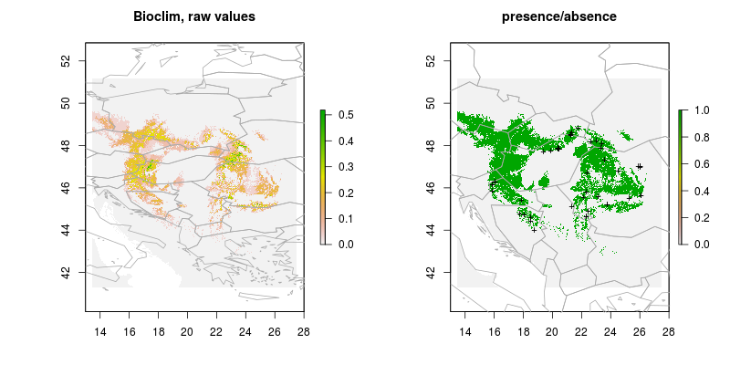
Results of Bioclim model.
class : ModelEvaluation
n presences : 13
n absences : 16
AUC : 0.8990385
cor : 0.6514319
max TPR+TNR at : 0.03693704

Domain
Application of the Domain model (Carpenter, Gillison, and Winter 1993).
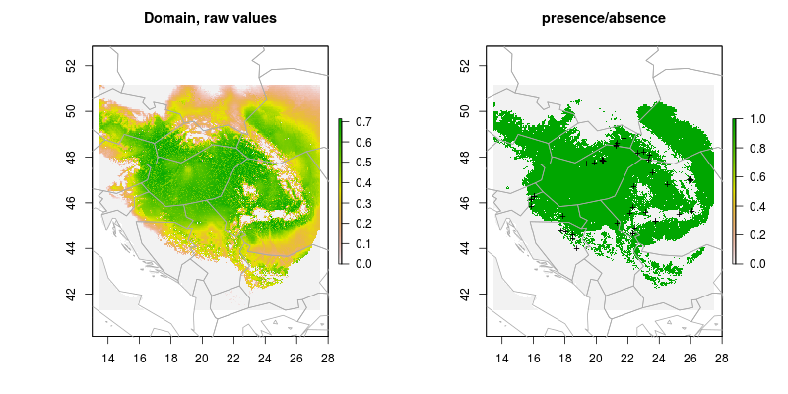
Results of domain model.
class : ModelEvaluation
n presences : 13
n absences : 16
AUC : 0.7331731
cor : 0.4003718
max TPR+TNR at : 0.3602315

Generalized Linear Models (GLM)
Application of the GLM method (Guisan, Edwards, and Hastie 2002).

Binomial

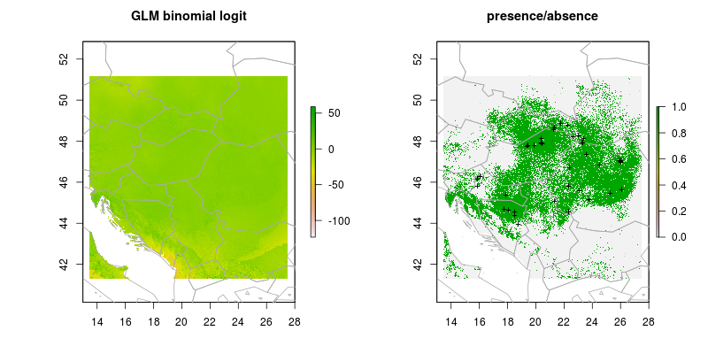
GLM binomial logit result.
class : ModelEvaluation
n presences : 13
n absences : 20
AUC : 0.7807692
cor : 0.3320665
max TPR+TNR at : -0.7914661

Gaussian

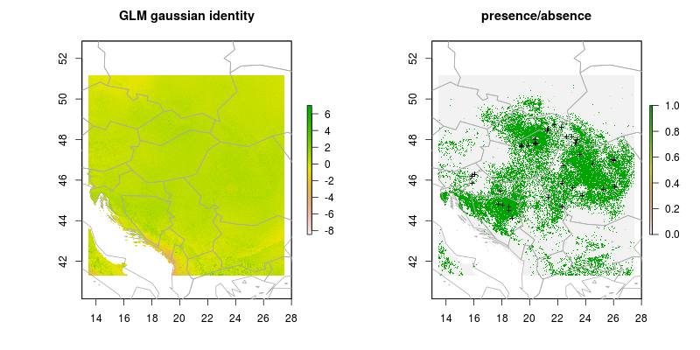
GLM gaussian identity result.
class : ModelEvaluation
n presences : 13
n absences : 20
AUC : 0.7807692
cor : 0.4246963
max TPR+TNR at : 0.5096578

Poisson

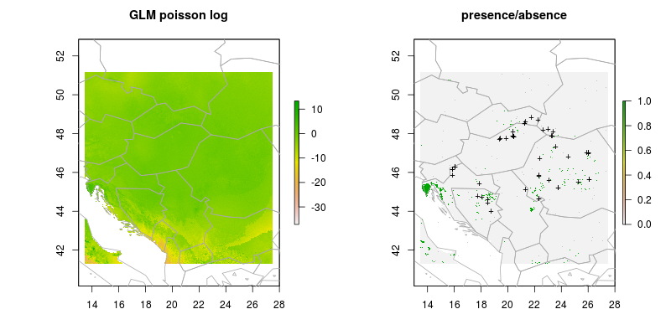
GLM poisson log.
class : ModelEvaluation
n presences : 13
n absences : 20
AUC : 0.8192308
cor : 0.3797152
max TPR+TNR at : -1.040075

Boosted Regression Trees
ToDo
(Elith, Leathwick, and Hastie 2008)

Random Forest
(Breiman 2001)

Support Vector Machines
(Vapnik 1998)

Combining the model predictions

Average score

Weighted mean

References
Jarvis, Andy, Hannes Isaak Reuter, Andrew Nelson, and Edward Guevara. 2008. “Hole-Filled Seamless SRTM Data V4, International Centre for Tropical Agriculture (CIAT)”.
Shapiro, Michael, and Olga Waupotitsch. 2015. “GRASS GIS R.slope.aspect Tool”. U.S.Army Construction Engineering Research Laboratory. https://grass.osgeo.org/grass70/manuals/r.slope.aspect.html.
Willmes, C., E. Hölzchen, C. Sommer, and J. Rodriguez. 2017. “Spatio-Temporal Interpolation of Paleoclimate Data Based on δ18O​ Climate Variability Observations (in Prep.)”. Quarternary International. https://www.authorea.com/155404/-9NUD9aEaZHN8y6vcNvRiA.
Hijmans, Robert J, and Jane Elith. 2016. “Species Distribution Modeling with R”. Dismo R Package Version 1.1-4. https://cran.r-project.org/web/packages/dismo/index.html.
Willmes, Christian. 2017. “Carpatian Basin 30ky Bp GIS Data Set”. Dataset. CRC806-Database. doi:10.5880/SFB806.37.
Booth, Trevor H., Henry A. Nix, John R. Busby, and Michael F. Hutchinson. 2013. “Bioclim: the First Species Distribution Modelling Package Its Early Applications and Relevance to Most CurrentMaxEntstudies”. Edited by Janet Franklin. Diversity and Distributions 20 (1). Wiley-Blackwell: 1–9. doi:10.1111/ddi.12144.
Carpenter, G., A. N. Gillison, and J. Winter. 1993. “DOMAIN: a Flexible Modelling Procedure for Mapping Potential Distributions of Plants and Animals”. Biodiversity & Conservation 2 (6): 667–80. doi:10.1007/BF00051966.
Guisan, Antoine, Thomas C Edwards, and Trevor Hastie. 2002. “Generalized Linear and Generalized Additive Models in Studies of Species Distributions: Setting the Scene”. Ecological Modelling 157 (2-3). Elsevier BV: 89–100. doi:10.1016/s0304-3800(02)00204-1.
Elith, J., J. R. Leathwick, and T. Hastie. 2008. “A Working Guide to Boosted Regression Trees”. Journal of Animal Ecology 77 (4). Wiley-Blackwell: 802–13. doi:10.1111/j.1365-2656.2008.01390.x.
Breiman, Leo. 2001. “Random Forests”. Machine Learning 45 (1): 5–32. doi:10.1023/A:1010933404324.
Vapnik, Vladimir N. 1998. Statistical Learning Theory. Wiley.

