Avikal Somvanshi

PUI2016 - Extra Credit Project

<Avikal Somvanshi, as10724, as10724>
Abstract: Ground-level ozone is a deadly pollutant and even short term exposure is know to cause health impact. But unlike other aerosols, ozone is not emitted directly into the air from any one source, but is created by photo-chemical reactions among oxides of nitrogen (NOx) in the presence of sunlight. Therefore, to control ozone pollution it is critical to understand the process of its formation in real world and what role weather and various pollutants play in this process. This study analysed hourly pollution and weather data from the Delhi, India from April 2015 to November 2016 to answer these questions. The results show that ozone concentration in Delhi is correlated with solar radiation, temperature, relative humidity and NOx concentration. No correlation was found with wind speed and PM2.5 concentration. Study also found that instances of high ozone pollution are distributed throughout the year (only exception being rainy days during the monsoon season) in Delhi and it is not only a summer season phenomena as generally believed.
Figure 1: Ozone concentration at ground level is positively correlates to solar radiation and ambient temperature conditions, while NOx and relative humidity exhibit negatively correlation. No correlation was found with wind speed and PM2.5 concentration.
Figure 1: Ozone concentration at ground level is positively correlates to solar radiation and ambient temperature conditions, while NOx and relative humidity exhibit negatively correlation. No correlation was found with wind speed and PM2.5 concentration.
Introduction: Ground level Ozone is one of the primary constituents of photo-chemical smog and breathing air laced with high ozone concentration has a marked effect on human health according to the World Health Organisation (WHO). According to the Ambient (outdoor) air quality and health factsheet of WHO “it can cause breathing problems, trigger asthma, reduce lung function and cause lung diseases”. Several European studies have reported that the daily mortality rises by 0.3% and that for heart diseases by 0.4%, per 10 µg/m³ increase in ozone exposure.
This study analyses ozone concentrations monitored in Delhi, India, which is consistently recognized as home to the most polluted air among the megacities in the world by WHO. Delhi is known to have sever ozone pollution problem but it is perceived to be a summer phenomena. This study explores the seasonal variation in ozone concentration in Delhi’s air and relative impact of other chemical and weather elements on it.
Research Questions: How is ground-level ozone pollution linked to concentration of oxides of nitrogen (NOx), ambient temperature and solar radiation? Is there any impact of wind speed, relative humidity and PM 2.5 concentration on the ozone formation? Is ozone pollution a strictly summer phenomena?
Science of Ozone formation: Ozone is formed by the reaction with sunlight (photochemical reaction) of pollutants such as NOx from vehicle and industry emissions and volatile organic compounds (VOCs) emitted by vehicles, solvents and industry. As a result, the highest levels of ozone pollution occur during periods of sunny weather (See Figure 2).
Figure 2: Ozone’s NOx cycle: (1) The Sun’s ultraviolet light breaks oxygen atoms off nitrogen dioxide molecules; (2) Oxygen atoms then react with oxygen molecules in the air to produce the ozone; (3) But ozone is destroyed by nitric oxide, reforming molecular oxygen and nitrogen dioxide. (Source: http://www.bbc.com/news/science-environment-20563591)
Figure 2: Ozone’s NOx cycle: (1) The Sun’s ultraviolet light breaks oxygen atoms off nitrogen dioxide molecules; (2) Oxygen atoms then react with oxygen molecules in the air to produce the ozone; (3) But ozone is destroyed by nitric oxide, reforming molecular oxygen and nitrogen dioxide. (Source: http://www.bbc.com/news/science-environment-20563591)
Data: The study uses the official pollution and weather data from the RK Puram pollution monitoring station of Delhi Pollution Control Committee, an autonomous agency of the Government of National Capital Territory of Delhi, India. The monitoring station is the only one located in South Delhi which has a population of more than 2.7 million people with approximate population density of 28,000 people per square mile. Landuse is mostly residential and institutional.
The dataset includes hourly concentrations of ozone, NOx and PM 2.5 (particulate matter of size 2.5 micrometer or lesser) and hourly measurement of ambient temperature, solar radiation, wind speed and relative humidity from April 2015 to November 2016. The data was downloaded from the website of the Central Pollution Control Board (CPCB) of India (equivalent of the US Environmental Protection Agency).
Data wrangling: CPCB website allows to download only excel files containing monitored data for one parameter and three months at a time. Therefore, the collected data is spread across 49 excel files. All the information in the excel files were collated, cleaned, merged and written onto a CSV file for this study (Click on the figure 3 to access them). The original data had dd/mm/yyyy date-time format which was converted to a format compatible with Pandas plotting package.
Figure 3: Matrix plot of the complete dataset.
Figure 3: Matrix plot of the complete dataset.
Methodology: The ground-level ozone formation was analysed using outlier detection via thresholding. Indian regulations define 180 µg/m³ of ozone concentration as the hourly safe-standard, which was used as the threshold to establish instances of unacceptable pollution level. Internationally, 8 hourly mean concentration is used to determine safe standard (WHO standard = 100 µg/m³) but due to missing data entries it was not possible to carry out rolling mean analysis based on the international standard, which could have given results that can be compared with other international studies.
Periodicity of peaking of ozone concentration was established using the Fourier analysis (See Figure 4). Further, the peaks of each individual variable was visually assessed if they correlated in their distributed in time. Correlation of ozone concentration with NOx, PM2.5, temperature, solar radiation, wind speed and relative humidity was assessed via linear regression analysis, which was done for the full sample and then repeated for three seasons (summer, winter and monsoon) with a smaller sample size of 30 days each.
Figure 4: Peaks of ozone concentration have a primary periodicity 24 hours.
Figure 4: Peaks of ozone concentration have a primary periodicity 24 hours.
Results: The study found that Indian hourly standard for ozone concentration was breached 723 times in the time span of the study data (See Figure 5). The peak ozone concentration recorded was 492.52 µg/m³ which is 2.7 times the standard. The mean concentration for the same was about 52 µg/m³. Seasonal findings are below:
Observation in Oct-Nov, 2016
Number of times hourly concentration of Ozone exceeded the standard = 21
Peak pollution value recorded was 256.03 µg/m3
Mean of the pollution was 50.3985416667 µg/m3
Observation in May, 2016
Number of times hourly concentration of Ozone exceeded the standard = 59
Peak pollution value recorded was 387.71 µg/m3
Mean of the pollution was 73.187828125 µg/m3
Observation in August, 2015
Number of times hourly concentration of Ozone exceeded the standard = 5
Peak pollution value recorded was 424.5 µg/m3
Mean of the pollution was 27.2738068182 µg/m3
Figure 5: The study found that Indian hourly standard for ozone concentration was breached 723 times in the time stamp of the study data. The peak ozone concentration recorded was 492.52 µg/m³ which 2.7 times the standard. The mean concentration for the same was about 52 µg/m³.
Figure 5: The study found that Indian hourly standard for ozone concentration was breached 723 times in the time stamp of the study data. The peak ozone concentration recorded was 492.52 µg/m³ which 2.7 times the standard. The mean concentration for the same was about 52 µg/m³.
Overall, summer seems to have more instances of concentration levels exceeding standard followed by winter/fall and lowest being in monsoon. But the visual inspection reveals that extreme peaks are erratically distributed. This also establishes that ozone pollution is not just a summer phenomena in Delhi, it is a problem throughout the year with exception of rainy days.
Correlation analysis: Study found that solar radiation and NOx has a direct correlation with concentration of ozone at any given time which was expected. Study also found that ambient temperature and relative humidity has a significant impact on the process. Higher temperature conditions positively correlate with ozone formation and on a seasonal level it was found to have higher adjusted R-square value for winter than in summer. This might be indicative of the fact that higher temperature in winter is also a very good indicator of sunny days or clearer sky conditions (more solar radiation) which is necessarily not true for Indian summer (which is sunny irrespective of temperature conditions). High relative humidity was found to have significant negative impact on ozone formation which was not anticipated at the onset of the study. Wind speed and PM 2.5 concentration were found to have no correlation with ozone formation. Seasonal analysis also reveals that during monsoons all the variables included in this study have little to no correlation with ozone levels in the atmosphere, which might be the impact of rain (not included in the study) washing the air clean.
The regression model built based on the study findings with solar radiation, temperature, NOx concentration and humidity as regressers has a decent adjusted R-square of 0.595.
Figure 6: Hourly analysis of ozone concentration in Oct-Nov, 2016 (fall/winter) found 21 times hourly concentration of Ozone exceeded the standard, Peak pollution value recorded was 256.03 µg/m³,Mean of the pollution was 50.3985416667 µg/m³
Figure 6: Hourly analysis of ozone concentration in Oct-Nov, 2016 (fall/winter) found 21 times hourly concentration of Ozone exceeded the standard, Peak pollution value recorded was 256.03 µg/m³,Mean of the pollution was 50.3985416667 µg/m³
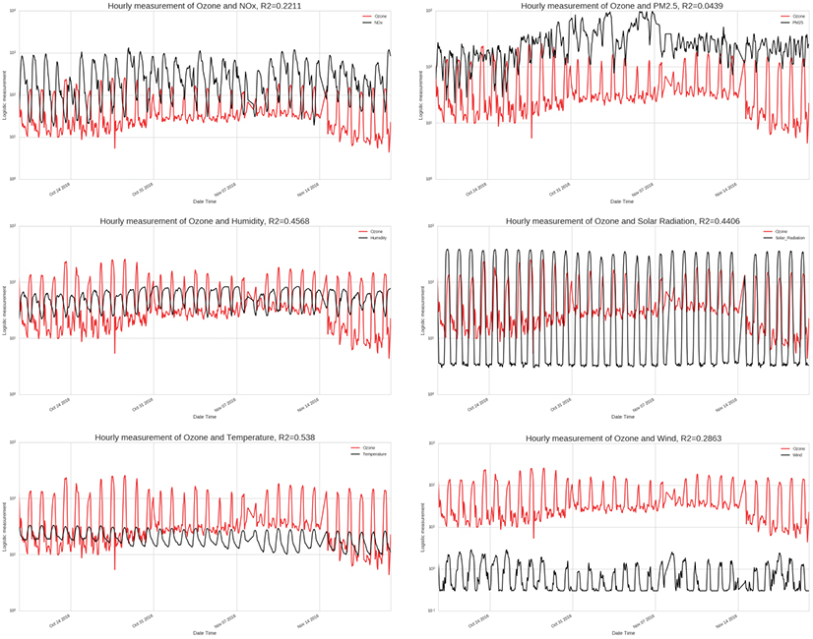
Figure 7: During fall/winter ozone concentration has good correlation with temperature, solar radiation and relative humidity while NOx and wind show poor correlation. PM2.5 has no correlation.
Figure 8: Hourly analysis of ozone concentration in May, 2016 (summer) found 59 times hourly concentration of Ozone exceeded the standard, Peak pollution value recorded was 387µg/m³, Mean of the pollution was 73 µg/m³
Figure 8: Hourly analysis of ozone concentration in May, 2016 (summer) found 59 times hourly concentration of Ozone exceeded the standard, Peak pollution value recorded was 387µg/m³, Mean of the pollution was 73 µg/m³
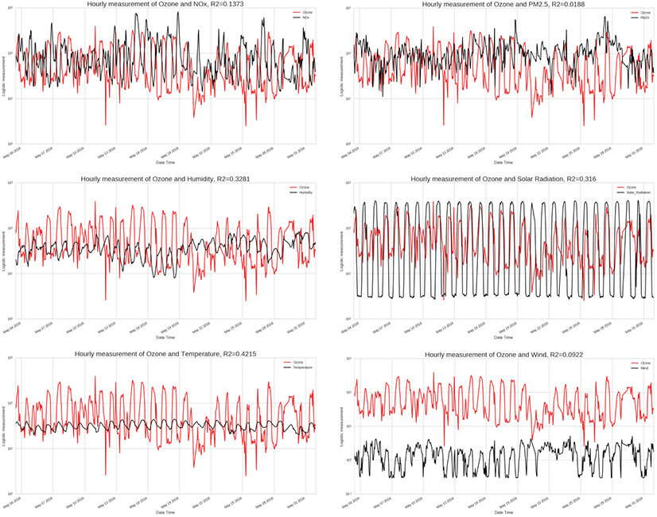
Figure 9: During summer ozone concentration has good correlation with temperature, solar radiation and relative humidity while NOx and wind show poor correlation. PM2.5 has no correlation.
Figure 10: Hourly analysis of ozone concentration in August, 2016 (monsoon) found 5 times hourly concentration of Ozone exceeded the standard, Peak pollution value recorded was 424 µg/m³,Mean of the pollution was 27 µg/m³
Figure 10: Hourly analysis of ozone concentration in August, 2016 (monsoon) found 5 times hourly concentration of Ozone exceeded the standard, Peak pollution value recorded was 424 µg/m³,Mean of the pollution was 27 µg/m³
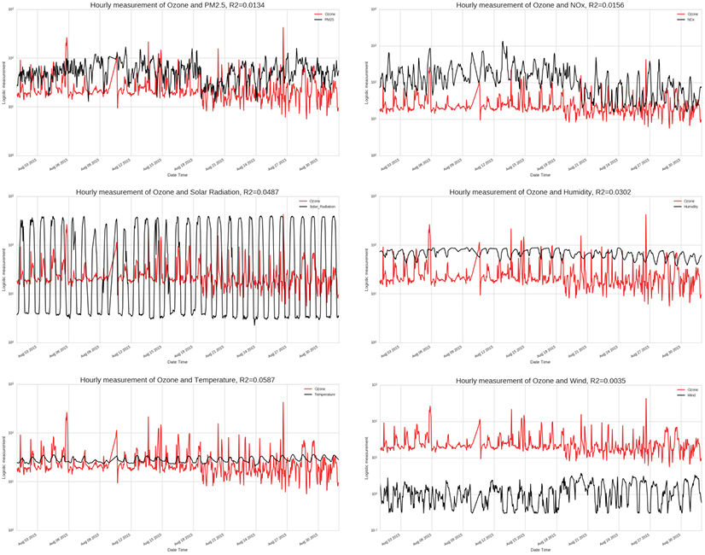
Figure 11: Ozone concentration has no correlation with any of the variables under inspection in this study during the monsoon season. This might be reflective of the impact of rain which was not included in this study.
Conclusion: The results show that ozone concentration in Delhi is correlated with solar radiation, temperature, relative humidity and NOx concentration. No correlation was found with wind speed and PM2.5 concentration. Study also found that instances of high ozone pollution are distributed throughout the year (only exception being rainy days during the monsoon season) in Delhi and it is not only a summer season phenomena as generally believed.
Study findings reveal that efforts to tackle ozone pollution which are currently concentrated in summer need to expand to the whole of the year. Model developed in the study be used to forecast highly ozone formation by CPCB to issue health alerts.
Future: The regression model built based on the study findings has a decent adjusted R-square of 0.595. But the Model’s R2 and adj_R2 improves after dropping the intercept, which is counter intuitive to how linear regression models work. Further analysis is required to resolve this issue. The model can surely be further improved by including precipitation information (explaining the unique pattern during monsoons) and data on volatile organic compounds (VOCs) which are the other source of ground level ozone formation but are not adequately monitored in Delhi thus not included in the scope of this study.
Bibliography:
- Delhi Summer Ozone Data Sheet , 2014, Centre for Science and Environment, http://www.cseindia.org/userfiles/ozone-fact-sheet-20140609.pdf
- Zhao H, Wang S, Wang W, Liu R, Zhou B (2015) Investigation of Ground-Level Ozone and High-Pollution Episodes in a Megacity of Eastern China. PLoS ONE 10(6): e0131878. doi:10.1371/journal.pone.0131878, http://journals.plos.org/plosone/article?id=10.1371/journal.pone.0131878
- Bordignon, S., Gaetan, C. & Lisi, F., Nonlinear models for ground-level ozone forecasting: Statistical Methods & Applications (2002) 11: 227. doi:10.1007/BF02511489, http://link.springer.com/article/10.1007/BF02511489
- Ambient (outdoor) air quality and health factsheet, WHO, http://www.who.int/mediacentre/factsheets/fs313/en/
- 2015 National Ambient Air Quality Standards (NAAQS) for Ozone, US EPA,
https://www.epa.gov/ozone-pollution/2015-national-ambient-air-quality-standards-naaqs-ozone
- Ozone pollution, US EPA, https://www.epa.gov/ozone-pollution
Link to GitHub repository: https://github.com/as10724/PUI2016_as10724/tree/master/EC_Project

